FT for schools: Will El Niño return for a heated-up 2023? Activity sheet 14

This resource was written by author and geography consultant Stephen Schwab.

The context
The El Niño and La Niña are large-scale climatic patterns which impact weather events around the world. They typically occur every 2 to 7 years and can last up to 12 months. The impacts of El Niño and La Niña are particularly felt by nations around the Pacific Ocean.

Currently, we are experiencing ENSO (El Niño Southern Oscillation) neutral conditions. However, in 2023 climate scientists anticipate the El Niño to return.

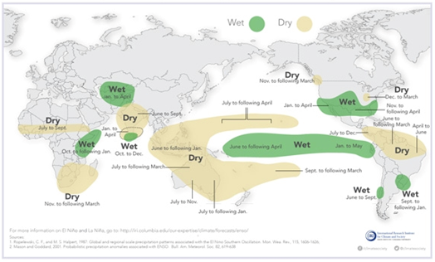
Figure 1 typical rainfall patterns during El Niño events © IRI Data Library Maprooms via World Meteorological Organisation

El Niño conditions in the tropical Pacific are known to shift rainfall patterns in many different parts of the world. Although they vary somewhat from one El Niño to the next, the strongest remain consistent in the regions and seasons shown in Figure 1 above.

The article
Access the article at www.ft.com/content/b1916d9b-0bf1-475e-b731-491ac254f1e7 to learn about the El Niño.

This month the World Meteorological Organisation has warned that the probability of El Niño developing has increased, and “its re-emergence would likely fuel higher global temperatures.”

The article emphasises that the last 3-year cycle of La Niña has “acted as a temporary brake on global temperatures”. Worryingly, even with this cooling-effect we have suffered the warmest years on record over the last 8 years.

If El Niño develops there will be increased rainfall for South America, the southern US, and across the Horn of Africa but drought will threaten Australia and Indonesia over the coming years. Drought can be life threatening, leading to lower water levels in lakes and reservoirs, dry vegetation, and the destruction of crops, as shown in Figure 2. During periods of drought farmers must spend more time and money on irrigation, whilst ranchers are often forced to spend more money on feed and water for animals.

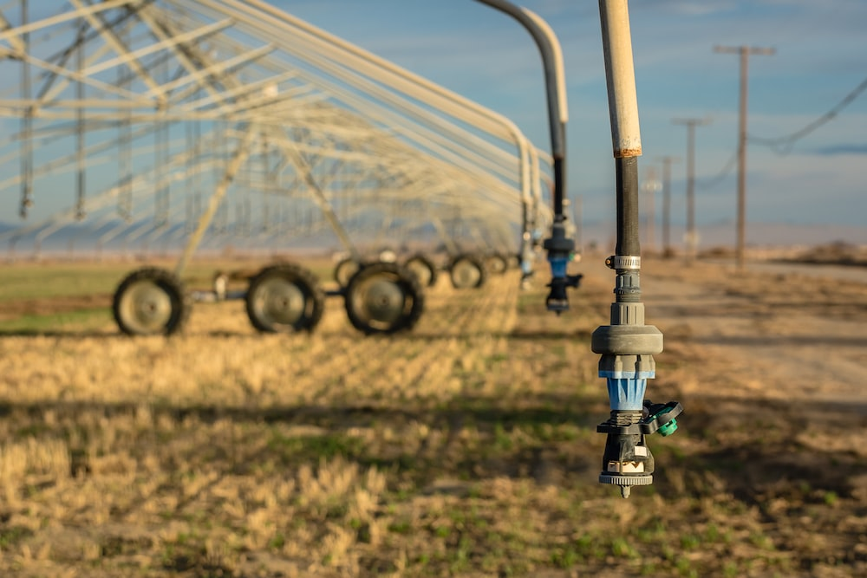
Figure 2 Drought conditions are expected for Australia and Indonesia with El Niño © Steve Harvey Unsplash

Specification links
AQA A level 3.1.5.5 Storm hazards.

Edexcel A level Area of study 1, Topic 1: Tectonic Processes and Hazards.

OCR A Level Topic3.1 Climate Change.

WJEC A level 3.1. Water and Carbon Cycles. 3.1.5 Deficit within the water cycle.

Activity
There are 3 graphics in the FT article: a map showing Pacific Ocean temperatures, El Niño and La Niña episodes, and the % likelihood of El Niño developing.

- Study each graphic carefully and describe what it shows in detail.

- Read the article and answer the question: will El Niño return for a heated-up 2023?

Note that your answer does not need to be binary.

- What might the human impacts of El Nino be in 2023? Consider water security, food security and other social and economic impacts.

- Read the FT article on climate change prevention, written by Mami Mizutori (link listed below). How can people prepare for and adapt to the impacts of future El Nino?

Further work
- Financial Times Climate graphic of the week: Will El Niño return for a heated-up 2023?
- World Meteorological Organisation Press release WMO Update: Prepare for El Niño

- The Guardian Warning of unprecedented heatwaves as El Niño set to return in 2023

- CarbonBrief State of the climate: Growing El Niño threatens more extreme heat in 2023

- The Conversation Four possible consequences of El Niño returning in 2023

- Reuters Peru to spend more than $1bn on climate plan, mitigate El Niño

- FT Mami Mizutori: With climate disasters increasing, prevention is better than cure

