Small Gases, Big Effect

What are the Small Gases?
The main gases responsible for changing our climate are carbon dioxide (CO₂), methane (CH₄), water vapor (H₂O), and nitrous oxide (N₂O). In the past these gases have created a natural greenhouse effect which worked to keep average global temperatures at an ambient 14°C. However, since the onset of the industrial revolution, human activities have added excessive amounts of all the greenhouse gases (GHGs) to the atmosphere. The Chair of the IPCC, said in the Sixth Assessment Report:

It shows that climate change is a grave and mounting threat to our wellbeing and a healthy planet. Our actions today will shape how people adapt and nature responds to increasing climate risks.
Hoesung Lee, Chair of the IPCC

Our atmosphere is vital to life on Earth as it contains the oxygen we need to live, creates pressure to maintain liquid water, makes the planet habitable, and protects us from harmful ultraviolet solar radiation. It is described as Earth’s ‘security blanket’.

Excessive pollution of greenhouse gases has led to a sustained increase in global temperatures and more extreme weather events – precipitating the term ‘climate change’. As a result, over the next two decades, the world now faces unavoidable multiple climatic hazards due to a minimum global warming of 1.5°C².

The specification
AQA 3.1.1.4 Water, carbon, climate, and life on Earth. The role of feedbacks within and between cycles and their link to climate change and implications for life on Earth.
Edexcel Topic 6: The Carbon Cycle and Energy Security. 6.7.c Climate change, resulting from the enhanced greenhouse effect, may increase the frequency of drought due to shifting climate belts.

OCR Topic 3.1 – Climate Change. 2. How and why has the era of industrialisation affected global climate?

WJEC 4.5: Weather and Climate. 4.5.4 Extreme weather events.

The authors
This teaching resource is designed to promote the international bestseller, Small Gases, Big Effect by David Nelles and Christian Serrer.

The RGS-IBG extends a special thank you to David and Christian for their work with the Society, to their publishers, Penguin, and the illustrators, Stefan Kraiss, Lisa Kauert (formerly Lisa Schwegler), and Janna Geisse who have kindly included their drawings in this educational resource.

You can listen to our podcast with the authors on iTunes, Soundcloud, or Spotify, titled The surprise bestseller: Small Gases, Big Effect by David Nelles and Christian Serrer.

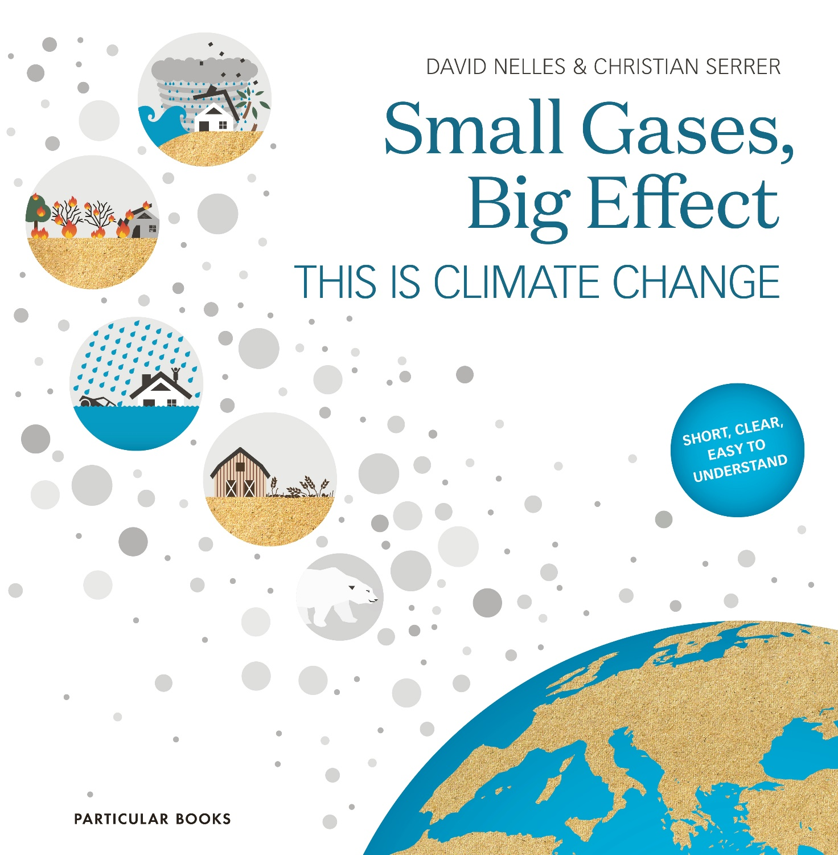
Figure 1 Small Gases, Big Effect © Penguin

Extracts from the book
To begin the book distinguishes between changes to climate and changes to weather:

Climate refers to the average weather conditions over a long period of time – a period of at least 30 years, according to the World Meteorological Organisation. In contrast to the weather, therefore, the climate changes very slowly. A 5°C drop in temperature from one day to the next is completely different from the climate cooling by 5°C. In the latter case, we would be plunged into conditions resembling the last ice age.

David Nelles and Christian Serrer

Climate change is fuelled by the burning of hydrocarbons. Approximately 85% of CO₂ emissions are created from burning fossil fuels to generate energy. The remaining amount is split between cement production (5%) and land use change (10%). In Figure 2 below the blue diagram shows how the energy derived from fossil fuels is used (in 2014). The illustration underneath shows the combination of coal, oil, and gas to fossil fuel emissions.
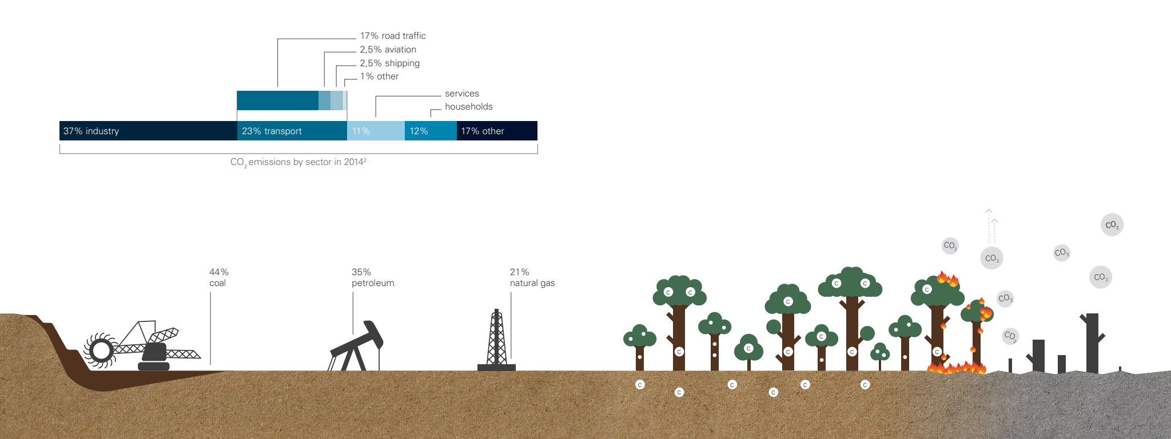
Figure 2 carbon dioxide emissions p40-41 © Stefan Kraiss, Lisa Kauert (Schwegler), and Janna Geisse

CO₂ remains the most abundant and dangerous of the GHGs however increasing attention is now focused on CH₄. Methane is described as a ‘potent gas’. This is because, if a little more is added to the atmosphere, it can have a big impact on how much and how quickly the planet warms. On a 100-year timescale, it is 28 times more powerful than CO₂ at warming the Earth. As a result, in 2021 a UN report identified methane as a key gas in the fight against climate change. The report identified the ‘urgent steps’ required to keep global warming within the 1.5°C limit set by the 2015 Paris Agreement. Methane is a powerful GHG and, despite pandemic lockdowns throughout 2020 and 2021, the levels are rising. Since 1970 methane concentrations have risen by more than 150% and continue to grow.
Figure 3 methane emissions (left 5 statistics) and nitrous oxide emissions (right 5 statistics) p42-43 © Stefan Kraiss, Lisa Kauert (Schwegler), and Janna Geisse

Table 1 below shows the increase in atmospheric methane from 1984 to 2020.

Year | Increase CH₄ parts per billion | Uncertainty
1984 | 12.83 | 0.84
1985 | 12.31 | 0.91
1986 | 12.90 | 0.65
1987 | 11.40 | 0.72
1988 | 10.80 | 0.55
1989 | 11.08 | 0.59
1990 | 8.71 | 0.47
1991 | 14.05 | 0.55
1992 | 2.40 | 0.51
1993 | 3.82 | 0.59
1994 | 7.21 | 0.61
1995 | 3.96 | 0.56
1996 | 2.51 | 0.48
1997 | 6.25 | 0.69
1998 | 12.15 | 0.70
1999 | 2.39 | 0.65
2000 | -1.48 | 0.54
2001 | -0.72 | 0.56
2002 | 3.23 | 0.56
2003 | 4.79 | 0.57
2004 | -4.85 | 0.42
2005 | 0.34 | 0.41
2006 | 1.93 | 0.56
2007 | 7.84 | 0.57
2008 | 6.53 | 0.44
2009 | 4.67 | 0.41
2010 | 5.20 | 0.71
2011 | 4.86 | 0.58
2012 | 5.00 | 0.51
2013 | 5.71 | 0.58
2014 | 12.77 | 0.50
2015 | 10.01 | 0.70
2016 | 7.07 | 0.67
2017 | 6.89 | 0.79
2018 | 8.68 | 0.52
2019 | 9.80 | 0.64
2020 | 15.57 | 0.38
Table 1 the global trend of CH₄ since 1984 © NOAA

Figure 3 shows that around 60% of methane emissions are from human sources. These sources are the 1.4 billion cows on the planet who belch and release flatulence, the bacteria in flooded rice paddy fields, extractive industries (i.e., oil and gas), and the decomposition of waste (in particular food waste) from landfill sites.

Natural sources of CH₄ come from volcanology, naturally burning landscapes, wetlands, and thawing permafrost in the Arctic.

Thawing permafrost is a huge environmental problem as the process exposes thousands of years of plant and animal remains to microbial decomposition (see Figure 4). This decomposition in turn releases further CO₂ and CH₄ creating a harmful positive feedback loop. Vast swaths of permafrost in the northern hemisphere have begun to suffer from abrupt permafrost thaw, described by the Carbon Brief as one of nine ‘tipping points’. Once organic matter in permafrost decomposes, releasing CO₂ and CH₄, there is no going back.

Further problems arise in permafrost areas when land collapses from thawing. This process can leave a pockmarked landscape with thermokarst lakes, filled with snow and meltwater. These wet conditions can lead to the release of more methane.

Permafrost stores around 1.5 trillion metric tons of organic carbon, twice as much as Earth's atmosphere.

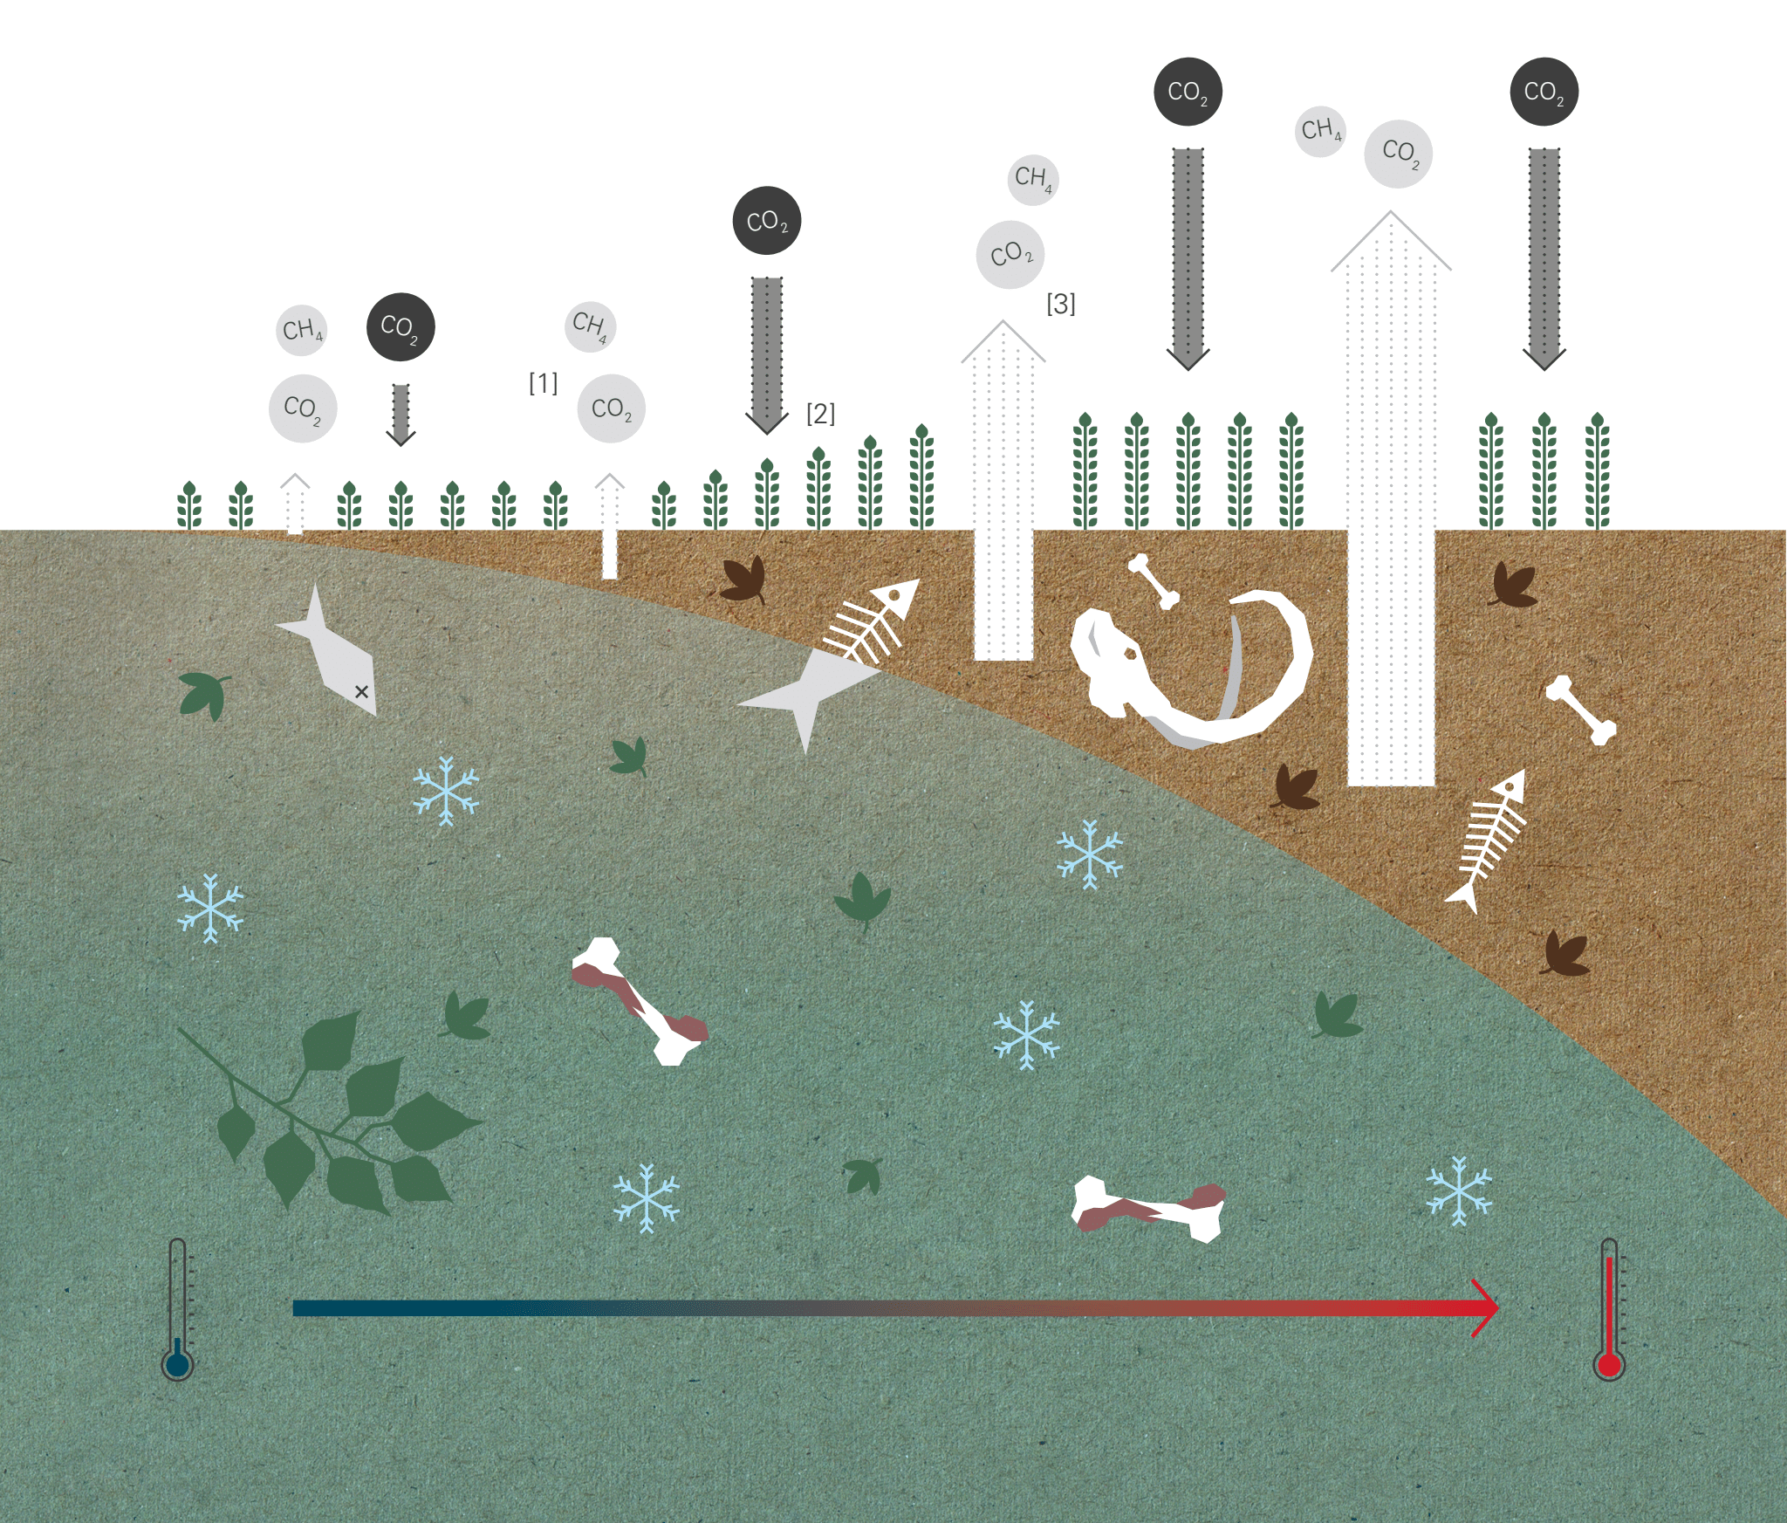
Figure 4 permafrost p62-63 © Stefan Kraiss, Lisa Kauert (Schwegler), and Janna Geisse

Figure 5 shows the other impacts from thawing permafrost. One example is unstable subsoil which can lead to ground deformation and damage to human infrastructure. You can learn more about the impact and financial cost of thawing permafrost in the teaching resource pack Climate Change and the Russian Arctic.
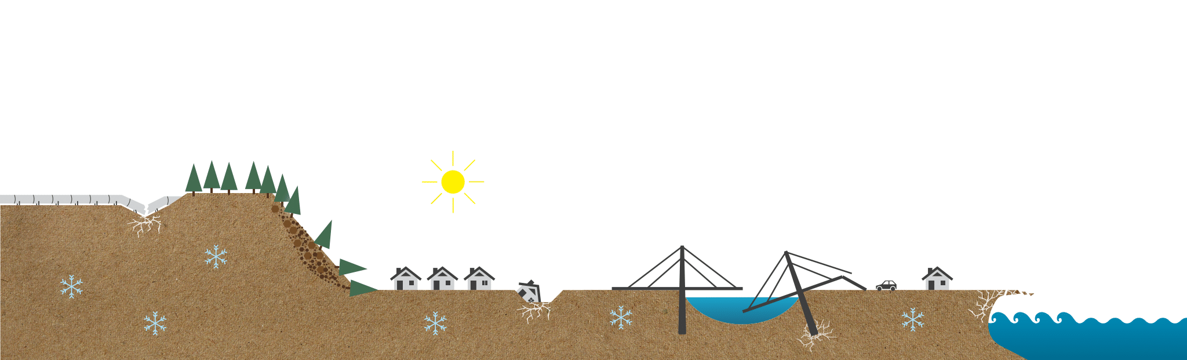
Figure 5 other consequences of thawing permafrost p64-65 © Stefan Kraiss, Lisa Kauert (Schwegler), and Janna Geisse

Water vapour is another GHG. Figure 6 illustrates the 4-step process of the formation of atmospheric water vapour. Ultimately, additional water vapour intensifies the greenhouse effect adding to the increasing rise in temperature. Once initiated, this is self-accelerating.
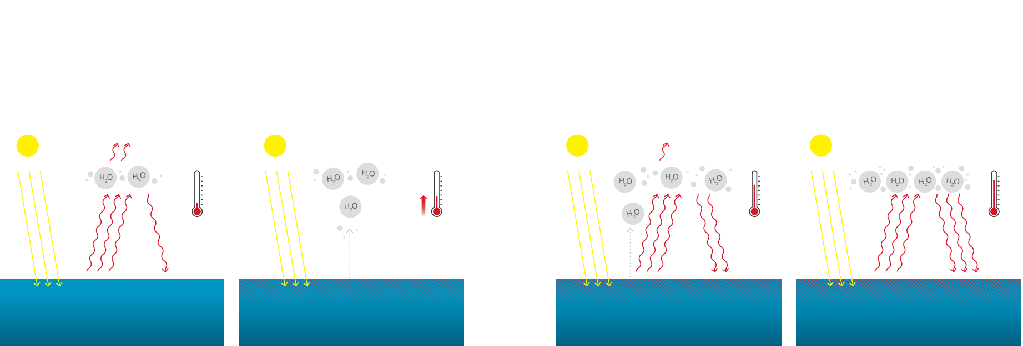
Figure 6 water vapour feedback p70-71 © Stefan Kraiss, Lisa Kauert (Schwegler), and Janna Geisse

The increasing levels of carbon dioxide, methane, nitrous oxide, and water vapour are fuelling climate change. In general terms, the climate is becoming more unpredictable and warmer. Record-breaking temperatures and heatwaves are becoming more common whilst cool spells and cold extremes are less frequent.

The diagram in Figure 7 illustrates the difference in extreme hot and cold weather between earlier climates and our current climate today.

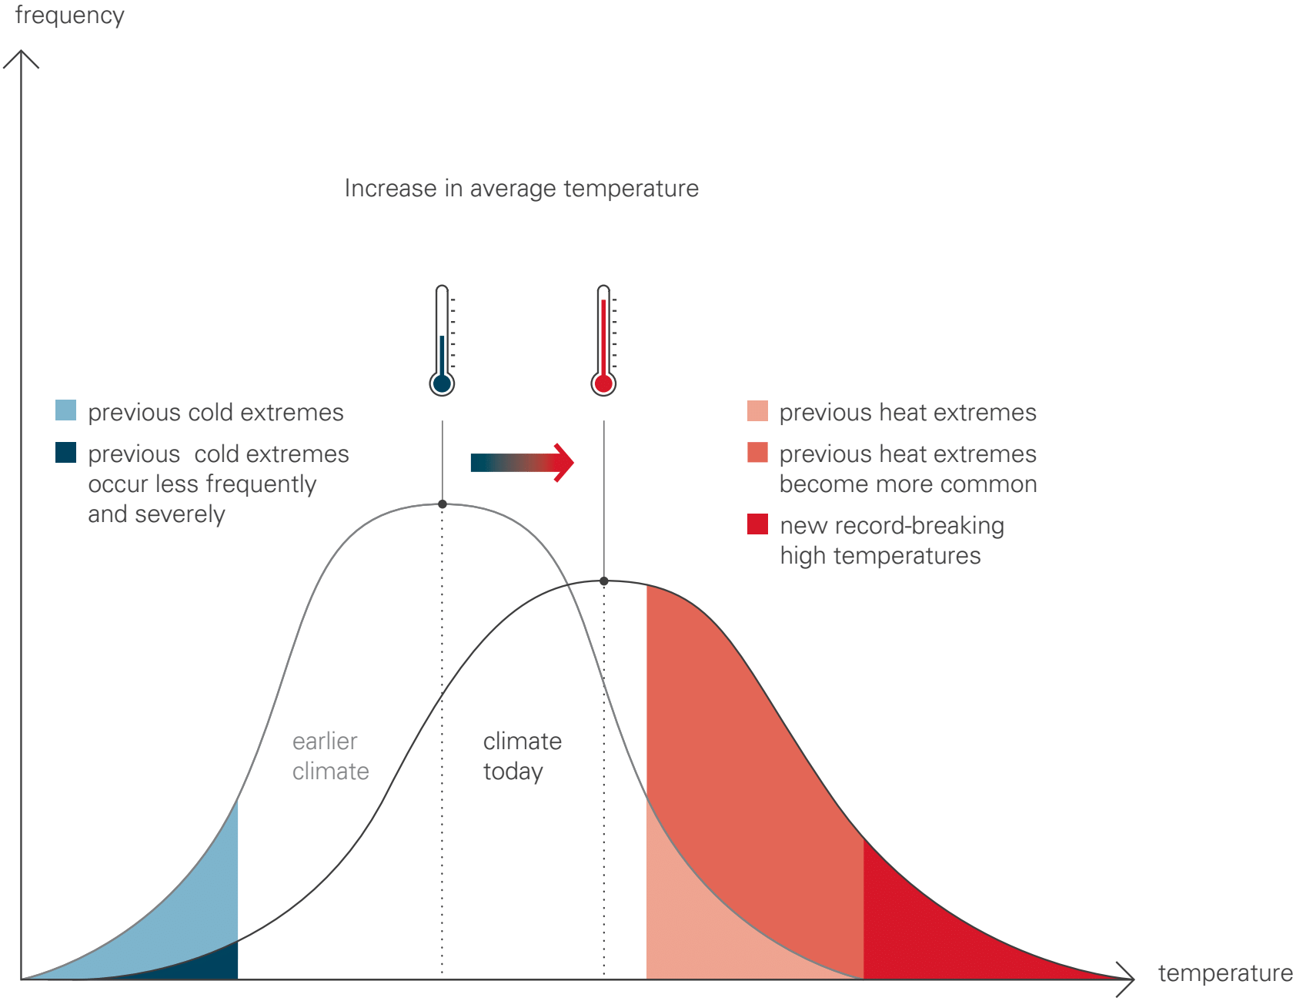
Figure 7 extreme hot and cold weather p78-79 © Stefan Kraiss, Lisa Kauert (Schwegler), and Janna Geisse
The plight of pikas are a small example of a specific impact from climate change. North American pikas are highly temperature-sensitive mammals (closely related to rabbits and hares) which don’t hibernate and rely on snow cover insulation to keep their burrows warm. However, due to a retreating snowline (and lack of insulting snow), these creatures are in danger of freezing to death.

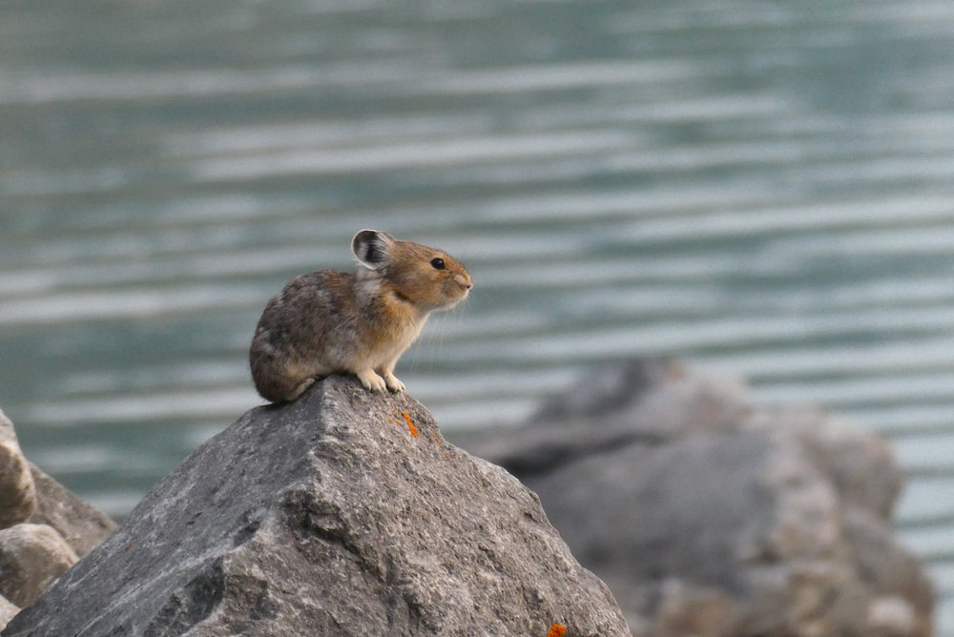
Figure 8 a pika © Derek Ryder Unsplashed

Similarly, the broad tailed hummingbird will also suffer the effects of climate change due to a phenological shift. Broad tailed hummingbirds migrate from Central America northwards to the mountains to breed every summer. Due to climate change these birds have started to arrive earlier to their northernmost breeding sites. Higher temperatures now mean the flowering season for nectar-rich plants has shifted forwards, effectively reducing the time between the birds’ arrival and the flowering of their food source.
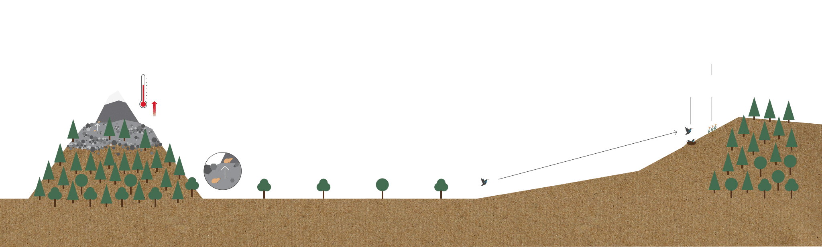
Figure 9 the plight of the pikas and hummingbirds p96-97 © Stefan Kraiss, Lisa Kauert (Schwegler), and Janna Geisse

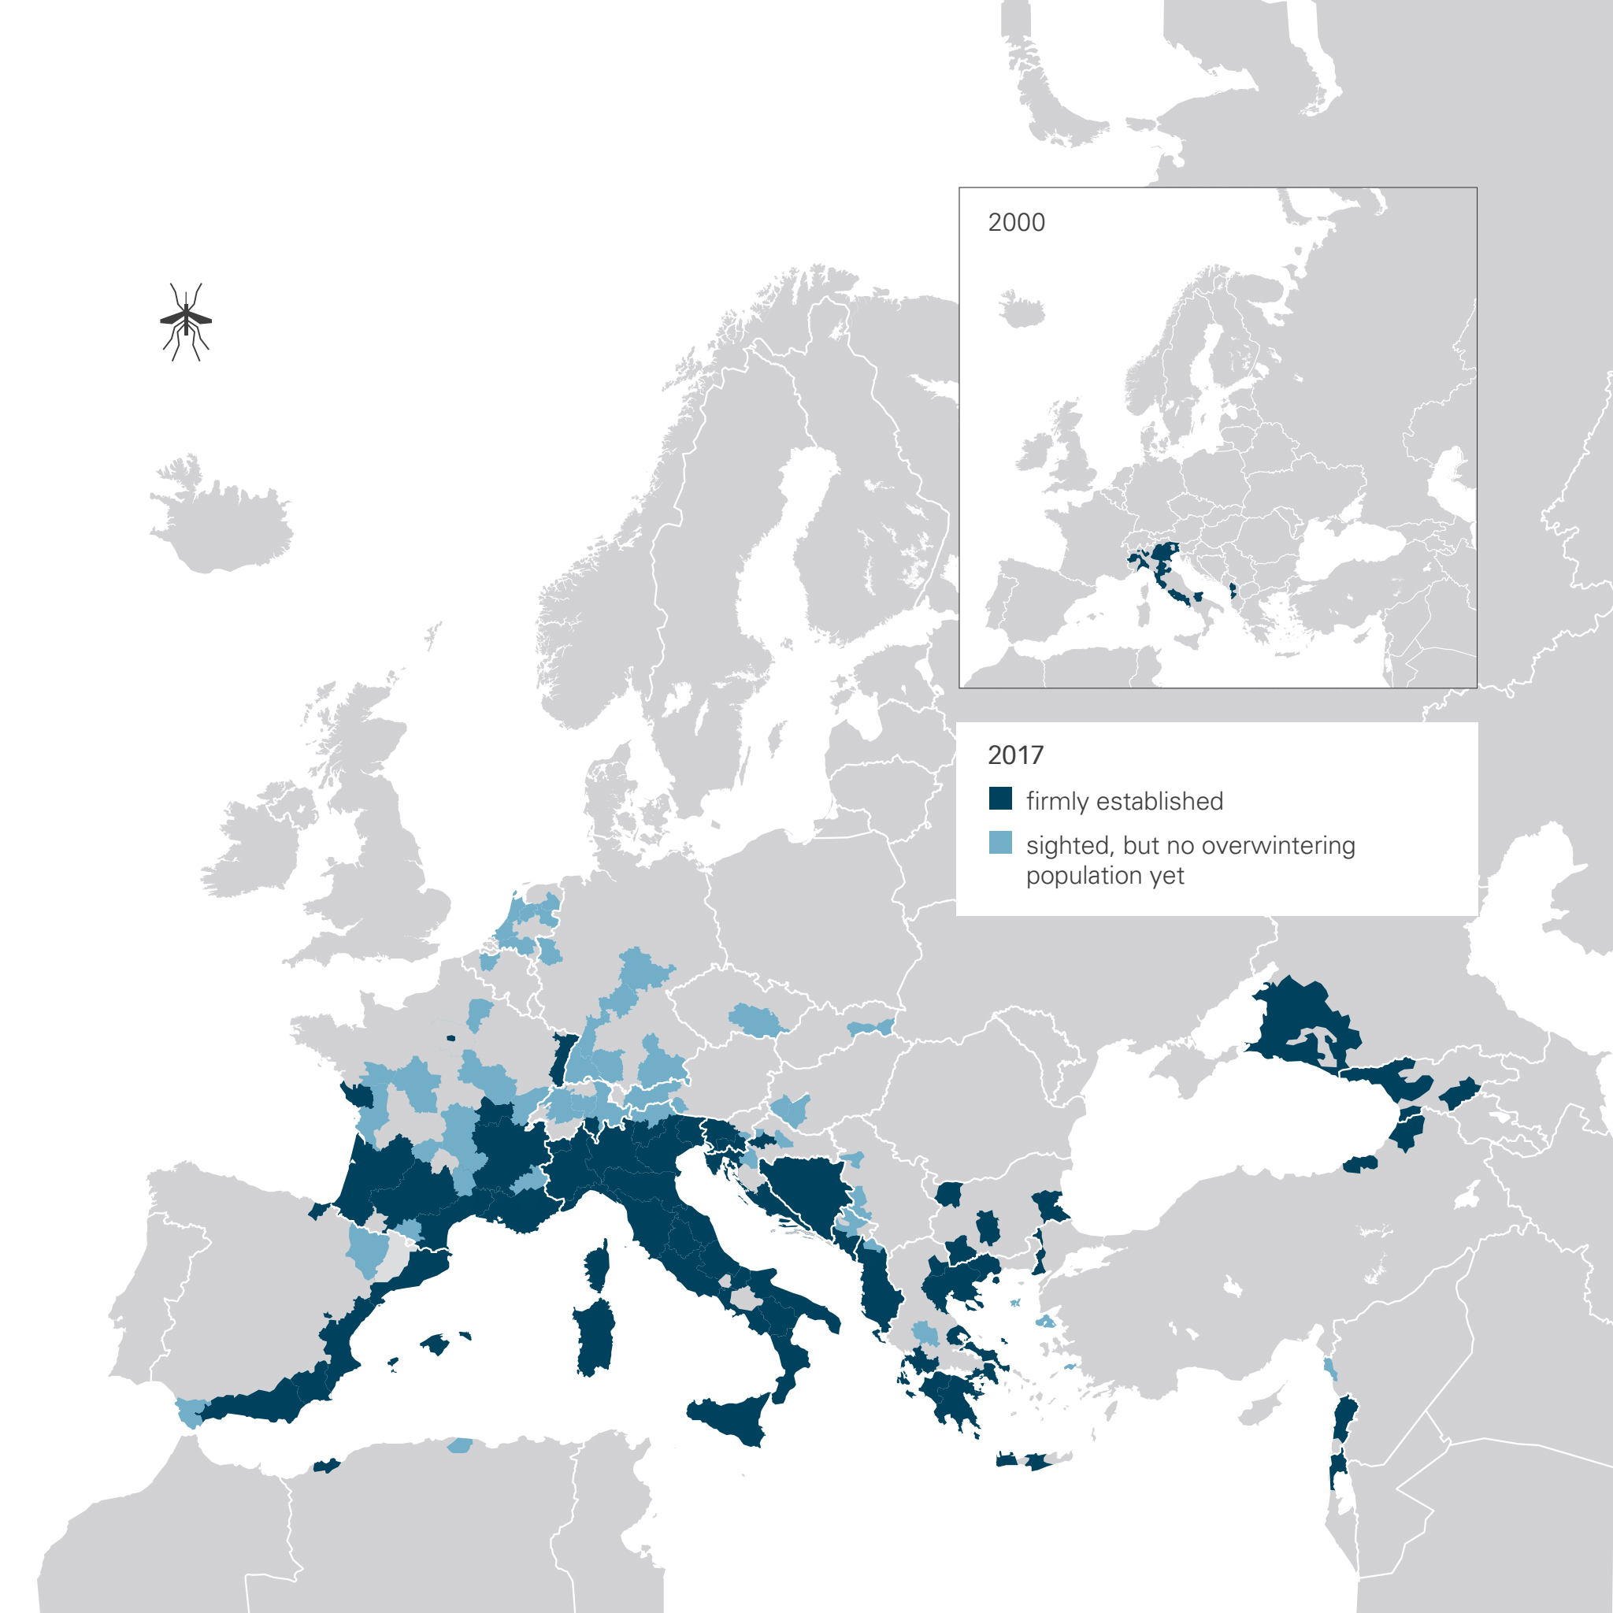
Figure 10 vector-borne diseases p108-109 © Stefan Kraiss, Lisa Kauert (Schwegler), and Janna Geisse

Vectors are organisms which can transmit pathogens from an infected animal or person to another. Figure 10 highlights one of several health implications stemming from climate change – and from globalisation and migration.

In this case higher temperatures are facilitating the westwards expansion of the Asian tiger mosquito, which has traditionally been confined to the tropical areas of southeast Asia. These insects are capable of transmitting pathogens such as dengue fever, yellow fever, zika, and chikungunya.

The pace of global warming is completely altering insect populations, with some species dying out and others thriving. The Asian tiger mosquito is spreading throughout southern Europe due to climate change.

In the UK some insects will survive the changes, such as dragon flies, whilst many others, namely the pollinators, will perish.
An example of a declining insect is the bumblebee – populations in North America have halved whilst European numbers have declined by 17%.

Agricultural practices, as well as climate change, are responsible for the global biodiversity crisis. Worldwide, the demand for food has led to habitat loss, over-exploitation, and fragmentation. Table 2 shows example activities which affect global biodiversity: the food system, logging activities, development or disturbance, fires and water management, climate change, other species, energy and mining, and pollution.

 | Habitat loss | Direct mortality | Other activities
Food system | 15,376 | 6,398 | 3,598
Logging or resource use | 10,713 | 3,962 | 2,982
Development or disturbance | 7,376 | 1,767 | 2,915
Fire and water management | 7,087 | 2,640 | 1,986
Climate change and weather | 3,337 | 1,542 | 1,723
Other species | 2,621 | 3,597 | 3,060
Energy and mining | 3,632 | 1,141 | 987
Other pollution | 2,217 | 401 | 280
Table 2 number of species threatened with extinction affected by various human activities © IUCN 2016 data

Weather extremes are likely to have a bigger and bigger impact on crop yields. On the left of Figure 11 the 3 tractors represent a low to moderate increase in yields linked to a 1-2°C increase in global temperature (compared to pre-industrial levels).

The optimum growth level is marked in the middle of the image, this will differ around the world due to different experiences of climate change, and different types of crops. Once this optimum growth level is exceeded there will be a sharp decline in crop yields due to heat, drought, or weather unpredictability (represented by the tractors to the right).
Figure 11 Agriculture p112-113 © Stefan Kraiss, Lisa Kauert (Schwegler), and Janna Geisse

Activity
- Study Figure 2. Which fossil fuel accounts for the largest share of emissions generated by burning fossil fuels?

- What does the forested part of Figure 2 represent?

- Describe the change in atmospheric CO₂ by completing the following steps:

  - Go to the Our World in Data page for CO₂ and greenhouse gas emissions
  - Scroll down to the subtitle Atmospheric concentrations of CO2 continue to rise
  - Click Download and select Full data (.CSV)
  - Delete column A Entity and column B Code
  - Select all the rows (down to 1872) and click the Insert tab
  - Click Recommended Charts and select the first one (a scatter chart)
  - Describe the graph

- Study Figure 3. What is the main source of methane and the main source of nitrous oxide?

- Study Figure 4. Moving left to right in the image, as the permafrost layer thaws, what changes do you see?

- Study Figure 5. What damage to human infrastructure can you see in the image?

- Study Figure 6. Describe what is happening in each of the 4 steps for water vapour feedback.

- Create a bar graph to illustrate the data from Table 2. x axis is Number of species affected; y axis is the 8 Direct threats.

Further reading
- Small Gases, Big Effect can be purchased from Hive (online network of 360 independent bookstores nationwide), Wordery, or Waterstones as well as other major book retailers

- NASA The Atmosphere: Earth's Security Blanket

- UN IPCC Sixth Assessment Report press release 28 February 2022

- The National Geographic Methane, explained

- Our World in Data CO₂ and Greenhouse Gas Emissions

- The Guardian How the speed of climate change is unbalancing the insect world

Answers

- Coal accounts for the largest share of emissions generated by burning fossil fuels.

- The forested part of Figure 2 represents the practice of slash-and-burn in tropical rainforests. This type of forest clearance is incredibly damaging to the natural environment as it releases CO₂ stored in the trees and the peat soils.

- GHGs continue to accumulate with consistent fluctuations in CO₂ concentrations between 800,000 BCE and present day. The Milankovitch cycles are responsible for these fluctuations – low levels of CO₂ are linked to ice ages, whilst high levels are from interglacial periods. However, since 6,402 BCE (258.3-ppm) there has been a continued, and unprecedented, increase in atmospheric CO₂. This is a rapid and exponential rise. Until this recent surge in CO₂, the 300-ppm threshold had never been exceeded in the entirety of the past 800,000 years. On 9 May 2013 the 400-ppm mark was subsequently breeched, for the first time in more than 3 million years of Earth history. The current level of atmospheric CO₂ is 412.5-ppm.

- The main source of CH₄ is fossil fuels. Globally 29% of man-made methane comes from the burning of fossil fuels. Nearly as much methane is generated by livestock. Agriculture is the largest contributor to N₂0 accounting for an enormous 59% of all global nitrous oxide emissions (largely from fertilisers and livestock).

- As permafrost thaws more and more carbon dioxide and methane will be released in Earth’s atmosphere. There will be more plant growth which will absorb some of the CO2 from the soil. In the long term this will be negligible, and global temperatures will rise considerably.

- Oil and gas pipelines will rupture. Houses will be destroyed as sinkholes open up. Bridges might collapse and roads will warp from unstable subsoil movement.

- Warm air absorbs more water vapour than cold. The process starts with rising H₂O (the water vapour), which increases the water vapour content of the atmosphere. The greenhouse effect is intensified, leading to an ever-rapid rise in temperature. Global warming is sped up as the process becomes self-accelerating, known as a positive feedback loop.

- Bar graph below.

Page 8 The Natural Greenhouse Effect, Small Gases Big Effect
IPCC Sixth Assessment Report press release 28 February 2022
Methane, explained

