FT for schools: COVID-19 inequality activity sheet 5

This resource was written by Alasdair Monteith, Head of Geography, Gordonstoun school.

The article
www.ft.com/content/49878986-6fa1-425a-bf83-a62925c5d88a?shareType=nongift poor countries ‘staggering’ hardship

Specification links
AQA
3.2.3.2 Urban forms. Spatial patterns of land use, economic inequality, social segregation and cultural diversity in contrasting urban areas, and the factors that influence them.

Edexcel
3.7 Globalisation has led to dramatic increases in development for some countries, but also widening development gap extremities and disparities in environmental quality.

OCR
2.1 – Changing Spaces; Making Places 3.a. The distribution of resources, wealth and opportunities are not evenly spread within and between places.

Eduqas
3.3: Economic Growth and Challenge: inequality (the consequences of economic, social and environmental change at regional and global scales).

Context
Those who were ‘already poor’ in the developing world (and, in some cases, in the developed) have suffered ‘staggering’ hardships and there is widespread concern that many millions of people across the world will slip into destitution.
In 2020 this and other FT articles estimate that:

- The GDP of the G7, the most advanced economies, contracted by 5.9%

- The GDP of the developing world shrank only by 3.3%

- The ‘final salary’ style pension schemes around the world could fall by as much as £60bn (in the UK 5,300 businesses fund such a plan)

- In the UK recent IFS (Institute for Fiscal Studies) research suggested in the last lockdown mothers spent 60% more time than men with children who were doing schoolwork

- In the UK (as in much of the world) mothers are more likely to be furloughed or quit work altogether, missing out on raised salaries and promotions

- Covid-19 is worsening wage equality around the world. The UN said that the level of growth rate of average wages had fallen in two-thirds of tracked countries

- The ILO (International Labour Organisation) has warned that the lowest paid workers have lost the most — 17.3% of their pay — with their share of the total wage bill falling from 27% to 23% globally
- Most countries have a statutory wage floor, but at present, out of an estimated 327 million workers paid at or below their local rate around the world, 266 million are paid below the legal minimum

- The World Bank estimates that as many as 150 million people might be pushed into ‘extreme poverty’ (destitution) by 2021 with the level of extreme poor rising for the first time since 1998

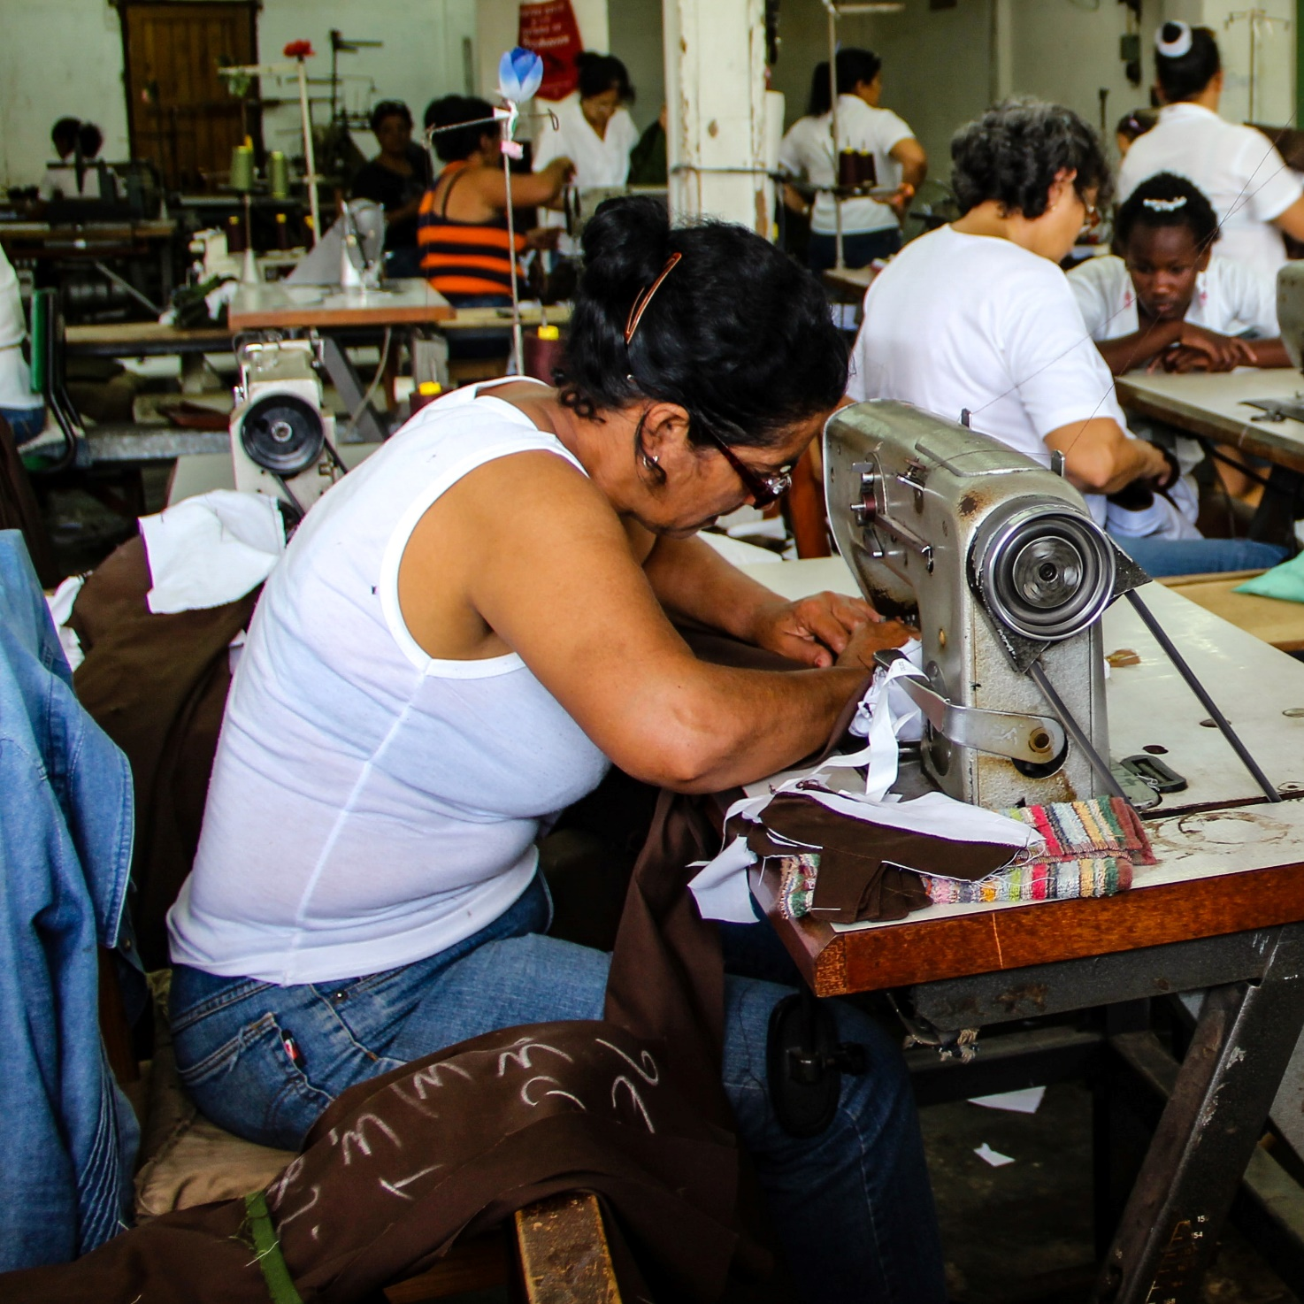
Low-paid garment factory workers © Fran Hogan

Activity
Using the articled link above, complete the following questions below.
- Briefly explain the financial impact of the pandemic on LIDC and EDC populations based on the survey's findings.

- Outline which age groups are particularly vulnerable to the increase in poverty.

- Using the information in the article and your own research consider the following question:

ACs should prioritise poverty reduction and development projects in LIDCs and EDCs following the pandemic. Discuss.

Further reading
- Female disadvantaged during Covid-19 Economic inequality: mothers face homeschool disadvantage | Financial Times (ft.com)

- Global wage inequality Covid crisis fuels global wage inequality | Financial Times (ft.com)

- Inequality will widen New Covid variant will increase stress on global economy and widen inequality | Financial Times (ft.com)

- World Bank projections Projected poverty impacts of COVID-19 (coronavirus) (worldbank.org)

- 150 million COVID-19 to Add as Many as 150 Million Extreme Poor by 2021 (worldbank.org)

- Low earners debt Low earners more likely to be racking up debt in pandemic as fears people are plunging into ‘deeper poverty’ | The Independent

- The Conversation 5 ways coronavirus is deepening inequality

