Performing analysis in ArcGIS online

Source: https://doc.arcgis.com/en/arcgis-online/analyse/perform-analysis.htm

Whenever you look at a map, you inherently start turning that map into information by finding patterns, assessing trends, or making decisions. This process is called spatial analysis, and it's what our eyes and minds do naturally whenever we look at a map.
But many patterns and relationships aren't always obvious by looking at a map. Often, there's too much data to sift through and present coherently on a map. The way you display the data on the map can change the patterns you see. Spatial analysis tools allow you to quantify patterns and relationships in the data and display the results as maps, tables, and charts. The spatial analysis tools empower you to answer questions and make important decisions using more than a visual analysis.
To learn more about accessing and running the tools, see Use the analysis tools.
An overview of each of the tools can be found below. The analysis tools are arranged in categories that are logical groupings and do not affect how you access or use the tasks in any way.
The Analysis page contains case studies that provide examples showing how analysis can be carried out using ArcGIS Online, ArcGIS Pro, and ArcGIS Desktop.

Summarise data
These tools calculate total counts, lengths, areas, and basic descriptive statistics of features and their attributes within areas or near other features.
Tool | Description
AggregateFind nearest Points | 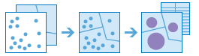  This tool works with a layer of point features and a layer of area features. It first figures out which points fall within each area. After determining this point-in-area spatial relationship, statistics about all points in the area are calculated and assigned to the area. The most basic statistic is the count of the number of points within the area, but you can get other statistics as well.  For example, suppose you have point features of coffee shop locations and area features of counties, and you want to summarise coffee sales by county. Assuming the coffee shops have a TOTAL_SALES attribute, you can get the sum of all TOTAL_SALES within each county, or the minimum or maximum TOTAL_SALES within each county, or the standard deviation of all sales within each county.
Join Features | 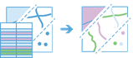  This tool transfers the attributes of one layer or table to another based on spatial and attribute relationships. Statistics can then be calculated on the joined features.  For example  - Join crime data to police districts using a spatial relationship.  - Join land use descriptions to land use polygons using code values.
Summarise Nearby | 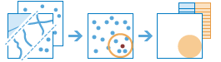  This tool finds features within a specified distance of features in the analysis layer. Distance can be measured as a straight-line distance or a selected travel mode. Statistics are then calculated for the nearby features.  For example  - Calculate the total population within five minutes of driving time of a proposed new store location.  - Calculate the number of freeway access ramps within a one-mile driving distance of a proposed new store location to use as a measure of store accessibility.  Note:  To summarise nearby features using one of the available travel modes, you need to be granted the Network Analysis privilege.
Summarise Within | 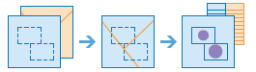  This tool finds features (and portions of features) within the boundaries of areas in the analysis layer.  For example  - Given a layer of watershed boundaries and a layer of land-use boundaries by land-use type, calculate total acreage of land-use type for each watershed.  - Given a layer of parcels in a county and a layer of city boundaries, summarise the average value of vacant parcels within each city boundary.
Summarise Centre and Dispersion | 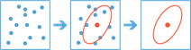  This tool finds the central feature, mean centre, median centre, or ellipse (directional distribution) of point features.  For example  - Find the central feature in a set of points, such as trees, buildings, or parks.  - Find the mean centre of a set of points, such as crime incidents or wildlife sightings.  - Find the median centre of a set of points, such as the locations of car accidents.  - Find the dispersion (ellipse) of a set of points, such as disease occurrences or the location of an invasive plant species.

Find Locations
These tools find features that pass any number of criteria that you specify. They are typically used for site selection, where the objective is to find places that satisfy multiple criteria.
Tool | Description
Find Existing Locations | 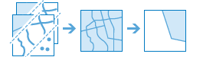  This tool selects existing features in your study area that meet a series of criteria you specify. These criteria can be based on attribute queries (for example, parcels that are vacant) and spatial queries (for example, parcels within 1 mile of a river).
Derive New Locations | 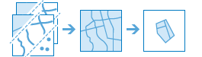  This tool derives new features in your study area that meet a series of criteria you specify. These criteria can be based on attribute queries (for example, parcels that are vacant) and spatial queries (for example, parcels that are within flood zones).
Find Similar Locations | 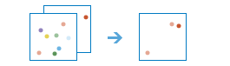  Based on criteria you specify, the Find Similar Locations tool measures the similarity of locations in your candidate search layer to one or more reference locations.
Choose Best Facilities | 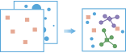  This tool finds the set of facilities that will best serve demand from surrounding areas.  Facilities might be public institutions that offer a service, such as fire stations, schools, or libraries, or they might be commercial ones, such as drug stores or distribution centres for a parcel delivery service. Demand represents the need for a service that the facilities can meet. Demand is associated with point locations, with each location representing a given amount of demand.  Note:  To choose facilities using one of the available travel modes, you need to be granted the Network Analysis privilege.
Create Viewshed | 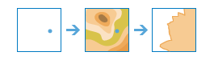  This tool creates areas where an observer can see objects on the ground. The input analysis points can represent either observers (such as people on the ground or lookouts in a fire tower) or observed objects (such as wind turbines, water towers, vehicles, or other people). The result areas are those areas where the observers can see the observed objects and vice versa: the observed objects can see the observers. The output is typically used in site suitability and selection analysis.
Create Watersheds | 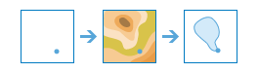  This tool identifies catchment areas based on locations you specify.
Trace Downstream | 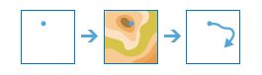  This tool determines the trace, or flow path, in a downstream direction from the points in your analysis layer.
Find Centroids | 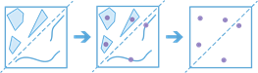  This tool creates central point features from multipoint, line, and area features.

Data enrichment
These tools help you explore the character of areas. Detailed demographic data and statistics are returned for your chosen areas. Comparative information can also be reported for expanded areas such as counties and states.
Tool | Description
Enrich Layer | 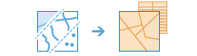  This tool enriches your point or area data by getting facts about the people, places, and businesses that surround your data locations. Enrich Layer enables you to answer new questions about locations that you cannot answer with maps alone; for example, What kind of people live here? What do people like to do in this area? What are their habits and lifestyles? What kind of businesses are there in this area?  The result will be a new layer containing all demographic and geographic information from given data collections. This new information is added as fields in the table.  Tip:  Click the star next to a variable in the Data Browser to add it to your list of favourites. Your favourites can be accessed by clicking Show Favourite Variables on the menu page of the Data Browser.  Note:  To use this tool, you need to be granted the GeoEnrichment privilege. In addition, to enrich features based on one of the available travel modes, you need to be granted the Network Analysis privilege.

Analyse patterns
These tools help you identify, quantify, and visualise spatial patterns in your data by identifying areas of statistically significant clusters.
Tool | Description
Calculate Density | 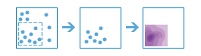  The Calculate Density tool creates a density map from point or line features by spreading known quantities of some phenomenon (represented as attributes of the points or lines) across the map. The result is a layer of areas classified from least dense to most dense.  For example  - Calculating densities of hospitals within a county. The result layer will show areas with high and low accessibility to hospitals, and this information can be used to decide where new hospitals should be built.  - Identifying areas that are at high risk of forest fires based on historical locations of forest fires.  - Locating communities that are far from major highways in order to plan where new roads should be constructed.
Find Hot Spots | 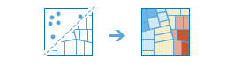  The Find Hot Spots tool will determine if there is any statistically significant clustering in the spatial pattern of your data.  For example  - Are your points (crime incidents, trees, traffic accidents) really clustered? How can you be sure?  - Have you truly discovered a statistically significant hot spot (for spending, infant mortality, consistently high test scores), or would your map tell a different story if you changed the way it was symbolized?  The Find Hot Spots tool will help you answer these questions with confidence.
Find Outliers | 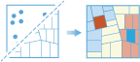  The Find Outliers tool will determine if there are any statistically significant outliers in the spatial pattern of your data.  For example  - Are there anomalous areas in the pattern of your data (crime incidents, trees, traffic accidents)? How can you be sure?  - Have you truly discovered a statistically significant outlier (for spending, infant mortality, consistently high test scores), or would your map tell a different story if you changed the way it was symbolized?  The Find Outliers tool will help you answer these questions with confidence.
Find Point Clusters | 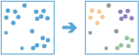  The Find Point Clusters tool finds clusters of point features within surrounding noise based on their spatial distribution.  For example  - Find clusters of houses infested with pests.  - Find clusters of crime incidents, like theft.
Interpolate Points | 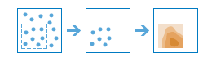  The Interpolate Points tool allows you to predict values at new locations based on measurements from a collection of points. The tool takes point data with values at each point and returns areas classified by predicted values.  For example  An air quality management district has sensors that measure pollution levels. Interpolate Points can be used to predict pollution levels at locations that don't have sensors, such as locations with at-risk populations—schools or hospitals, for example.  - Predict heavy metal concentrations in crops based on samples taken from individual plants.  - Predict soil nutrient levels (nitrogen, phosphorus, potassium, and so on) and other indicators (such as electrical conductivity) in order to study their relationships to crop yield and prescribe precise amounts of fertilizer for each location in the field.  - Meteorological applications include prediction of temperatures, rainfall, and associated variables (such as acid rain).

Use proximity
These tools help you answer one of the most common questions posed in spatial analysis: What is near what?
Tool | Description
Create Buffers | 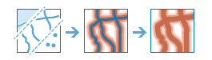  A buffer is an area that covers a given distance from a point, line, or area feature.  Buffers are typically used to create areas that can be further analysed using a tool such as Overlay Layers. For example, if the question is What buildings are within 1 mile of the school?, the answer can be found by creating a 1-mile buffer around the school and overlaying the buffer with the layer containing building footprints. The end result is a layer of those buildings within 1 mile of the school.
Create Drive-Time Areas | 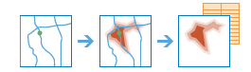  Create Drive-Time Areas creates areas that can be reached within a specified drive time or drive distance. It measures out from one or many points (up to 1,000), along roads, to create a layer that can help you answer questions such as the following:  - Where can I go from here within a 30-minute drive?  - Where can I go from here within a 30-minute drive at 5:30 p.m. during rush hour?  - What areas of town can the fire department reach within 5 minutes?  - How would fire-response coverage improve by building a new fire station here?  - What market areas does my business cover?  You may be able to answer your questions solely through visualizing the output areas. Alternatively, you can perform further spatial analysis using the output areas. For instance, running Aggregate Points using drive-time areas with demographic data can help determine which potential store location would likely provide the best customer base for your type of business.  Note:  To use this tool, you need to be granted the Network Analysis privilege.
Find Nearest | 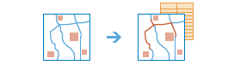  This tool finds the nearest features and, optionally, reports and ranks the distance to the nearby features. To find what's nearby, the tool can either measure straight-line distance or a selected travel mode. There are options to limit the number of nearest features to find or the search range in which to find them.  The results from this tool can help you answer the following kinds of questions:  - What is the nearest park from here?  - Which hospital can I reach in the shortest drive time? How long would the trip take on a Tuesday at 5:30 p.m. during rush hour?  - What are the road distances between these major cities?  - Which of these patients reside within 2 miles of these chemical plants?  Find Nearest returns a layer containing the nearest features and, optionally, a line layer that links the start locations to their nearest locations. The optional line layer contains information about the start and nearest locations and the distances between.  Note:  To find nearby features using one of the available travel modes, you need to be granted the Network Analysis privilege and your inputs must be point features.
Plan Routes | 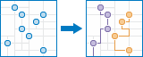  Plan Routes determines how to efficiently divide tasks among a mobile workforce.  You provide the tool with a set of stops and the number of vehicles available to visit the stops. The tool assigns the stops to vehicles and returns routes showing how each vehicle can reach their assigned stops in the least amount of time.  With Plan Routes, mobile workforces reach more jobsites in less time, which increases productivity and improves customer service.  - Inspect homes, restaurants, or construction sites.  - Provide repair, installation, or technical services.  - Deliver items and small packages.  - Make sales calls.  - Transport people from their homes to an event.  The output from Plan Routes includes a layer of stops coded by the routes to which they are assigned, a layer of routes showing the shortest paths to visit assigned stops, and, depending on whether any stops could not be reached, a layer of unassigned stops.  Note:  To use this tool, you need to be granted the Network Analysis privilege.
Connect Origins to Destinations | 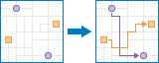  This tool measures the travel time or distance between pairs of points. The tool can report straight-line distances, road distances, or travel times. You provide starting and ending points, and the tool returns a layer containing route lines, including measurements, between the paired origins and destinations. If many origins go to one destination, a table summarizing multiple trips to the destination is included in the output.  Note:  To connect origins to destinations using one of the available travel modes, you need to be granted the Network Analysis privilege.

Manage data
These tools are used for both the day-to-day management of geographic data and for combining data prior to analysis.
Tool | Description
Extract Data | 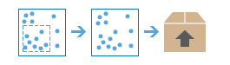  With this tool, you can select and download data for a specified area of interest. Layers that you select will be added to a ZIP file or layer package.
Dissolve Boundaries | 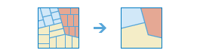  Areas that overlap or share a common boundary are merged together to form a single area.  You can control which boundaries are merged by specifying a field. For example, if you have a layer of counties, and each county has a State_Name attribute, you can dissolve boundaries using the State_Name attribute. Adjacent counties will be merged together if they have the same value for State_Name. The end result is a layer of state boundaries.
Generate Tessellations | 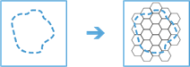  This tool creates bins of a specified shape and size for the study area.  Bins can be square, hexagonal, transverse hexagonal, triangular, or diamond.
Merge Layers | 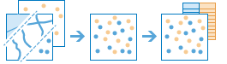  This tool copies features from 2 layers into a new layer. The layers to be merged must all contain the same feature types (points, lines, or areas). You can control how the fields from the input layers are joined and copied.  For example  - I have 3 layers for England, Wales, and Scotland, and I want a single layer of Great Britain.  - I have 12 layers and each contains parcel information for contiguous townships. I want to join them together into a single layer, keeping only the fields that have the same name and type on the 12 input layers.
Overlay Layers | 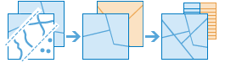  Overlay Layers combines 2 or more layers into 1 single layer. You can think of overlay as peering through a stack of maps and creating a single map containing all the information found in the stack. In fact, before the advent of GIS, cartographers would literally copy maps onto clear acetate sheets, overlay these sheets on a light table, and hand draw a new map from the overlaid data. Overlay is much more than a merging of line work; all the attributes of the features taking part in the overlay are carried through to the final product. Overlay is used to answer one of the most basic questions of geography: What is on top of what?  For example  - What parcels are within the 100-year floodplain? (Within is just another way of saying on top of.)  - What roads are within what counties?  - What land use is on top of what soil type?  - What wells are within abandoned military bases?

