Getting started using secondary data with ArcGIS Online

Contents

Introduction 3
Which data? 4
A heuristic approach 4
Adding a data layer to a map in ArcGIS Online 6
Searching for ArcGIS Online 6
Adding an externally hosted data layer 10
Searching for geo-located datasets 12
Geocoding & transcoding data 12
Preparing data in Excel 14
Publishing data as a hosted layer 19
Filtering the data 21
Data errors 29
Data cleaning 29
Appendicies 31
Appendix A – GIS content in A-level specifications 31
Appendix B - Geo-spatial data sources 39
Appendix C - ArcGIS Online user types 42
Appendix D – Geocoding in ArcGIS Online 43

Introduction

The ability to use, interpret and analyse data is a core A-level skill. ArcGIS Online provides many opportunities to practice and develop key skills while exploring course content and facilitates an enquiry question approach that will encourage a confident, independent and investigative approach to analysing information.
This resource provides a basic overview of which topic areas may be the easiest to explore using secondary data in ArcGIS Online, the process of determining the data you’d like, and where you might find it, and how to import the data into ArcGIS Online.
Appendix A provides a brief overview of relevant specification content from AQA, Edexcel and OCR. Even if you do not teach the Edexcel specification, their exemplification of the possibilities GIS provides to explore course content is worth reading as a source of inspiration as this resource cannot comprehensively cover the range of opportunities that are possible.

Which data?
The amount and variety of spatial data available online can be daunting. Finding the data is only the first challenge, however, as it must then be extracted/saved, formatted correctly, and uploaded to ArcGIS Online so that it can be mapped and analysed.

A heuristic approach
Unless the data you are looking for has already been added to ArcGIS Online as a hosted layer (and can therefore be found by searching for online layers) you’re going to have to have to complete several steps to get the data you want on your map.
Although these steps are always similar, the exact process will vary depending on the source of the data and your requirements, so success relies on a heuristic approach, and a willingness to both learn and adapt on the user’s part.
Follow these steps to find data and get it mapped.

Step 1 | Be clear about what you’re doing and why (and make it is straightforward as you can)
- If you have a course component you want to explore on GIS, consider whether it is likely that data will be easily available. Some statistics are much simpler to find than others.
- If you’re just looking for data to practice/develop skills with, choose one of the easier topics (indicated in Appendix A) that will make the process straightforward to begin with, start at a straightforward source like Gapminder data, or be led by available layers (such as crime, population, deprivation). A quick Google of topics with keywords including Storymap, ArcGIS Online, A-Level, and Geography will find existing content already available.

Step 2 | Clearly define your data
- Finding data is much easier if you have a very specific dataset to look for.
- Define key terms, size and scope of data before beginning; at the very least clearly define the topic area (if you have the flexibility to explore various data around a theme).
- ArcGIS Online can accommodate large datasets, and these may be hosted elsewhere already (try searching for them in ArcGIS Online – see page 4). Although it’s possible to host them on your account, they will be slow to map and credit-expensive to analyse. It is probably worthwhile limited the geographic/temporal scope of the data to make mapping and analysis easier, quicker and more focused. This might need to be done at the point of extracting/saving data, when processing data in Excel, or when filtering hosted data within ArcGIS Online.

Step 3 | Find and evaluate data sources
- Start by looking for existing data hosted on the ArcGIS Online platform. Hosted data has been prepared and uploaded by another user and is ready to go – you just find it and add it to your map. It is your responsibility to verify it’s provenance, and it may not meet your needs precisely, but it is the simplest way to get data onto a map.
- A starting list of data sources is provided in Appendix B; if this doesn’t provide you with the data you’re looking for, do a Google Search (The Power Searching course is a good primer to level-up your search skills - https://www.google.com/insidesearch/searcheducation/).
- Be specific in your search terms, and for each source you find evaluate whether it provides the data you’re looking for, and the extent to which you’ll have to manipulate the data for it to be useful. If it looks too complex, consider contacting the site to ask for help.

Step 4 | Extracting, filtering, and formatting data
- An overview of extracting, filtering and formatting data is provided on pages 17-21.
- If you determine that your data processing and/or Excel skills are the limiting factor, consider completing an online MOOC to improve them, or search YouTube for teachers who have uploaded ‘how-to’ videos that might help (but will almost certainly not specifically address your problem).
- In the short-term, stick to using hosted data layers (see page 4).
- In the medium-term you will have to improve your digital literacy to give yourself the capability to find and process data for GIS analysis. Ultimately, if you can’t find data that you can use, you’ll have to choose another analysis or try finding a website/web application that offers similar mapping to that you were trying to implement (though most probably with more limited content and/or utility to your end goal).

Adding a data layer to a map in ArcGIS Online

Step 1 | Find your data
- Search ArcGIS Online
- Search online for hosted layers.
- Search online for geo-located datasets

Searching for ArcGIS Online
This is the easiest way of adding secondary data to your map.
Start by logging into ArcGIS Online and opening a new, blank map.
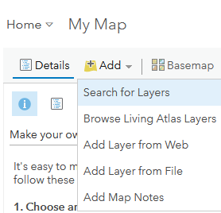 | Click on the Add menu button and select Search for layers.
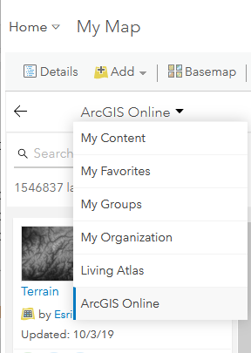 | Choose ArcGIS Online from the dropdown menu above the search box.  Other options are useful once you’ve created some content:  - My Content allows you to find previous layers you’ve created or added to your own maps  - My Groups and My Organisation allow you to search for content within your school/department/class.  - Living Atlas provides a variety of data layers with an Earth Science focus (you can also browser Living Earth layers from the initial Add menu above).
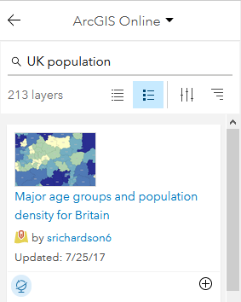 | Search for a data layer of interest.  In this example we’ve searched for UK population.  Click The plus symbol to add it to your map; after a few seconds the process will complete, and the data will show on your map.  NB data layers may not map immediately – they may only appear at a greater zoom level, may already be filtered (and therefore show few data, possibly at a high level of zoom, too), or may contain less data than you expect.
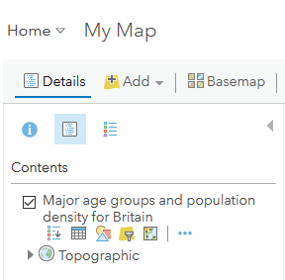 | To see information about the new data layer click the details button on the main menu bar.
 | The icons below the layer description provide further actions: (Left to right) Show legend, show table, change style, Filter, Perform analysis, options.
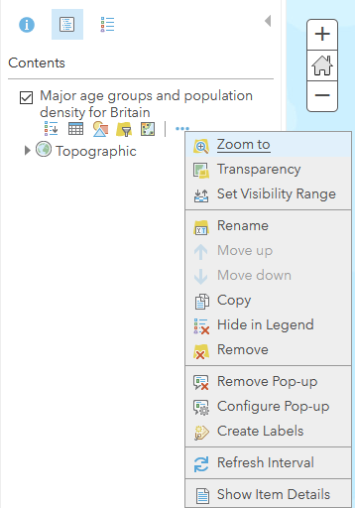 | The options dots open a further context menu (left).  Show legend displays a map key.  Show table displays mapped data.  Change style formats the visual appearance of the data.  Filter selects specific subsets of data to map.  Perform analysis processes mapped data spatially.  NB See the accompanying document Performing analysis in ArcGIS Online for an overview of what’s possible, and links to online help.
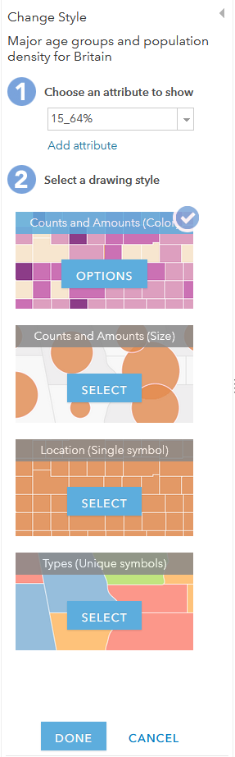 | If your data layer contains multiple datasets you can choose to map only one of these (you can also filter any or all datasets).  Click on the Change Style icon (the circle, square and triangle), then choose to map the dataset relating to the percentage of the population aged 15-64.  NB Sometimes attribute layers are easy to interpret, sometimes not! If you’re not sure, look for explanatory notes with the layer (Show item details on the options menu) and/or go back to the original data to see what you can deduce.  Selecting the top (default) option – Counts and Amounts (colour) will map the data to show values by colour. Clicking the Options button will allow you to configure colour and precisely how the data are mapped to different colours (by allowing you to, for instance, move the colour intensity against the average data value).
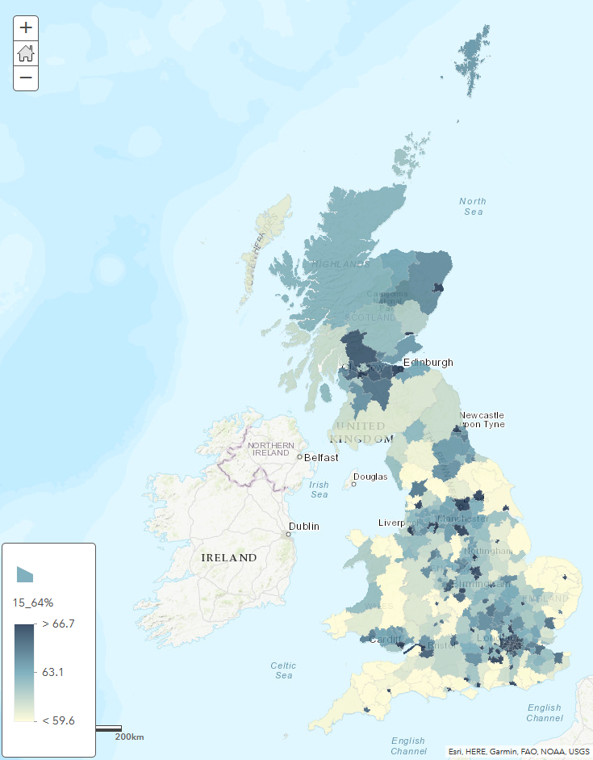
Using the defualt settings the resulting map with data layer added will redraw.

Zooming in will show greater detail to the area for which statistics are collated (typically the smaller census enumeration areas).

Clicking on any part of the map will display a pop-up showing all of the data for that specific area – the colour only relates to the 15-64% as mapped – including the area, name, total population, population density and percentages for under 15 and over 64.

Adding an externally hosted data layer
You may find a data layer hosted by an external organisation, e.g. Defra, Centre for Ecology & Hydrology, USGS, BGS, that you wish to add to your map.
Follow the process below.
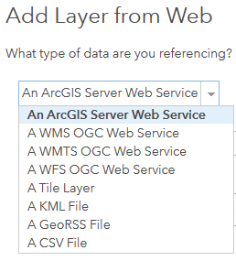 | There are several different ways in which a layer may be hosted (its data held on a remote server and provided to your ArcGIS Online map as you need it).  The formats that ArcGIS Online will accept are listed to the left.  NB You cannot perform analysis on WMS (Web Map Service) and WMTS (Web Map Tile Service) layers. The same may be true of an ArcGIS Online server Web service.
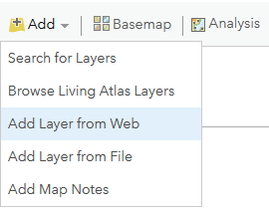 | In ArcGIS Online, click Add, and choose Add Layer from Web
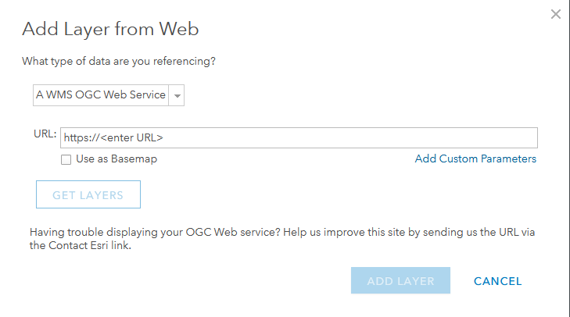 | Go to webpage that contains the link to your online data and copy the link. The type of data will be indicated on the page or can normally be determined by looking at the link itself (by, for example, containing WMS or WMTS in the link).
 | Paste the web layer link in its entirety into the URL box in ArcGIS Online, and make sure you have chosen the appropriate type of data you are referencing. After a few seconds the Get Layers and Add Layer buttons will illuminate. Get Layers allows you to choose which layers you want to display. Add Layer will add everything contained in the Web Layer link.
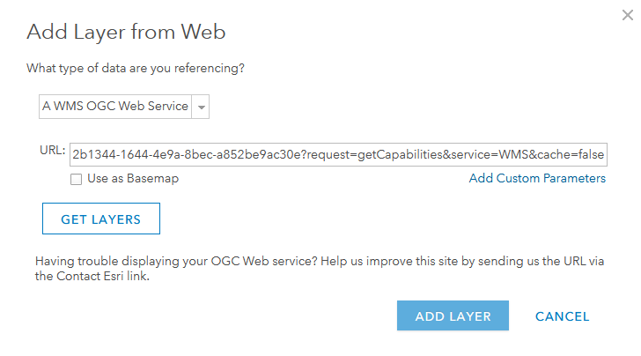 | Once you have clicked Add Layer your data layer will appear on your ArcGIS Online map.

Searching for geo-located datasets
This is the most complex way to import data into ArcGIS Online, as you need to find and format spatial data into a form that can either be directly imported into ArcGIS Online, or hosted as a data layer.
Spatial datasets you find will most likely be in the form of a CSV or XLS/XLSX file:
- CSV – Comma Separated Variables – are the type of data file that ArcGIS Online can import directly. They are data formatted in columns and rows like a spreadsheet, but saved such that the data are separated by commas. These will open in any text editor but will look a mess; if you open them in a spreadsheet they will look like a spreadsheet file. As a consequence, they can be filtered and manipulated in a spreadsheet if required.
- XLS/XLSX files are created in Microsoft Excel, and open in Excel. ArcGIS Online can host Excel files, but not import them directly to the map. An Excel Workbook may contain several datasets as different sheets – tabs along the bottom of the workbook. Saving the file as a CSV will discard all but the active (visible) sheet – and Excel will warn you of this – s0 it’s best to filter and manipulate the original file and save it, then re-save it as a CSV when you need to import it.
ArcGIS Online is limited to directly importing CSV files containing at most 1000 features. Anything greater and you’ll need to host the CSV data as a feature layer (data layer) on ArcGIS Online, and to do that you’ll need Publisher permissions or greater (see Appendix C). (Your user type would have been determined by your account administrator).

Geocoding & transcoding data
If you have found spatial data online, it should already be geocoded (i.e. it will contain location data for each data). If you are importing fieldwork data that you have gathered, you may need to add location data yourself.
ArcGIS Online uses ArcGIS Online World Geocoding Service to find addresses, cities, landmarks, business names, and postal codes in more than 100 countries. It can also find the location of x,y coordinates using longitude and latitude, as well as coordinate reference systems such as the Ordnance Survey British National Grid (BNG). (See Appendix D for further information).
It is often the case that you need to convert one type of spatial data into another, for instance to circumvent mapping issues that arise when the ArcGIS Online Geocoding Service mis-codes locations (for example London Boroughs) and locates them hundreds of miles away. To do this you will need a geocoding (if you need to add location data), or transcoding (if you need to convert location data from one form to another) service.

Geocoding and transcoding services
- https://www.doogal.co.uk/BatchGeocoding.php
Doogal Bell provides a variety of useful geocoding and mapping tools. His Batch geocoding page is particularly useful for the flexibility of its outputs. If you provide a postcode, for instance, you can output Lat/Long, What3words, a Google maps link, UK administrative info and the nearest station (particularly useful if you’re looking at travel time analysis, for instance, when evaluating whether house prices reflect distance to a station/journey time to the nearest city).
- http://www.geodojo.net/uk/converter/
GeoDojo converts between most location formats, though you’ll probably need to have a look at the help page to work out how to format your data for transcoding; it isn’t particualry user friendly for beginners, and it’s ownership is unknown so be wary of transcoding any personal data.
- https://www.ordnancesurvey.co.uk/gps/transformation/
The Ordnance Survey provide a tool to transcode individual data – so this is most useful if you have field data and need to convert the location data between BNG and Lart/Long.

Preparing data in Excel
This walk-through will use UK house price data.
Step 1 | Search for data.
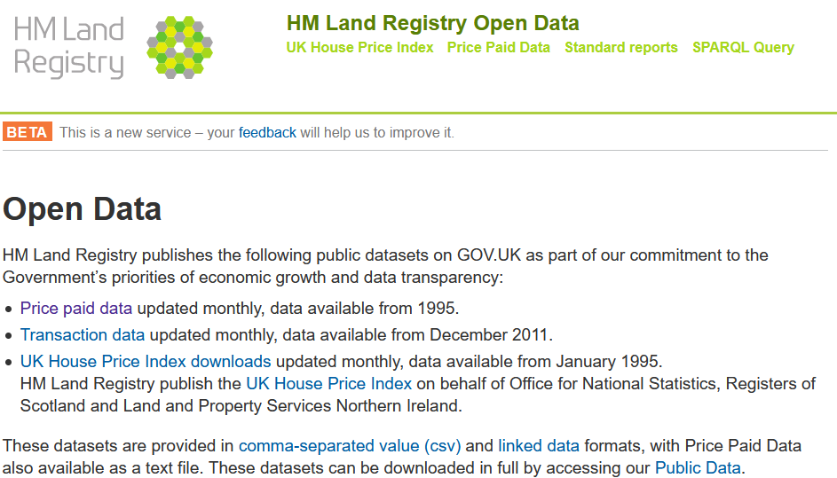
UK house price data is published monthly by HM Land Registry and is Open Data so is freely downloadable. A simple Google search of UK house price data leads you to the Land Registry website at landregistry.data.gov.uk.
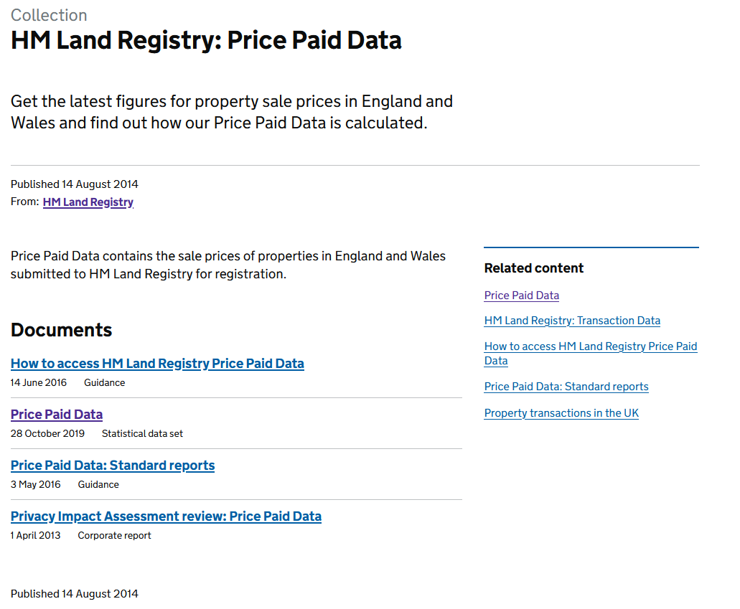
Clicking on the Price Paid data takes me to another page where I can download the Price Paid Data statistical data set.
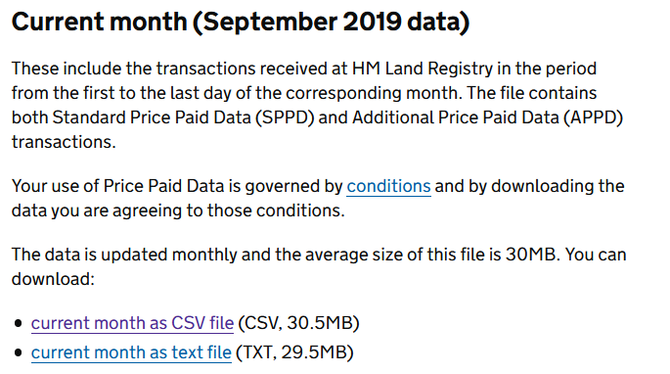
Clicking on the link, and scrolling down the next page, I find the data for the current month and download it as a CSV file. It’s very large – 30.5Mb – as it has many records.

I could also choose to download all house price time-series data as one file, or as a yearly file. All would require work to prepare the data, to some extent, before using in ArcGIS Online.

Further down the page there is a Price Paid Data Report Builder that might be useful another time.
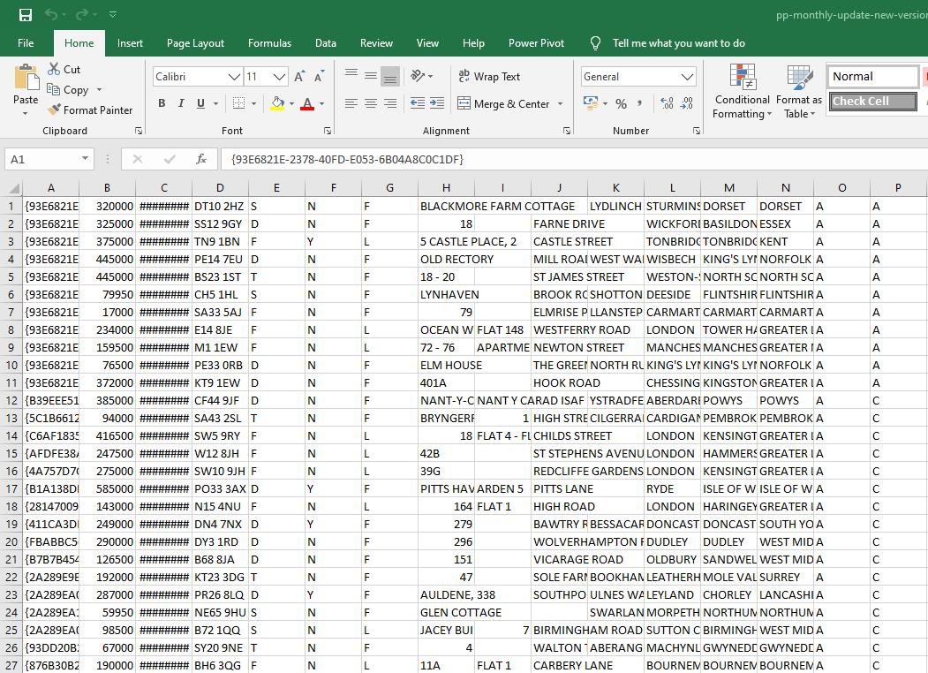
Opening the file in Excel reveals a file containing 99,727 transaction records. Unhelpfully there are no column headings, but the data are relatively easy to interpret, and the linking page would give me more clues if I needed them.

Double clicking on each column separator to view the full contents of each column (if the column isn’t wide enough content will display as hashes), I right-click on the number one next to row one, and insert a row, then enter column headings for the columns I need (see below).

Column | Purpose | Needed? | Name given
A | Unique transaction identifier | Yes | SaleID
B | Price paid (GBP) | Yes | Price
C | Date of transaction | No²
D | Postcode of property | Yes | Postcode
E | Type of property | No²
F | Unknown | No
G | Freehold/Leasehold | No
H-N | Address details | No
O-P | Unknown | No

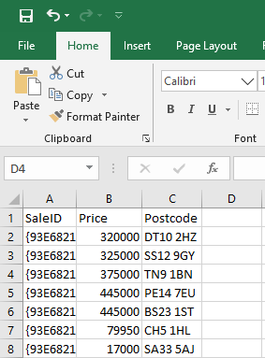 | We just want price paid data, and a location. So, deleting the unwanted columns gives us a spreadsheet that looks like this.  We need to save this file (give it a new name, appending -edited maintains an obvious link to the original file) and select yes when Excel warns us about losing features (because CSV files are limited versus Excel Workbooks).  The file is now much smaller at 5.4Mb, but still contains too much data to directly import into ArcGIS Online.
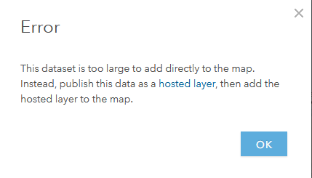 | To prove this point, try dragging and dropping the file onto an ArcGIS Online map (it’s that simple). As our CSV file contains too many data you get this message (left). If it contained fewer data, the data would be imported onto the map ready for analysis.

In general, we would now have two ways forward:
- Choose to publish the data as a hosted layer
- Filter the data to select a smaller number of data.
In this instance we also have the Price Paid Report Builder mentioned previously.

Publishing data as a hosted layer
ESRI provide easy-to-follow instructions at https://doc.ArcGIS Online.com/en/ArcGIS Online-online/manage-data/publish-features.htm that will remain up-to-date even if ArcGIS Online is updated.
To begin, you need to choose the type of data you’d like to host. In our example this is a CSV file. Clicking on the link above, and then clicking on Publish a CSV file gets us to the instructions we need.

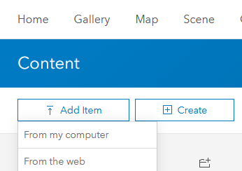 |  | Log in to ArcGIS Online, open a new map by clicking on the Map menu button, then click on the Content button of the main ArcGIS Online menu, then Add Item, then From my computer.
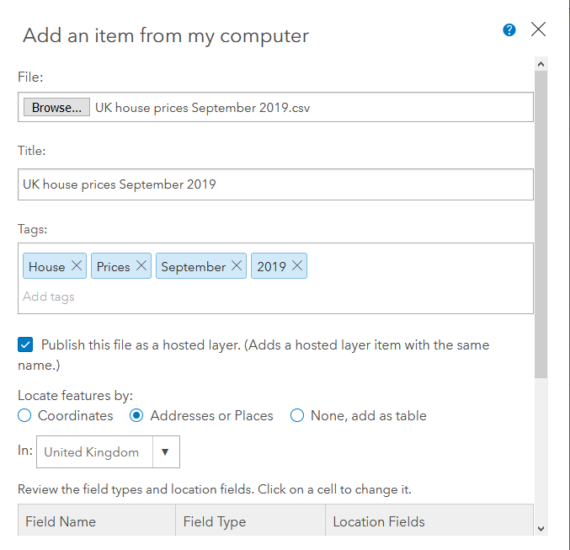 |  | In the dialogue box that appears, Click Browse to navigate to your CSV file.  Make sure there is an appropriate title and Take the time to add some Tags (use individual descriptive words/numbers as these will help you keep track of your data and find it later - press enter after each word/phrase to enter a Tag.  Notice that the importer has used the Postcode column to locate the data (in practice this is down to a few houses on an individual street – for greater precision we’d need to use the whole address).
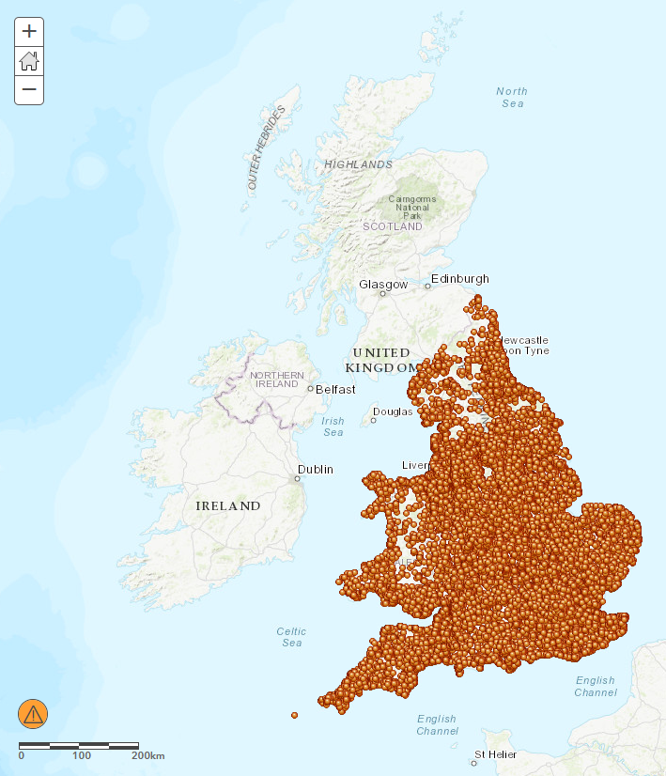
The resulting map shows lots of data though not all of it – the orange warning symbol in the bottom-left corner will indicate that some data are not mapped at this zoom-level if you move the mouse cursor over it.
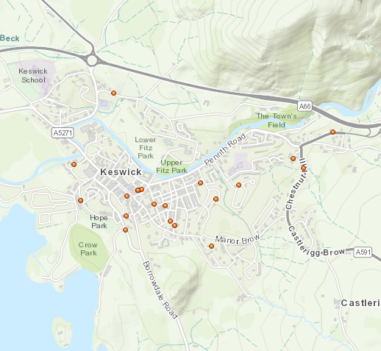 | Let’s say we want to look at Keswick, in Cumbria.  If we zoom in the data are displayed as points – they don’t indicate the value of a property, just that a transaction occurred – though if we click on any point a pop-up will display the data available (in this case, just the price paid).
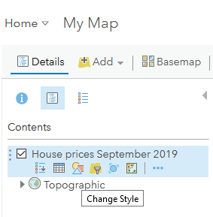 | If we try to change how the data is displayed, by Clicking on the Details pane, then choosing Change Style, we come across a problem.  Formatting these data means formatting the whole of the UK (even though we’re zoomed in), and the value of some transactions in the UK is a lot higher than in Keswick, so things don’t look very representative.  Our sample is too large – we need to filter our data.

Filtering the data
The CSV file we have has nearly 100,000 records with location data given by Postcode. If we want to select only the data from Keswick, we’d normally need to use a transcoding service to convert the postcodes into address details which would include the postal town, and we could then select only data for Keswick.
In this instance, however, we can go back to our original data downloaded from the Land Registry and recreate the CSV file but now incorporating column L which contains the place name.
NB If its unclear which column has the data you’re looking for, click on the column letter and press Ctrl+F to search for key words in only that column. In our example, searching for Keswick identifies that Column L is the one we need.

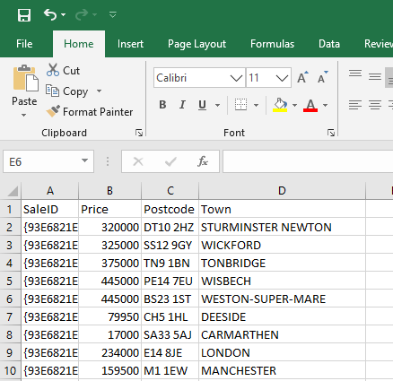 | The updated CSV now looks like this.
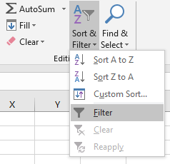 | We can now filter the Town column by clicking on the number one to select row one, then clicking on Sort & Filter on the Home tab and choosing Filter.
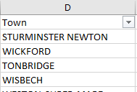 | A small dropdown-box icon will appear to the right of each column header (in row one).
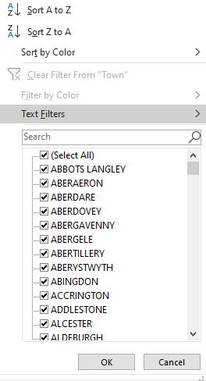 | Click on the icon, then uncheck (Select all) to deselect all places.
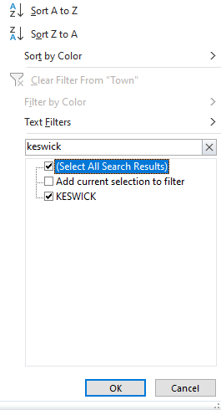 | Type Keswick into the search box to select all records from Keswick, and press OK.
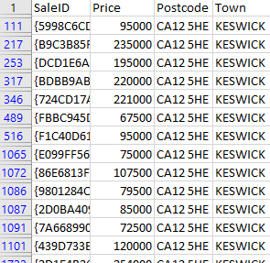 | The spreadsheet now only displays records from Keswick (although the rest of the data is unchanged, just hidden).  Press Ctrl+A, then Ctrl+C to copy the data, then paste it into a new spreadsheet.  Save the new spreadsheet as a CSV file (choose CSV (comma delimited) in the file type box in Excel).
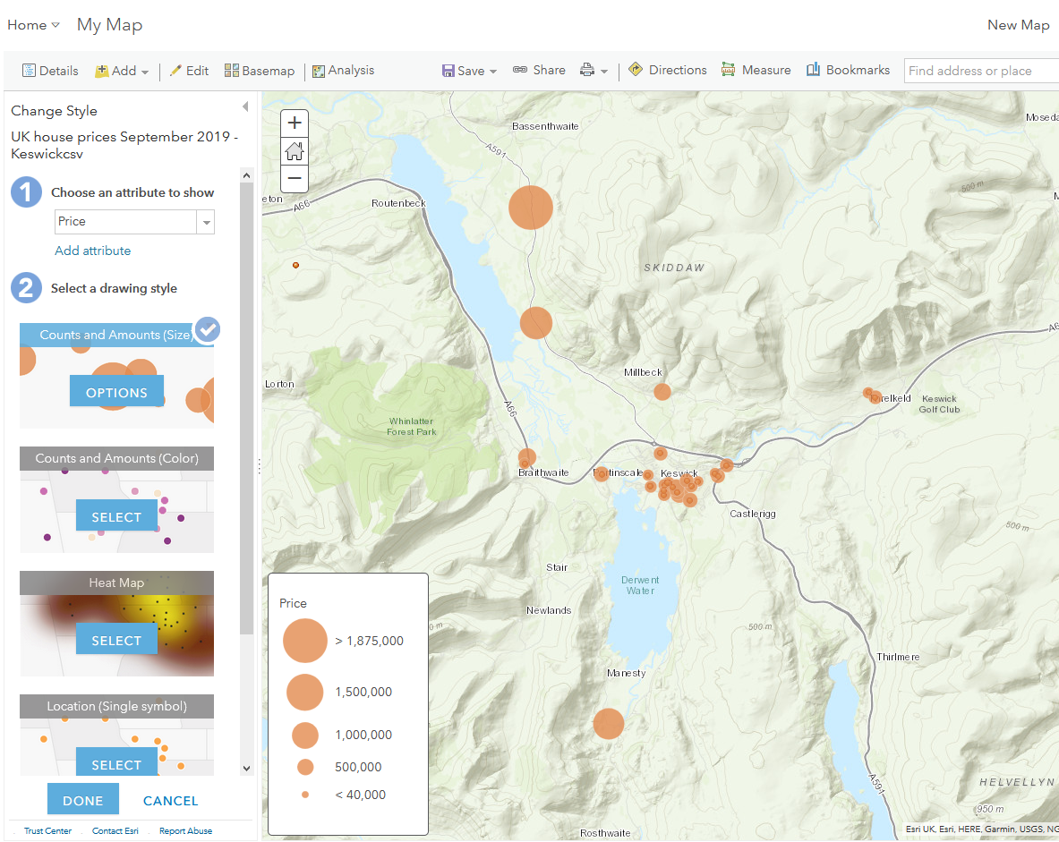
As the CSV file now contains fewer than 1,000 data we can import it into ArcGIS Online by simply dragging the file onto a new map.

A dialogue box will appear – sometimes you will have to indicate which column in your data contains location information – but in this instance you can just click Add layer.

We are now able to click on the Change Style icon as described previously, can choose to map the price attribute of the data, and choose proportional symbols to indicate the value of the price paid symbolically.

The map created will be similar to the one above.

Using the Price Paid Report Builder
As noted previously, in this instance we have a third option – the Price Paid Data Report Builder available at landregistry.data.gov.uk.
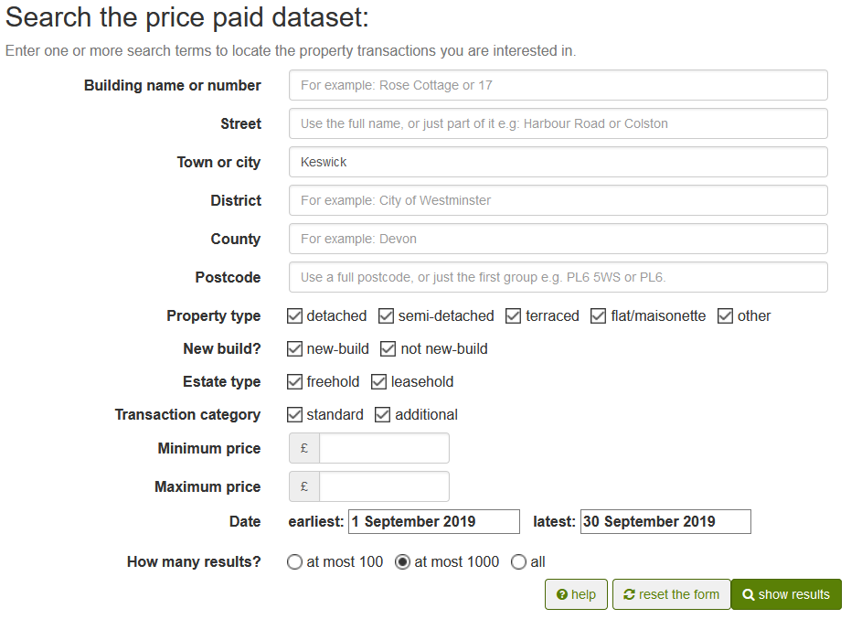
This lets us specify lots of variables to generate a data set the meets our specific needs. Typing Keswick in the Town or City box, and entering the appropriate date range, we can click show results to see the data extracted.
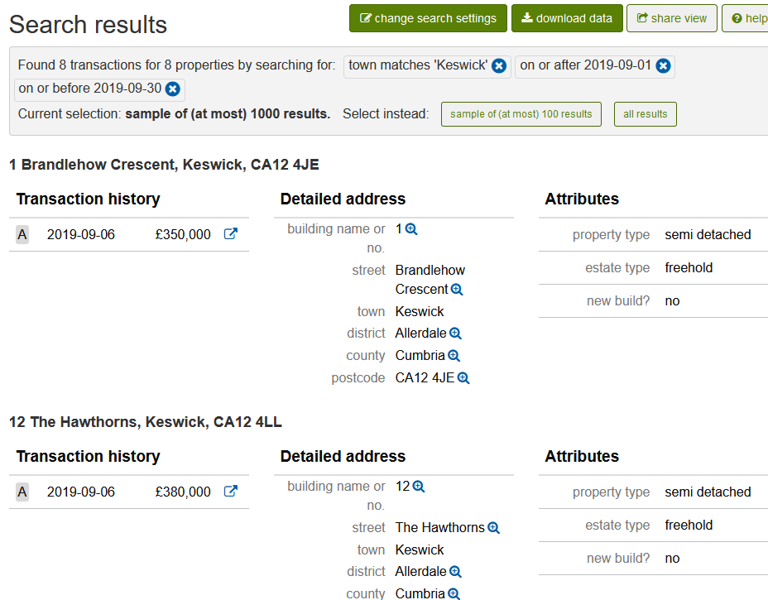
Eight data are returned, which we can download by clicking on the download data button.
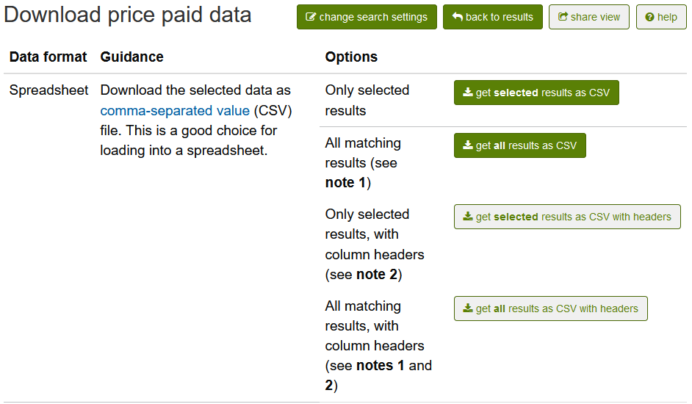
Several options are provided – choosing All matching results, with column headers is the most appropriate (and also clears up ambiguity from the previous download).
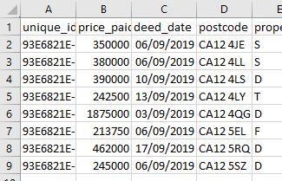 | We can now prepare the resulting file as previous, removing unneeded columns prior to importing into ArcGIS Online by dragging onto a blank map.

Data errors
While filtering for Keswick in the September 2019 figures and subsequently downloading Keswick data from the Price Paid Report Builder you may have noticed a discrepancy in the data between the methods despite the source being identical. Upon investigating, the September data contain some data going back over 15 years, including price paid data for one property three times; they have significant errors.
This would have distorted any analysis significantly and raises an important point about evaluating the quality of secondary data and determining how best to identify and deal with errors.
For large datasets it is impractical to verify data manually – you must use the source as a proxy for quality. You could adopt a sampling strategy, and randomly select data to verify, but this would not catch many types of error (including that described above) and requires significant skill to be statistically significant. It may become evident that something isn’t right when mapping data, or when completing analysis.
Identifying errors does not invalidate data, and is a valuable experience and skill. Ameliorating the effects of errors, reducing their occurrence, and identifying them in the first place are all A-level skills that are worth practicing.

Data cleaning
Although instructions about how to clean data go beyond the scope of this document a few basic Excel functions that are useful for cleaning up data are listed below. There are plenty of guides on YouTube, and Excel forums on the internet are helpful places to ask questions.

- In Excel, on the Data tab, the Text-to-columns button is a good place to start.
- =LEFT(text, [num_chars])/ =RIGHT(text, [num_chars])/ =MID(text, start_num, num_chars) are functions that let you extract text from a long string.
- =CONCATENATE([CellA],[CellB] or =CONCATENATE([CellA]&” “&[CellB] (without/with a space between the joined data) lets you join to cells together.
e.g.
 | A | B | C
1 | 1234ABCD5678 | =LEFT(A1, 4) 1234
2 | 1234ABCD5678 | =RIGHT(A2, 4) 5678
3 | 1234ABCD5678 | =MID(A3, 5, 4) ABCD
4 | 1234ABCD5678 | XYZ | =CONCATENATE(A4, B4)
5 | 1234ABCD5678 | XYZ | =CONCATENATE(A5&” “&B5)
6 | 1234ABCD5678 | =CONCATENATE((LEFT(A6, 4)), (RIGHT(A6, 4))) 12345678
7 | 1234ABCD5678 | =CONCATENATE((LEFT(A7, 4))&” “& (RIGHT(A7, 4))) 1234 5678

- In row 4, =CONCATENATE(A4, B4) will return 1234ABCD5678XYZ (no space between data).
- In row 5, replacing a comma and space with &” “& returns 1234ABCD5678 XYZ.
- Rows 6 & 7 show the same effect, but rather than using a straight cell reference (e.g. A1), they nest the =LEFT and =RIGHT functions to remove a step in the processing.

Appendicies

Appendix A – GIS content in A-level specifications
Content extracted from awarding body specifications.
Source (AQA): https://www.aqa.org.uk/subjects/geography/as-and-a-level/geography-7037
Source (Edexcel): https://qualifications.pearson.com/en/qualifications/edexcel-a-levels/geography-2016.html
Source (OCR): https://www.ocr.org.uk/qualifications/as-and-a-level/geography-h081-h481-from-2016/

NB Topics for which secondary data is likely to be easier to find are highlighted in green.

AQA
NB Due to the nature of how AQA flags GIS in their specification teachers may find the Edexcel specification provides further practical learning ideas.
Every unit of work offers some opportunity for exploration/exemplification using GIS.
- 3.1.1.5 Analysis and presentation of field data, e.g. precipitation mapping, soil throughflow/saturation/carbon content
- 3.1.2.5 Geospatial mapping skills and data manipulation…applied to field measurements. E.g. sediment cells, landform identification using remotely sensed data.
- 3.1.3.5 Geospatial mapping skills and data manipulation…applied to field measurements. e.g. coastal flooding/erosion, landscape features, beach profiles, coastal defences
- 3.1.3.5 Geospatial mapping skills and data manipulation…applied to field measurements. E.g. qualities of landscape features (orientation, size, proximity et al.), distribution of glaciated environments, characteristics of glaciers.
- 3.1.5 Distribution and impacts of hazards.
- 3.1.6 Biome distribution and relationship to other physical characteristics, e.g. insolation, precipitation.
- 3.2.1.1 Mapping globalisation data, e.g. GPD, trade, money. Exploring UN/UNEP data in relation to Antarctica, environmental impacts of human activity.
- 3.2.2.3 Quantitative data, including the use of geospatial data, must be used to investigate and present place characteristics, particular weight must be given to qualitative approaches involved in representing place, and to analysing critically the impacts of different media on place meanings and perceptions. The use of different types of data should allow the development of critical perspectives on the data categories and approaches.
- 3.2.2.4 Place studies, including data such as:
  - statistics,
  - census data
  - maps
  - geo-located data
  - geospatial data, including geographic information systems (GIS) applications
  - photographs
- 3.2.4.2 Mapping physical environmental values (e.g. climate, soil)
- 3.2.4.3. Global patterns of health, Economic and social development, air quality, HDI, population/migration, disease.
- 3.2.5 Resource distribution and exploitation, water, energy.

Specific skills
- 3.4.2.1 Core skills
  - Use and annotation of illustrative and visual material: base maps, sketch maps, OS maps (at a variety of scales), diagrams, graphs, field sketches, photographs, geospatial, geo-located and digital imagery.
  - Use of overlays, both physical and electronic.
  - Numeracy – use of number, measure and measurement.
- 3.4.2.2 Cartographic skills
  - Atlas maps.
  - Maps with located proportional symbols.
  - Maps showing movement – flow lines, desire lines and trip lines.
  - Maps showing spatial patterns – choropleth, isoline and dot maps.
- 3.4.2.5 ICT skills
  - Use of remotely sensed data (as described in Core skills).
  - Use of electronic databases.
  - Use of innovative sources of data such as crowd sourcing and ‘big data’.
  - Use of ICT to generate evidence of many of the skills provided above such as producing maps, graphs and statistical calculations.

OCR
Option A – Coastal landscapes
- measurement and geo-spatial mapping skills
- data manipulation and statistical skills applied to field measurements
- e.g. identification of coastal landforms, investigation of coastal landscapes, human intervention along the coastline, sediment cells.

Option B _ Glaciated landscapes
- measurement and geo-spatial mapping skills
- data manipulation and statistical skills applied to field measurements
- e.g. glacial landforms, geomorphology, landscape characteristics, glaciers, global climate, human activity in a glacial environment.

Option C – Dryland landscapes
- measurement and geo-spatial mapping skills
- data manipulation and statistical skills applied to field measurements
- e.g. fluvial and periglacial landforms, distribution of drylands and their relationship with other physical characteristics, e.g. precipitation, winds, insolation.

Topic 1.2 – Earth’s Life Support Systems.
- Analysis and presentation of field data
- e.g. water and carbon, human factors that disturb the water and carbon cycles, exploration of remote landscapes, e.g. Arctic tundra, rainforests

Topic 2.1
- The use of geospatial data to present place characteristics

Topic 2.2
- Option A - Mapping trade
- Option B – Mapping population, migration and economic variables
- Option C - Mapping human rights violations/laws
- Option D – Mapping challenges to state authority and conflict

Topic 3.1
- Mapping physical characteristics and variables
- Mapping climate change impacts

Topic 3.2
- Mapping global patterns of disease in relation to physical variables (temperature, relief etc.)
- Exploring links between disease and economic development

Topic 3.3
- Mapping the physical characteristics of oceans – salinity, temperature, biomass.
- Exploring natural resources, sources and distribution of pollution,
- Exploring the interaction between climate change impacts, ice cover and other physical and human factors.
- Ocean-going trade and piracy

Topic 3.4
- Sources of food and associated factors including precipitation, insolation, inputs/outputs, sediment budgets, hazards.
- Irrigation, deforestation /biodiversity, changing landscapes, water quality

Topic 3.5
- Tectonic data, impacts and hazards

Specific skills
4.1 Geographical information:
With respect to geographical information, learners should:
- understand what makes data geographical
- understand the ethical and socio-political implications of collecting, studying and representing geographical data, especially with regard to human communities
- understand the nature of and use different types of geographical information, including:
  - qualitative and quantitative
  - primary and secondary
  - images, maps, diagrams and graphical representations
  - factual text and discursive/creative material
  - digital data
  - numerical and spatial data
  - innovative forms of data, including crowd-sourced and ‘big data’.
- collect, analyse and interpret such information, and demonstrate the ability to understand and apply suitable analytical approaches for the different information types
- undertake informed and critical questioning of data sources, analytical methodologies, data reporting and presentation, including the ability to identify sources of error in data and to identify the misuse of data
4.2 Geo-located data:
With respect to geo-located data, learners should:
- demonstrate an ability to collect and to use digital data through the use of geospatial technologies, such as smart phones and tablet devices
- understand the opportunities and benefits of presenting and analysing geographical data through the use of Geographical Information Systems (GIS).

Edexcel

Topic 1
- Analysis of hazard distribution patterns on world and regional scale maps
- Interrogation of large data sets to assess data reliability and to identify and interpret complex trends.
- Use of Geographic Information Systems (GIS) to identify hazard risk zones and degree of risk related to physical and human geographical features.

Topic 2 (Option 2A)
- Comparison of past and present distribution of glaciated landscapes using global and regional maps.
- Use of numerical data to calculate simple mass balance and equilibrium line position;
- use of GIS to identify main features of glacier types and assess glacier health.
- Cirque orientation analysis using large-scale maps (OS maps);
- Use of British Geological Society (BGS) glacial drift maps, Ordnance Survey (OS) maps, GIS and fieldwork results to reconstruct past ice extent and ice flow direction.
- Drumlin morphometry and orientation survey to measure correlation of height, length and elongation ratio.

Topic 2 (Option 2B)
- GIS mapping of the variety of coastal landscapes, both for and beyond the UK.
- Satellite interpretation of a variety of coastlines to attempt to classify them
- Map and aerial interpretation of distinctive landforms indicating past of sea level
change.
- Use of GIS, aerial photos and maps to calculate recession rates for a variety of
temporal rates (annual changes and longer-term changes).
- Interrogation of GIS of management cells to ascertain land use values and develop cost/benefit analysis to inform the choice of coastal management strategy.

Topic 3
- Analysis of human and physical features on maps to understand lack of connectedness
- Use of population, deprivation and land-use datasets to quantify the impacts of
- deindustrialisation.
Topic 4 (Option 4A)
- Use of GIS to represent data about place characteristics
- Use of Index of Multiple Deprivation (IMD) database to understand variations in levels and types of deprivation.
- Investigation of social media to understand how people relate to the places where they live.
- The interpretation of photographic and map evidence showing ‘before and after’
cross-sections of regenerated urban and rural places.
Topic 4 (Option 4B)
- Investigation of social media to understand how people relate to the places where they live.
- Use of GIS to represent and analyse crime data and to show variations in levels of crime across communities.
- Use of indexes to measure ethnic and cultural diversity
- Interpretation of photographic and map evidence showing ‘before and after’
cross-sections.
Topic 5
- Use of large database to study the pattern and trends in floods and droughts worldwide.
- Use of a global map to analyse world water stress and scarcity.
Topic 6
- Use of maps showing global temperature and precipitation distribution
- Analysis of maps showing global energy trade and flows
- Comparisons of emissions from different energy source
- Using GIS to map land-use changes such as deforestation over time
- Analysis of climate model maps to identify areas at most risk from water shortages, floods in the future

Topic 7
- Mapping past, present and future sphere of influence and alliances using world maps
- Mapping emissions and resource consumption using proportional symbols
- Plotting the changing location of the world’s economic centre of gravity on world maps
- Analysing future Gross Domestic Product (GDP) using data from different sources
Topic 8 (Option 8A)
- Use of proportional circles to show the relative size of government spending and the share of that spending devoted to welfare, health and education across developing, emerging and developed nations.
- Use qualitative and quantitative indicators to derive an index of corruption and show this on global maps to compare variations in levels of corruption with types of government

Topic 8 (Option 8B)
- Comparison of global maps of languages and colonial histories to analyse relationship between them (Anglophone, Francophone and Lusophone).
- Use of proportional circles to show size of output and level of foreign ownership of different economic sectors.

Appendix B - Geo-spatial data sources

UK
- https://data.london.gov.uk/
The London datastore. A repository for data about jobs and economy, transport, environment, community safety, housing, communities, health, and the capital ‘as a world city’. The site also provide analysis on various topics and area profiles.
- https://data.gov.uk/
Find open data published by government and public bodies. Organised by theme, with the facility to search, too, if there is official data available it should be here. Due to the number and variety of data and datasets, it is best to approach the site with a specific dataset in mind, rather than browsing. Don’t be afraid to contact the site for help and guidance, as the data managers may be able to point you in the right direction.
- https://environment.data.gov.uk/
The Defra Data Services Platform collates environmental data into one portal. Providing an App Gallery that visualises and maps a range of datasets, the data are accessed by search, so you need to have an idea of exactly what you’re looking for.
- https://magic.defra.gov.uk/
Magic provides comprehensive mapping of official environmental information. There is a bit of a learning curve, but the interface is relatively intuitive. It does not seem possible to extract the data, however you can annotate, measure, print and bookmark the mapping – essential a simple GIS layer implementation.
- https://www.ceh.ac.uk/data
The Centre for Ecology and Hydrology provides both data and an Environmental Information Platform that allows datasets to be visualised and interrogated. It also hosts national datasets at its Environmental Information Data Centre. Datasets include the National River Flow Archive, species records across the UK, and the Countryside Survey, as well as land cover, flood risk and hydrological resources (soil types, rainfall frequency etc.)
- https://www.ukdataservice.ac.uk/
UK Data Service. A collection of social, economic and population data resources, with over 7,000 collections. You will have to apply for a username, which takes 3 working days to be processed. Data is categorised in a variety of ways, including by theme and geography. There is also a search facility, and plenty of guidance.

EU
- https://data.europa.eu/euodp/en/visualisation-home
EU Open Data Portal. A collection of visualisation tools, as well as access to 14,000 datasets across a range of topic areas. Best approached with a specific data requirement in mind, although search and filtering is possible. Datasets can be visualised in a variety of ways before the data is downloaded which helps to determine if it is what you’re looking for. You will need to explore the site and learn how it archives and allows access to data to be able to successfully extract datasets. (The help provided isn’t very helpful).
UN
- http://data.un.org/Default.aspx
UN data. A comprehensive repository of UN data, across 32 topic areas, containing 60 million records. Filed heirarchiically, or accessible via Search, the data are easy to find, filter and download, are both spatial and temporal, and can be formatted prior to download.
Business
- https://www.statista.com/
Statistica provides business data. Statistics are organised hierarchically, and can also be accessed via search. The site also provides reports, analysis and infographics. However, access is limited for individuals, and you will be limited to downloading graphics of your statistic, then re-entering data so best used for small datasets.
Health
- https://www.who.int/gho/en/
World Health Organisation (WHO) data across a large range of themes organised hierarchically. The site also has a search facility, country-based summaries, and resources including fact sheets, infographics and publications. If you want global health data, it should be here.
Repositories
- https://www.gapminder.org/data/
Gapminder is well known for its visualisation tools and TED videos, however it also provides access to over 400 datasets across a range of socio-economic and environmental indicators. Organised hierarchically and easy to access, this is a good site to start if you want the process to be as simple as possible.

Appendix C - ArcGIS Online user types
Source: https://doc.ArcGIS Online.com/en/ArcGIS Online-online/reference/roles.htm
Only Publishers and Administrators can create and publish hosted feature layers.
- Viewer—View items such as maps, apps, demographics, and elevation analysis layers that have been shared with the member. Join groups owned by the organization. Use geocoding, geosearch, and network analysis (routing and directions). Members assigned the Viewer role cannot create or share content, or perform analysis or data enrichment. The Viewer role is compatible with all user types.

Tip - Although the default Viewer role does not support joining groups owned by outside organizations, a member can be granted the Join external groups privilege through a custom role created based on the default Viewer role.
- Data Editor—Viewer privileges plus the ability to edit features shared by other ArcGIS Online users. The Data Editor role is compatible with all user types except Viewer.
- User—Data Editor privileges plus the ability to view content shared by other ArcGIS Online users; use the organization's maps, apps, layers, and tools; and join groups owned by the organization. Members assigned the User role can also create maps and apps, edit features, add items, share content, and create groups. The User role is compatible with the Creator, GIS Professional, and Insights Analyst user types.
- Publisher—User privileges plus the ability to publish features and map tiles as hosted web layers. Members assigned the Publisher role can also perform analysis on layers in maps. The Publisher role is compatible with the Creator, GIS Professional, and Insights Analyst user types.
- Administrator—Publisher privileges plus privileges to manage the organization and other users. An organization must have at least one administrator. However, there is no limit to the number of Administrator roles that can be assigned within an organization. It is recommended that an organization have at least two administrators, while restricting this role to those who require the additional privileges associated with it. The Administrator role is compatible with the Creator, GIS Professional, and Insights Analyst user types.

Appendix D – Geocoding in ArcGIS Online
Source: https://doc.ArcGIS Online.com/en/ArcGIS Online-online/reference/geocode.htm

Addresses, Postal Codes and Populated Places
When you choose Addresses, Postal Codes and Populated Places as the types of locations you want to find, you can further refine the locator view's search results by selecting the categories and subcategories you want to search. The following categories for Addresses, Postal Codes and Populated Places are available:
- Address—Selecting this category automatically includes all of the address subcategories listed in the table below. This category limits search results to places that can be categorized as addresses while filtering out results for places of interest, postal codes, countries, or states. For more precise search results, choose any combination of address subcategories that meet your search requirements.
- Postal—Selecting this category limits search results to any type of postal code match, including 5-digit and longer postal code formats. To limit search results to matches that are at least this precise, select both the Postal category and the top-level Address category.
- Populated Place—Selecting this category automatically includes all of the populated place subcategories listed in the table below. This category limits search results to administrative divisions (or boundaries), such as cities, provinces, or countries, while filtering out results for addresses, places of interest, and postal codes. For more precise search results, choose any combination of populated place subcategories that meet your search requirements.
Category | Subcategory | Description
Address | Point Address | A point address is a street address based on points that represent house and building locations. The point addresses represent the rooftop, or actual, location of the address. Typically, this is the most spatially accurate match level. Reference data contains address points with associated house numbers and street names, along with administrative divisions and optional postal code information—for example, 380 New York St, Redlands, CA, 92373.  A locator view configured with this subcategory limits results to these highly precise address points, which will allow you to avoid matching to any less precise address points if you require very high precision in matching.
 | Street Address | A street address is different from a point address in that the house number in a street address is interpolated from a range of numbers. Reference data contains street centre lines with house number ranges, along with administrative divisions and optional postal code information—for example, 647 Haight St, San Francisco, CA, 94117.  A locator view configured with this subcategory limits results to an interpolated result. If you want to limit results to matches that are at least this precise, you should select both this subcategory and the Point Address category.
 | Intersection | An intersection is a street address consisting of a street intersection, along with city and optional state and postal code information—for example, Redlands Blvd & New York St, Redlands, CA, 92373.  A locator view configured with this subcategory limits results to intersections instead of complete addresses that exist on only one street.
 | Street Name | A street name is similar to a street address but without the house number. It contains street centre lines with associated street names (no numbered address ranges), along with administrative divisions and optional postal code information—for example, W Olive Ave, Redlands, CA, 92373.  A locator view configured with this subcategory limits results to street names only. If you want to limit results to matches that are at least this precise, you should select this subcategory as well as the Point Address and Street Address subcategories.
 | Subaddress | A subaddress is a subset of a point address that represents a house or building subset location such as an apartment unit, floor, or individual building within a building complex—for example, 3836 Emerald Ave, Suite C, La Verne, CA, 91750.  A locator view configured with this subcategory limits results to subaddress points that include a house number, street name, and subaddress elements, along with administrative divisions and optional postal code information, while leaving out other types of address matches.
Postal | No subcategories | A locator view configured with the Postal category returns any type of postal code match, including 5-digit (for example, 92373) and other postal code formats. To limit results to matches that are at least this precise, select Postal and the top-level Address category.
Populated Place | Neighbourhood | A neighbourhood is a subsection of a city, smaller than a district and larger than a sector.
 | City | A locator configured with this subcategory limits results to cities only—for example, the city of Venice in Italy.
 | Subregion | A subregion is a subset of a state or province, such as a county in the United States—for example Adams County in the state of Wisconsin.
 | Region | A region is a subsection of a country, typically a state or province—for example, the province of Ontario in Canada.
 | Country | A country is the highest administrative division, also known as a nation—for example, Japan.
 | Sector | A sector is an administrative division larger than a block and smaller than a neighbourhood, representing a subdivision of a neighbourhood or district, or a collection of blocks.
 | Block | A block is the smallest administrative area for a country, representing a subdivision of a sector or neighbourhood, or a named city block.
 | District | A district is an administrative division smaller than a city and larger than a neighbourhood—for example, a municipal district.
 | Metro Area | A metropolitan (metro) area is an urban conglomeration consisting of a large city and the smaller cities surrounding it—for example, Greater Tokyo.
 | Territory | A territory is a large administrative division, smaller than a country and larger than a state or province—for example, the Yukon territory in Canada.
 | Zone | A zone is a category representing an unofficial administrative area that does not belong to a country, such as a disputed area or a grouping of other administrative zones—for example, Central America.

Coordinates
When you choose Coordinates as the types of locations you want to find, you can further refine the locator view's search results by selecting the categories you want to search. These are described in the table below.

Category | Description
Longitude, Latitude | This category represents geographic (x,y) coordinates. X refers to longitude (east-west coordinates), and y refers to latitude (north-south coordinates). Coordinates are entered and returned as x,y.
Latitude, Longitude | This category represents geographic (x,y) coordinates. X refers to longitude (east-west coordinates) and y refers to latitude (north-south coordinates). Coordinates are entered and returned as y,x.
MGRS | This category represents Military Grid Reference System (MGRS) coordinates.
USNG | This category represents the United States National Grid (USNG) coordinate system.

Places of Interest
When you choose Places of Interest as the types of locations you want to find, you can further refine the locator view's search results by selecting the categories you want to search. These are described in the table below.

Category | Description
Education | This category represents all types of educational institutions, including universities, primary schools, and vocational schools.
Food | This category represents restaurants of all types.
Shops and Service | This category represents all types of commercial or retail businesses.
Airport | This category represents airports, designated either by name or by airport code.

https://doc.ArcGIS Online.com/en/ArcGIS Online-online/reference/geocode.htm
It might be that these data are useful for another investigation, for instance, is there a monthly pattern to property transactions? A spatial pattern to type of property? Why? I might also want to locate properties in a small area precisely – if considering place or the impact of a local issue.

