Everyday Drone Stories
KS5.1 Pupil information form

What is this form about?
You are being invited to take part in the Everyday Drone Stories research project.

Drones, like the one pictured below, are small aircraft without a pilot on board, and which can be operated by a pilot on the ground or can be pre-programmed to follow a set flight path or route. Some drones have cameras attached to them so they can take photographs or videos from the air. Other drones are used to carry, transport, and deliver things – like medicine or small parcels.

Drones are a growing feature of UK skies, and have lots of different users and uses. Drones can be flown:

- As a hobby or for fun (perhaps a family member or friend has a drone).

- By researchers (to capture images of places and environments from the air).

- By civil actors such as emergency services (police, fire, search and rescue) to help locate people or identify the spread of fires.

- By businesses to inspect buildings and critical infrastructure from the air, or to deliver items.

We are interested to learn what you think about drones, including current drone uses and what drones could be used for in the future.

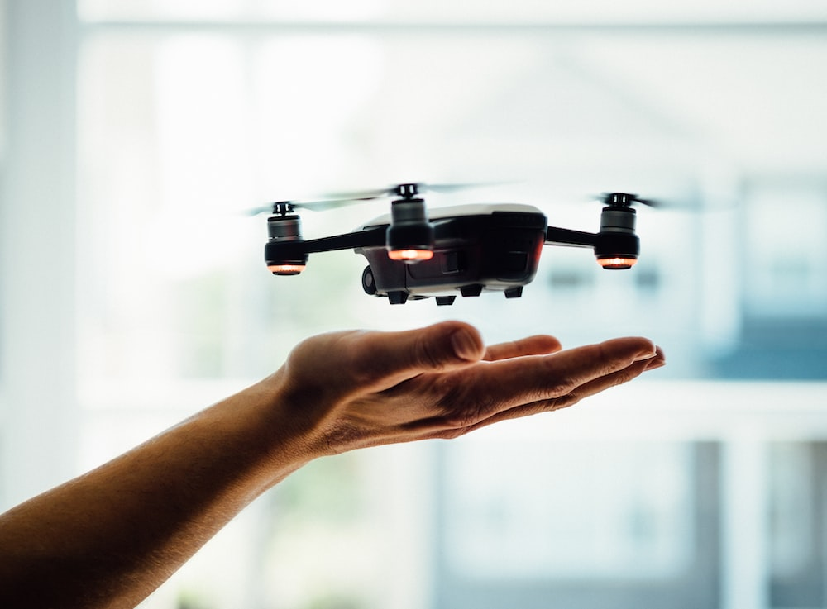

DJI mini drone Spark © Dose Media

Who can take part?
If you are a pupil in school, years 10, 11, college and sixth form (aged 14-18).

If you go to a participating school.

What happens if you take part?
Your teacher will provide you with an activity sheet and you will be invited to share your views on drones, including:
- What drones are and do.
- Your views on current drone applications (including potential benefits and risks).
- How drones might be used in the future.
There are no right or wrong answers, we are interested in gaining a deeper understanding of how young people view drones, their impacts, and potential future drone use.
Once you have completed the activity, please return your responses to your teacher if you would like to share a copy of these with the researchers (you can have the original back).
If you choose to share your responses with the researchers, you will need to fill in a short form which gives your consent (permission) to include your responses on an online webpage and/or in research outputs (e.g., reports, blog posts, academic journal articles). Your teacher will provide this form.
If we share your responses online, no personal data (like your name or the name of your school) will be used or included. Your personal data (your name or the name of your school) will be stored separately from your responses, which will be anonymised. The researcher will follow appropriate laws (including UK General Data Protection Regulation; UK Data Protection Act 2018) to ensure that your personal data is collected and stored correctly. Anonymised project data will also be archived, so that it is available for other academic researchers to access and re-use.
It is up to you if you’d like to take part in this activity or not. If you don’t want to take part, you don’t need to provide any reason, and it won’t impact your school record. If you have any questions, you can ask your teacher (who can also contact the researcher, Dr Anna Jackman).

You can read more about the Everyday Drone Stories research project by visiting the project’s webpage https://www.rgs.org/schools/teaching-resources/everyday-drone-stories/

