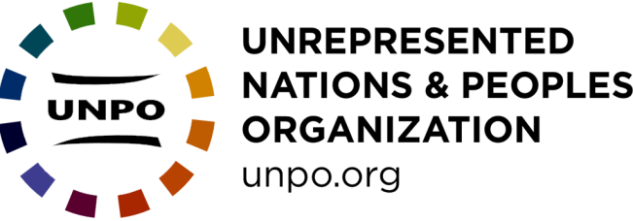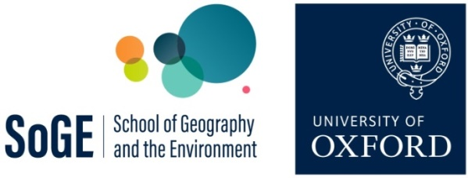

Debating Global Governance: “Model UNPO” role play

This activity engages students with issues facing some of the most marginalised communities in the world and enthuses them about how we can think differently about equality and diversity in the global governance system. It addresses key sections of the A-level in Geography (e.g. on global interdependence, inequality, injustice, diversity, citizenship. See Appendix I), and offers an opportunity for the development of public speaking, debating and self-confidence.

Associated materials:
- Debating Global Governance Student Sheet
- Debating Global Governance Student follow up sheet
- Model UNPO Set up documents

Equipment
- UNPO Member and President desk signs (from ‘Set up documents’)
- Timing cards (from ‘Set up documents’)
- Pens and paper
- Tables and chairs
- Name badges for all participants with delegation name
- EITHER a screen and projector for displaying the draft resolution, OR a Google Docs (or equivalent) with the resolution accessible for all delegates.

Introduction to the activity

The state has come to dominate understandings of geopolitics: political maps of the world consist of neatly coloured-in state units, and state leaders dominate international headlines. However, those who are most acutely affected by conflict, human rights abuses and environmental injustices are often not represented by state interests. In many cases they seek to represent themselves on the international stage, as stateless nations (e.g. Tibet) as indigenous communities (e.g. Crimean Tatars) as minorities (e.g. Kurds in Iran) or as de facto states (e.g. Somaliland). Over 45 of these non-state actors have come together as the ‘Unrepresented Nations and Peoples Organization’ (UNPO; www.unpo.org). This activity brings the issues faced by these non-state actors into secondary school classrooms.
The activity enables teachers to run role-play debating exercises on issues of environmental justice, human rights and conflict resolution. The exercises are loosely based on Model UN simulations but instead of students being assigned roles as representatives of nation-states and enacting UN meetings, they are designated roles as representatives of stateless nations, indigenous peoples and minority communities. Students research their assigned non-state actor in advance of the class, and then come together to simulate a debate of the UNPO’s General Assembly based on pre-established rules of procedure.

Model UNPO enables teachers to run role-play debating exercises on issues that relate to topics covered in A Level Geography (see Appendix I). Other examples of themes could be taken from session themes of the UN Forum on Minority Issues, or the UN Permanent Forum on Indigenous Issues. The chosen theme should be reflected in the resolution and/or guidance given to students for preparing initial statements and draft operational clauses. The theme might also inform which UNPO members are chosen to be present at the debate. The Model UNPO activity should be run as a safe space where students can speak freely and respectfully.

Before the Model UNPO session:

- Assigning delegations
Allocate students into pairs/ small groups and assign each group a UNPO member from the following list. There should be a minimum of 5 UNPO member delegations:

- Abkhazia
- Ahwazi
- Barotseland
- Catalonia
- Crimean Tatars
- District of Columbia (Washington DC)
- East Turkestan
- Guam
- Khmer Krom
- Ogaden
- Ogoni
- Somaliland
- Taiwan
- Tibet
- West Papua

When assigning UNPO members consider the relevance of members to the chosen theme of the debate, geopolitical dynamics, and the geographic spread of communities (see Map in Appendix II). This list of members is not exhaustive: for additional UNPO members see https://unpo.org/nations-peoples Minority/ indigenous/ stateless communities that are not currently UNPO members can also be included in the activity.

- Preparing fact sheets and initial statements
In advance of the session, explain the nature of the exercise, how the debate will be run and what the students will be expected to do. Before the debate each UNPO member group will need to prepare: a fact-sheet, a 2-minute speech, and three draft clauses for a resolution. The teacher needs to prepare a skeleton resolution based on these draft clauses and should be on hand to answer questions from the participants regarding their preparation.

Ask each group to prepare a one-page fact sheet on the UNPO member that they have been assigned. This will serve as a reference resource during the debate and can be circulated amongst all students afterwards as reference material from the activity. Most importantly, the fact sheet should include issues faced by that UNPO member as they relate to the topic of the debate e.g. peace/ conflict, economic situation, environmental challenges, human/ indigenous/ minority rights, gender discrimination, youth issues. These will act as prompts for the moderated debate. The fact sheet could also include the following information about the UNPO member:

- Location, territorial size and population size
- Recent history and current political environment
- Economic Situation
- Aspirations for self-determination e.g. independent statehood/ autonomy within another state/ greater cultural and political rights
- Obstacles to good governance
- Alliances and/or tensions with states and other political actors (e.g. supportive states, host states, occupying states)

Suggested resources for each UNPO member are freely available here: https://linktr.ee/munpo
Additional resources are listed in Appendix III.

Each group should also prepare a short two-minute speech about the member they are representing. This speech could include:
• an overview of who the delegation is (their organisation and which community/ nation they represent)
• the current situation in their community/ homeland
• aspirations for self-determination
• a brief statement on their position in relation to the topic of debate

Each delegation should also prepare and submit three draft clauses for a resolution prior to the lesson. Draft clauses should relate directly to the topic of the debate (see Student Sheet). During the debate, students will be able to debate, amend and then vote on clauses.

- Preparing the draft resolution
Before the debate teacher should prepare a draft resolution:

a. Draft a preamble to the resolution (a sample preamble is included in Appendix IV). The purpose of the preamble is to show that there is a problem that needs to be solved. It should set out the background to the broad theme of the debate but not propose any action.
Clauses in the preamble are not numbered, end with a comma, and start with a verb such as ‘affirming’, ‘approving’, ‘believing’, ‘declaring’ ‘desiring’, ‘expecting’, ‘observing’, ‘recalling’, ‘recognising’, ‘welcoming’.
Clauses can include references to:
• the UN Charter, UN resolutions, conventions or declarations
• recognition of the efforts of regional organisations or NGOs in dealing with the issue
• general statements on the topic, its significance and its impact. This could include official figures and/ or the difficulties that have been encountered with the issue in the past.

b. The teacher should select 3-5 draft operative clauses from the submissions that cover a range of issues. It is worth having a couple in reserve in case students are particularly quick during their debates. This will form the skeleton resolution (see Appendix IV). It is also worth having additional clauses in case the debate moves quickly. Operative clauses set out what is to be done about the issue described in the preamble, and by whom (e.g. the UNPO, governments, UN bodies, NGOs). Operative clauses should be numbered (1, 2, 3), can include sub-clauses (1a, 2a, 3a), should each end with a semi-colon and start with a verb such as ‘accepts’, ‘affirms’, ‘calls upon’, ‘condemns’, ‘deplores’, ‘endorses’, ‘proclaims’, ‘recommends’, ‘reminds’, ‘supports’, ‘urges’. They should be organised in a logical progression, and each clause should be brief and contain a single idea or policy proposal.

Examples might include:
- Unrepresented communities are often disproportionately affected by violence and therefore should be key players in conflict resolution mechanisms
- Unrepresented communities should have as equal a say on environmental justice issues as nation states
- Unrepresented communities challenge the sovereignty and territorial integrity of nation states
- The global governance system should develop mechanisms for including unrepresented communities in decision making over development issues.

c. Circulate the draft resolution with preamble and operative clauses to students in advance, and ask them to think about amendments to clauses and/or additional clauses to bring to the debate. Issuing students with the ‘Student Follow Up Sheet’ will help them to structure this preparation.
During the Model UNPO debate (2 hours):

In order to encourage students to get into role and engage fully with the activity, set up the classroom with tables in a semi-circle for the member delegations, and a table and chair at the front for the President.
The teacher takes on the role of UNPO President and oversees the debate. Their role is:
- To open and close the debate
- To maintain order during the session
- To decide which delegate can speak, and decide on the amount of time that each delegate can speak for
- To call a delegate to order if their remarks are not relevant to the topic under discussion
- To submit a subject or proposal to a vote and direct the voting procedure
- To announce decisions
- To re-cap issues discussed and highlight points of connection and/or disagreement between delegations

Structure of the debate
- The UNPO President/ teacher begins the session by welcoming everyone to the debate and providing a brief an overview of the structure of the debate and rules of procedure.

- UNPO Member initial speeches: Each delegation representing a UNPO member is given two minutes to present their initial speech. The President allows time for questions and points of clarification after each speech.

- Moderated debate. This is the main part of the session and is chaired by the President. Every delegation member should be encouraged to speak during the moderated debate at least once. Students are aiming to produce a resolution which should, if possible, be agreed through consensus. The draft resolution should be displayed or shared online as an editable document.
- Preamble to the resolution. The President reads out the preamble to the resolution and asks if there are any suggested amendments from the delegations. Limited time should be spent on the preamble as the focus of the debate should be on the operative clauses. A vote is held to approve the preamble.

- Operative clauses. Each operative clause is taken in turn. The President asks for amendments from the delegations. Amendments can change the wording of clauses – removing, changing and/or adding text (see Appendix V for an example of an amended clause).

When all amendments to a clause have been considered a vote is held on that clause. Each UNPO member has one vote. Votes on clauses of the resolution require a simple majority (greater than 50%) to pass, expressed by raising hands or desk cards.

The debate then moves onto the next operative clause. Delegations can add operative clauses during moderated debate after the existing clauses are debated and voted upon. Delegations may also ask to reorder the clauses once all clauses are included.

- Voting on the final resolution: After the moderate debate has ended and each clause has been voted on, the debate moves into the final vote. For the resolution to be adopted, each delegation has one vote on the final resolution. They can vote for the resolution, against the resolution or abstain from voting. The resolution is accepted with a simple majority vote

Rules of procedure for the moderated debate
- No delegate may address the floor during the moderated debate without first obtaining the permission of the President (by raising their hand or desk card)
- The member of the UNPO Secretariat maintains a speakers’ list for the clause under discussion. Delegates may ask the President (by raising their hand or desk card) to be placed on the speakers’ list.
- Time limits for contributions from delegates may be set by the President. It is at the President’s discretion to cut short these speeches to allow for other delegates to contribute.
- If the discussion addresses a particular subject, the President can bring to order a speaker whose remarks do not relate to that subject
- Attacks of a personal nature, or against a particular nation, are prohibited.
- At the discretion of the President, a delegate whose position is challenged may be granted an immediate Right of Reply.

A break should be scheduled mid-way through the debate, with students encouraged to stay ‘in role’ and interact with other delegations in the room. They might use this time to forge alliances, ask how other delegations are going to vote, and discuss strategy. Note passing between delegations should be encouraged during the moderated debate in order to facilitate informal negotiations.

After the debate:

It is useful to have time to discuss the simulation with the group directly after the debate. Questions to reflect on may include:
- Why have certain groups and communities been marginalised from global politics?
- What challenges do unrepresented nations and peoples face because they are not recognised states?
- What are the similarities and differences in the experiences of UNPO members e.g. around human rights, economic and cultural rights, environmental justice?
- What can the issues faced by UNPO members tell us about equality and diversity in the global governance system?
- Should there be definite rules for determining what constitutes a state? And, if yes, what should they be? Or should decisions about statehood be considered on a case by case basis?

Appendix I: Connections to A-level Geography specifications

Exam board | Topics within A-level syllabus that Model UNPO can support
Edexcel | Topic 7 “Superpowers”  Topic 8 “Global Development and connections”  - Option 8a “Health, Human rights and Intervention” (specifically 8a.5 “differences between countries in their definitions and protection of human rights” and 8a.7 “different forms of geopolitical of geopolitical intervention in defence of human rights”)  - Option 8b “Migration, Identity and Sovereignty”.
OCR | “Global Governance: Option C – Human Rights”  “Global Governance: Option D – Power and Borders” allowing students to debate questions “What is meant by sovereignty and territorial integrity?”; “What are the contemporary challenges to sovereign state authority?”; “What is the role of global governance in conflict?”; “How effective is global governance of sovereignty and territorial integrity?”
WJEC | “Section B – Global Governance: Changes and Challenges”, specifically the topic “Processes and Patterns of Global Migration – Causes, Consequences and management of refugee movements”.
AQA | Section 3.2.1 “Global Systems and Global Governance”, specifically 3.2.1.2 in relation to how “unequal power relations enable some states to drive global systems to their own advantage and to directly influence geopolitical events, while others are only able to respond to resist in a more constrained way”, and 3.2.1.4 “the emergence and developing role of norms, laws and institutions in regulating and reproducing global systems”.

Appendix II: Map of UNPO members
https://unpo.org/nations-peoples

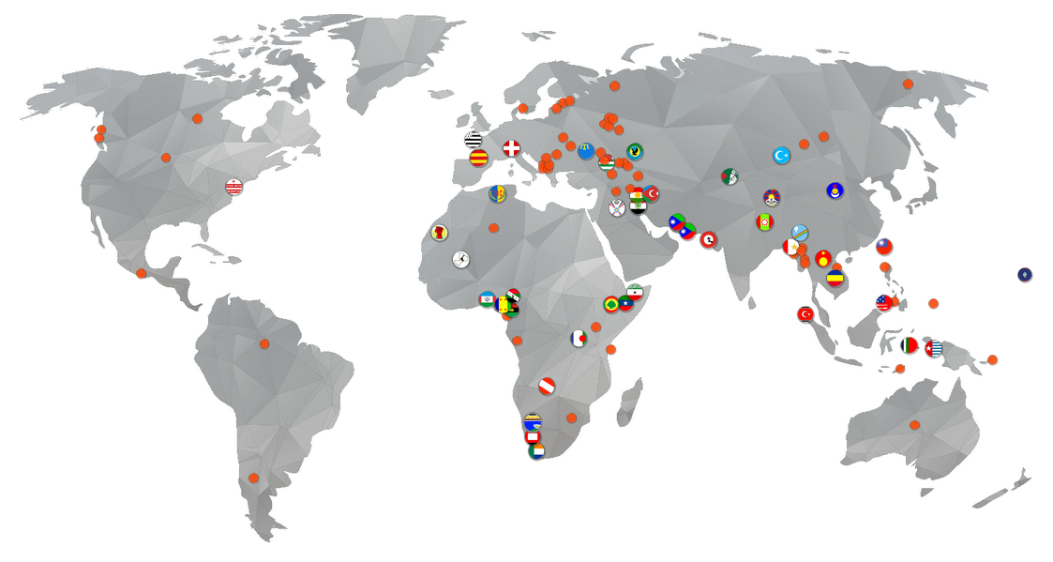
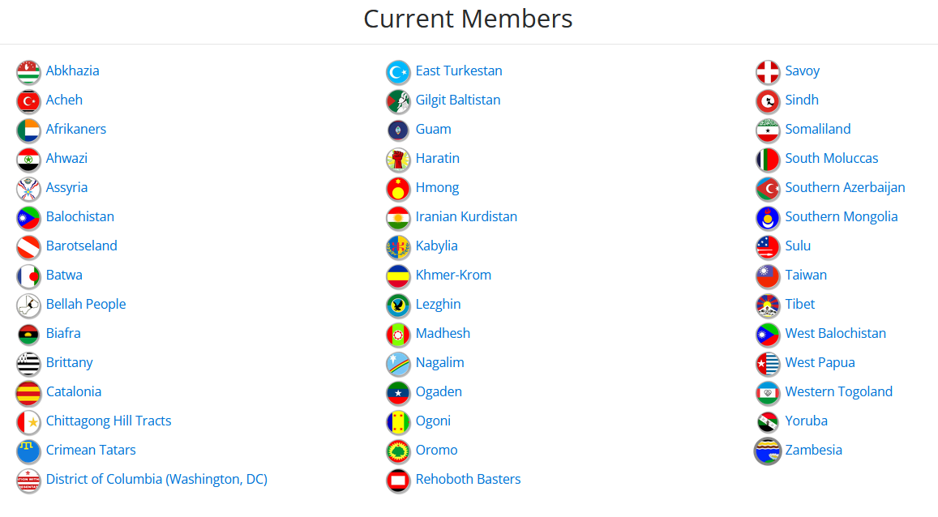

Appendix III: Additional resources

Anan, K. (1999) Two Concepts of Sovereignty, The Economist, 16 September 1999 http://www.economist.com/node/324795

Inman H. A. and Sharp, W. G. (1999) ‘Revising the U.N. Trusteeship System - Will It Work?’ American Diplomacy, September 1999:
https://americandiplomacy.web.unc.edu/1999/09/revising-the-u-n-trusteeship-system-will-it-work/

Moore, M., Ed. (1998). National self-determination and secession. Oxford, Oxford University Press.

UN, The United Nations and Decolonization:
https://www.un.org/dppa/decolonization/en

UN, The United Nations and Decolonization Documents
https://www.un.org/dppa/decolonization/en/documents

UN Office of the High Commissioner for Human Rights:
General Comment No.12 , the right to self-determination of peoples (Art. 1), 1984: https://www.uio.no/studier/emner/jus/humanrights/HUMR5508/v12/undervisningsmateriale/General%20Comment%20No12-self-determination.pdf

General Recommendation No. 21 , right to self-determination, 1996: http://hrlibrary.umn.edu/gencomm/genrexxi.htm

UNPO on self-determination: http://www.unpo.org/section/2/2

UNPO Membership http://unpo.org/members.php

Appendix IV: Example resolution

General Resolution adopted by the Model UNPO General Assembly on [TOPIC OF RESOLUTION]:
[DATE AND LOCATION]:

Signatories: [LIST UNPO MEMBERS ATTENDING]

Preamble
The purpose of the preamble is to show that there is a problem that needs to be solved. It should set out the background to the broad theme of the debate but not propose any action.
Operative clauses set out what is to be done about the issue described in the preamble, and by whom (e.g. the UNPO, governments, UN bodies, NGOs). They should be numbered, can include sub-clauses (e.g. 1a, 2a, 3a), should each end with a semi-colon and start with a verb such as ‘accepts’, ‘affirms’, ‘calls upon’, ‘condemns’, ‘deplores’, ‘endorses’, ‘proclaims’, ‘recommends’, ‘reminds’, ‘supports’, ‘urges’. They should be organised in a logical progression, and each clause should be brief and contain a single idea or policy proposal
The Model UNPO General Assembly

Expressing its solidarity with UNPO Members and other communities subjected to any form of oppression, violence, and discrimination,

Reiterating all UNPO members’ commitment to the Organization’s fundamental principles: democracy, non-violence, human rights, self-determination, tolerance, and environmental protection as expressed in the Covenant,

Affirming the importance of ensuring that all nations and peoples have the opportunity to have a say in the decisions that concern their territory, culture, language, heritage, and environment,

The Model UNPO General Assembly:
Operative clauses set out what is to be done about the issue described in the preamble, and by whom (e.g. the UNPO, governments, UN bodies, NGOs). They should be numbered, can include sub-clauses (e.g. 1a, 2a, 3a), should each end with a semi-colon and start with a verb such as ‘accepts’, ‘affirms’, ‘calls upon’, ‘condemns’, ‘deplores’, ‘endorses’, ‘proclaims’, ‘recommends’, ‘reminds’, ‘supports’, ‘urges’. They should be organised in a logical progression, and each clause should be brief and contain a single idea or policy proposal
1. Challenges the UN position on territorial integrity and condemns its inability to authorise interventions in matters which are within the domestic jurisdiction of a member state when there are human rights violations;
2. Recommends the UN’s establishment of a mechanism that will effectively mediate in claims of self-determination which includes unrepresented nations and peoples;
3. Notes the importance of referenda for enacting the right to self-determination and calls upon the UN to assist in the peaceful running of referenda in disputed territories;
4. Calls on the international community to implement mechanisms that protect minority rights including language and cultural rights;
5. Demands all UN members to recognise acts of genocide when they occur, including recent human rights violations of Uyghur people in East Turkestan;
6. Encourages states to…
7. Recommends the UNPO to…

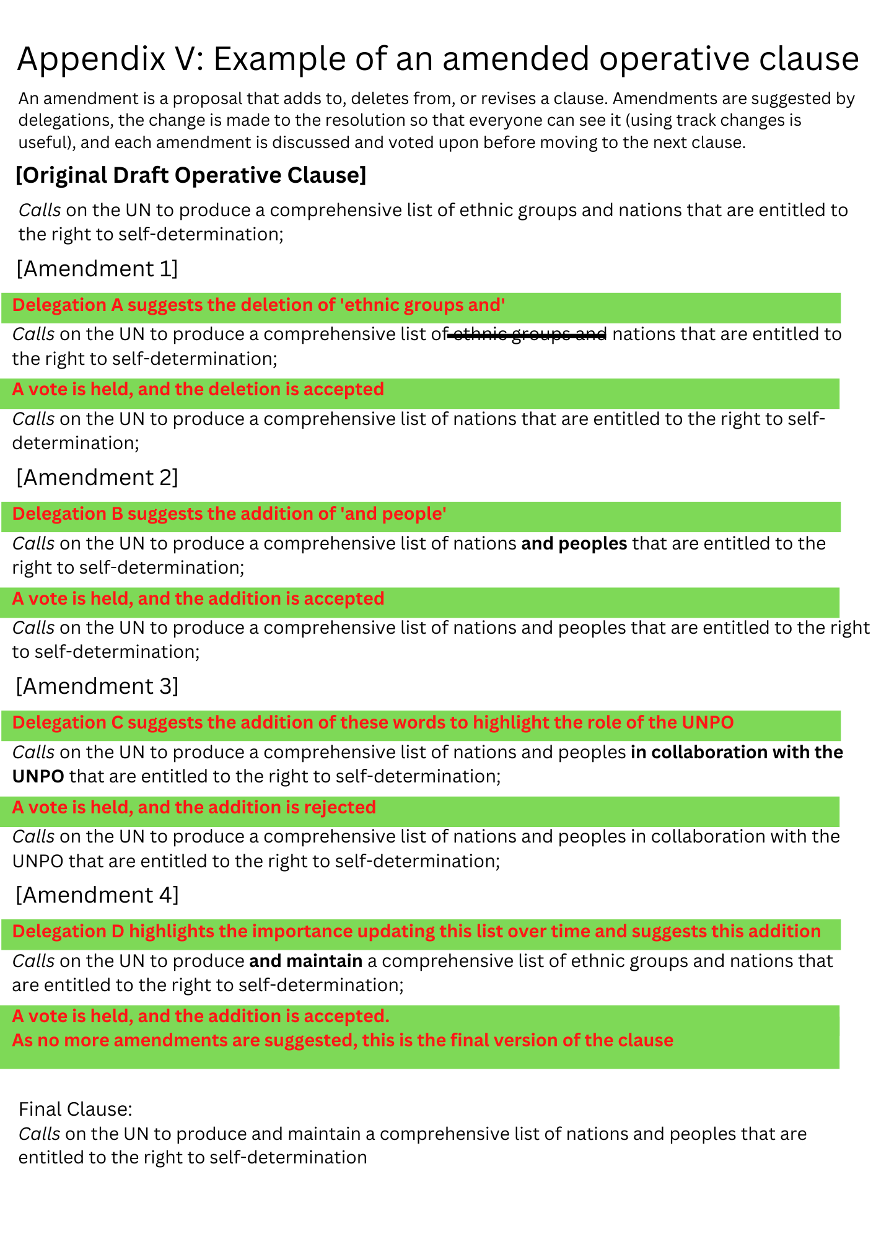

These materials have been developed by Professor Fiona McConnell (University of Oxford) and Dr Liam Saddington (University of Cambridge), and the UNPO Secretariat. Funding for trialling these materials was provided by a Ray Y Gildea Jr Award from the Royal Geographical Society (with the Institute of British Geographers) and Prof. McConnell’s Philip Leverhulme Prize for Geography (2019).

