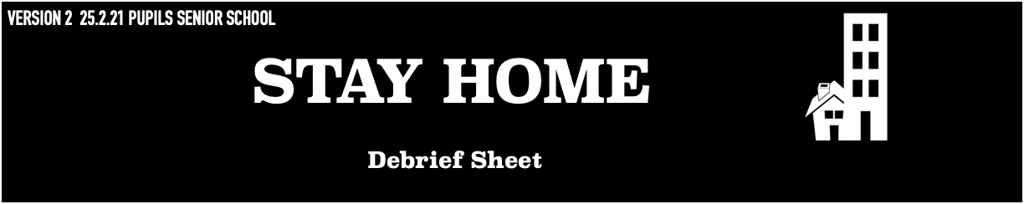

Thank you for participating in this research. We thank you for your valuable time and effort. If you are interested in the background of the study, you can read below for more information.

The Research
People live in all different types of home. Some people live in flats and others in houses. There are people who live on houseboats, in caravans or even castles! Every home is special. You might live in a city or in the country, have a balcony, yard or garden. How people live and use the spaces in their homes is unique. This study wants to understand how the COVID-19 pandemic might have affected how children and young people understand and use their home spaces. To learn about the project, you can visit: www.stayhomestories.co.uk.

If the research has raised anything that you would like to talk about further, we would encourage you to talk to your teachers or parents.

You can also contact Youngminds (https://youngminds.org.uk) which is the UK's leading young people's charity. They provide online resources on coping with different challenges. Childline (https://www.childline.org.uk) offers professional support 24/7 to anyone under 19 by phone (0800 1111), through online chat or email with a counsellor who provides anonymous help.

Data
All information provided by you will anonymised. This means your maps are stored without your name or any other personal information that could reveal your identity.
During the exhibition the maps will associated with your school and year group not your name. If you have any further questions regarding this experiment or would like to receive follow-up information, please contact any of the researchers: Georgina Endfield: endfield@liverpool.ac.uk ; Jaqueline Waldock: Jaqueline.Waldock@liverpool.ac.uk

All documents submitted via bit.ly/rgsstayhome and project correspondence (including emails to eduadmin@rgs.org and Georgina.Endfield@liverpool.ac.uk) will be shared by RGS-IBG and The University of Liverpool. Both organisations will process your information in accordance with their respective data protection and privacy statements, available here https://www.rgs.org/privacy-notice/ and here https://www.liverpool.ac.uk/legal/data_protection/.

