2019 and 2020 Briefing Document
Sources, diagrams and further notes to follow the tabulated information
QUESTION UNDER CONSIDERATION | KEY POINTS | DETAIL AND FURTHER INFORMATION
How significant was the flooding of Venice in November 2019 compared with its historic record of flooding?  Suggest reasons for the flooding of Venice in November 2019.  Give some economic and social impacts of this episode of flooding.  What might be a reason for the exceptionally low water levels observed in January 2020?  What types of problems for the city result from both exceptionally high and exceptionally low water levels? | >largest flood event since 1966  >Around 80% of the city’s area flooded  >the interior of St Mark’s Basilica flooded for only the 6th time in its 1,200-year history  >there are direct and indirect causes relating to weather conditions, to human modification of the lagoon, and to climate change and its effects  >The MOSE tidal barrier scheme not operational  >there are numerous economic and social impacts, many of which are difficult to quantify  >overall this event was very costly, with estimates of about 1 billion euros (£850 million) of damage  >Unusual meteorological conditions and human changes to the hydrodynamics of the lagoon  >transport problems and other disadvantages for residents and tourists | The peak water level of +187cm was reached on 12 November 2019 at 22:50, and this caused around 80% of the city to flood. This is the highest level recorded since 4 November 1966, when the level reached +194cm.  The level of +187cm (and the other episodes of high water that occurred on the 13th, 15th, and 17th of November 2019) was very damaging and disruptive for the city.  The 12 November level of +187cm is the second highest since modern measurements began in 1872, and over the period of record, there have only been 9 times when the water level exceeded +150 (equating to over 60% of the city being flooded).  Specific weather conditions and a high spring tide were the direct cause, although there are also indirect causes that increased the probability of an event of this magnitude.  Direct causes include: strong winds (Sirocco winds) from the south pushing water up the Adriatic Sea towards the Venice lagoon; storm surge associated with these winds and atmospheric low pressure and rainfall, and with an astronomical high spring tide.  More indirect causes include human modification of the lagoon’s shape and depth profiles (bathymetry) and loss of salt marsh (barena) which causes water to move more quickly between the Adriatic Sea and the lagoon; and sea level rise caused by climate warming which means storm surges can reach higher levels. A period of accelerated city subsidence linked with groundwater abstraction until the 1970s has also increased the probability of such high water events. MOSE scheme designed to protect against such events not yet operational (over-budget and delayed until end of 2021 at the soonest).  Human modification of the lagoon has occurred to facilitate shipping, and as a direct result of the ships.  Container and cruise ships, and other large vessels with motors, increase erosion through their wake and displacement of water causing:  - vertical erosion of lagoon’s bed  - A homogenization of the lagoon’s bed as erosion in some areas causes sediment to accumulate in other areas  The level of economic damage has been estimated at about 1 billion euros. In addition to damaged buildings and infrastructure, and the clean-up cost, there has been damage to cultural treasures such as St Mark’s Basilica. Transport systems were severely disrupted, causing absences from work and lost revenue. Hotel bookings declined by about 40% following the November 2019 flooding event.  Social impacts include the hardships and personal difficulties faced by residents of the historic city and those who commute to work in the city, and the closure of schools, museums, and other city services.  Those currently residing in the city might now be even more likely to leave the historic city, adding to its problem of a declining resident population.  In January 2020, extremely low water levels occurred which left many canals un-navigable, causing transport disruptions and unsightly conditions.  Direct causes include weather conditions and a low astronomical spring tide.  Due to human changes in the shape and depth profiles across the lagoon, water can exchange between the Adriatic Sea and the lagoon of Venice at a faster rate than would occur naturally, so accentuating both high and low tides.  This is related both to areas of the lagoon that have been dredged to provide sufficient depth for container ships and cruise ships, and to loss of salt marsh habitat (barena) which would otherwise slow the water flow and moderate the range.  It is estimated that the area of salt marsh within the lagoon has declined from 115 km² to 33.5 km² over the course of the last two centuries. Causes include: land reclamation for human use, erosion, pollution, subsidence, and decreased accretion of sediments (Cecconi, 2005).  The tidal range would be expected to increase if the lagoon of Venice becomes more like a bay of the sea, which is the current trend.  Various forms of water transport, such as the water buses (vaporetto) cannot pass under the bridges if the water is too high, and cannot pass through certain canals if the water is too low.  Problems with waste and pollution can occur in both high and low water situations. Flooding can lead to sewage backing up and to the spreading of pollutants across pavements and into buildings. Low water can expose waste that would otherwise not be visible, and cause an unpleasant odour and be unsightly.

Overview of main trends in the incidence of high tide (acqua alta):
Of the 10 exceptionally high tides (+140cm from 1897 reference point) recorded in the past hundred years, at least 8 occurred after 1960. Moderately high water (over 80cm above the 1897 reference) is now a much more frequent occurrence. In the early 20th century this typically occurred less than 20 times a year. From the 1990s onwards, it has often been 80 to 100 times a year.
An acqua alta (high water flooding) is defined as the tide reaching a level of at least 80cm above an 1897 reference point at Punta della Salute, which is in fact just 50cm above today’s mean water level. This is due to a combination of sea level rise, natural ground subsidence, and human caused subsidence associated with industrial ground water abstraction until the 1970s.
‘Intense’ high tide reaches up to 110cm above, ‘very intense’ is up to 120cm above, and ‘exceptional’ is over 140cm.
St Mark’s Square and Basilica start to flood when the high tide reaches about 70cm. Very intense high tides (+110cm) flood over 14% Venice and now it is not unusual for this to happen more than ten times in a year.
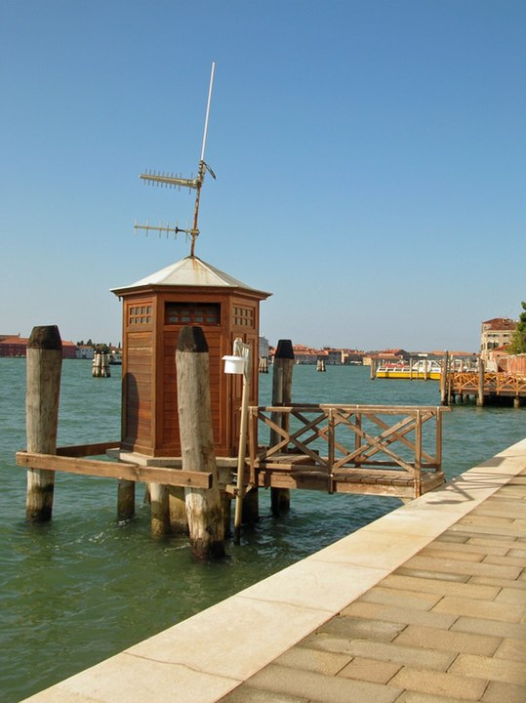
The Punta della Salute tidal gauge station
By L736E at Italian Wikipedia - Transferred from it.wikipedia to Commons., Public Domain, https://commons.wikimedia.org/w/index.php?curid=36765119

https://en.wikipedia.org/wiki/Acqua_alta
Other Sources:
https://www.bbc.co.uk/news/world-europe-50401308
https://www.bbc.co.uk/news/world-europe-51098129
https://news.sky.com/story/venice-canals-almost-run-dry-just-two-months-after-flooding-11907106
https://www.comune.venezia.it/it/content/grafici-e-statistiche (high water tide gauge data)
Cecconi, 2005 in Flooding and Environmental Challenges for Venice and its Lagoon: State of Knowledge (C.A. Fletcher and T. Spencer, eds.) CUP

