Colouring London
Sustainability at A Level
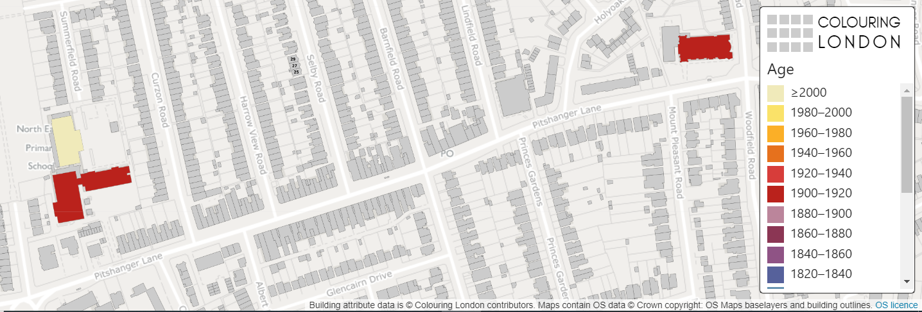

[Start text here]

Colouring London aims to collect information on every building in London, to help make the city more sustainable. It provides information about your local area.
https://colouringlondon.org/

Linking sustainability with Colouring London

- Buildings and building construction are responsible for around 40% of global energy use, and 24% of global material extraction from the lithosphere.

- Should we continue to build new properties or should we seek to reduce energy and waste flows within existing buildings?

- This has created an urgent demand for more detailed data on the characteristics of the building stock, for measurement, monitoring and analysis purposes. ​ Colouring London has been set up to collate, capture, generate and drive the release of open building attribute data in the UK.

Colouring London data can be used to explore and address the contemporary urban issues relating to sustainability in the city.

- What kind of buildings make up London?
- What are their size, shape, age and use?
- How are they built?
- How energy efficient are the buildings in my local area?
- How long could the existing building stock last if well-maintained?
- Are there sufficient green spaces in the city?

Colouring London would like to collect
- Location
- Land use
- Type
- Age
- Size & Shape
- Construction
- Streetscape
- Team

Detailed information is available on https://www.pages.colouring.london/buildingcategories

Possible questions

Which buildings are likely to be vulnerable to demolition and why?
Is there sufficient greenery around buildings to reduce risk from pollution, urban heat and flooding?
What are the ways in which we can best extend lifespans to reduce energy and waste flows?
Which buildings work best in the city, and in what ways?
Can you determine the liveability of an area using Colouring London data?

Suggested activity for a local area

For your local study area, determine how sustainable the physical environment is, by collecting and mapping energy performance data.

Primary data collection:
Public buildings are required to display DEC (Display Energy Certificates). For your local area record the ratings and enter the data into Colouring London.

Secondary data:
Energy Performance Certificate data can be obtained using CDRC (Consumer Data Research Centre) maps
https://maps.cdrc.ac.uk/#/metrics/epc_current/default/

Energy performance and retrofit
The energy performance of buildings is monitored by the UK government through an energy rating system. Energy Performance Certificates (EPCs) are required for all properties, when constructed, let, or sold. They are based on paid for surveys, and capture information on efficiency measures such as insulation and double glazing to give a current, as well as a potential, energy rating. For public buildings, a Display Energy Certificate (DEC) is required.
Colouring London are collecting and visualising EPC and DEC data.

Energy Performance Certificates data
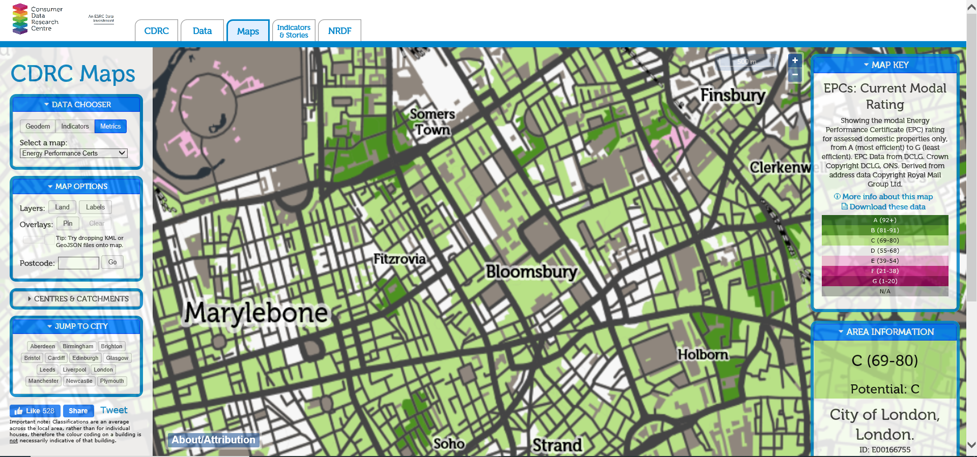

Display Energy Certificate

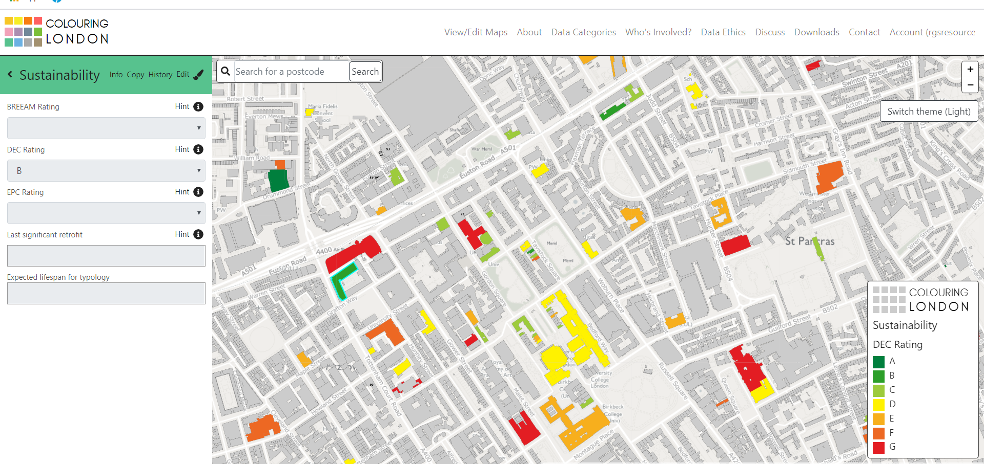

Example: Display Energy Certificate

Summary

- Visualising energy performance can help map the ecological footprint and be used to change the way people behave.
- Local governments could use the maps to identify which areas are in most need of improved efficiency measures.
- Buildings could be analysed to determine whether they should be retrofitted or demolished and replaced.

