Migrants on the Margins
- Let’s investigate, Tawanda’s story (Harare)

The Migrants on the Margins research explores four cities: Colombo, Dhaka, Hargeisa and Harare. We explore the lives of four people living in these cities through comics. This quiz will help you to find out more about why each participant has moved and how they find life on the urban margins.
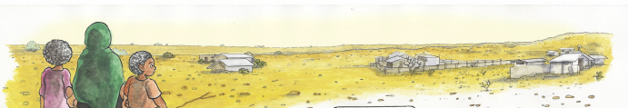

- How many kilometres does Tawanda’s daughter walk to school? _________________
- When Tawanda moved to Harare in 2000, what did he sell? _________________

- How many people wanted the right to live on Porta Farm? _________________

- In which year did Tawanda move to Hopley, Zone 4? _________________

- What does MDC stand for? ___________________________

- If you could ask Tawana one question about his life and experience what would it be?
__________________________________________________________________________________________________________________________________________________________
_____________________________________________________________________________

