Migrants on the Margins
- Let’s investigate, Sabina’s story (Dhaka)

The Migrants on the Margins research explores four cities: Colombo, Dhaka, Hargeisa and Harare. We explore the lives of four people living in these cities through comics. This quiz will help you to find out more about why each participant has moved and how they find life on the urban margins.
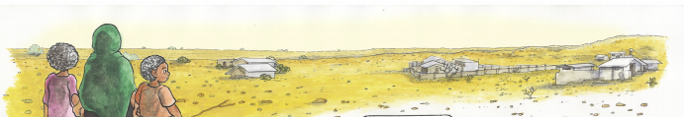

- How old was Sabina when she began work in the garment factory? _________________

- What did Sabina’s mother sell to buy a family room in Godawn Bosti? _________________

- What is the name of the largest underserved community in Dhaka? _________________

- How old is Sabina’s daughter? _________________

- The garment factory will not take Sabina beyond which age? _________________

- If you could ask Sabina one question about her life and experience what would it be?
__________________________________________________________________________________________________________________________________________________________
_____________________________________________________________________________

