The Fluvial System: Lessons using data skills

Lesson 5: Sediment Transport During Floods

Lesson Objectives
- To use the data collected during the passage of a flood wave to quantify when sediment moves during a flood
- To use the same data to begin to think about how changing flood magnitude might affect sediment transport

Setting the Scene

Most of the world’s big rivers are composed of sand beds (Figure 1). When this sediment is transported by the river it forms ‘bedforms’ which are effectively underwater sand dunes (Figure 2). When these dunes are present they potentially make it difficult to navigate by boat since the boats possibly hit the dunes and get stuck. The size of these bedforms is controlled by discharge where, generally, larger bedforms are formed under higher discharges. However, little is known about exactly how they grow during the rising limb and how they shrink during the falling limb but understanding how dunes grow and shrink during a flood is very important if we are to know when the world’s big rivers might and might not be navigable. This lesson is focused on beginning to explore this problem.

The Data
We can quantify how the bedforms change during the passage of a flood wave by measuring their height at different discharges and creating a 3D map of the river bed called an elevation model, which is similar to a map (Figure 1a). We can either do this in a laboratory under controlled conditions in an indoor river called a flume or directly in the field by measuring the bed topography during the passage of a real flood wave.
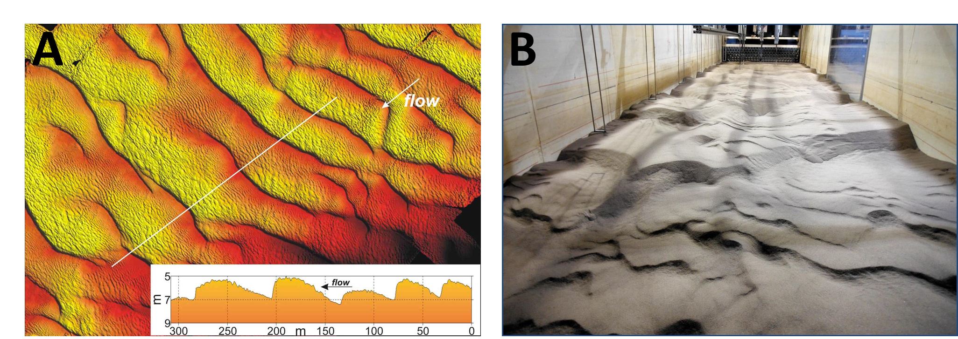

Figure 1:(a) A birds eye view of an Elevation Model of the sand bed of the Rio Parana (Parsons, 2005) collected from a boat based survey. Red colours mean higher elevation and yellow lower elevation. The smaller image bottom right shows a cross section through the map (b) sand bedforms developed in a flume during a 4-hour flood experiment.

This lesson uses data collected from a flume. We filled the flume with sand and ran water down the flume at discharges to represent the discharges experienced during a flood. This data is collected from an experiment that was run using a hydrograph with a 58-minute rising limb and 50 minute falling limb and which was representative of a 1 in 5 year return period winter snowmelt flood on the Mississippi River. Elevation models were taken at change in the discharge and allow us to see how the flood wave affects the size of the bedforms. The data set contains information on bedform height and bedform wavelength.

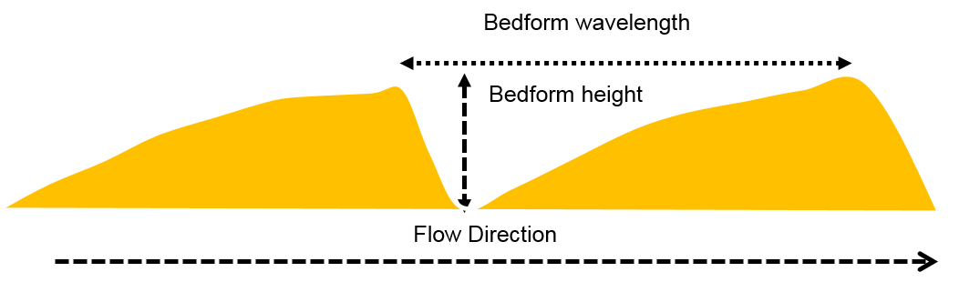

Figure 2: Schematic diagram of a sand bedform looking side on (similar to the profile diagram in the bottom right of Figure 1A) and relevant metrics of bedform height and wavelength

Tasks
- How do sand bedforms change during the rising and falling limb of a hydrograph?

Open the Microsoft Excel Bedform Data file. The file has three columns of data: 1) the Discharge (m³/s), 2) The bedform wavelength (cm) and 3) the bedform height (cm).

Using the data plot x,y, scatter graphs either by hand or in excel of the following:
- Graph 1: Rising Limb Discharge on the x axis and rising limb wavelength on the y axis.
- Graph 2: Falling Limb Discharge on the x axis and falling limb wavelength on the y axis.
- Graph 3: Rising Limb Discharge on the x axis and rising limb bedform height on the y axis.
- Graph 4: Falling Limb Discharge on the x axis and falling limb bedform height on the y axis.

Your graphs should look like the examples below in Figure 3.

Looking at both relationships compare and discuss the findings. You might want to think about:
- Is there a relationship with discharge?
- Is this relationship the same for both bedform height and wavelength? Think in terms of how much each variable is changing between the start and end of the rising and falling limb
- Can you estimate how quickly the height and wavelength are changing? Is one changing faster than the other? Is the rising limb changing faster or slower than the falling limb? Why might this be important?

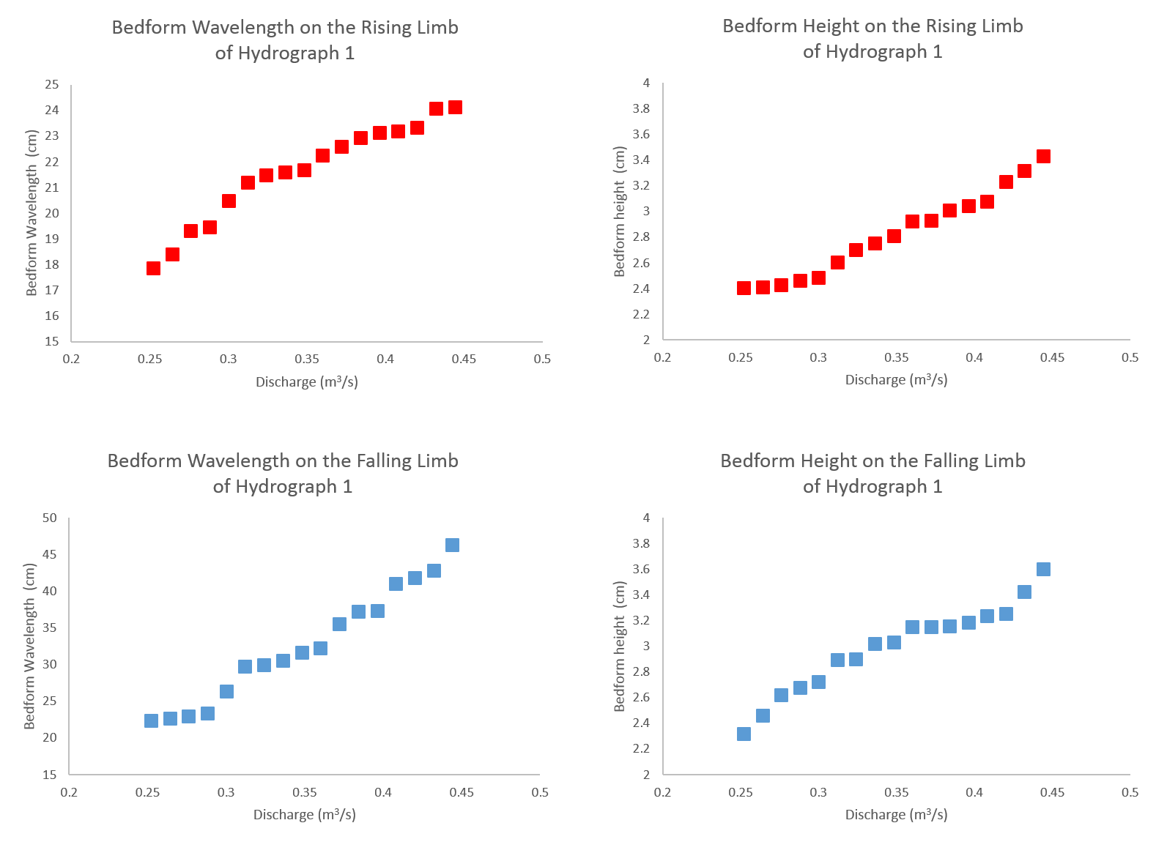
Figure 3: The relationship between bedform wavelength (a and c) and bedform height (b and d) with discharge

Take it further

Looking at raw data:
- Calculate the percentage change between the beginning and end of the rising limb, the beginning and end of the falling limb and the beginning and end of the entire flood wave.
  - What are the differences?
  - Which variable shows a greater change?
  - Using Figure 2 as a basis, draw what you think the bedforms look like at the beginning and end of the flood wave

- Comparing bedform characteristics over the whole hydrograph

Plot two further graphs:
- Combine the data from Figure 1 with the data for Figure 2 - so plot the discharge on the x axis and the bedform wavelength during both the rising and falling limb on the y axis.
- Combine the data from Figure 3 with the data for Figure 4 - so plot the discharge on the x axis and the bedform height during both the rising and falling limb on the y axis.

Tip: If you are doing this in excel you don’t need to drawer the graphs from scratch. If you right click on the graph which plots the rising limb data and press copy you can then right click on the graph which contains the data from the falling limb and press paste. This will combine the data.

Your graphs should look like the examples below in Figure 4.

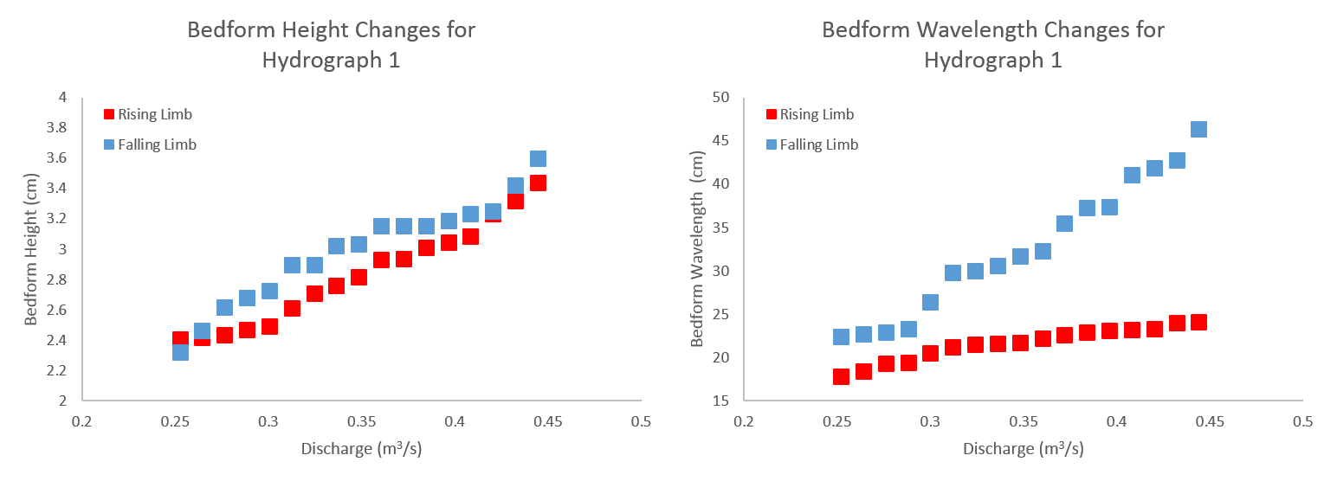

Figure 4: The relationship between bedform wavelength (a) and bedform height (b) over the duration of the hydrograph

Looking at both relationships compare and discuss the findings. You might want to think about:
- Are bedforms bigger on the rising or falling limb?
- Is wavelength bigger or smaller on the rising or falling limb?
- What does this mean if you are trying to navigate a boat down the river? HINT – the higher the dunes the more likely it is that the boat will ground.

Take it further

Looking at raw data:
- Calculate the percentage change between difference between the rising and falling limb values for the bedform height and wavelength.
  - What are the differences?
  - Which variable shows a greater change?

Plenary

Return to the main lesson question. Discuss:
- Using the links below discuss how the frequency and magnitude of floods are predicted to change in the future and what we might or might not do about that
- think about how changing flood magnitude might affect the development of bedforms. What would happen if the shape of the hydrograph changed?

http://www.independent.co.uk/environment/climate-change/frequency-of-severe-flooding-across-europe-to-double-by-2050-9163852.html

https://theconversation.com/total-flood-defence-is-a-myth-we-must-learn-to-live-with-the-water-22670

https://theconversation.com/climate-change-and-natural-patterns-combined-to-bring-wettest-winter-ever-23450

