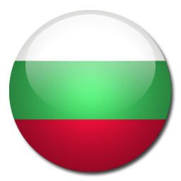
Country: Bulgaria
Joined the EU: _____________
Current energy production (draw a pie chart here)
Figures: 2005
Coal 36%
Oil 22%
Nuclear 22%
Gas 13%
Renewables 5%
Other 2%

Suggest what the ‘other’ might be:

Visit the Nationmaster site which has statistics on many countries.
It allows you to compare two countries, so visit:
http://www.nationmaster.com/compare/Bulgaria/United-Kingdom/Energy
How do the UK and Bulgaria compare on at least three forms of energy ?

