A focus on East Oxford by Thames Valley Police

Specification links
AQA GCSE 3.2.1. Urban Issues and Challenges Urban change in cities in the UK leads to a variety of social, economic, and environmental opportunities and challenges.

Edexcel GCSE 4.5 Globalisation and economic change create challenges for the chosen UK city that require long-term solutions. How economic change is increasing inequality in the city and the differences in quality of life.

OCR GCSE 1.2.3. There are different causes and consequences of development within the UK. The causes of uneven development within the UK, including geographical location, economic change, infrastructure, and government policy.

Eduqas 2.2.2 What are some of the contemporary challenges facing UK towns and cities?

Introduction
Thames Valley Police (TVP) have taken a more detailed look at bike theft in Oxford that goes beyond the open access crime data referenced in previous resources.

Efforts to reduce bicycle theft often fall into one of four general categories:

- Interventions designed to catch bicycle thieves in the act
- Interventions designed to deter bicycle thieves often through focusing on the registration and recovery of bicycles (thereby making it harder to sell stolen bicycles)
- Interventions designed to improve the security of bicycle parking facilities
- Interventions designed to increase the security of locks and/or the way they are applied

Low-cost, scalable prevention strategies have had a high impact on bike theft in the UK. Simple initiatives such as stickers attached to a series of bicycle parking stands depicting how to lock a bicycle securely have been successful in improving bike locking practice. Also, advertising campaigns like ‘cycle thieves, we are watching you’ across three UK university campuses have deterred criminals due to the so-called ‘watching-eyes effect’. Simply explained, bike criminals are reminded that they are likely to be observed committing the act of theft, and that this could ultimately lead to repercussions.

Safer Streets
In October 2019, the Home Office launched the Safer Streets fund to prevent acquisitive and neighbourhood crimes. The Prime Minister and his Crime and Justice Taskforce (CJTF) have prioritised combatting neighbourhood crime, focusing on the four crime types of burglary; robbery; theft from the person (including bike crime); and vehicle related theft.

TVP were 1 of 35 Police and Crime Commissioners (PCC) across the country to receive Safer Streets funding. TVP have been working with local authorities and partner agencies to implement a series of interventions to reduce both bike theft and burglaries within specific areas of East Oxford. Interventions include:

- CCTV where there are gaps in coverage at The Plain Roundabout, St Clements St and on Cowley Road

- Enhanced street lighting at The Plain Roundabout and on St Clements St

- Provision of secure cycle parking facilities at strategic locations within the boundaries of residential properties and student accommodation

- Creation of an app to assist with finding cycle parking availability

- Provision of approved ‘anti-theft’ D-locks, tamper proof bike marking labels and free bike registration service

- Secure storage facilities at the sports centre on the Iffley Road

- A scheme which offers landlords of student accommodation and other homeowners the opportunity to enhance their property’s existing security standards through a number of target hardening measures such as window opening restrictors, additional perimeter lighting and improved door locking systems

- Enhanced street lighting on Nye Bevan Close, Cosin Close and St. Marys Rd

- Community engagement exercises involving local groups and schools to provide personal safety and crime prevention advice to both students and residents within the area

This resource focuses on three areas of work undertaken by TVP and has been produced in partnership with the Royal Geographical Society (with IBG) because the city of Oxford has high rates of cycling which are expected to grow further still in the future.

Oxford
Appendix A shows a ward map for the city of Oxford. It is a university city with 3 colleges in Cowley and East Oxford: St Stephen’s House OX4 1JX, St Hilda’s College OX4 1DY and Greyfriars OX4 1SB (which closed in 2008 and is now a Franciscan monastery). Because of the large number of students who live in Oxford, and the fact that car use is discouraged with 4 park and ride schemes around the city, there is therefore an exceptionally high level of cycling.

A 2018 report on cycling found that 39.2% of people in Oxford cycled at least once a week. Consequently, the combination of a high volume of bikes and a young population who are susceptible to bike crime has created a substantial problem around bike theft. It is well understood that more secure locking practices and better bike parking in the city would improve the situation.

How a bike is locked is partly influenced by what a bike is locked to. Bike parking stands improve the security of cyclist locking practice by facilitating the locking of both wheel and frame. In both image 1 and image 2, taken in different parts of Oxford, you can clearly see bikes that have not been secured properly.

On the next page is a picture of the High Street in Oxford. It is one of the main roads in the city and has multiple bike parking stands. However, many bikes are not locked safely.

- Using image 2 as a stimulus, explain why do you think bike theft is high in Oxford?

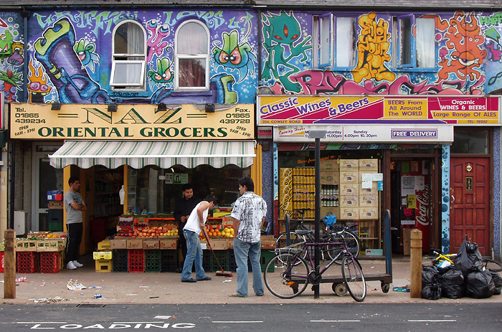
Image 1 Shopkeepers on the Cowley road © Kamyar Adl Cowley and East Oxford are young student areas

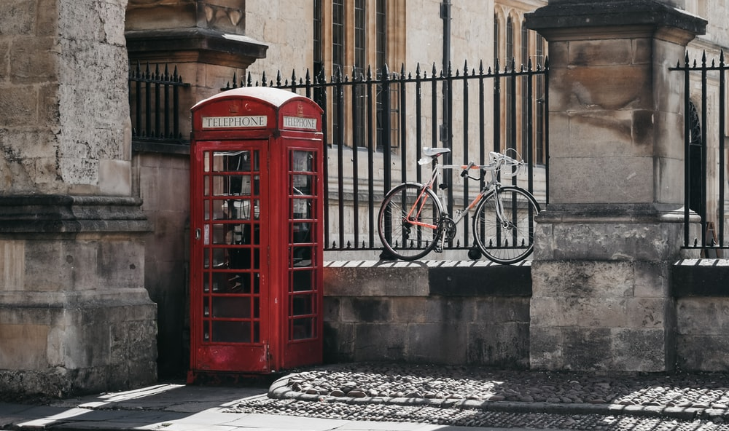
Image 2 Locking practice in Oxford © Darya Tryfanava

The Iffley Road Innovation Zone (an area of East Oxford)
The Iffley Road Innovation Zone (IRIZ) is described as an area of East Oxford, situated on the egde of the city centre and extending into the residential areas of East Oxford and Cowley. It includes most of St Mary’s Ward, and extends to cover the busy Plain roundabout, where the busy Cowley and Iffley roads converge.

- The IRIZ has been identified as an area which will benefit from a renewed focus on 3 crime categories: cycle theft, theft other, and shoplifting. Using the crime heat map in Appendix C and an OS map identify the 4 crime hotspot areas. The IRIZ is shown in Appendix B.

A summary response to bike crime in Iffley, Oxford
There are three proposed responses to the ongoing bike crime afflicting Oxford.

- The installation of a diverse range of secured-by-design cycle storage solutions (called Streetpods) in hotspots across the zone (these can clearly be seen in the Appendix C)

- A bespoke app has been designed to record the availability of cycle parking within the zone (like apps for multi-storey car parks)

- TVP aim to offer every single cyclist living within the IIZ a free bike marking registration kit and secure–by- design accredited D-locks.

To deliver the above recommendations TVP have worked with two companies: Bike Register and CyclePods.

BikeRegister
BikeRegister is a national UK database which all UK Police Forces have access to. Owners register their bikes on the secure online database which means they may be able to return a stolen bike to its rightful owner. It is the largest bike registration database in the UK with 1 million bikes registered as of January 2021.

Table 1 shows the data which has been collected since 2011 by BikeRegister, called the National Cycle Crime Survey. This is separate from Police Force recorded data and the Crime Survey for England and Wales (CSEW).

Year | Total bike registrations with BikeRegister
2011 | 18726
2012 | 44252
2013 | 46180
2014 | 62564
2015 | 75081
2016 | 155149
2017 | 145650
2018 | 121833
2019 | 82595
2020 | 77539
Table 1 Total bike registrations to BikeRegister

The reason for the dip in registrations in 2018 and 2019 was mainly because of the introduction of GDPR (with partners from then onwards having to change to an opt-in method of registering their customers on BikeRegister), and a reduction in police budgets. Therefore, less public bike marking has taken place since then.
- Create a line graph of bike registrations in the UK with years along the x axis and total bike registration with BikeRegister up the y axis.

Table 2 below shows the amount of bike theft, over a 10-year period, as registered with BikeRegister.

Year | Registered stolen with BikeRegister
2010 | 188
2011 | 463
2012 | 491
2013 | 1517
2014 | 1731
2015 | 3665
2016 | 4224
2017 | 6058
2018 | 5784
2019 | 6415
2020 | 8243
2021 | 1330
Table 2 The number of bikes that are reported stolen to BikeRegister

- Add the data from Table 2 onto your line graph on BikeRegister registrations.

- Describe any patterns or trends between the two data sets that you can see.

COVID-19 restrictions have led to a change in UK behaviour, societally and economically; more people are now thought to be cycling. With regards to thefts reported to BikeRegister, it is interesting to compare like-for-like figures from 2019 to 2020 (the first two COVID19 patients tested positive in the UK 29 January 2020). As you can see, there was a significant increase in cycle theft from June 2020 last year (compared to 2019).

- Calculate the percentage change, per month, from 2019 to 2020 using Table 3 below.

Month | 2019 thefts | 2020 thefts | % change
January | 482 | 497
February | 502 | 460
March | 506 | 431
April | 498 | 376
May | 588 | 556
June | 531 | 786
July | 594 | 900
August | 587 | 932
September | 628 | 988
October | 576 | 976
November | 507 | 808
December | 416 | 533
Total | 6415 | 8243
Table 3 Bike theft from 2019 to 2020 as registered with BikeRegister

Streetpods
Secure-by-design bike storage is a key part of the IIZ and should dramatically reduce bike theft in the coming years in Oxford. Streetpods are designed so that the inside of the large outer metal locking hoop has a piece of angled internal solid steel to add an extra layer of security. When a thief tries to cut through this with a hacksaw or similar type of saw, the angle compresses against the blade and jams it, usually snapping any blade in the process.

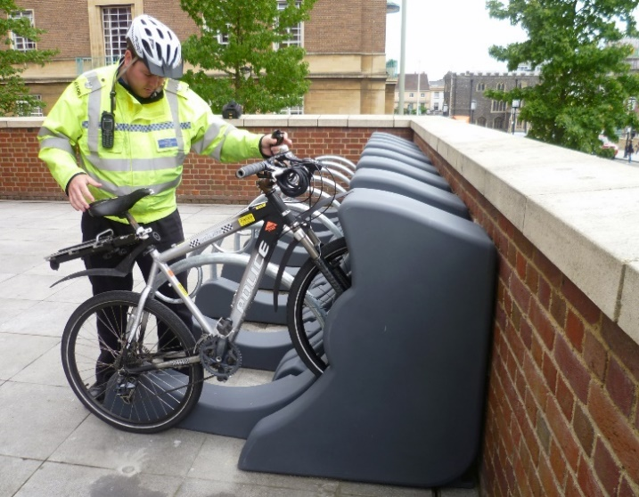
Image 3 A Streetpod being used by a Police Officer and Image 4 the internal angled steel to prevent cutting

The Streetpods has just been awarded Sold Secure Diamond accreditation which is the highest level of bike security available in the UK making it the most secure bike parking stand (other products to achieve this rating currently are all lockers).

Each Streetpod holds two bikes in a ‘high-low’ configuration which stops handlebars and pedals clashing and allows for two bikes to be held in a 700mm space. The design uses 30% less space than traditional Sheffield stands. Each bike is held separately so they do not knock against each other and cause damage.

Image 5 below shows the inside of the Streetpod with protective metal plates, this is where the front wheel sits, and it means thieves cannot get to the quick release on the front wheel of the bike.

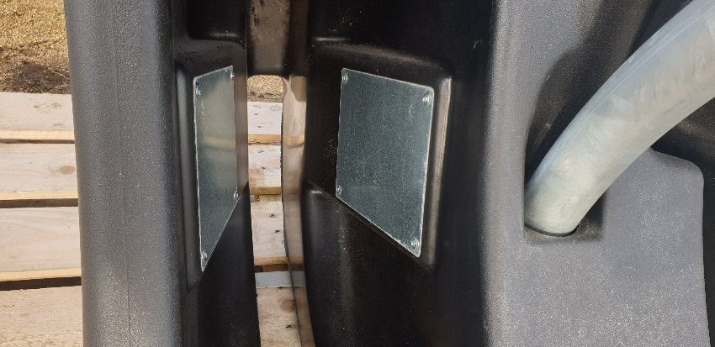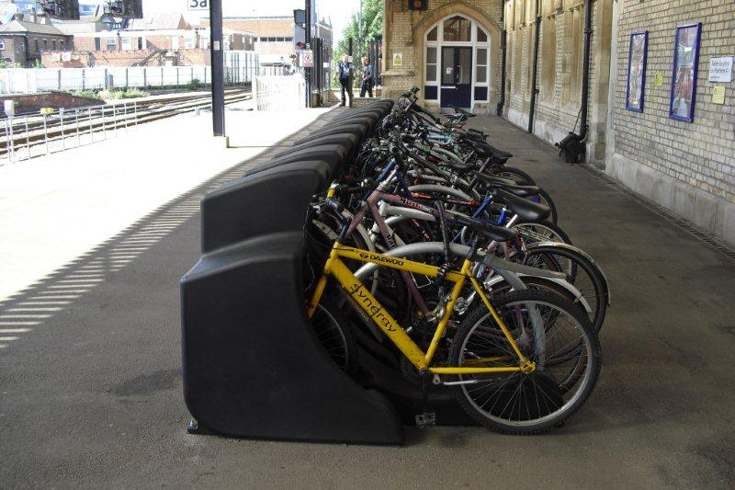
Image 5 the Streetpod front wheel space and Image 6 showing the rollout of Streetpod in the East Midlands

In addition, when cyclists in the IIZ use the Streetpod there will be a locking guide luggage tag attached to the Streetpods. This will show users how to securely lock bikes using a D-lock to lock the back wheel and bike frame through the inner secure locking hoop.

Black Streetpods made from 100% recyclable MDPE (Medium density polyethylene) plastics have been used in the TVP scheme for the IIZ. Recyclable galvanised steel is also a part of the design, so the whole Streetpod can be recycled in the future if necessary. The MDPE is graffiti resistant, resistant to minor fire damage and easy to clean and maintain.

- Now you understand Streetpod and the intention of the design, label and annotate the sketches in Appendix D.

- Look at image 7. Annotate above and beneath the drawing to explain why this is a good example of secure locking practice?

Image 7 Good locking practice?

Anti-theft bike designs
There are several ongoing responses to bike crime in the UK. Two examples are: new anti-theft bike designs and registration databases.

Turn-1 are a Danish company committed to reinventing the bike lock. They have created an innovative N-Lock (Image 8), which consists of a multi-purpose stem lock, a cable and an unlocking key which renders the bike unusable if stolen.

- Watch the N-Lock – The Multipurpose Bike Lock video and learn how this design thwarts would-be bike thieves.

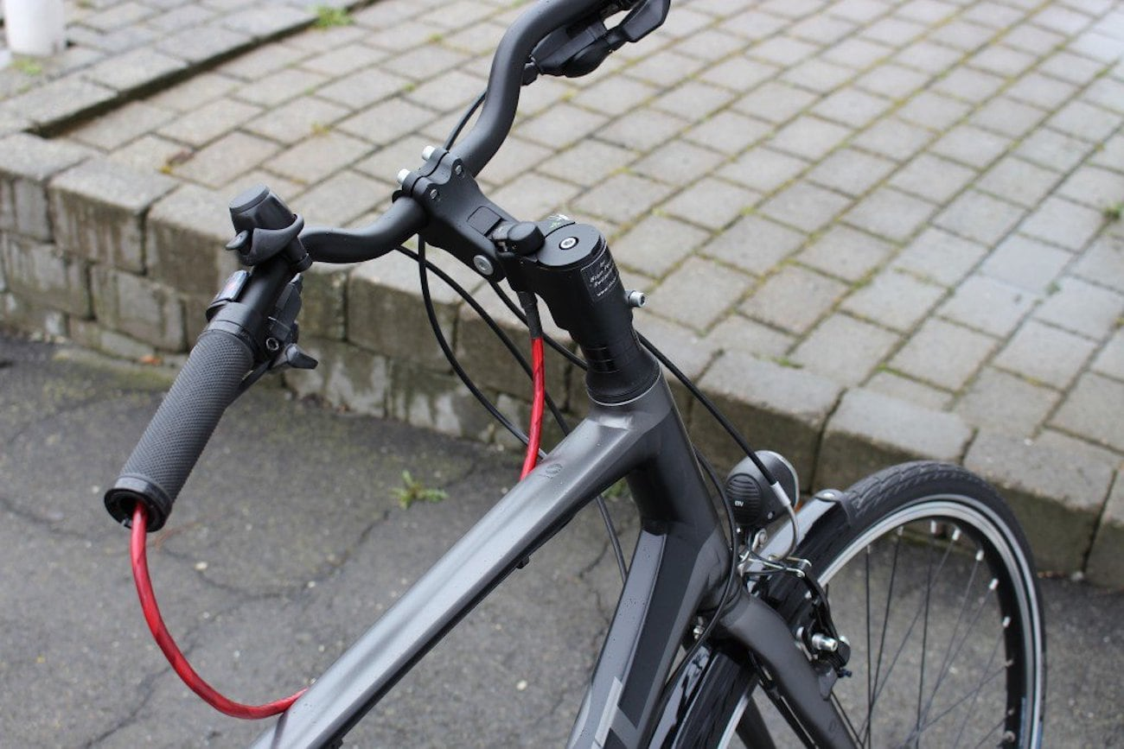
Image 8 The N-Lock © Gadget Flow

The folding Puma bike is an example of an innovative anti-theft bike shown below in Image 8. Also known as ‘the Disko’ the design addresses both the limited storage space typically available in urban homes and the desires for low maintenance and to reduce the threat of theft.

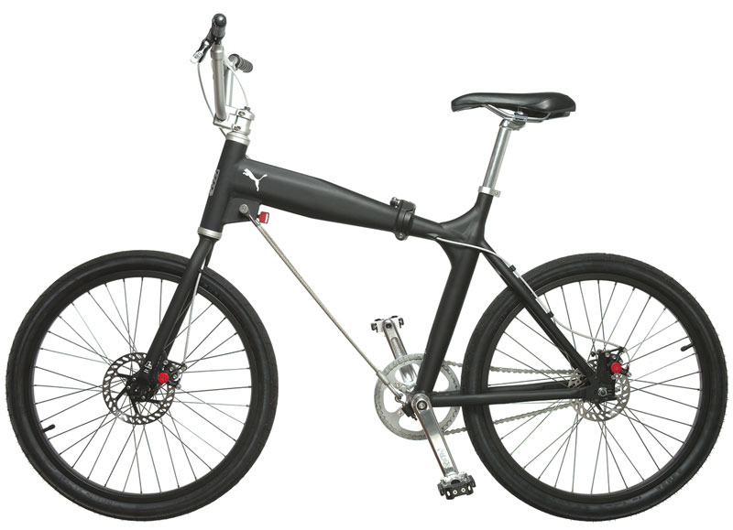
Image 9 The folding Puma bike

The Puma bike is a part of the Bikeoff Design project from the Design Against Crime (DAC) series at the University of Arts London. It uses “a spoiling principle” which you can read more about on the UAL website on the Puma bike design.

There is an online design activity called the “Bikeoff design challenge” which asks you to consider how the design of cycling related products, infrastructure, schemes, and services might contribute to reduced risk of cycle theft.

- Access and read about the design challenge and design brief. Enter the competition and design your own cycling related product. Use Appendix E to help you consider what offences might be committed and how your design could mitigate against them.

Further reading
- End of UK lockdown may mean a rise in bike thefts — the importance of BikeRegistration https://www.theguardian.com/environment/bike-blog/2021/feb/19/end-of-uk-lockdown-may-mean-a-rise-in-bike-thefts

- The new Oxford boundaries map 2021 https://www.oxford.gov.uk/downloads/file/6912/map_of_new_ward_boundaries

- Mapping files from the boundary commission https://www.lgbce.org.uk/all-reviews/south-east/oxfordshire/oxford

- The N-lock N-Lock – The Multipurpose Bike Lock

- The Puma bike design from UAL Design Against Crime – Puma Bike

- The Bikeoff Design project Bikeoff Design project

- Streetpod by Cyclepods Transforming Bike Storage | Cyclepods | UK and Worldwide

- Bike theft clampdown begins Clampdown on bike theft in Oxford has begun | Oxford Mail

- How safe is your locked bike? How safe is your bike? | Thames Valley Police

- Nettle, D., Nott, K. and Bateson, M. (2012). ‘Cycle Thieves, We Are Watching You’: Impact of a Simple Signage Intervention against Bicycle Theft PLoS ONE 7(12): e51738. doi:10.1371/journal.pone.0051738

- Sidebottom, A., Thorpe, A., & Johnson, S. D. (2009). Using targeted publicity to reduce opportunities for bicycle theft: A demonstration and replication European Journal of Criminology, 6(3), 267-286

- Thorpe, A., Johnson, S. D. and Sidebottom, A. (2012). The impact of seven prototype bicycle parking stands on opportunities for bicycle theft. In P. Ekblom (ed.) Designing out crime from products: Towards research-based practice. Crime Prevention Studies, Vol. 26. Monsey, NY: Criminal Justice Press. Available on request

- A 10-year plan to up the number of cyclists in Oxford to increase the uptake by 50% by 2031 www.oxfordmail.co.uk/news/18304027.cyclist-numbers-oxford-go-10-year-plan/

Answers
- In 2020, there was a nationwide increase in cycling because of the changes wrought from COVID19. In Oxford, cars are strongly discouraged from entering the city with bus gates, priority bus lanes and 5 park-and-ride schemes. The reason for such deterrence is that the city is that “the majority of emissions and air pollution in Oxford city centre are generated by motorised traffic” with road transport accounting for “68% of NOx emissions and 16% of carbon dioxide (CO2) emissions in Oxford”. Oxford County Council intend on implementing a larger city centre ZEZ (Zero Emissions Zone) in 2022, with the ZEZ expanded to cover the whole city by 2035. Therefore, cycling is expected to grow.

- The general trend is that bike theft has increased since 2011 with the 2 highest years for the number of bikes being stolen being 2019 and 2020.

- Calculate the percentage change, per month, from 2019 to 2020 using Table 3 below.

Month | 2019 thefts | 2020 thefts | % change
January | 482 | 497 | 3.1
February | 502 | 460 | -8.4
March | 506 | 431 | -14.8
April | 498 | 376 | -24.5
May | 588 | 556 | -5.4
June | 531 | 786 | 48.0
July | 594 | 900 | 51.5
August | 587 | 932 | 58.8
September | 628 | 988 | 57.3
October | 576 | 976 | 69.4
November | 507 | 808 | 59.4
December | 416 | 533 | 28.1
Total | 6415 | 8243 | 28.5

Appendix A

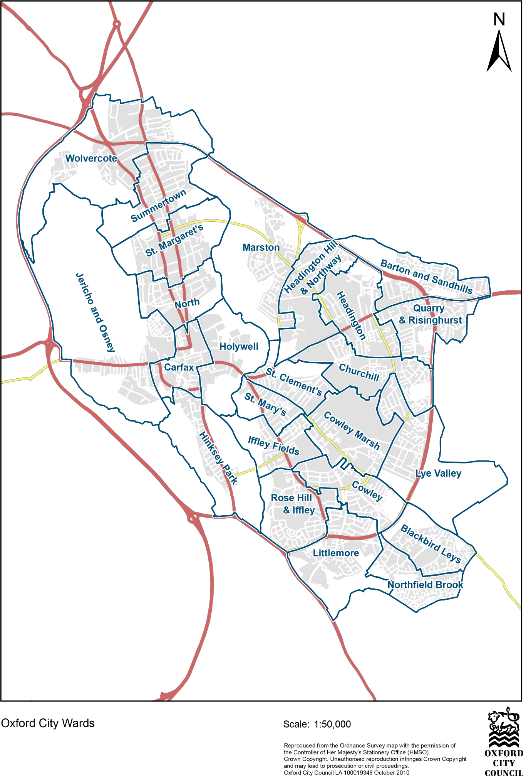

Appendix B

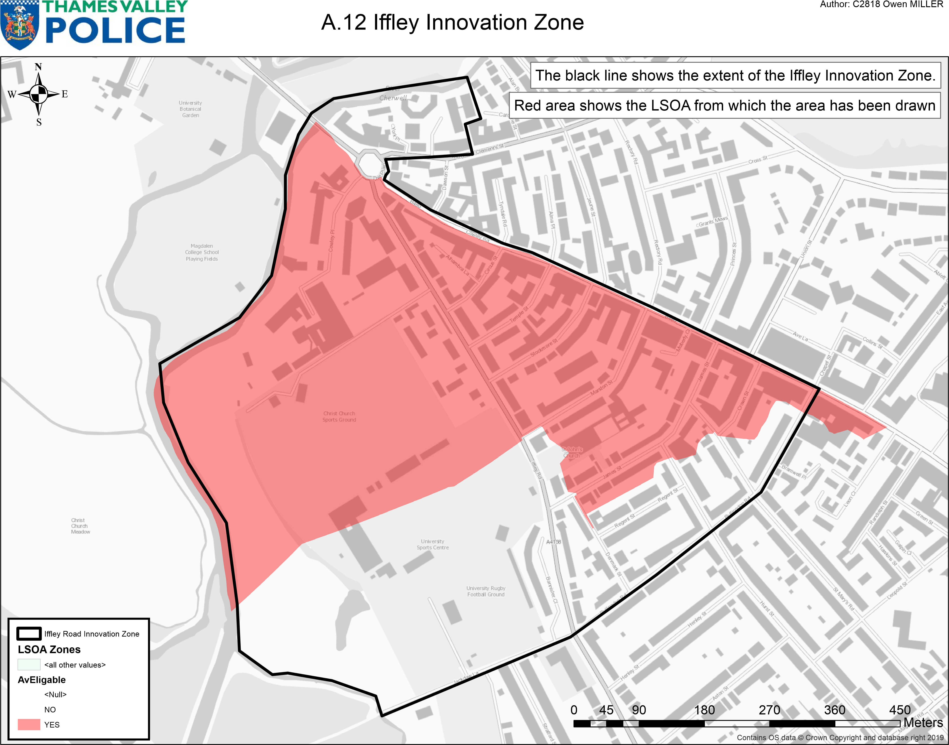
Appendix C
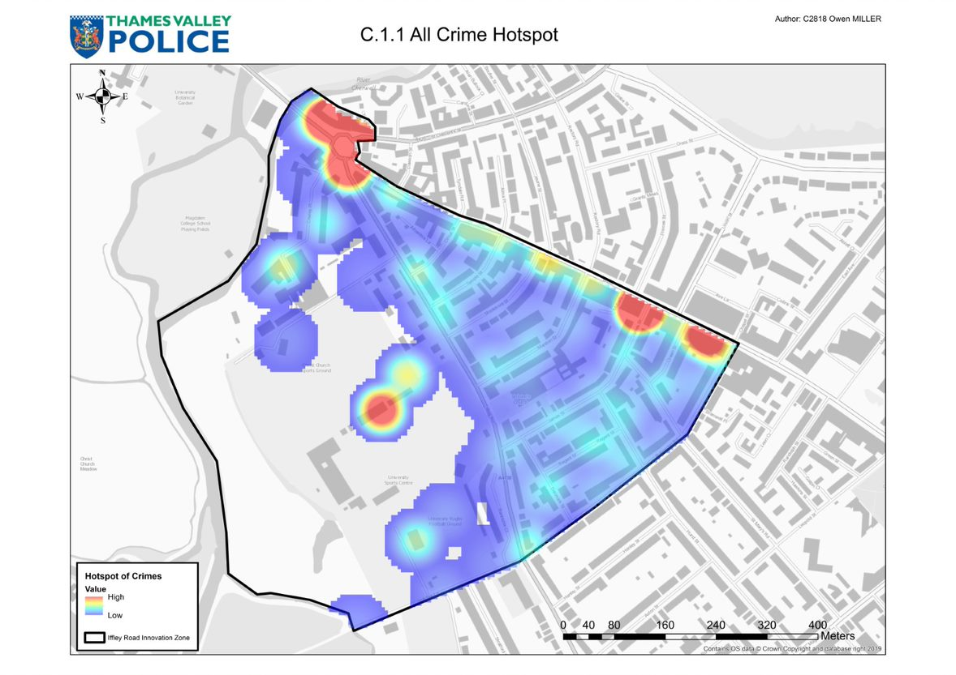

Appendix D

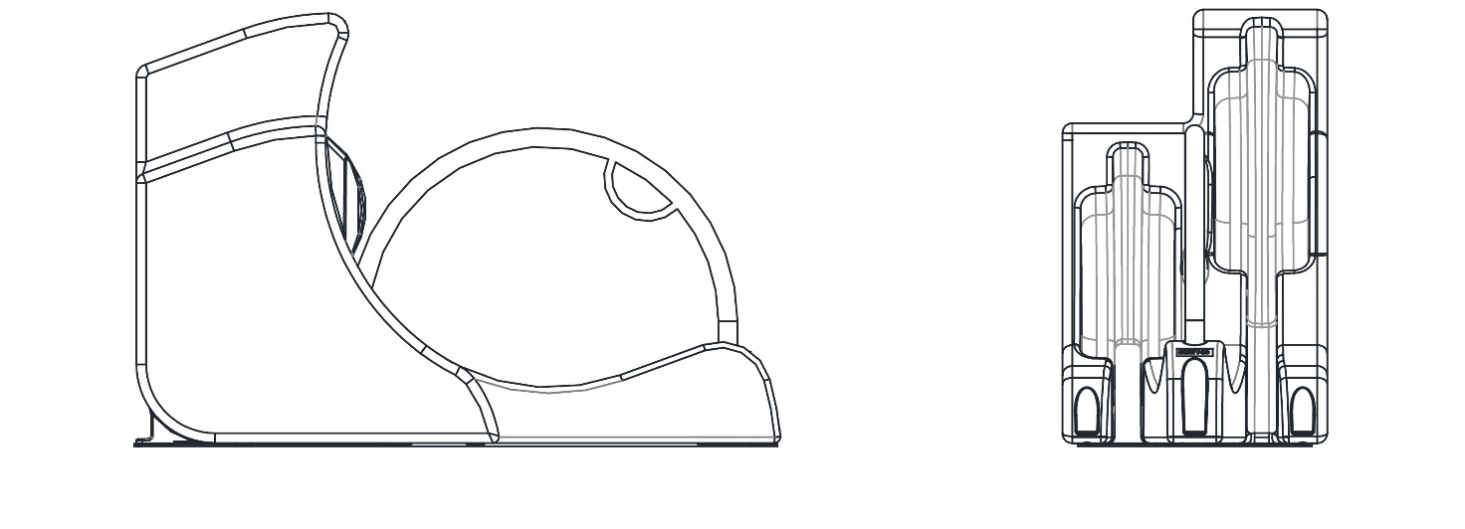

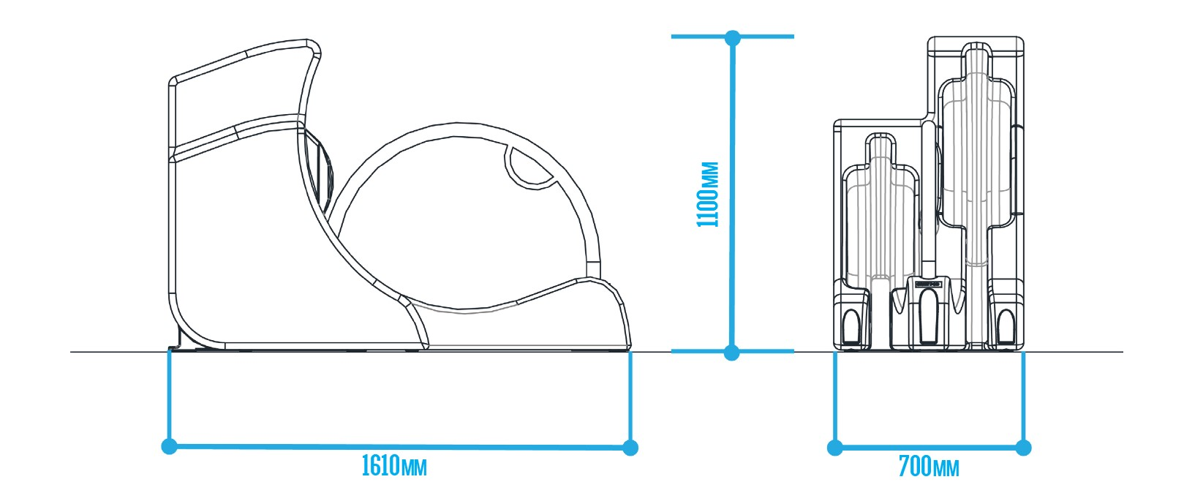

Appendix E

Method – how are the offences committed?​
Interventions designed to detect offenders in the act.​
​
“Bait bikes” bikes with tracking systems left unsecured to catch offenders stealing the bike. This also provides knowledge of where stolen bikes are disposed.
Improving the registration of bikes and increasing the difficulty of disposing of stolen bikes. ​

​Ultraviolet pens. ​

​

RFID tags ​

​

Disrupting stolen bike markets​,.
Four interventions have been identified to address bike theft
Improving the security of cycle parking facilities.​

Increased natural surveillance in areas of poor visibility. ​

Increasing flow of passersby. ​

Repositioning businesses such as taxi ranks​.
Interventions seeking to improve how cyclists lock their cycles​.

​Education campaigns informing cyclists of recommended practices concerning the types of locks to use and the manner with which they should be applied.
Striking: If the chain or lock is touching the ground, thieves can use a hammer and chisel to split the securing chain or lock​.
Cutting: Thieves can use tin-snips, bolt cutters, hacksaws, and angle grinders to cut their way through locks and chains to steal bikes.​
Levering: ​

Thieves use the gap between the stand and the bike from a loosely fitted lock to insert tools such as jacks or bars to lever the lock apart. ​

​

Thieves can also use the bike frame as a lever by rotating it against the stand or other stationary object to which it is locked. Either the bike or the lock will break.​
Unbolting:​

Thieves can undo bolts and quick-release mechanisms.​

​

If a cyclist locks a bike by the wheel alone, then it may be all that is left when the cyclist returns. ​

​

If a cyclist locks only the frame, then a thief can remove a wheel or wheels. ​
Lifting:​

Thieves lift the bike and lock over the top of the post the bike is secured to.​

​

If the post itself is not anchored securely and it can be lifted clear of the bike and the lock.​

