2050 Instructions
In order to reduce UK carbon emissions by 80% we need a revolution in our energy mix and that means major choices for the UK about how to move to a secure, low carbon economy. Government has produced the 2050 Pathways Analysis work to allow people to explore the scale of the challenge and the choices we face.
What would you do?
Whether it’s more nuclear power stations, driving electric cars or putting solar panels on every roof, the choice is yours as long as you can hit the target to reduce carbon emissions by 80 per cent by 2050.
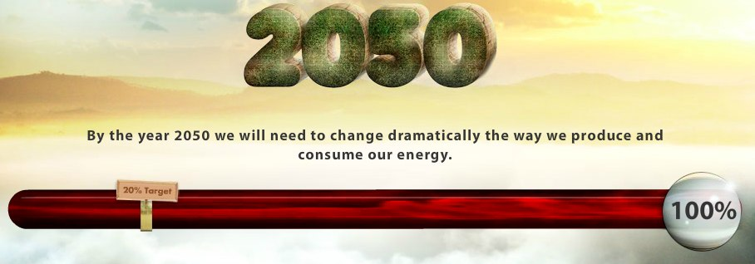
My2050 simulation is aimed at 16-25 year olds, this is a user-friendly web application designed to help the public have a go at making the hard choices we face when it comes to tackling climate change, and to share their views on the big debates.

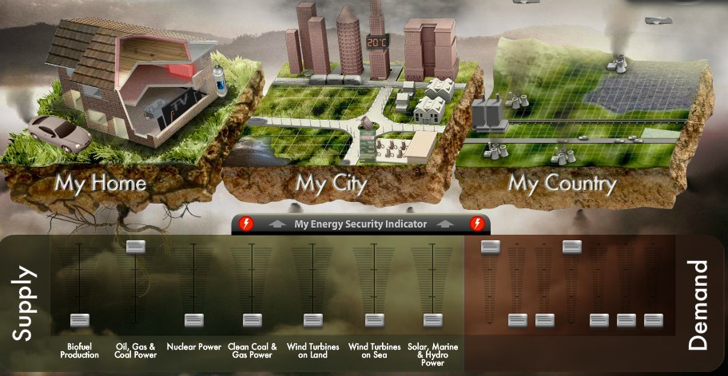
Slide the sliders so that SUPPLY keeps pace with DEMAND
Look at the graphics for MY HOME, MY CITY, MY COUNTRY and to see the impacts
Make a note of the sliders, or do some screenshots to show their location and add them on the final page of this document. As you move the slider into position, an information box will display – make a note of what it says in the table below:
SUPPLY | DEMAND
Biofuels | Manufacturing
Oil, Gas & Coal | Business Greenness
Nuclear | Home Efficency
Clean Coal & Gas | Home Temperature
Wind (Land) | Heating Fuel
Wind (Offshore) | Travel
Solar, Marine & Hydro | Transport Fuel

SCREENSHOT FOR SUPPLY

SCREENSHOT FOR DEMAND

