Information Sheet: Kurdistan
Where is Kurdistan?
Kurdistan refers to a region where the Kurdish people make up most of the population. It covers the modern day countries of Turkey, Iraq, Armenia, Iran and Syria.
How big is Kurdistan?
Kurdistan is roughly 520,000 square kilometres
How many Kurdish people are there?
It is estimated that there are between 25 and 35 million Kurdish people worldwide.
What is the religion in Kurdistan?
The Kurdish follow a number of different religions, but the majority are Sunni Muslims.
What language do the Kurdish people speak?
People in Kurdistan speak the Kurdish language.
What is the history of Kurdistan?
Following the defeat of the Ottoman Empire in World War I, the Empire was divided up between Britain, France, Greece and Russia. The Allies (Britain, France and Russia) had promised the Kurdish people their own country however when the borders of Turkey were set no Kurdish country was established.
The Kurdish people have been treated unfairly within Turkey, Iraq, Armenia, Iran and Syria. In the 1980s, Iraqi President Saddam Hussein forced many Kurds from their homes and killed many of them. Around 180,000 people disappeared. After the First Gulf War (1990-1991), Iraq withdrew its army from Iraqi Kurdistan.
Kurdish people have been ill treated by the Turkish government for generations. In the 1920s and 1930s, many Kurdish people were forced to move, Kurdish names and costumes were banned and the use of the Kurdish language restricted.
In Iran, the Kurdish people have suffered from significant harm from the government, and face issues in education, housing and employment.
What problems has Kurdistan faced recently?
In 2013, the terrorist group Islamic State attacked Kurdish communities in Syria and Iraq. The US-led coalition has provided the Kurds with military support and advisers. In October 2019, the US withdrew its troops from Syrian Kurdistan as Turkey announced it was planning to establish a “safe zone”. Many Kurdish people felt betrayed by the US as the Kurdish people had helped in the fight against Islamic State.
The future of Kurdistan remains uncertain due to instability in Iraq and Syria.
What do the Kurdish people want?
Some Kurdish people want Kurdistan to become an independent country. Other Kurdish people are campaigning for greater control within the existing borders of countries.

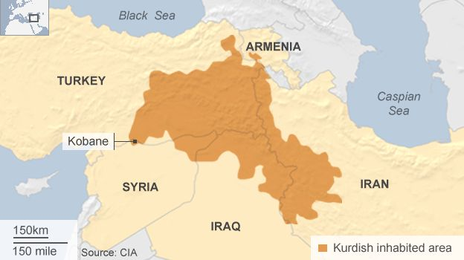
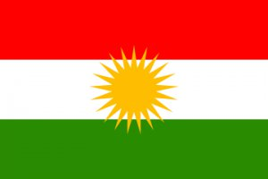
2 Source: https://www.bbc.co.uk/news/world-middle-east-29702440
1 Source: https://unpo.org/members/7882

