Dhaka, Bangladesh
- Factsheet

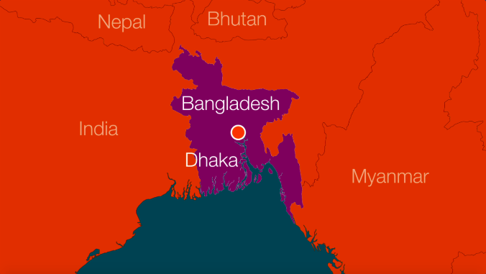

Population
The Greater Dhaka area has a population of over 19 million, with over 7 million living in the city itself. Not only is Dhaka Bangladesh’s largest city, it is also one of the world’s most densely populated cities.

Climate
Bangladesh has a tropical climate, with a monsoon season between June and October. The capital city, Dhaka, is located along the Buriganga River and is only 4m above sea level which results in regular flooding during the monsoon season.

Infrastructure
Informal settlements proliferate around the city with large numbers of people living in close proximity with fragile urban environments. Settlements are built on environmentally fragile land and when the monsoon season hits each year, many residents must live with flood waters in their homes.

Families often live in small shelters with narrow walkways separating them. From the air it is almost impossible to see where one shelter ends and another begins as the roofs overlap, covering the passageways between them.
Economy
Its booming economy has come with numerous infrastructural improvements in recent years.
Politics
Bangladesh became independent from Pakistan in 1971 and has been ruled by a range of political parties since most recently the Governing Awami League. This political instability has been the cause of much internal population displacement.

Why do people move?
Rural people are driven to the city both for economic reasons and by extensive riverine erosion and frequent cyclonic activity along the southern coast. The Bhola slum was formed almost 50 years ago when people moved to Dhaka after a cyclone devastated the Bhola district in 1970. Families in rural communities will often supplement their incomes by sending younger family members to Dhaka to pull rickshaws or to work in construction or the garment sector.

