Analysis of entries and attainment in A-Level geography

Report for the Royal Geographical Society

Philip Nye

Dave Thomson

October 2019

Contents

1. Introduction 2
Acknowledgments 2
2. Summary 3
3. Student characteristics 4
3.1 Gender 4
3.2 Disadvantage 5
3.3 Ethnicity 6
3.4 Prior attainment 7
4. Establishment characteristics 8
4.1 Region 8
4.2 Area type, Coastal, Opportunity area 9
4.3 Establishment type, Governance 10
4.4 Inspection rating 11

Introduction

This report presents output from a project analysing entries into, and attainment in, A-Level geography for the period 2009/10-2017/18. Analysis has been completed for a range of student and establishment characteristics, building a detailed picture of participation in geography at Key Stage 5 over this time period.

A separate document is available which describes the methodology followed and definitions used.

Acknowledgments

This publication includes analysis of the Department for Education National Pupil Database. Inferences or conclusions derived from the NPD in this publication are the responsibility of FFT Education Datalab and not the Department for Education.

Navigation

Titles used in sections 3 and 4 of this report correspond to worksheets in the Excel document provided showing all of the results of this project. This workbook also includes charts showing trends in entries and attainment for each of the student and establishment characteristics looked at. Sections 3 and 4 of this report are best read as an accompaniment to these charts.

Summary

Over the period since 2010, entries in geography A-Level have increased from around 28,500 to 30,000 in 2018, during which there was a small fall in the number of A-Level students (explained by a drop in the age 18 population). In percentage terms, the share of A-Level students taking geography increased from 10.7% in 2010 to 11.3% in 2018.
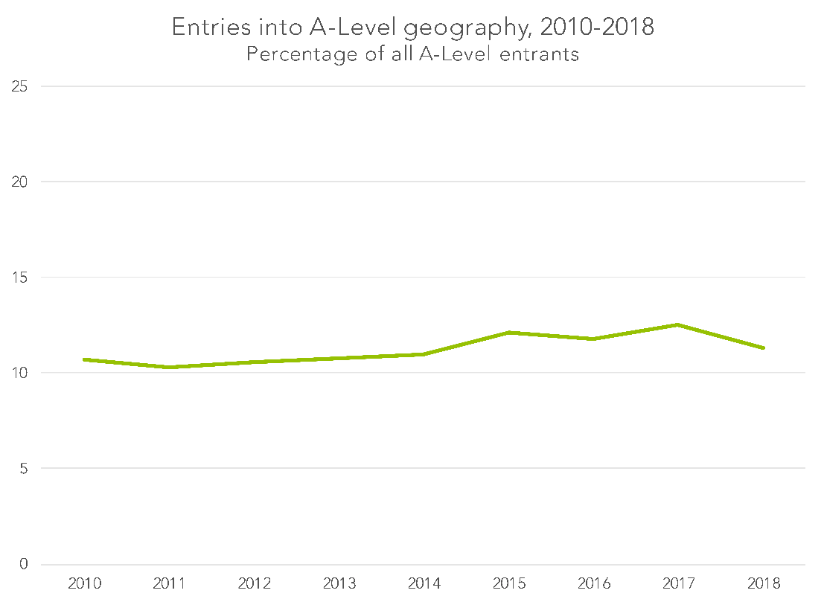
Throughout this period there have also been a small number of entries into the separate global development A-Level. These reached a recent high of around 1,200 in 2014, but were down to 500 in 2018. Analysis elsewhere in this report focuses solely on entry into geography A-Level.
Attainment in geography A-level is at a lower level than at other points in the period since 2010, with attainment at grade B or above of 55.3% in 2018 compared to a high of 59.4% in 2011 and 2012, and attainment at grade A or above of 25.3% versus a high of 31.5% in 2011.
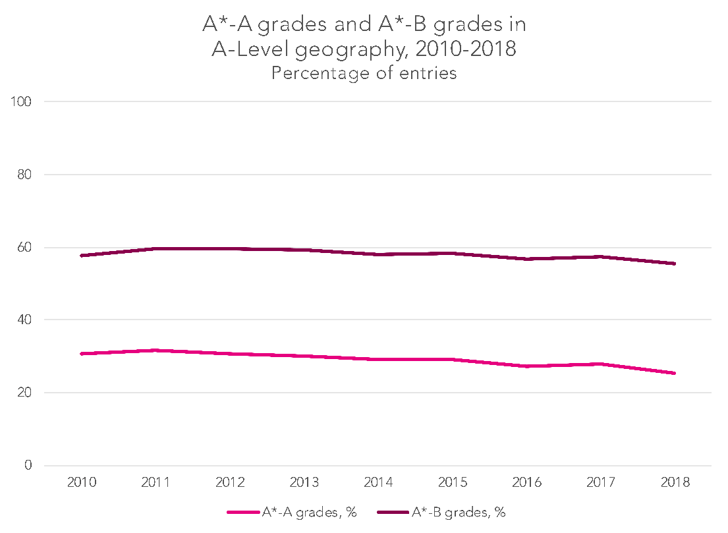
The decline in attainment is greater in the period since 2014, during which entry numbers grew most strongly. Growth in entries from those with the highest prior attainment has not been as strong as for those slightly lower down the ability range, which is likely to explain much of this decline in A-Level attainment.
A pronounced dip in attainment occurred between 2017 and 2018, when there was a corresponding decrease in geography entries. This decrease in entries was driven largely by a reduction in entries in the independent sector – where on average students have higher attainment.

3. Student characteristics

3.1 Gender

Looked at by gender, there has been a halving of what started out as a sizeable gap in A-Level geography entry rates between 2010 and 2018. In 2010, a gap of 3.6 percentage points existed (12.6% of male students taking A-Levels took geography, versus 9% of female students), reducing to one of 1.7 percentage points in 2018 (12.3% versus 10.6%).
Over the same period, a gender gap in attainment in favour of female students has persisted – and stood at the highest level in 2018 in all three of the attainment measures considered (attainment of grade A or above, attainment of grade B or above, and average point score). In terms of average point scores, a gap of 3.7 points was present in 2018 – equal to a little more than a third of a grade.

3.2 Disadvantage

There is a stark gap in entry rates between students who were disadvantaged during their final six years in education up to age sixteen and those who were not disadvantaged – although the gap in 2018 was the lowest it has been in the period 2010 to 2018. In 2018 it stood at 5.6 percentage points (12.1% of non-disadvantaged A-Level students entering geography, versus 6.5% of disadvantaged students) – down from a high of 6.3 percentage points the previous year.
Attainment gaps at grade B or above and grade A or above were also some way smaller in 2018 than had been the case in preceding years. 24% of non-disadvantaged students achieved a grade A or above, compared to 15.2% of disadvantaged students – a gap of 8.8 percentage points.
The gap had only been less than 9 percentage points in two other years in the period from 2010, and the narrowing of the gap is even more pronounced when considering attainment at grade B or above.
This suggests that the increase in the share of disadvantaged students taking geography A-Level did not come overwhelmingly from the bottom end of the ability range.

3.3 Ethnicity

There are fairly sizeable disparities in A-Level geography entry rates when considered by ethnicity – though disparities in attainment are less noticeable.
Entry rates for all major ethnic groups have increased over the period since 2010, with more than 5% of A-Level students in each ethnic group taking geography in 2018 (in 2010 this was not the case for Asian/Asian British or black/black British students).
Differences in attainment between ethnic groups are small – particularly when average point scores are considered. The exception to this is the black/black British group, for whom attainment is some way below that of other groups – mirroring something that is the case in other subjects. Attainment for this group also appears to have dropped more between 2017 and 2018 than was the case for students of other ethnicities.
The group for whom ethnicity data is not available will almost exclusively be in the independent sector. There is high A-Level geography attainment for this group – an average point score in 2018 of 41.2, equal to a little higher than a grade B.

3.4 Prior attainment

Prior attainment in English and maths at GCSE has historically been a strong predictor of likelihood to take geography A-Level. In 2010, 12.8% of those with prior attainment equal to a grade A or above entered geography A-Level, and 12.2% of those with prior attainment of between a grade B and a grade A. Entry rates for those with prior attainment between grade B and grade C was some way lower, at 8.6%.

By 2018, entry rates for those with prior attainment in the A-B range were the highest, with entry rates for those with prior attainment of grade A or above and those with prior attainment of grade B-C converging. Much of this convergence took place in 2018 and – when looking at entries by establishment type (discussed further below) – it is likely that this is largely explained by a shift away from geography A-Level by the independent sector, where prior attainment rates tend to be highest.

Entry for those with prior attainment of below grade C at GCSE remains low.

Attainment rates are strongly tied to prior attainment, and have been so over the whole period under consideration. It is noteworthy, however, that it is among those with the highest prior attainment – grade A or above – where there has been the greatest decline in geography A-Level attainment.

(A noticeable increase in the number of students with prior attainment information that is not available – with a related change in the apparent entry rate and attainment of this group – will to a large extent have been explained by a technical change in data. A popular maths international GCSE ceased to count in school performance measures from 2016, and prior attainment has been calculated based on qualifications that counted in these measures. For the cohort taking A-Levels in 2018 – who would predominantly have taken Key Stage 4 exams in 2016 – a greater share do not therefore have prior attainment data.)

4. Establishment characteristics

4.1 Region

Geography A-Level entry rates vary quite considerably by region – with London’s rate of 8.6% and the south west’s of 14.4% at the extremes in 2018 (the same regions were also the highest and lowest, with a similar gap between them, in 2010).
There is less difference in attainment, particularly when looking at average point score, which takes account of students across the entire ability range. London has the highest average point score – of 37.5 in 2018, equal to a little below a grade B – and has done for every year in the period under consideration.

4.2 Area type, Coastal, Opportunity area

While there are reasonably sizeable differences in entry rates into geography A-Level when considered by area type (urban/rural classification), only very small differences exist when considering average point scores of each of these area types. This suggests that students of similar ability are accessing geography A-Level in all types of area.
There is an attainment gap between coastal areas (defined as those within 5.5km of the coast) and non-coastal areas. In terms of average point scores this stood at 1.4 points in 2018 – fairly small, at a little more than a tenth of a grade, and the smallest over the period considered.
Similarly, students in opportunity areas – areas identified by the Department for Education as having particularly poor social mobility – have attainment that is a little below that of students in other parts of the country.

4.3 Establishment type, Governance

Entry rates differ quite notably by establishment type, with independent schools having particularly high rates, at above 15% of all A-Level students in all years except 2018. Students in school sixth forms have also had high entry rates over the period under consideration, with a large gap persisting between this group of establishments and sixth form colleges and further education colleges.
In 2018 there was a large drop in entry rates from independent schools and colleges – from 16.5% of A-Level entrants to 12% – which we suspect was the result of a transfer to a non-A-Level qualification. Given the high attainment of those attending independent schools this shift away from A-Level geography by the independent sector is likely a large contributory factor to the dip in attainment seen overall in geography A-Level in 2018.
Students in the independent sector have attainment that is markedly above that for students in other establishments. There is relatively little difference in attainment between students at school sixth forms and sixth form colleges, though a larger gap between these two types of establishment and further education colleges – reflecting different levels of prior attainment for the students attending these different types of establishment.
When looking at A-Level students’ entry rates by governance types, there are relatively few entries from students in sponsored academies that offer post-16 provision, as was also the case with sixth form colleges and further education colleges. In the case of sponsored academies, this may be explained by these generally replacing establishments that had poor exam results, which may be resulting in different subject choice post-16. Attainment rates also differ by governance, in ways that to a large extent are likely to be explained by different levels of prior attainment at different types of establishment.

4.4 Inspection rating

Ofsted ratings – only available for state establishments – are fairly strongly tied to both entry rates and attainment, with outstanding establishments having the highest entry rates. Perhaps most notably when analysing attainment by inspection rating, those establishments judged to be good have attainment broadly on a par with those judged to be outstanding.

Throughout this report, years refer to year in which the academic year finished – that is, 2010 refers to 2009/10, for example.
Free school meals are not available post-16, therefore disadvantage can only be considered based on data up to age 16. See the methodology document (A1) for further details.

