Christmas movie activity sheet
Kiss the Ground questions

Synopsis
Kiss the Ground is a film on Netflix. Shortlisted by the Tribeca Film Festival and rated 8.3 on IMDB it is an excellent film about the importance of our soils, and the danger of desertification.

Described as an ‘optimistic climate documentary’ by the New York Times, this is a film which argues ‘for the healing power of soil, which could offer a solution to the climate crisis’. Narrated by Woody Harrelson and featuring interviews with Gisele Bündchen, NFL quarterback Tom Brady, and Patricia Arquette, the filmmakers find a solution in regenerative farming which describes the practice of restoring degraded land and facilitates something called ‘carbon drawdown’.

It is a perfect film for students to consider the future of our food, mass production, intensive agriculture, and the worrying UN FAO statement that the world has roughly 60 harvests left.

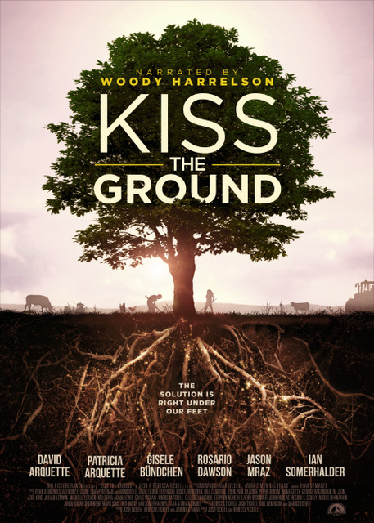
Questions
- How does earth/dirt/soil have the potential to help? (1:50)

- What does Ray Archuleta, the conservation agronomist, say (at 3:40) is the same problem with soil everywhere he goes in the US?

- What did America experience in the 1930s? (4:30)

- What specifically is carbon? (7:35)

- Annotate the image below with atmospheric carbon dioxide, sunlight, carbon fuel, leakage, soil microorganism, mineral nutrients, and carbon sequestration. Add as much information as you can (also add further detail on the gigatonnes of carbon in plants, the atmosphere, and soil at 31:50).

- What does Dr. Kristine Nichols say about a handful of soil? (9:40)

- What’s the problem with soil sprayed with toxic chemicals (insecticides, herbicides)? (12:30)

- When was industrial agriculture invented? (13:00)

- What’s the number one America crop, and what is it sprayed with? (16:30)

- What is desertification? (20:15)

- According to the United Nations, when will the world’s remaining topsoil be gone by? (24:30)

- What is bio-sequestration? (28:45)

- What’s the size of our legacy carbon load? (35:45)

- What is the one type of farming which draws on the most carbon? (37:20)

- What are the benefits of no-till agriculture in Gabe Brown’s ranch in North Dakota?

- What’s the problem with the Commodity Credit Corporation in America? (56:30)

- What did San Francisco governor Gavin Newsom do? (1:02:00)

- What’s being done in Detroit by Pashon Murray? (1:03:30)

- What’s Patricia Arquette doing in Haiti? (1:04:00)

- Freeze-frame the screen at 1:06:34. What are the 25 nature-based solutions?

Further reading
- New York Times Regenerating Hope for the Climate film review

- Natural justice Professor Lorna Dawson School Member Lecture

- Kiss the Ground Film trailer

- Royal Society Soil structure and its benefits

- The Conversation Bare winter fields to disappear as part of new plan for healthy greener countryside

- The Conversation To restore our soils, feed the microbes

- The importance of soil The Upside-Down Forest

- The UN World Soil Day

