Mapping population and migration in Bangladesh

Resource to accompany the Migrants on the margins teaching resource ‘Mapping Population and migration in Bangladesh.ppt’
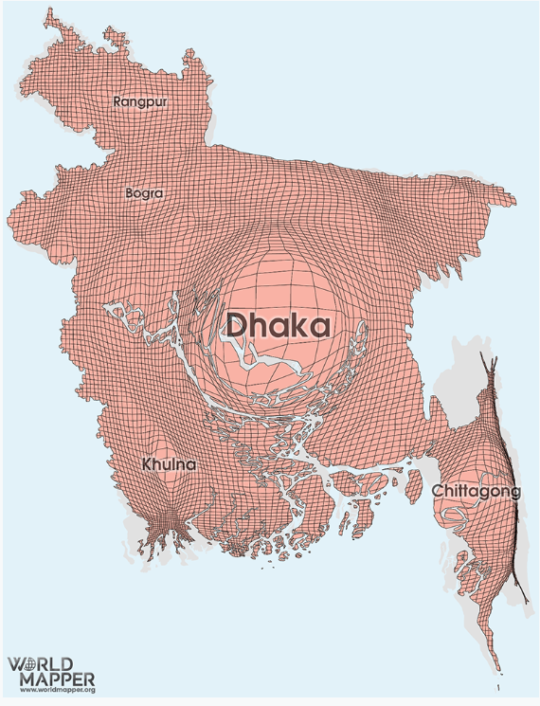

Source: Bangladesh Gridded Population https://worldmapper.org/maps/gridded-population-bgd/

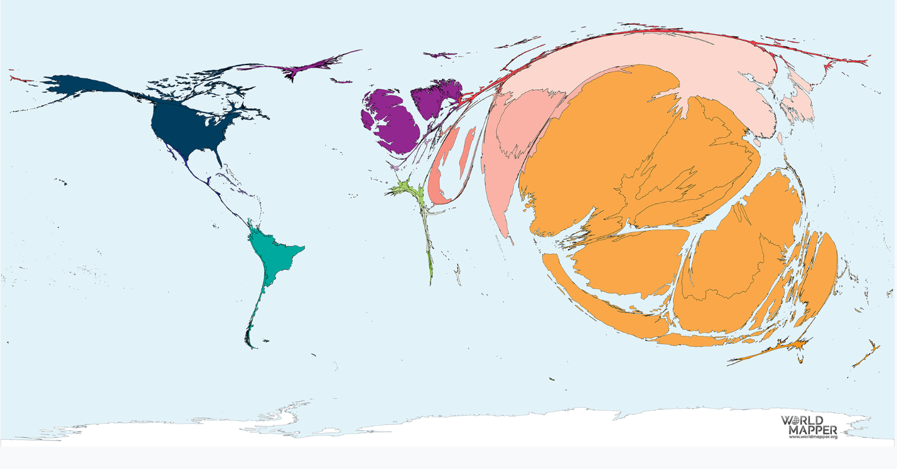

Source: Migration to Bangladesh 1990-2017 https://worldmapper.org/maps/migration-to-bangladesh-1990-2017/
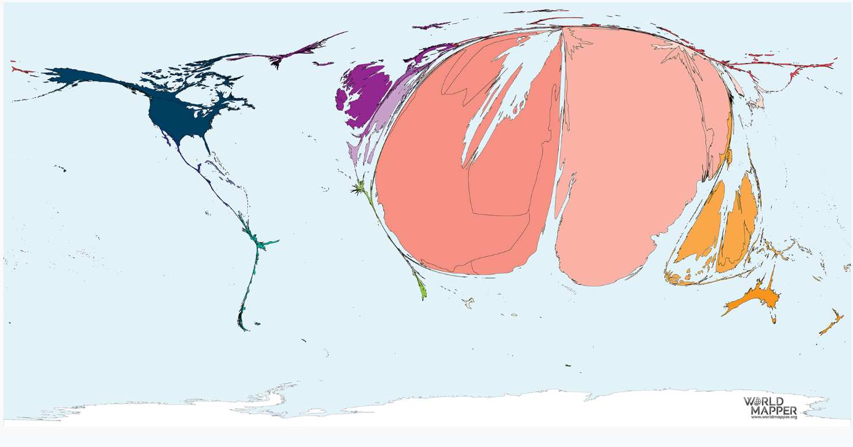

Source: Migration from Bangladesh 1990-2017 https://worldmapper.org/maps/migration-from-bangladesh-1990-2017/

