The Fluvial System: Lessons using data skills

Lesson 2: Changing Flood Frequency

Lesson Objectives

- To describe the changing pattern of peak flow data in the River Severn, UK
- To understand how the length of data records affects the patterns produced through time and therefore the certainty with which we can predict future changes

Setting the Scene

Rivers and streams experience flooding as a natural result of large rain storms or spring snowmelt that quickly drains into streams and rivers. Although the risk of flooding varies, most areas are susceptible to floods, even dry and mountainous regions. The size or magnitude of flood events is influenced by how much water enters the catchment upstream and how quickly. Flood frequency largely depends on the frequency of weather events.
Large flood events can damage homes, roads, bridges, and other infrastructure; wipe out farmers’ crops; and harm or displace people. Although regular flooding helps to maintain the nutrient balance of soils in the flood plain, larger or more frequent floods could disrupt ecosystems by displacing aquatic life, impairing water quality, and increasing soil erosion. Climate change may cause river floods to become larger or more frequent than they used to be in some places, yet become smaller and less frequent in other places. As warmer temperatures cause more water to evaporate from the land and oceans, changes in the size and frequency of heavy precipitation events may in turn affect the size and frequency of river flooding. Changes in streamflow, the timing of snowmelt, and the amount of snowpack that accumulates in the winter can also affect flood patterns.
This lesson explores how peak flow is changing through time in the River Severn at Bewdley, UK and compares it with the River Thames at Kingston. This is framed in the context of describing the patterns of change though time and the need to understand how the length of flow record is critical for interpreting data.

The Data
The data is downloaded from the National Flow Rivers Archive (https://nrfa.ceh.ac.uk/data/search). The NRFA collates daily, monthly and flood peak river flow data from over 1,500 gauging stations across the UK. NRFA data also include catchment rainfall totals, derived from the Met Office and various spatial data sets (e.g. digital elevation data, land cover, geology and hydrogeology), developed by the Centre for Ecology and Hydrology and the British Geological Survey.

The data sets detail the annual peak flow discharge. The first comes from the River Severn at Bewdley between 1924 and 2014. The River Severn has a diverse catchment with a distinct relief and rainfall gradient as shown in figure 1 with land use over the catchment predominantly moorland, forestry and mixed farming. The River Severn data is compared to data collected from the River Thames at Kingston between 1896 and 2014. The River Thames catchment has a diverse topography and land use but is characterised by a wide pattern of water utilisation across the catchment.
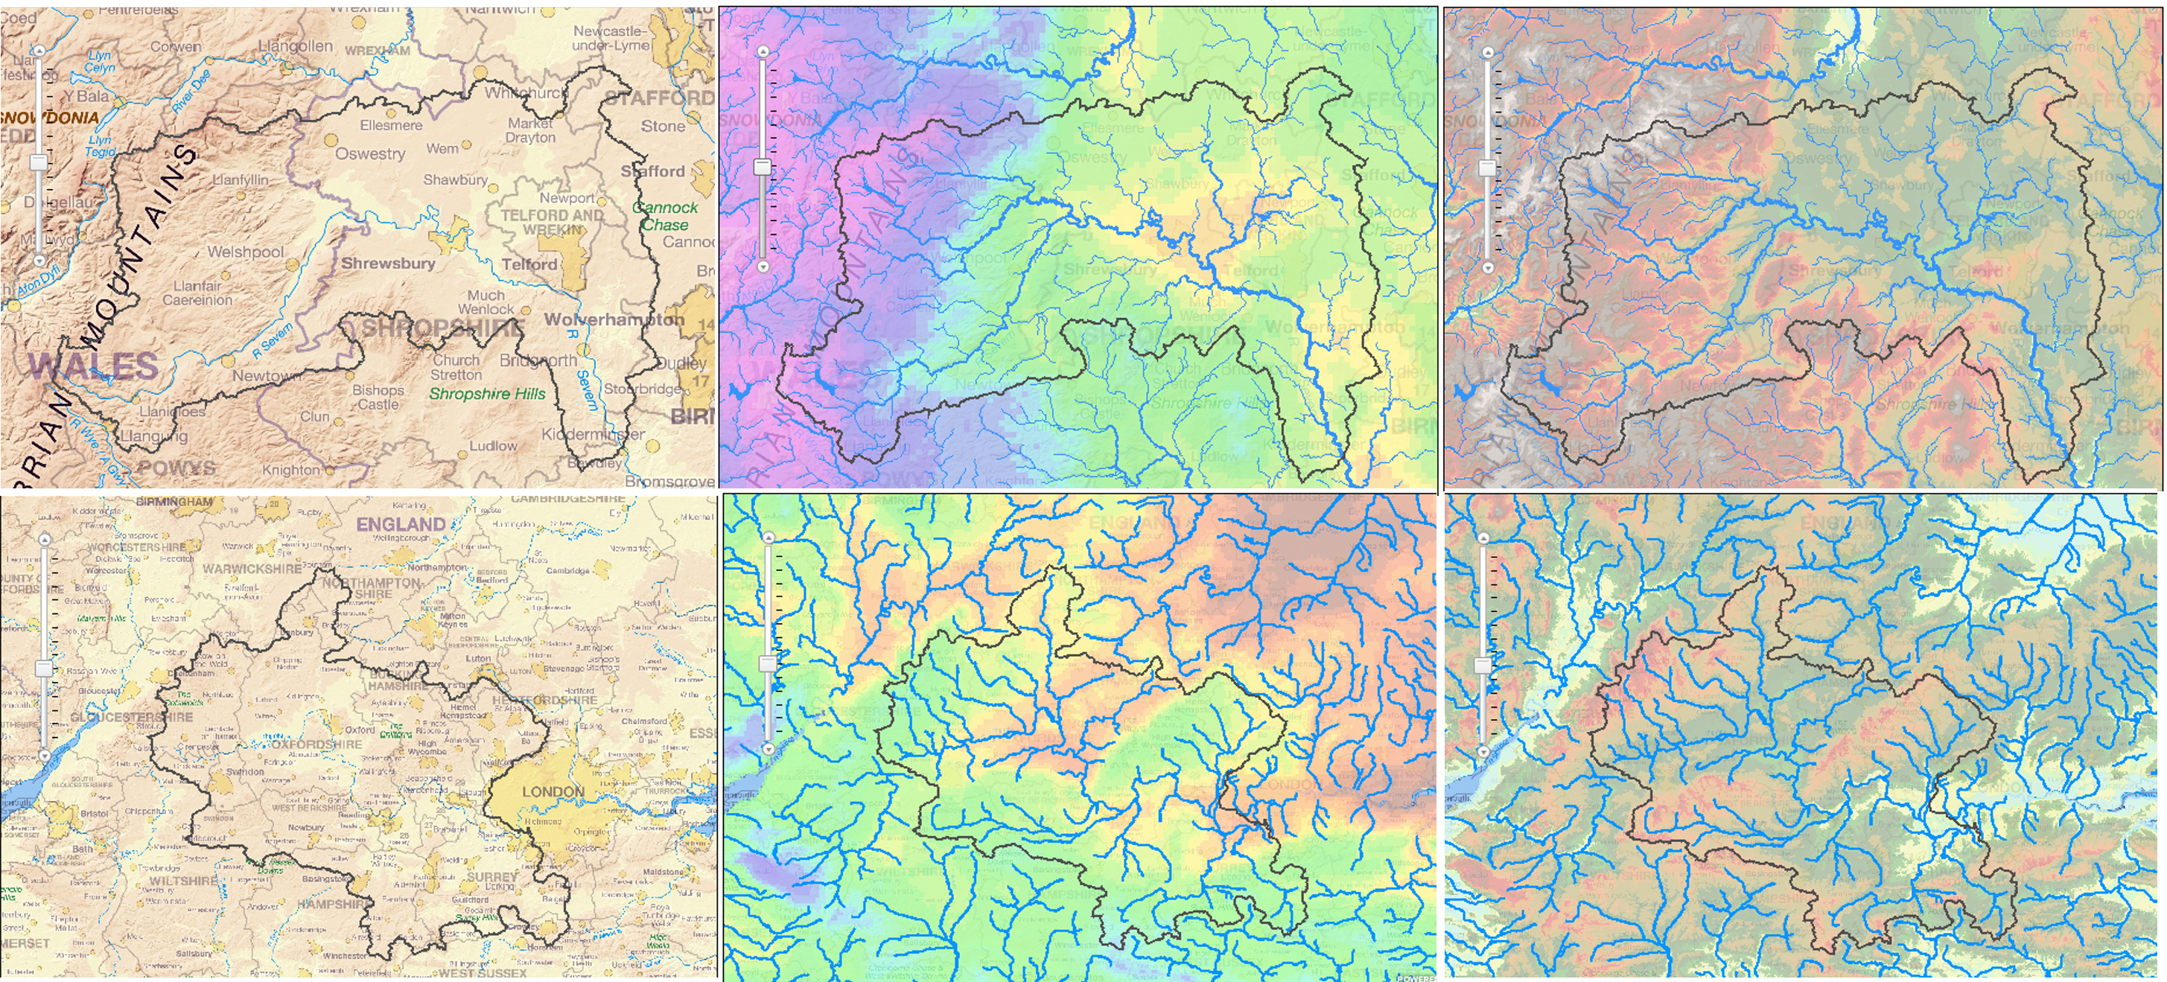
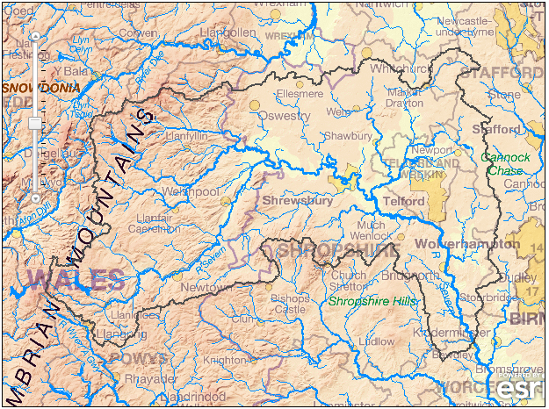
Figure 1: Location, rainfall and relief maps of the River Severn at Bewdley (top images) and River Thames at Kingston (bottom images) taken from the National Flow Rivers Archive webpages for both catchments

1) Interpreting changes to the River Severn peak flow discharges between 1974 and 2014

- Open the Microsoft Excel Flood Frequency data file for the River Severn at Bewdley. There are two columns: 1) Year 2) Max Annual Discharge (meters cubed per second).
- Plot the data for the period of 1974 – 2014. You can either do this by hand where you have year on the x axis and discharge on the y axis or you can plot it in excel by
  - Highlighting the two columns of data, pressing insert x,y scatter. Your graph should look like Figure 2 below.

Figure 2: Maximum annual discharge between 1974 and 2014 for the River Severn at Bewdley

Look at your table and Figure 2 and discuss the findings. You might want to think about:
- Is there a change in maximum annual discharge through time?
- How would you describe this pattern in the maximum annual discharge – look both at the overall trend and the amount of scatter in the data – is this changing?

2) Interpreting changes to the River Severn peak flow discharges between 1924 and 2014

- Open the Microsoft Excel Flood Frequency data file for the River Severn at Bewdley. There are two columns: 1) Year 2) Max Annual Discharge (meters cubed per second).
- Plot the data for the period of 1924 – 2014. You can either do this by hand where you have year on the x axis and discharge on the y axis or you can plot it in excel by
  - Highlighting the two columns of data, pressing insert x,y scatter. Your graph should look like Figure 3 below.

Figure 3: Maximum annual discharge between 1924 and 2014 for the River Severn at Bewdley

Look at the data table and Figures 2 and 3 and discuss the findings. You might want to think about:
- How would you describe the relationship you see in Figure 2?
- Is there still the same relationship in the data when the entire data set is considered?
- How would you describe this pattern in the maximum annual discharge – look both at the overall trend and the amount of scatter in the data – is this changing?

Take it Further

Using the same data as above, calculate the average maximum annual discharge for five, ten and twenty year periods and plot the data as you have done above
- Are there trends in the data? Describe these trends
- What is the impact of the duration over which you average the data?
- What impact might this have on your ability to describe the change in maximum discharge through time?

3) Interpreting and comparing the changes to the River Thames peak flow discharges between 1896 and 2014

- Open the Microsoft Excel Flood Frequency data file for the River Thames at Kingston. There are two columns: 1) Year 2) Max Annual Discharge (meters cubed per second).
- Plot the data for the period of 1924 – 2014. You can either do this by hand where you have year on the x axis and discharge on the y axis or you can plot it in excel by
  - Highlighting the two columns of data, pressing insert x,y scatter. Your graph should look like Figure 4 below.

Figure 4: Maximum annual discharge between 1896 and 2014 for the River Thames at Kingston

Look at the data table and at Figure 4 and discuss the findings. You might want to think about:
- How would you describe this pattern in the maximum annual discharge – look both at the overall trend and the amount of scatter in the data – is this changing through time?
- How would you describe the relationship you see in Figure 4 compared to that which you see in Figures 2 and 3?
- How might the difference in land and water use between the two catchments be used to explain the differences in the trends of maximum annual discharge?

Take it Further

Using the same data as above, calculate the average maximum annual discharge for five, ten and twenty year periods and plot the data as you have done above
- Are there trends in the data? Describe these trends
- What is the impact of the duration over which you average the data?
- What impact might this have on your ability to describe the change in maximum discharge through time?

Plenary

Return to the main lesson question. Discuss:
- How future changes to the climate might affect the catchments you have analysed here
- How important is it to have long records for data? What happens if we don’t have these records?
- How would you describe the pattern in maximum annual discharge to the media to help members of the public to understand the likelihood of flooding on the River Severn? Would this be different for the River Thames?

