The Russian Arctic: the cryosphere is melting activity sheet 1

The aim of this teacher worksheet is to teach students about the importance of the cryosphere, to appreciate the difference in size of carbon stores and to learn about methane bubbles.

A Level Specification
Edexcel
6.8 Increased temperatures affect evaporation rates and the quantity of water vapour in the atmosphere with implications for precipitation patterns, river regimes and water stores (cryosphere and drainage basin stores) e.g., the Arctic.

AQA
3.1.1.3 The carbon cycle. Global distribution, and size of major stores of carbon – lithosphere, hydrosphere, cryosphere biosphere, atmosphere.

OCR
4.a. The ways in which the two cycles (water and carbon) link and are interdependent via oceans, atmosphere, cryosphere, and vegetation.

Eduqas
2.1.10. Consequences of change within and between the water and carbon cycles including cryosphere feedbacks, marine carbon feedbacks, terrestrial carbon feedbacks and methane feedbacks

Activity
The cryosphere is any area of the Earth’s surface where water is in solid form — where it is frozen. This covers ice caps, ice sheets, sea ice, permafrost, Alpine glaciers and floating ice out in the Arctic Ocean. It covers a large area of the Earth’s surface and has a significant effect on the Earth’s climate.

Without external influences, pure water freezes in the atmosphere at -36°C. In nature this is rare. In the natural world, particles (microbes, dust and black carbon) in water droplets allow freezing at higher temperatures due to nucleation. Therefore, a colder atmosphere leads to more snow — as does a dustier one (the threshold for freezing is met and there is more material for the ice crystals to nucleate around). This relationship between water availability and nucleation is one of the reasons for the occurrence of polar deserts. Polar deserts are formed by water being locked up as ice in the cryosphere and also because this ice prevents dust particles, microbial life and pollen from being released.

When water changes state i.e. changing from a solid (ice) to a liquid or gas (water vapour) this is called a phase transition. Water modules that form in a crystalline formation are called ice. If we melt these molecules there is less and less interaction between the water molecules. A water phase diagram illustrates the optimum thermodynamically stable point for temperature and pressure (to create either a solid, liquid or gas). If water changes from one phase to another a certain amount of extra heat is required, called latent energy. Freezing water from a liquid to a solid is called an exothermic reaction. Current melting of Arctic ice is the opposite, an endothermic reaction. This describes heat that is absorbed leading to thermal decomposition — otherwise known as global warming of the cryosphere.

Watch this video on the Cryosphere by Tom and Simon from the Scott Polar Research Institute titled Water and ice | Crash Course Cryosphere #1.

- Having watched Water and ice Crash Course Cryosphere answer the following question: why is nucleation so essential for ice to form?
Carbon
Carbon is everywhere — it is in the oceans, the atmosphere, rocks and soils and of course it is found in all forms of biological life. It is an element from organic sources such as living things and inorganic sources like gases, rocks and fossil fuels.

It is becoming clear that the lithosphere is an incredibly important store of carbon — a store which is increasingly being influenced by human interference. For example, it is estimated that the world’s soils have lost a total of 133 billion tonnes of carbon since humans first started farming land around 12,000 years ago. Within the lithosphere it is specifically one type of rock which holds the most carbon, a staggering 99.9% of carbon is held by sedimentary rocks, such as limestone.

The carbon budget describes the amount of carbon that is held as a store of carbon or transferred between the stores. When the cryosphere melts, whether it is sea ice or terrestrial, carbon is released (which was previously held either in the ocean or the soil). Carbon flows are extremely active — constantly moving back and forth between the land, atmosphere, and ocean, although the majority of the planet’s carbon is found in the Earth’s oceans and crust. Later in this resource we will address the significance of melting sea ice and thawing permafrost in the Arctic on these two major stores of carbon.

- Stores of carbon change in size over time due to carbon flux. Use the data below to draw a proportional circle diagram in Appendix A graph 1, to represent the different carbon stores on planet Earth.

Major global stores of carbon | Carbon (GtC) approx.
Atmosphere | 750
Lithosphere | 100,000,000
Hydrosphere | 38,000
Cryosphere | 1,400
Biosphere | 3,170
Total | 100043320
Table 1 © Cool Geography www.coolgeography.co.uk/advanced/Stores_of_Carbon.php

The significance of melting sea ice
The melting of sea ice in the Arctic will have a huge impact on the planet. The effects will be:

- A reduction in bright sea ice, reducing the overall Arctic albedo (definition below)
- More solar energy will therefore be absorbed at the surface and ocean temperatures will rise
- A cycle of warming and melting
- Possible disruption to normal ocean circulation patterns
- Possible changes to winter weather patterns

- Read the Carbon Brief article Five reasons why the speed of Arctic sea ice loss matters and make notes on each point.

Sea ice occupies roughly 7% of the world’s oceans and is also rapidly declining in the Arctic. It is of particular importance because of its high albedo rate, which plays an incredibly important role in regulating the Earth’s temperature. The albedo value is the amount of incoming solar radiation that is reflected back into space. The more reflective a surface the higher the albedo value — the white surfaces of fresh snow and ice are very reflective in contrast to the dark open ocean which absorbs far more heat. With more and more sea ice melting there is consequently more solar radiation being absorbed — a self-reinforcing feedback loop (see definition below) As a consequence, the Arctic is warming 2-3 times faster than the rest of the world, a phenomenon called ‘Arctic Amplification’.

Watch this video on the Cryosphere by Tom and Simon from the Scott Polar Research Institute titled Sea ice | Crash Course Cryosphere #4.

- Having watched Sea ice Crash Course Cryosphere answer the following question: Why it is so important that the density of ice is greater than the density of water on planet Earth?

A feedback loop is a natural cycle which is either positive or negative. A positive feedback loop amplifies an occurrence whilst a negative feedback loop nullifies it. Melting sea ice is an example of positive feedback. Below are 8 comments and a blank figure-of-eight diagram to illustrate the impact of climate change on sea ice and thawing permafrost.

- Place these text boxes onto diagram 2 in Appendix B, the figure-of-eight positive feedback loop. You will find further information on our recent poster Climate Change and the Russian Arctic.

Sea ice is melting in the Arctic

Release of CO² and CH₄

Dark surfaces are exposed

Arctic Ocean warming

Permafrost is thawing in the Arctic

Leading to further warming
Warming of the ground
Increasing microbial activity

The significance of thawing tundra
Permafrost is defined as ground below zero degrees for at least two consecutive years. Located below the Earth’s surface, it is often consisting of sand, gravel, and soil which might be bound together by ice. The thawing of Arctic permafrost will have a range of impacts on the planet:

- The release of previously locked away carbon as microbial activity accelerates
- Introduction of invasive species and the subsequent increase in pathogens
- The collapse of Arctic ground (especially when ground ice content is high) and increase in landslides
- The release of methane bubbles, from ice-covered frozen lakes and the ocean floor

Carbon is stored as carbon dioxide but also as methane in the atmosphere. Whilst the atmosphere only holds 0.001% of the Earth’s carbon this store has seen a considerable growth since the Industrial Revolution. Smaller quantities are also found as methane in the atmosphere.

When methane is in solid form, with molecules frozen into ice crystals, it is called methane hydrate — methane hydrates account for roughly 5% of the global methane emissions from natural sources. There is a general lack of knowledge on how much methane is trapped in this way. As a result, there is widespread concern that if these hydrates can melt, they could potentially release enormous quantities of methane from the cryosphere.

The Figures in Appendix C show the enormity of climate change in the Russian Arctic. Arctic tundra is normally frozen with methane entombed in the frozen ground of the permafrost. However, permafrost is increasingly thawing.

- Go to Appendix C. Print off the following four Figures and annotate any physical or human feature you can see.

Permafrost does not always form in a continuous, single sheet, it can also be classified as sporadic, discontinuous, or isolated. Continuous permafrost describes a single continuous range of frozen material covering 90-100% of the land whilst discontinuous refers to broken up and separated areas covering 40-90% of land. An example of continuous permafrost can be found in the Siberian region of Russia as it has year-round solid, frozen ground. Discontinuous permafrost is found further south in Asia on the Tibetan plateau where permafrost largely thaws from the summer sun — bar isolated patches which remain frozen, possibly in the shadow of a mountain or under heavy vegetation.

The Arctic stores one of the largest natural reservoirs of organic carbon in the world, locked in its frozen soils. As Arctic tundra thaws greenhouse gases such as carbon dioxide and methane will increasingly be released. This occurs from microbes (microorganisms) becoming active in the bogs, consuming organic carbon inside the soil and converting it into greenhouse gases. These microorganisms go from being frozen in the soil to marshy methane producers (see Figure 4, Appendix C for a photograph of methane escaping from the thawing permafrost of the Arctic tundra).

- Research the four topics of: arctic tundra, thawing permafrost, ice wedge polygons and methane bubbles. Make notes around the printed Figures from question 6.

- Watch the following video from Dr Iain Stewart. What happens when Dr Katey Walter drills a hole in a lake with bubbles of methane? https://www.youtube.com/watch?v=NVpQnpWS2wU

Extension task
The boundary of the Arctic is interpreted as: the area where the average temperature of the warmest month (July) is less than 10°C or by the delineation of the Arctic Circle or — a third way is to mark the boundary by the arctic treeline, which is the case in this map by Toolik-Arctic Geobotanical Atlas.
- Go to Appendix D. This map also splits the Arctic tundra up into Arctic ‘climatic subzones’. Using the above TAGA map link, colour code the 5 Arctic climatic subzones. Make notes on each of the subzones within the Arctic tundra.

Further reading
- Carbon simulation from the University of Holloway

- NOAA What is methane?

- Science Daily How drowsy microbes in Arctic tundra change to methane-makers as permafrost thaws

- The IPCC’s special report on the ocean and cryosphere

- Carbon Brief Food and Farming

- National Geographic Arctic permafrost is thawing fast. That affects us all

- The Guardian What are climate change feedback loops?

- Phys.org Siberia heatwave: why the Arctic is warming so much faster than the rest of the world

- CNBC Russia is dominating the Arctic — but it’s not looking to fight over it

- Berkeley Beware of false balance: Are the views of the scientific community accurately portrayed?

- How do ice-wedge polygons, a very typical geomorphological feature of permafrost regions, form? YouTube Patterned Ground: How Permafrost Ice Wedges Cause Tundra Polygons and Mounds

- Geography Directions (the Society’s blog linked to scholarly journals) The ice-edge is a high risk environment for Arctic Industries

Appendix A

100 million

50 million
100,000

10 million
1 million
< 50,000
Graph 1

y

x
Appendix B

Climate
is
warming

Appendix C

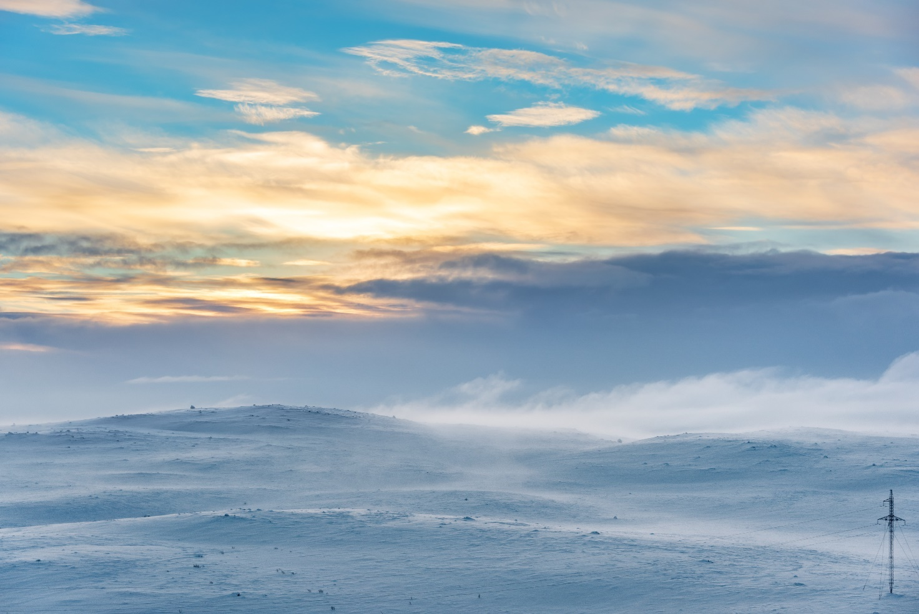
Figure 1 Arctic tundra © Niccolo Bertoldi Pond5

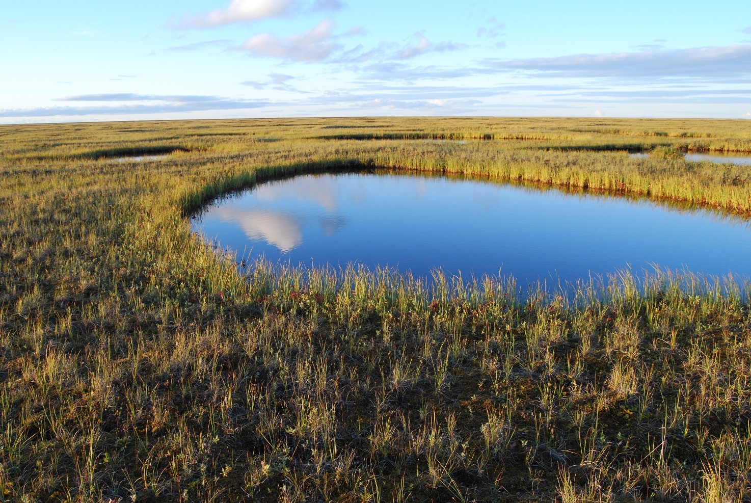
Figure 2 thawing permafrost leads to the formation of lakes © Thomas Opel

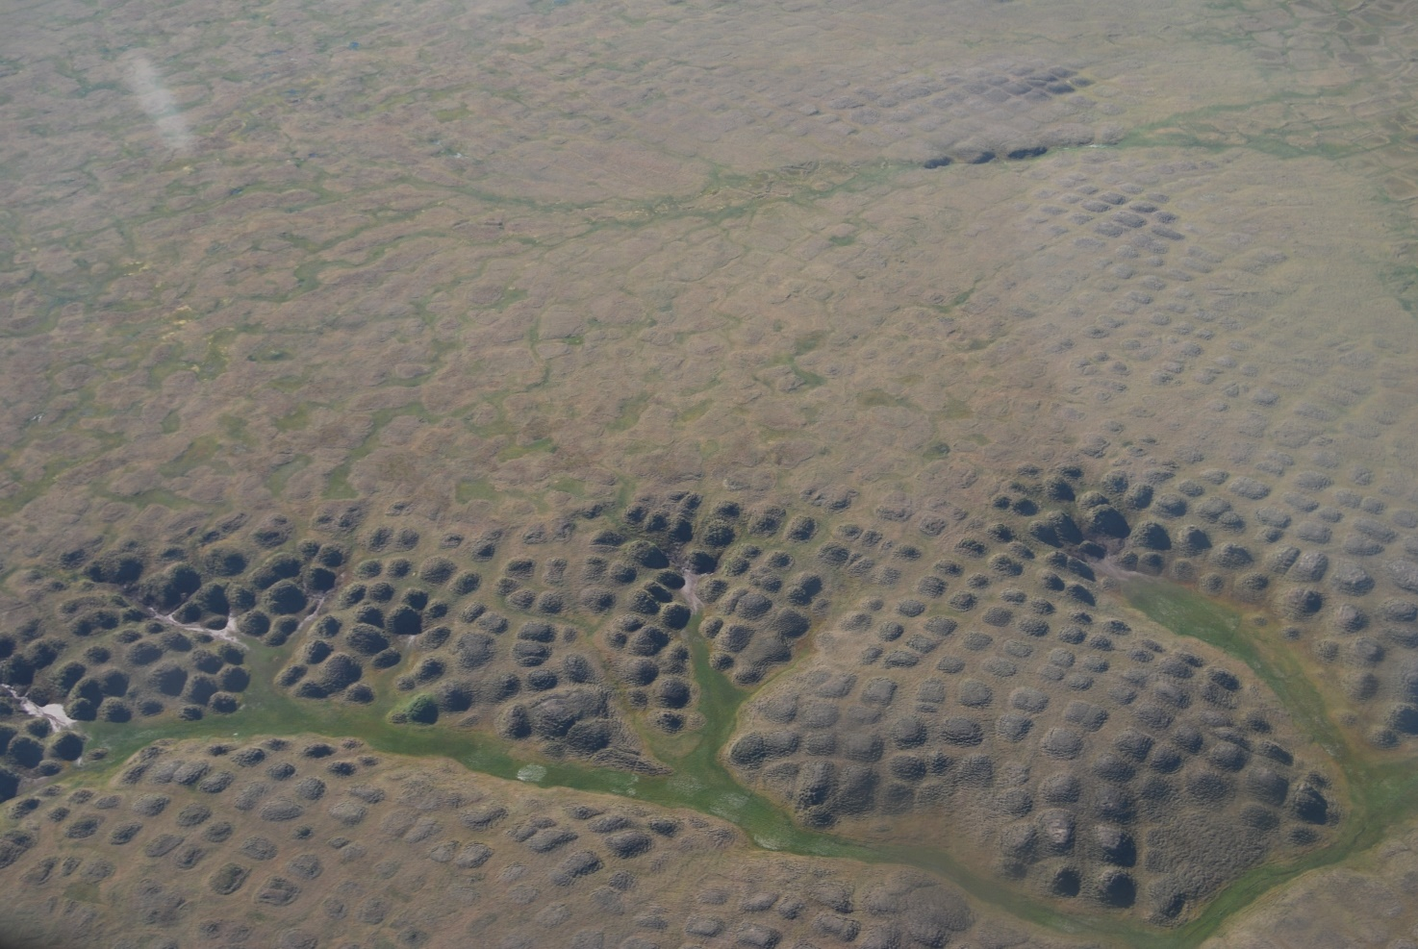
Figure 3 ice wedge polygons © Thomas Opel

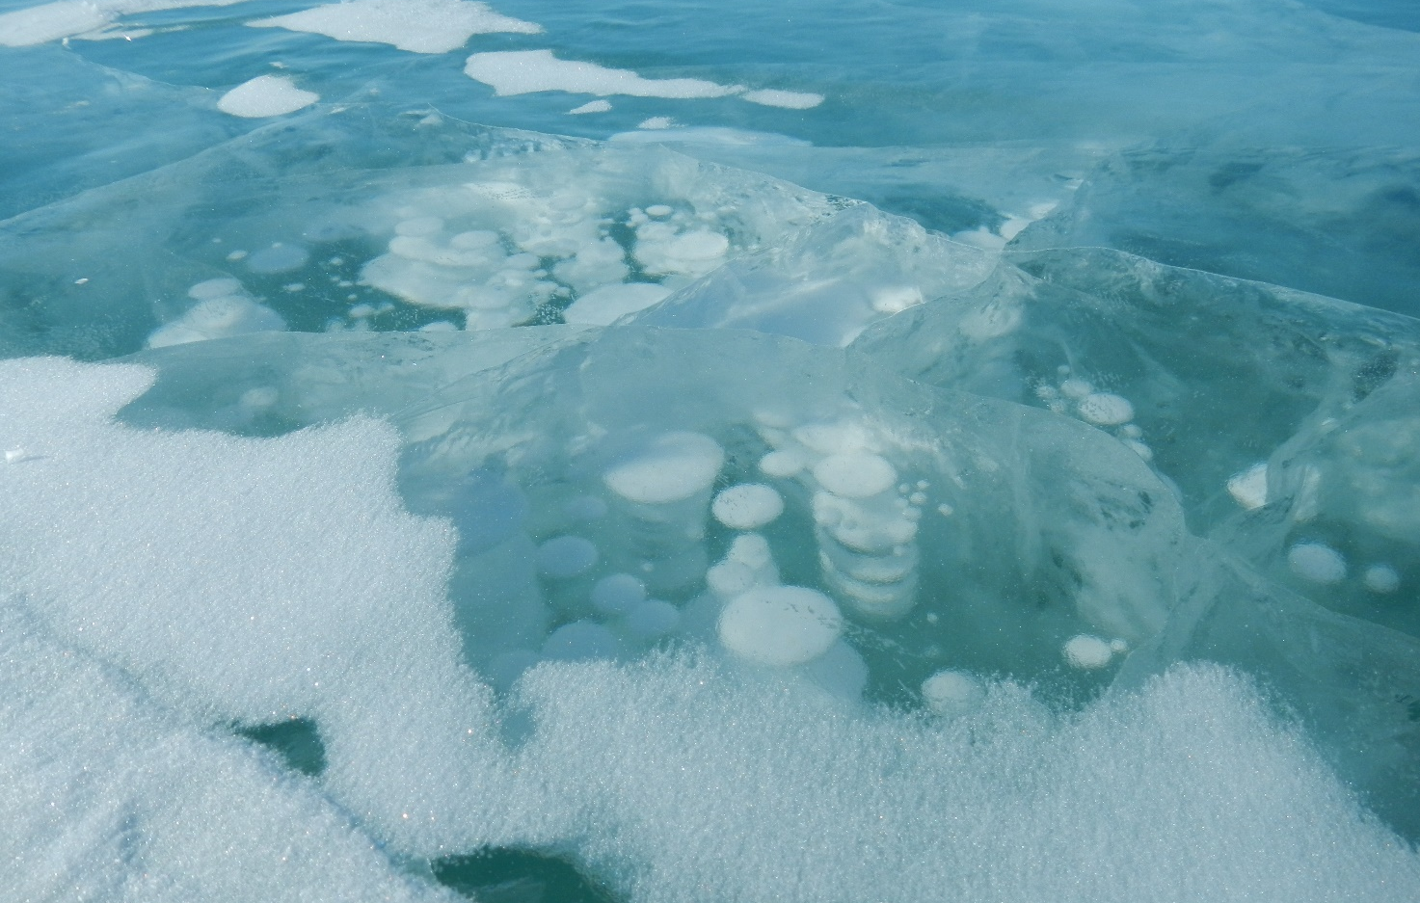
Figure 4 previously trapped methane now bubbles to the surface © Thomas Opel
Appendix D

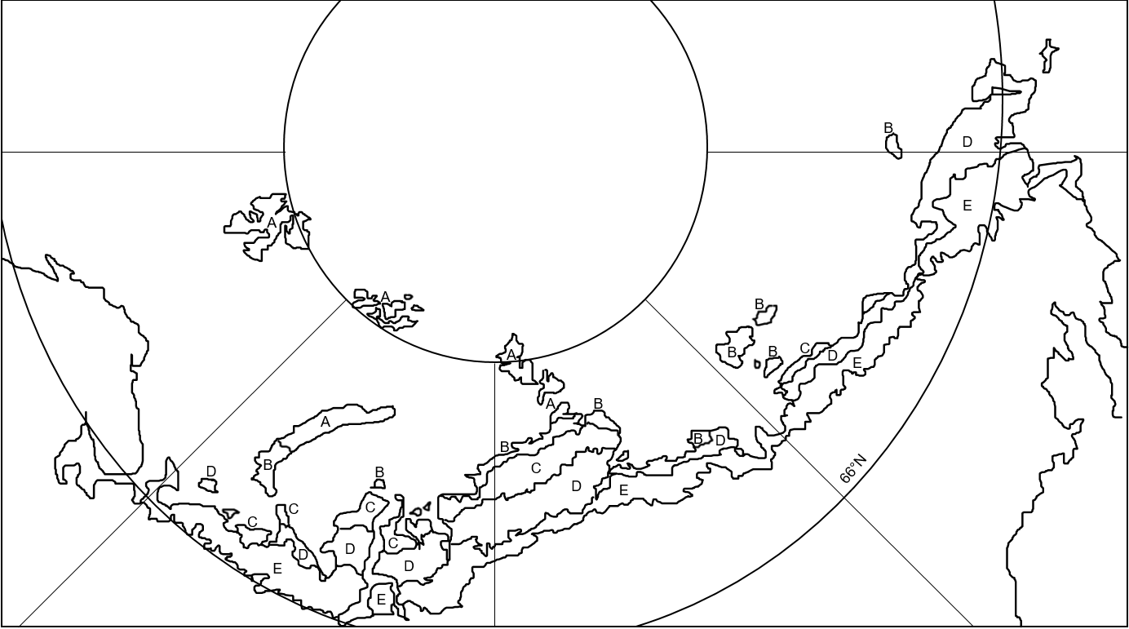
Figure 5

Thank you to Dr Caroline Coch, Polar specialist at WWF-UK, for helping with the production of this resource

