Analysis of the progression of A-Level geography entrants to higher education

Report for the Royal Geographical Society (with IBG)

Original report by

Natasha Plaister

Dave Thomson

October 2019

Contents

1. Introduction 2
Acknowledgments 2
Navigation 2
2. Summary 2
2.1 A note on A-Level numbers 4
2.2 Data suppression 4
3. Progression to geography at degree level 5
3.1 Gender 5
3.2 Ethnicity 5
3.3 Region 5
3.4 School type 6
3.5 Other A-Level subject choice 6
4. Progression to other subjects at degree level 6
4.1 Overview 6
4.1 Popular alternative subjects 7

Introduction

This report analyses the characteristics of undergraduate geography students, and the progression of A-Level geography students to higher education. In this particular report, we look at the progression of A-Level geography students to higher education, during the period 2004/05-2016/17.

There are two main sections: an examination of how likely different groups of students were to progress to study geography at university; and an analysis of the subjects studied by those A-Level geography students who did progress to university, but chose not to study geography.

A separate document is available which describes the methodology followed and definitions used.

Acknowledgments
This publication includes analysis of the Department for Education National Pupil Database, linked to the HESA student record. Inferences or conclusions derived from the NPD or the HESA student record in this publication are the responsibility of FFT Education Datalab and not the Department for Education or HESA.

This work was produced using statistical data from ONS. The use of the ONS statistical data in this work does not imply the endorsement of the ONS in relation to the interpretation or analysis of the statistical data.

Navigation
Titles used in sections 3 of this report, and the title of section 4, correspond to worksheets in the Excel document provided showing all of the results of this project. This workbook also includes charts showing trends in progression. Sections 3 and 4 of this report are best read as an accompaniment to these charts.

2. Summary
Over the period from 2005 to 2015, the number of A-Level geography students progressing to study geography at university has increased from 5,743 to 6,547. This trend generally echoes trends in the number of students studying geography at A-Level; the proportion of students progressing has remained fairly consistent, at around 19-20%.

In the graph overleaf, to take account of a significant number of students who progress to university two or more years after completing A-Levels, we show those students who went on to take a geography degree within a year of completing their A-Levels. The spike in 2011 is probably the result of reforms to higher education spending in 2012.

We also looked at rates of progression broken down by type of geography degree: those categorised by the Joint Academic Coding System (JACS) as either: physical geographical sciences (JACS code: F8) and human and social geography (JACS code: L7).Throughout this report, we will refer to these degree types using their JACS codes. Between 2005 and 2013, more students progressed to F8 degrees than L7, but since 2013 this has reversed.

2.1 A note on A-Level numbers
The number of A-Level students shown in this report is slightly different to that shown in our companion report on entries and attainment at A-Level geography. This is because our earlier report included only those students who took A-Levels at the end of Key Stage 5. This is the standard method for measuring trends in entry numbers, and allows us to link the trends in entry numbers to trends in the overall student population for each year.

In this report, as we are not interested in linking A-Level numbers to the overall Key Stage 5 population, we were able to use a slightly broader method, which is more appropriate when looking at progression to degree; we included all students who took an A-Level in geography in any given year. This means that the entry numbers used in this report are slightly higher than those in the earlier report, as they also include resits and early entries.

2.2 Data suppression
There are some restrictions placed on the publication of data and statistics from the National Pupil Database. In particular, data based on ten or fewer individuals is ‘suppressed’: the exact number, and any statistics based on that number, cannot be published. This is to avoid possible disclosure of information on individuals.

In this report and the accompanying Excel document, any numbers of ten or fewer have been replaced with a range. In most cases, this was not sufficient, as the number could still have been calculated from data provided. To avoid this issue, we have also replaced one or more other values in the data with a range. This is clearly noted in the Excel document whenever it has occurred. Suppression has been applied to data in the ethnicity section and in the section on other subjects at degree level.

Progression to geography at degree level

3.1 Gender
A higher proportion of female students than male students went on to study geography at degree level. This was true of every year considered in this report. Of those students who took geography A-Level in 2015, for example, 21% of female students had begun a geography degree by 2018, compared to 17% of male students. Between 2005 and 2007 the progression rate for male students fell and the gender gap in progression rate increased. Since then, the gender gap has remained fairly consistent.

This picture looks rather different if we consider F8 students and L7 students separately. Female students of A-Level geography were consistently more likely to progress to an L7 degree, with a gender gap of between 2-4 percentage points in every year we looked at. However, for F8 degrees, the gender gap is generally much smaller and inconsistent in direction; in some years, more male students progressed to this type of degree, and in other years, more female students. However, in every year since 2013, a higher proportion of female students have progressed than male.

3.2 Ethnicity
White and mixed students had consistently higher rates of progression than black and Asian students. Of those who took A-Levels in 2015, 19% of white and 17% of mixed students progressed to geography at university by 2018, compared to 14% of black and 15% of Asian students.

Progression rates for students in the ‘other’ ethnic group varied considerably from year to year - this is because of the relatively low numbers of students in this group who took A-Level geography, only 261 in 2017, for example. With smaller numbers, a difference of only a few students progressing can make a relatively big difference to the proportion.

When broken down by degree type, differences by ethnic group are less clear when looking at progression to L7 degrees, but we see consistently higher progression for white and mixed students to F8 degrees.

3.3 Region
There was some variation in progression to geography degree by region. In every year that we considered, a higher proportion progressed from London than any other region. In 2015, for example, 22% of A-Level geography students from London had progressed to a geography degree by 2018, compared to 19% of students overall. The North West also tended to have a higher progression rate than other regions. Of the remaining regions, none had consistently higher or lower progression rates than others.

However, when broken down by degree type a different pattern emerged. While London students were more likely to progress to an L7 degree, they were not more likely to progress to an F8 degree than those from other regions. Similarly, students from the North West tended to be more likely to progress to an F8 degree, but not to an L7 degree.

3.4 School type
Generally, students from independent schools were the most likely to progress to a geography degree, with 21% of those who took A-Levels in 2015 having progressed by 2018. Those from selective state schools were next most likely, most years closely followed by those from non-selective state schools and sixth form colleges. Those from FE colleges were least likely; only 17% of those who took A-Level in 2015 progressed.

The same pattern was clear when looking at progression to L7 degrees. However, for F8 degrees there were less differences by school type and, if anything, students from independent schools were slightly less likely to progress to this type of degree.

3.5 Other A-Level subject choice
Students who took an A-Level in business alongside geography were the least likely to progress; 13% of those who took geography A-Level in 2015 had progressed to a geography degree by 2018, compared to 19% overall. Those who took physical education were also rather less likely to progress (14%), as were those who took chemistry and physics (both 16%). Students who studied economics, history or English more likely than others, at 22%, 23% and 23% respectively for those who took A-Levels in 2015.

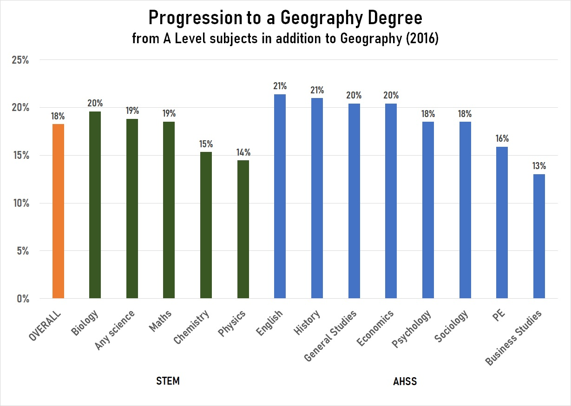

Graphic generated by Martin Davis, RGS-IBG.

As might be expected, there are some differences when we look at the different degree types. Students with an A-Level in physics, biology or chemistry were particularly likely to progress to studying an F8 degree, at 12%, 13% and 11% of 2015 geography A-Level students, compared to an overall rate of 9%. Those who took business or economics at A-Level were less likely to progress (6% and 7%).

Looking at L7 degrees, students who studied economics at A-Level were most likely to progress (15% of 2015 A-Level students), followed by those who studied history or English ((14% and 13%). This compares to an overall rate of 10%. Least likely to progress were those who took science A-Levels, particularly physics and chemistry (4% and 5%). Students who took PE and business were also less likely to progress (both 7%).

Progression to other subjects at degree level

Around 19-20% of A-Level geography students went on to take a geography degree in the period covered by this report, with around two thirds of A-Level geography students going on to study subjects other than geography at degree level. This was less consistent year-on-year than the proportion of students who went on to study geography. It was at its highest in 2009, but then fell every year until 2014, following reforms to higher education funding in 2010.

Geography A-Level students went on to study a broad range of subjects at university. The chart below gives an overview of the destinations of A-Level geography students from 2004-2017. The degree subjects used here are those defined by JACS. Biological sciences were the most popular, with 10% of students who took A-Level geography in 2015 progressing to a degree in that area by 2018. Social studies (other than human and social geography) were also very popular, with 9% of 2015 geography A-Level students progressing to study in this area by 2018, as were business and administrative studies, also with 9% progressing.

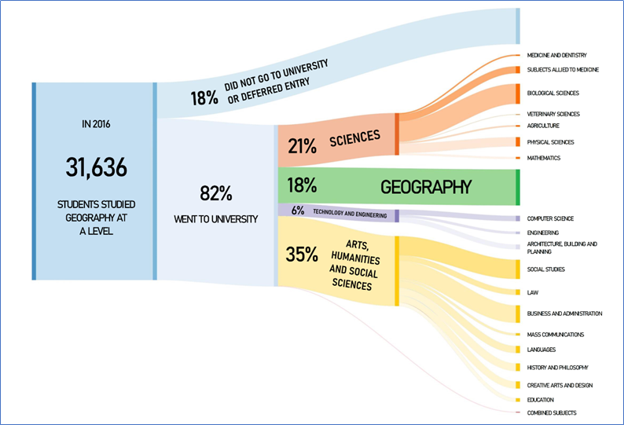

Graphic generated by Martin Davis, RGS-IBG.

Throughout this report, years refer to the year in which the academic year finished – that is, 2010 refers to 2009/10, for example. In the accompanying Excel document, the year shown is the year in which students took their geography A-Level.
The number of students who progressed to a geography degree in a particular year is defined as the number of students who began a degree in the relevant year.
Region here refers to the Government Office Region in which a student’s school or college was located. See the methodology document for more details.

