**Ocean Acidification**

**Lesson 3: Practical task**

**Key question:** How can the process of ocean acidification be replicated in the laboratory, enabling us to consider its potential impacts on global ecosystems?

**Aim:** To carry out two experiments to investigate ocean acidification:

1. An experiment to determine the effect of increase CO₂ on the pH of saltwater.
2. An experiment to determine the effect of increased saltwater acidity on the calcium carbonate shells and skeletons of marine organisms.

**Starter**

Watch the video clip “Back in the lab” which explains how water samples collected in the Arctic are analysed back home in the laboratory.

While you’re watching, draw a flow diagram to summarise the process of data analysis. The template below shows you what to include:

What are the researchers looking for?

What questions need to be answered?

What measurements are taken?

**Main**

Design your own experiment!

You will be provided with access to a set of equipment and materials from the list below. Your task, in groups, is to design an experiment which tests one of two hypotheses:

1. An increase in CO₂ will cause an increase in the acidity levels of saltwater (a decrease in pH).
2. An increase in saltwater acidity (a decrease in pH) will alter the structure of calcium carbonate shells.

List of available equipment / materials:

* Sea water or water and salt (so you can make your own)
* Litmus paper or pH meter
* Sea shells or eggs
* Sea shells that have been soaked in vinegar solution for 48 hours
* Beakers
* Straws
* White vinegar
* Stopwatch
* Measuring jug
* Tablespoon
* Heavy books

*Tip:* if you are mixing your own seawater, the concentration of salt is approximately 3.5% (or 35,000 parts per million), which equates to 35 grams per litre. 1 level tablespoon is approximately 18 grams.

In designing your experiment you should include the following:

1. A list of the equipment required
2. The method (instructions for carrying out the experiment) in bullet point format
3. A labelled diagram so that someone could replicate your experiment
4. A table in which you could record your results

Once you’ve designed your experiment, put it into practice!

If you have access to video recording equipment, film your group carrying out your experiment whilst giving a commentary on what they are doing and why. Record your findings in the table you created.

Following your experiment, describe what you found and explain your results.

Include answers to the following questions in your explanation:

1. Did you prove or disprove the hypothesis?
2. Using your knowledge of ocean acidification, can you explain your findings?
3. What have you learnt about the process of ocean acidification from your experiment?
4. What are the limitations to your experiment?
5. How could your experiment be improved?

If you don’t have any video recording equipment, why not record some audio instead, or you can write down your analysis.

**Note for teachers - alternative activity:**

As an alternative to students designing and carrying out their own experiments, the following two documents give step-by-step instructions for two experiments to investigate the same hypotheses. The same equipment will be required, and questions are provided for students to complete. Again, video recording equipment could be used to film students conducting the experiments and explaining their results.

Experiment 1: Investigating the effect of carbon dioxide on the acidity of water

Experiment 2: Investigating the effect of acidity on the shells of sea creatures

**Plenary**

Who is affected by ocean acidification?

Choose one of the three photographs below*.* They are all images of microorganisms that inhabit the Arctic Ocean. Carry out some Internet research to find out about your microorganism, and annotate your photo with the information you’ve found, including most importantly, any physiological features that means it might be particularly vulnerable to the effects of ocean acidification.

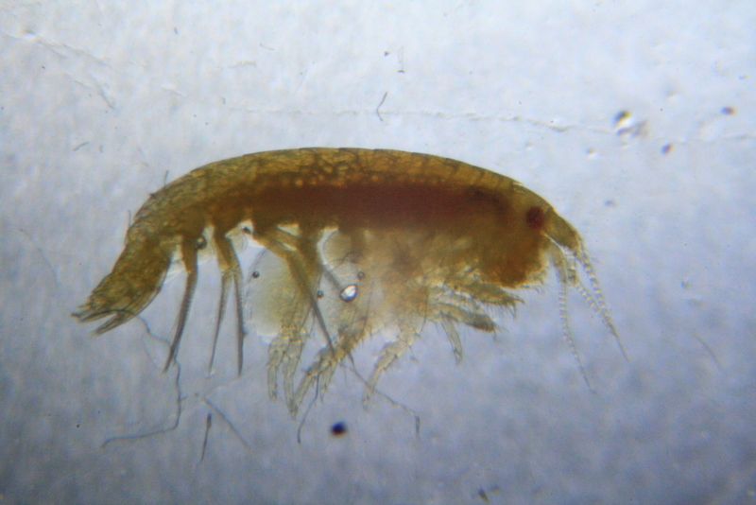

**Amphipod**

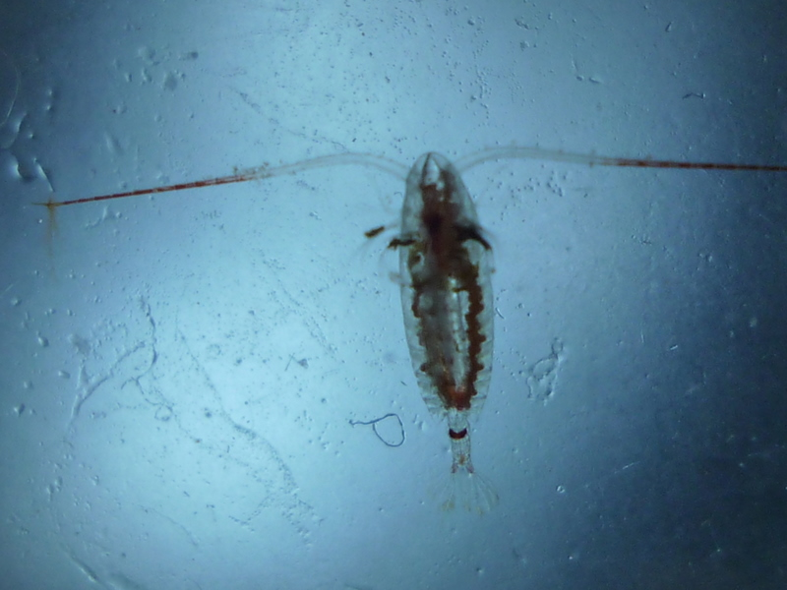

**Copepod**

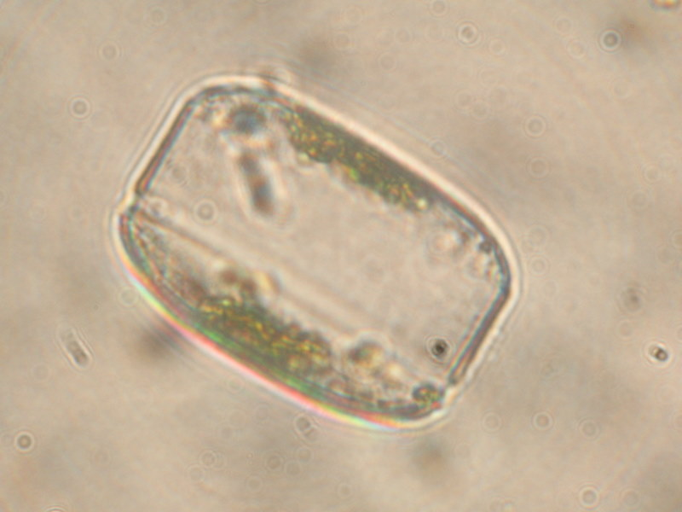

**Diatom**

A video clip is also provided. This is quite interesting as it shows two microorganisms, a copepod and a fish larva, moving through the water of the ice sampling hole.

Now find out where your microorganism lies in the Arctic Ocean food web and draw a diagram to show this.

* What are the wider implications of ocean acidification for the food web of this region?



C:\Users\Eleanor.Coulber\AppData\Local\Microsoft\Windows\Temporary Internet Files\Content.IE5\AD7DUBAJ\MC900250762[1].wmf

**Experiment 1:**

**Investigating the effect of carbon dioxide on the acidity of water**

Your task is to investigate how carbon dioxide (CO₂) can affect the acidity of seawater. This will give you an idea of whether increasing CO₂ emissions are likely to result in ocean acidification.

**Equipment list:**

* Salt
* Water
* 2 cups
* 1 lid
* 2 straws
* pH meter
* Measuring jug
* Tablespoon
* Stopwatch
* Where might we get a reliable and free source of CO₂…?

**Instructions**

1. The concentration of salt in seawater is approximately 3.5% (or 35,000 ppm), which equates to 35 grams per litre. Mix two cups of seawater using these proportions.

(Tip: 1 level tablespoon of salt is approximately 18 grams)

1. Use the pH meter to record the pH of the water in the first cup. Write this value into the first column of Table One on the back of this sheet.
2. Choose one person from your group who will have the task of adding CO₂ to the water. Their job is to blow gently through a straw into the water for two minutes. You will measure the pH of the water every 30 seconds during this process and record your findings in Table One. Don’t worry, they are allowed to breathe! They should take small breaths when they need to.

(WARNING: Remind them to blow, not suck! The water will taste revolting!)

1. Repeat the experiment but this time cover the cup with a lid and insert the straw into the opening. Record your findings in Table Two.
2. Answer the questions on the back of this sheet and be prepared to share your findings with the rest of the group.

**Results**

Table One: results (no lid)

|  |  |  |  |  |  |
| --- | --- | --- | --- | --- | --- |
| **Time (seconds)** | **0** | **30** | **60** | **90** | **120** |
| **pH** |  |  |  |  |  |

Table Two: results (with lid)

|  |  |  |  |  |  |
| --- | --- | --- | --- | --- | --- |
| **Time (seconds)** | **0** | **30** | **60** | **90** | **120** |
| **pH** |  |  |  |  |  |

**Questions**

1. Your breath contains CO₂ gas in it. After blowing through the straw into the samples, describe what happened to the pH of the water.

_______________________________________________________________________________________________________________________________________________________________________________________________________________________________________

1. Using your knowledge of ocean acidification, can you explain what happened here?

____________________________________________________________________________________________________________________________________________________________________________________________________________________________________________________________________________________________________________________

1. Was there any difference in the pH change of the two samples of water, one without a lid and one with? Why do you think this was?

____________________________________________________________________________________________________________________________________________________________________________________________________________________________________________________________________________________________________________________

1. What have you learnt about the process of ocean acidification from this experiment?

_______________________________________________________________________________________________________________________________________________________________________________________________________________________________________________________________­­­­­­­­­­­­­­­­­­­­­­­­­­­­­­­­­­­­­­­­­­_____________________________________________________

1. What do you think are the limitations of this experiment?

____________________________________________________________________________________________________________________________________________________________________________________________________________________________________________________________________________________________________________________

1. How could this experiment be improved?

____________________________________________________________________________________________________________________________________________________________________________________________________________________________________________________________________________________________________________________





C:\Users\Eleanor.Coulber\AppData\Local\Microsoft\Windows\Temporary Internet Files\Content.IE5\AD7DUBAJ\MC900250762[1].wmf**Investigating the effect of acidity on the shells of sea creatures**

**Experiment 2:**

Your task is to investigate how increased acidity in seawater can affect the calcium carbonate shells of sea creatures. This will give you an idea of the possible implications of ocean acidification for marine organisms and ecosystems.

**Equipment list:**

* Salt
* Water
* Vinegar
* 2 cups
* Measuring jug
* Tablespoon
* 1 soaked shell
* 3 unsoaked shells
* Stopwatch
* Heavy books

There are two parts to this experiment. The first looks at what happens to a calcium carbonate shell when it is placed in an acidic liquid. The second compares the strength of two shells, one of which has been soaked in vinegar (a strong acid) for two days.

**Instructions – part one**

1. The concentration of salt in seawater is approximately 3.5%, which equates to 35 grams per litre. Mix one cup of seawater using these proportions.

(Tip: 1 level tablespoon of salt is approximately 18 grams)

Now add the same quantity of vinegar to your cup so that you have a ratio of 1:1 water and vinegar.

In the other cup, pour a measure of vinegar on its own.

1. Place one unsoaked shell in each cup and start the stopwatch. Observe what happens and record it in Table One on the back of this sheet.

**Instructions – part two**

1. Take two shells, one that has been soaked in vinegar solution for two days and one that has not. Compare the difference between the two shells visually and write your observations in Table Two on the back of this sheet.
2. Lay the shells between two sheets of paper and pile books on the top of each shell. Record what happens in Table Two.
3. Answer the questions on this part of the experiment and be prepared to share your findings with the rest of the group.

**Results**

Table One: results (part one)

|  |  |
| --- | --- |
| Shell one: vinegar solution | |
| Time | Observation |
|  |  |
|  |  |
|  |  |
|  |  |
| Shell two: pure vinegar | |
| Time | Observation |
|  |  |
|  |  |
|  |  |
|  |  |

Table Two: results (part two)

|  |  |  |  |
| --- | --- | --- | --- |
| Shell three (soaked) | | Shell four (unsoaked) | |
| Visual observations of the difference between the two shells | | | |
|  | |  | |
| Observations about the strength of the two shells | | | |
| Time taken to break | Number of books | Time taken to break | Number of books |
|  |  |  |  |

**Questions**

1. What happened when you placed the shells in vinegar / vinegar solution? Why do you think you were asked to do both?

____________________________________________________________________________________________________________________________________________________________________________________________________________________________________________________________________________________________________________________

1. You may have seen some bubbles generated around the shells. What do you think these bubbles were composed of?

_____________________________________________________________________________

1. What had happened to the shell that had been soaked in vinegar for two days?

_______________________________________________________________________________________________________________________________________________________________________________________________________________________________________

1. What have you learnt from this experiment about the effect of ocean acidification on sea creatures?

____________________________________________________________________________________________________________________________________________________________________________________________________________________________________________________________________________________________________________________

1. What do you think are the limitations of this experiment?

____________________________________________________________________________________________________________________________________________________________________________________________________________________________________________________________________________________________________________________

1. How could this experiment be improved?

____________________________________________________________________________________________________________________________________________________________________________________________________________________________________________________________________________________________________________________



**Ocean Acidification**

**Setting up the experiments – teacher notes**

Some advance preparation is required for the ocean acidification experiments for Lesson 3.

The equipment required per group is as follows:

* Sea water or water and salt
* Litmus paper or pH meter
* Sea shells or egg shells
* Sea shells that have been soaked in vinegar solution for 48 hours
* Beakers
* Straws
* White vinegar
* Stopwatch
* Measuring jug
* Tablespoon
* Heavy books

The role of each piece of equipment is explained in the worksheets that accompany this lesson. These worksheets give instructions for carrying out two experiments, the first to investigate the effect of carbon dioxide on the acidity of water, and the second to investigate the effect of water acidity on the shells of sea creatures.

In the lesson, students are encouraged to design their own experiment to investigate these two processes without the use of the worksheets. However, for some groups it might be preferable to provide them.

If you are unable to collect seawater for the experiments, a similar concentration can be mixed using tap water and salt. The concentration of salt in seawater is approximately 3.5% or 35,000 ppm, which equates to 35g per litre. One level tablespoon of salt is approximately 18g. You can either mix the water in advance, or ask the students to do it as part of the experiment.

Something that will need to be done in advance is the soaking of sea shells in vinegar solution for the experiment to investigate the effect of water acidity on the shells of sea creatures. This can either be done by the teacher or by the students in a previous lesson. Shells can be soaked in pure white vinegar, a 50:50 mix of vinegar and water, or a mixture which recreates the possible pH of seawater affected by ocean acidification (between pH 7.0 and 7.5).

Ideally, thin sea shells such as slipper limpets or mussels would be used, as these have the potential to show the greatest effect. Alternatively, egg shells can be used. They should be soaked for between 24 and 48 hours.