**Model UNPO – Set up documents**

This pack consists of:

* UNPO General Assembly Poster
* Desk signs for UNPO members (fold in half length-wise)
* Desk sign for UNPO President (fold in half length-wise)
* Time cards



**General Assembly**

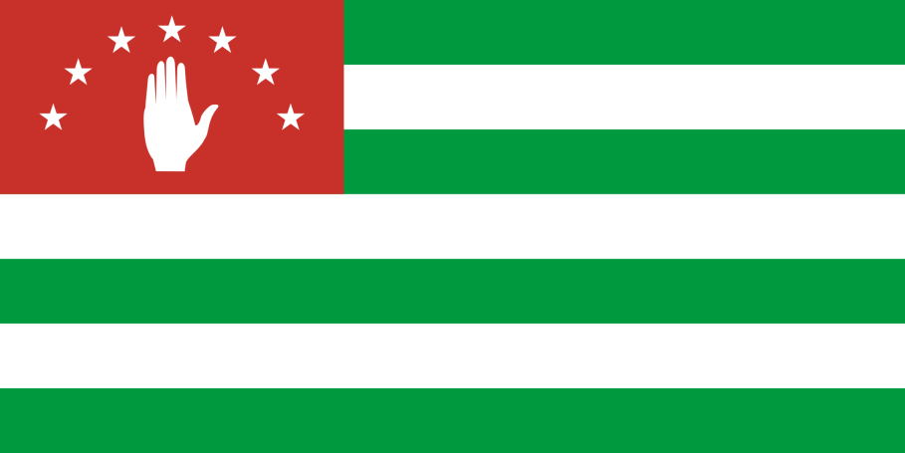

**Abkhazia**

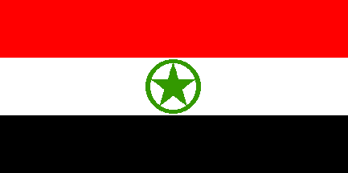

**Ahwaz**



**Barotseland**

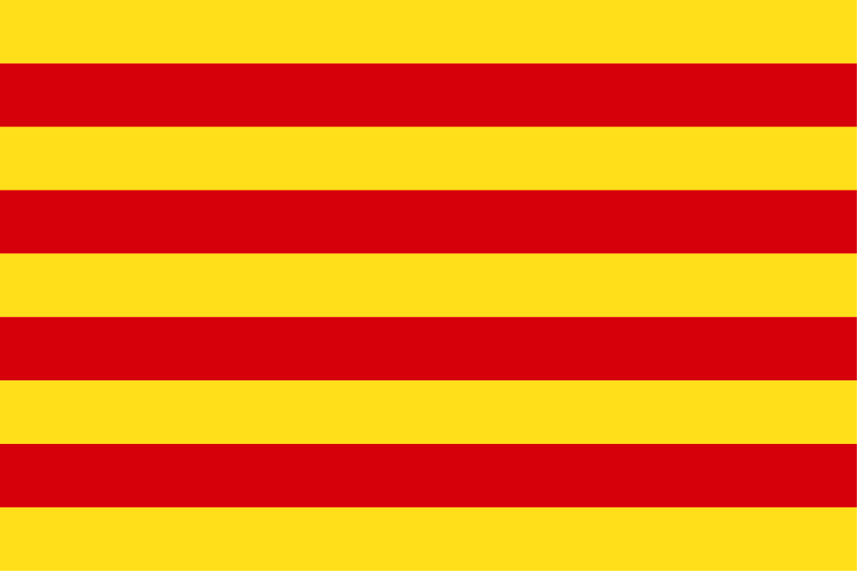

**Catalonia**

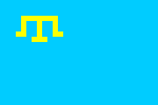

**Crimean Tatars**



**District of Columbia (Washington DC)**



**East Turkestan**

**Guam**

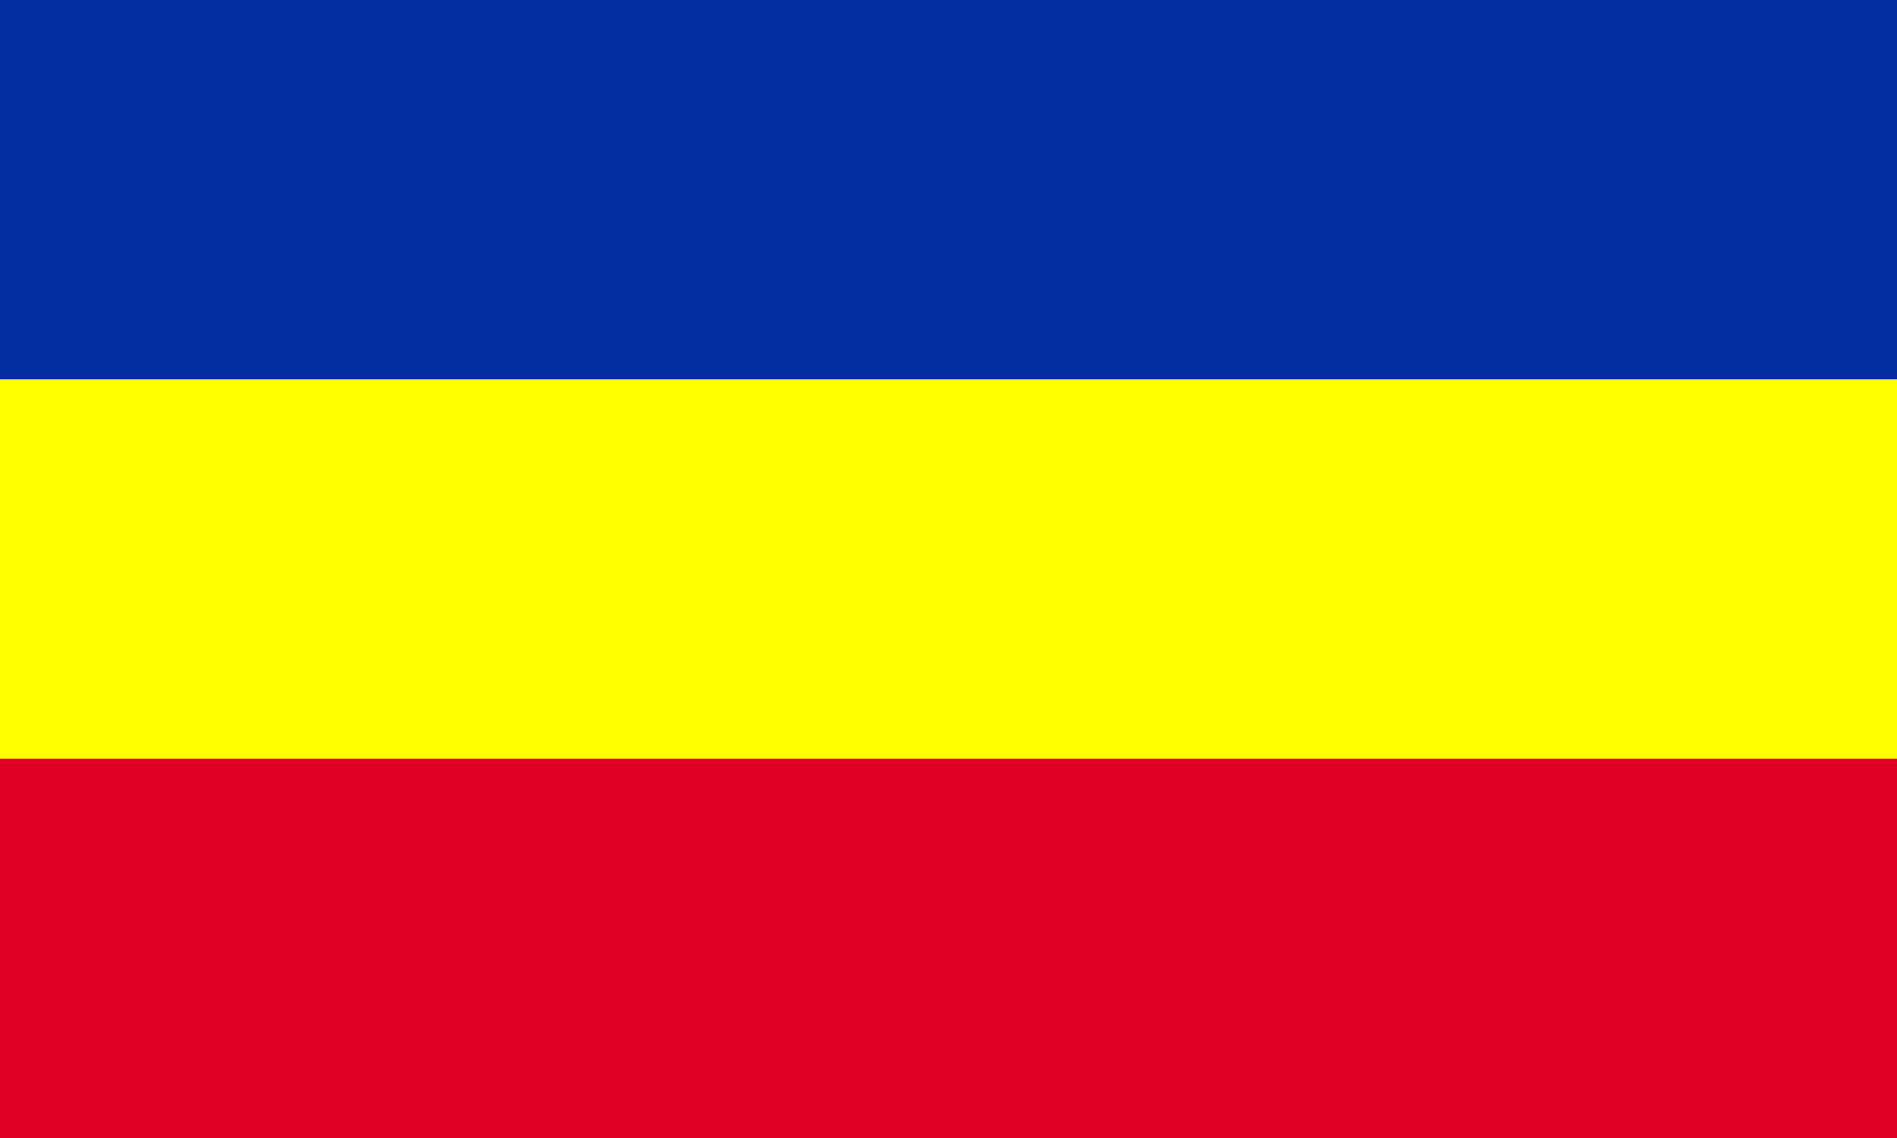

**Khmer Krom**

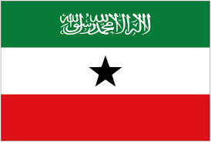

**Somaliland**

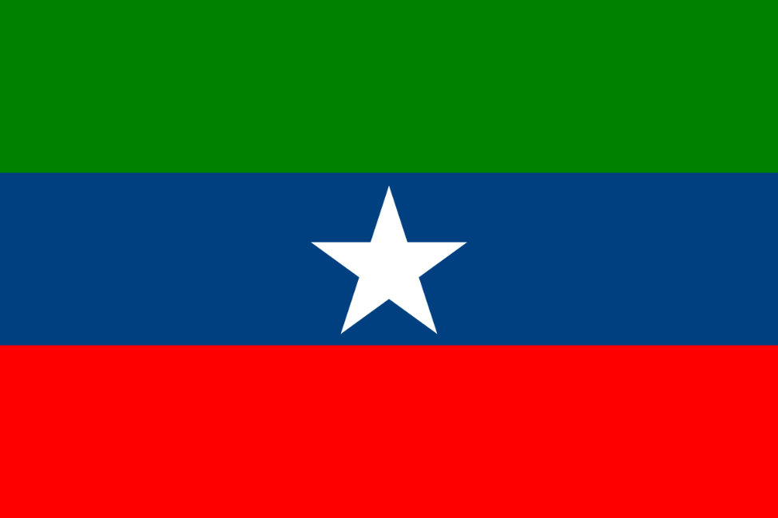

**Ogaden**

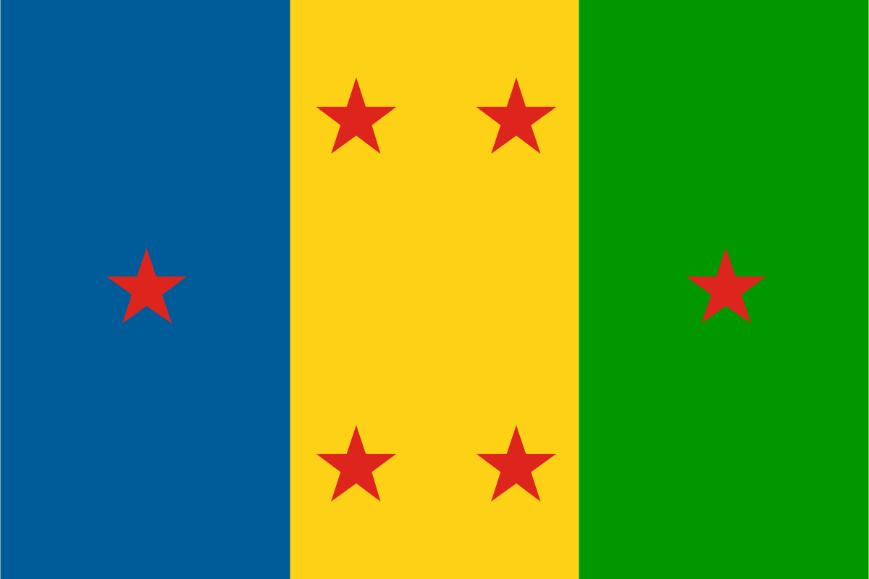

**Ogoni**

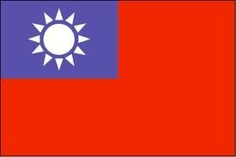

**Taiwan**

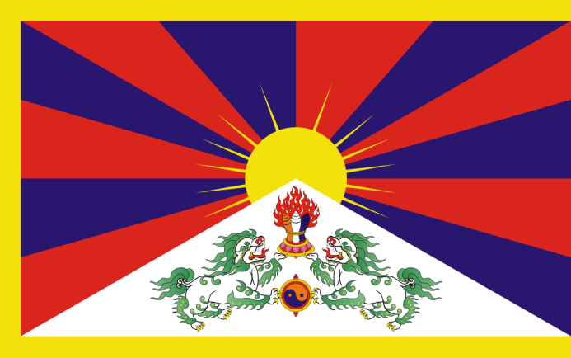

**Tibet**

**West Papua**



**UNPO President**

**2 minutes**

**1 minute**

**Time is up!**