**National Parks**

[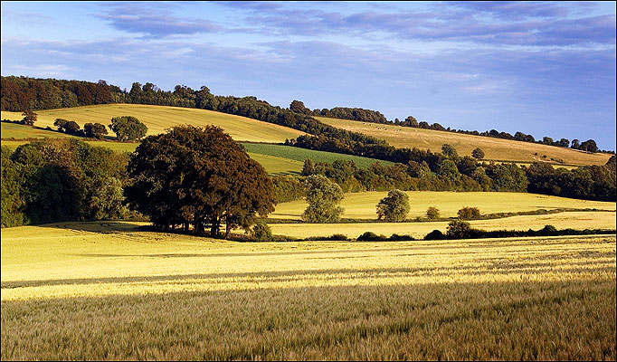](http://www.google.co.uk/url?sa=i&rct=j&q=&esrc=s&frm=1&source=images&cd=&cad=rja&uact=8&ved=0CAcQjRxqFQoTCO2uls6JjccCFcXsFAodi60Efw&url=http://www.thesun.co.uk/sol/homepage/travel/3039965/South-Downs-wahey.html&ei=IXS_Va2aJMXZU4vbkvgH&bvm=bv.99261572,d.eXY&psig=AFQjCNFCqBAWBvzSe22WRsUVpPZYeIJFGA&ust=1438696823488104)[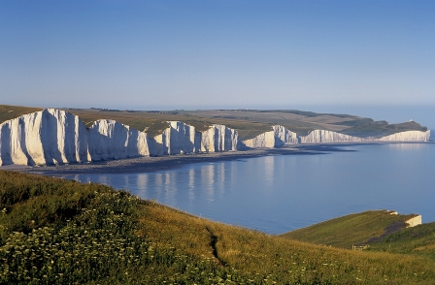](http://www.google.co.uk/url?sa=i&rct=j&q=&esrc=s&frm=1&source=images&cd=&cad=rja&uact=8&ved=0CAcQjRxqFQoTCLGC4q-JjccCFUM3FAodPnsDSA&url=http://www.southdownscycling.com/&ei=4XO_VfGNMsPuUL72jcAE&bvm=bv.99261572,d.eXY&psig=AFQjCNG8KAYy8TipMVp-JeWxm_W5VnDXZQ&ust=1438696787618422)

**South Downs**

**National Parks**

[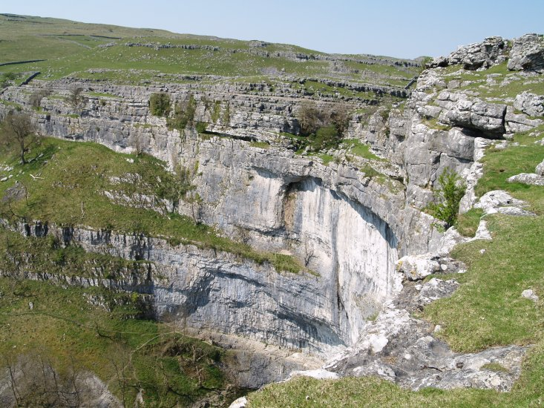](http://www.google.co.uk/url?sa=i&rct=j&q=&esrc=s&frm=1&source=images&cd=&cad=rja&uact=8&ved=0CAcQjRxqFQoTCID3sMiIjccCFcI3FAoda-kOnw&url=http://www.docbrown.info/docspics/northern/norspage22.htm&ei=CXO_VcBOwu9Q69K7-Ak&bvm=bv.99261572,d.cWw&psig=AFQjCNGzMm-4EaDqu1e2OZLlylNQvEjBqA&ust=1438696574979268)[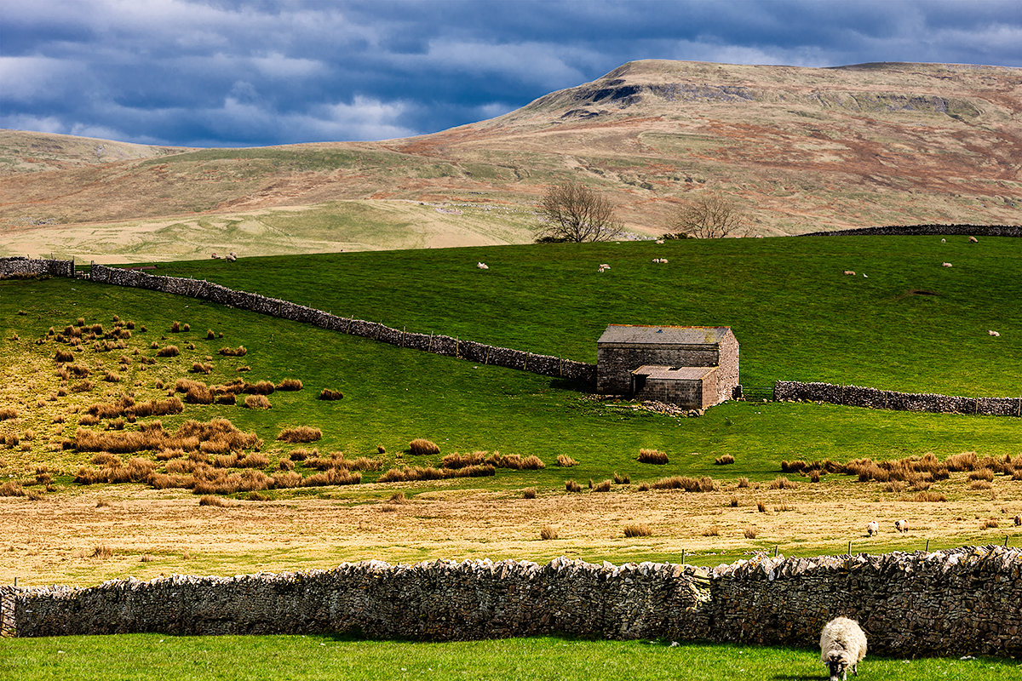](http://www.google.co.uk/url?sa=i&rct=j&q=&esrc=s&frm=1&source=images&cd=&cad=rja&uact=8&ved=0CAcQjRxqFQoTCLWQsdyIjccCFYfTFAodOf8FUQ&url=http://www.richardkingphoto.com/contents/National%20Parks/Yorkshire%20Dales/image-Yorkshire-Dales-National-Park-12-014336_vv/&ei=MnO_VbWvOoenU7n-l4gF&bvm=bv.99261572,d.eXY&psig=AFQjCNHmC53islGdD4ZyqVx9MUlRtpvtVg&ust=1438696612531663)

**Yorkshire Dales**

**National Parks**

[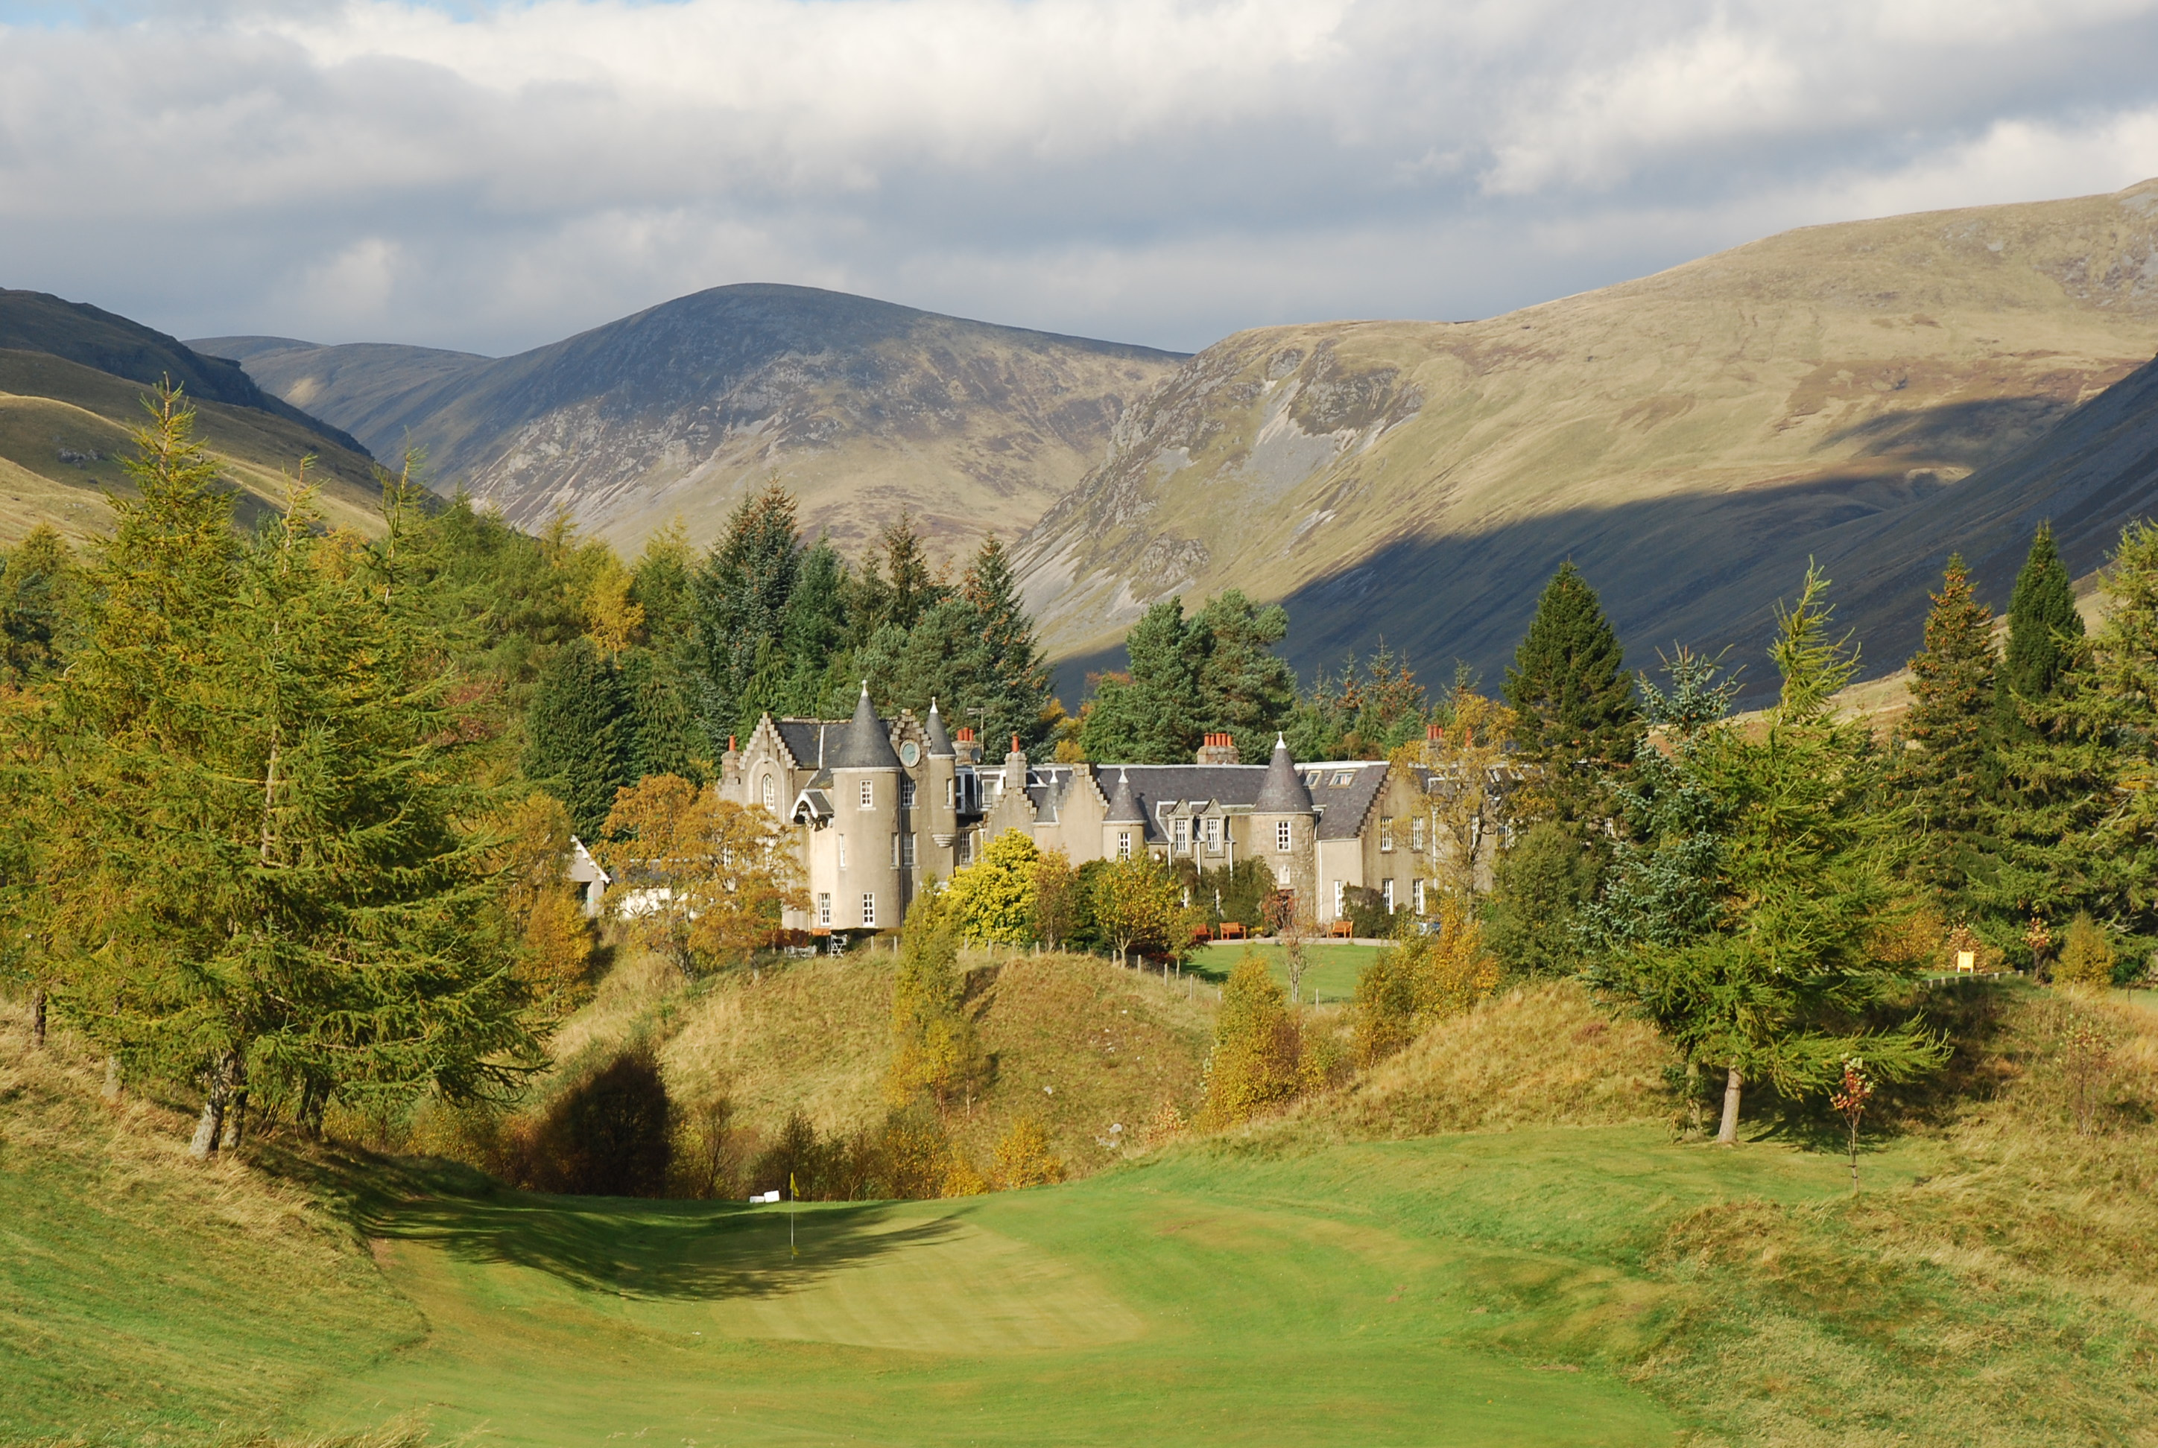](http://www.google.co.uk/url?sa=i&rct=j&q=&esrc=s&frm=1&source=images&cd=&cad=rja&uact=8&ved=0CAcQjRxqFQoTCNHUz_eHjccCFcJtFAod2-IBmw&url=http://visitcairngorms.com/spittalofglenshee&ei=X3K_VZGpJ8LbUdvFh9gJ&bvm=bv.99261572,d.eXY&psig=AFQjCNFdfgAiseYPlrj1Ml8XHgAmCGhLSg&ust=1438696390879164)[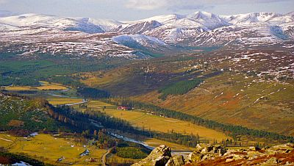](http://www.google.co.uk/url?sa=i&rct=j&q=&esrc=s&frm=1&source=images&cd=&cad=rja&uact=8&ved=0CAcQjRxqFQoTCMvspuCHjccCFUm2FAod36kMCQ&url=http://www.walkingholidayinfo.co.uk/walking-in-scotland.php&ei=LnK_VcudLcnsUt_Tskg&bvm=bv.99261572,d.cWw&psig=AFQjCNHL8K7_KMMT_3qnX6_ZdQYvLydg6A&ust=1438696338858610)

**Cairngorms**

**National Parks**

[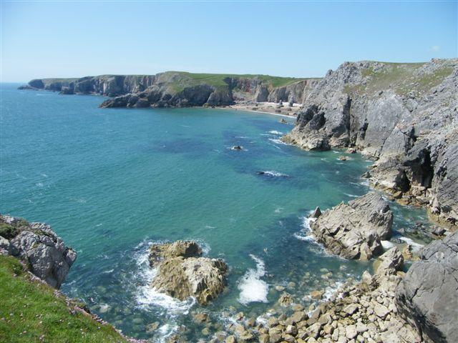](http://www.google.co.uk/url?sa=i&rct=j&q=&esrc=s&frm=1&source=images&cd=&cad=rja&uact=8&ved=0CAcQjRxqFQoTCMbI1ICHjccCFQXVFAod37UEKw&url=http://www.pembrokeshirecoast.org.uk/?PID%3D160&ei=ZnG_Vcb9CYWqU9_rktgC&bvm=bv.99261572,d.cWw&psig=AFQjCNH2WzBaSr8wMDNpnsAtqAHmf2x_1Q&ust=1438696138204018)

[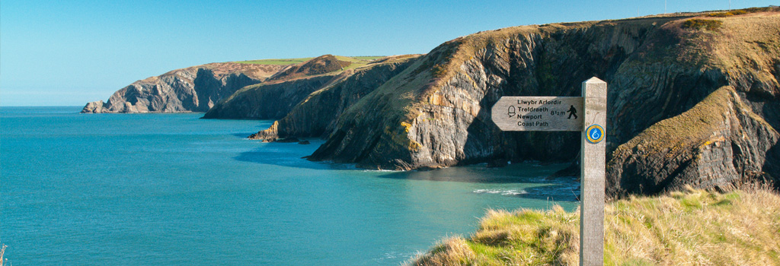](http://www.google.co.uk/url?sa=i&rct=j&q=&esrc=s&frm=1&source=images&cd=&cad=rja&uact=8&ved=0CAcQjRxqFQoTCPzYiZiHjccCFco8FAodK3wEFw&url=http://www.visitwales.com/explore/national-parks/pembrokeshire-coast&ei=l3G_VbyxEMr5UKv4kbgB&bvm=bv.99261572,d.cWw&psig=AFQjCNHO51j_X5QuTn0KjtW_eOtZ_Lf8uQ&ust=1438696213076537)

**Pembrokeshire Coast**

**Dartmoor**