**Islands**

[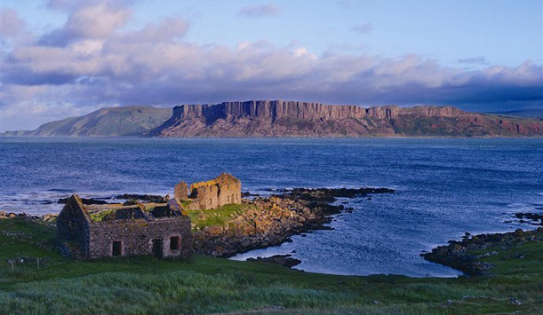](http://www.google.co.uk/url?sa=i&rct=j&q=&esrc=s&frm=1&source=images&cd=&cad=rja&uact=8&ved=0CAcQjRxqFQoTCJ2F5dqOjccCFUnXFAodZVwLRQ&url=http://www.ireland.com/en-gb/what-is-available/attractions-built-heritage/islands/articles/robert-and-rathlin/&ei=enm_VZ3gDcmuU-W4ragE&bvm=bv.99261572,d.cWw&psig=AFQjCNEphAPqf_uEBziRfvl3AQygnY1zTg&ust=1438698171913922)[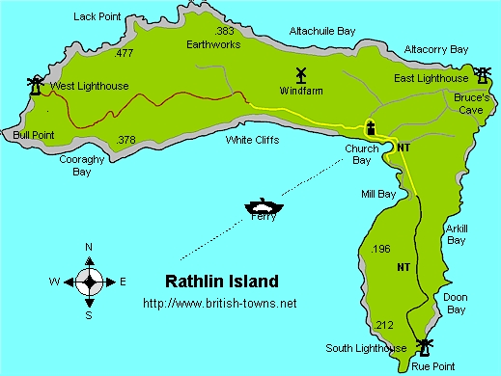](http://www.google.co.uk/url?sa=i&rct=j&q=&esrc=s&frm=1&source=images&cd=&cad=rja&uact=8&ved=0CAcQjRxqFQoTCKnJvcOOjccCFYhvFAod3-QA-g&url=http://www.british-towns.net/northern-ireland/rathlin-island/rathlin-island/album/rathlin-island-map&ei=SXm_VemAFYjfUd_Jg9AP&bvm=bv.99261572,d.cWw&psig=AFQjCNEphAPqf_uEBziRfvl3AQygnY1zTg&ust=1438698171913922)

**Raithlin Island**

**Islands**

[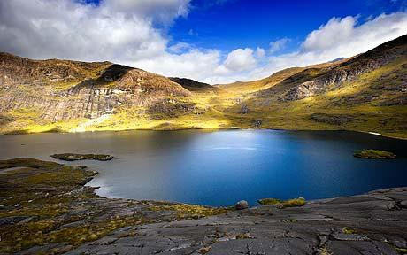](http://www.google.co.uk/url?sa=i&rct=j&q=&esrc=s&frm=1&source=images&cd=&cad=rja&uact=8&ved=0CAcQjRxqFQoTCObPoNWNjccCFcs_FAod-XsN7A&url=http://www.telegraph.co.uk/travel/destinations/europe/uk/scotland/3123604/Isle-of-Skye-On-the-shores-of-Loch-Coruisk.html&ei=Yni_VeaWC8v_UPn3teAO&bvm=bv.99261572,d.cWw&psig=AFQjCNEPQlWYfRkIWOt_thealDqHCGNpPA&ust=1438697894264185)[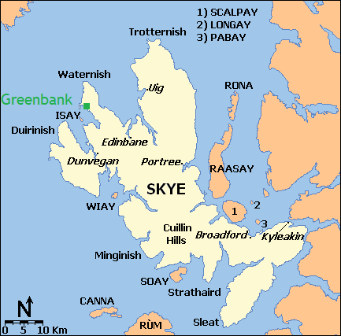](http://www.google.co.uk/url?sa=i&rct=j&q=&esrc=s&frm=1&source=images&cd=&cad=rja&uact=8&ved=0CAcQjRxqFQoTCL69taONjccCFcazFAodW1oBzg&url=http://www.greenbankonskye.co.uk/&ei=-Xe_Vf7cKMbnUtu0hfAM&psig=AFQjCNH6c1HQ74aLR8_lXw9Bip1gzypOaA&ust=1438697742816747)

**Isle of Skye**

**Islands**

[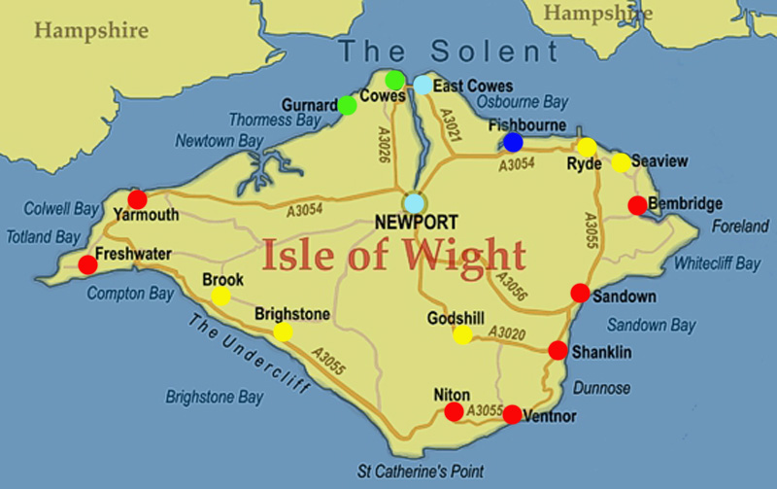](http://www.google.co.uk/url?sa=i&rct=j&q=&esrc=s&frm=1&source=images&cd=&cad=rja&uact=8&ved=0CAcQjRxqFQoTCP_Q04uLjccCFQHrFAodDb4PUA&url=http://www.missdottys.co.uk/delivery.html&ei=rnW_Vf_BOoHWU438voAF&bvm=bv.99261572,d.cWw&psig=AFQjCNG-dIAvAgnI9CpRXJMivoTaUR9ERw&ust=1438697229479441)[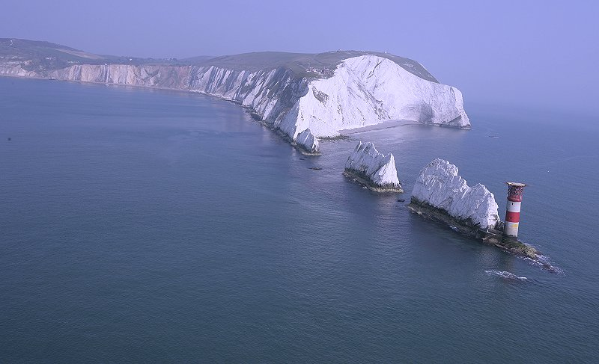](http://www.google.co.uk/url?sa=i&rct=j&q=&esrc=s&frm=1&source=images&cd=&cad=rja&uact=8&ved=0CAcQjRxqFQoTCP2K--eKjccCFcS8FAodNxUAyA&url=http://www.redfunnel.co.uk/island-guide/places-to-visit/isle-of-wight-historic-sites/the-needles-old-battery/&ei=ZHW_Vf3IBsT5UreqgMAM&bvm=bv.99261572,d.cWw&psig=AFQjCNGoEiiJOssikN3Ftf_YFN8VbHYR_A&ust=1438697165469084)

**Isle of Wight**

**Islands**

[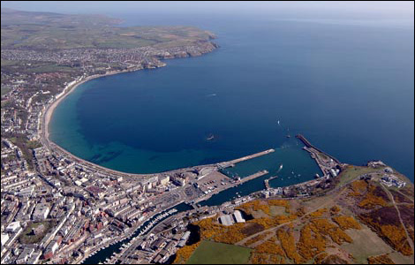](http://www.google.co.uk/url?sa=i&rct=j&q=&esrc=s&frm=1&source=images&cd=&cad=rja&uact=8&ved=0CAcQjRxqFQoTCLDBpeyLjccCFcNvFAodYEcNig&url=http://www.bbc.co.uk/isleofman/content/image_galleries/island_in_the_sky_gallery.shtml&ei=eXa_VfCgJsPfUeCOtdAI&bvm=bv.99261572,d.cWw&psig=AFQjCNHTMvUsdrJAM8YIANJM9lufqZh78Q&ust=1438697457602634)[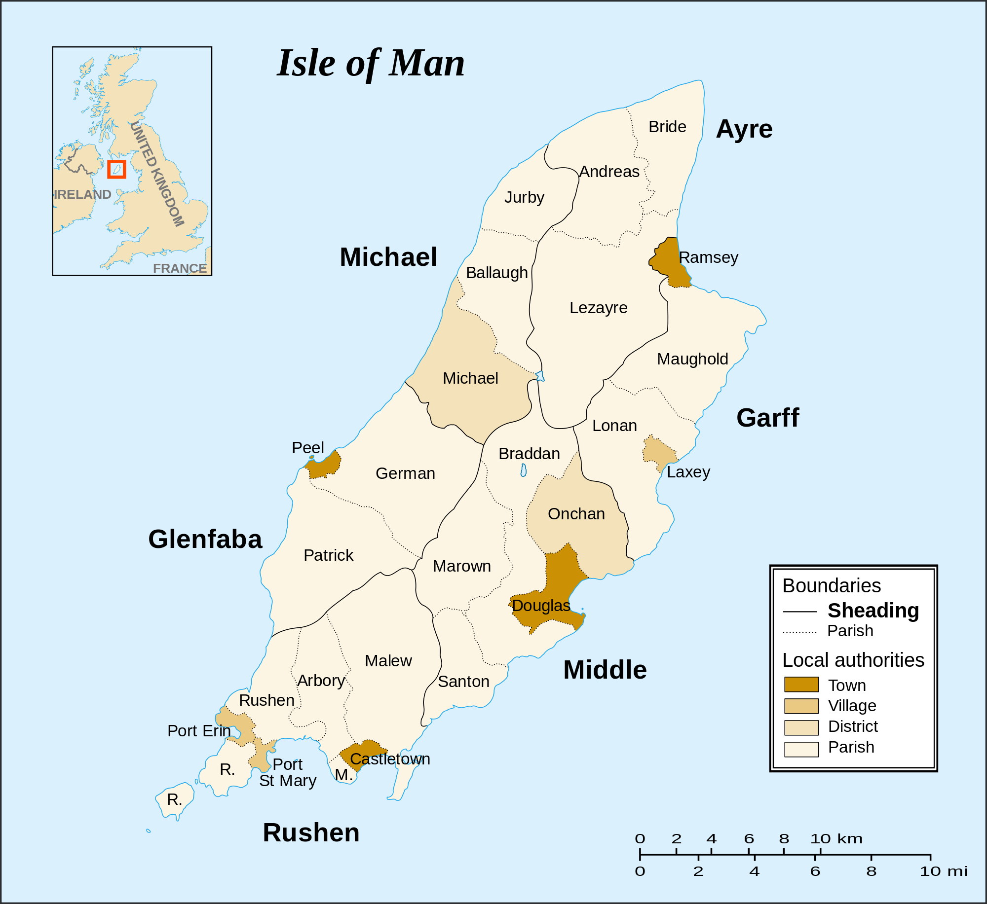](https://www.google.co.uk/url?sa=i&rct=j&q=&esrc=s&frm=1&source=images&cd=&cad=rja&uact=8&ved=0CAcQjRxqFQoTCIfpnNGLjccCFUnVFAodHVEEhw&url=https://en.wikipedia.org/wiki/Local_government_in_the_Isle_of_Man&ei=QHa_VYfJNMmqU52ikbgI&bvm=bv.99261572,d.cWw&psig=AFQjCNEIy_zegNYa3gKykLOrwWZ9j_XT6Q&ust=1438697378657599)

**Isle of Man**