**Natural Landscapes**

[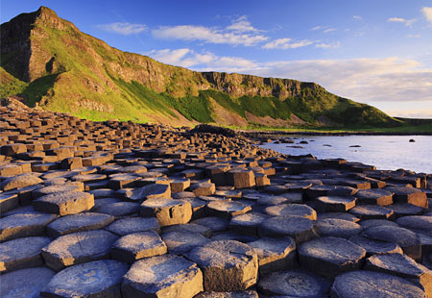](http://www.google.co.uk/url?sa=i&rct=j&q=&esrc=s&frm=1&source=images&cd=&cad=rja&uact=8&ved=0CAcQjRxqFQoTCJaIoe-EjccCFcdtFAodNJ8KpQ&url=http://number10coleraine.com/?page_id%3D15&ei=KG-_VZbUMMfbUbS-qqgK&bvm=bv.99261572,d.eXY&psig=AFQjCNFKiiW1-2c6qhr8pgseH92TcLKprQ&ust=1438695585324962)[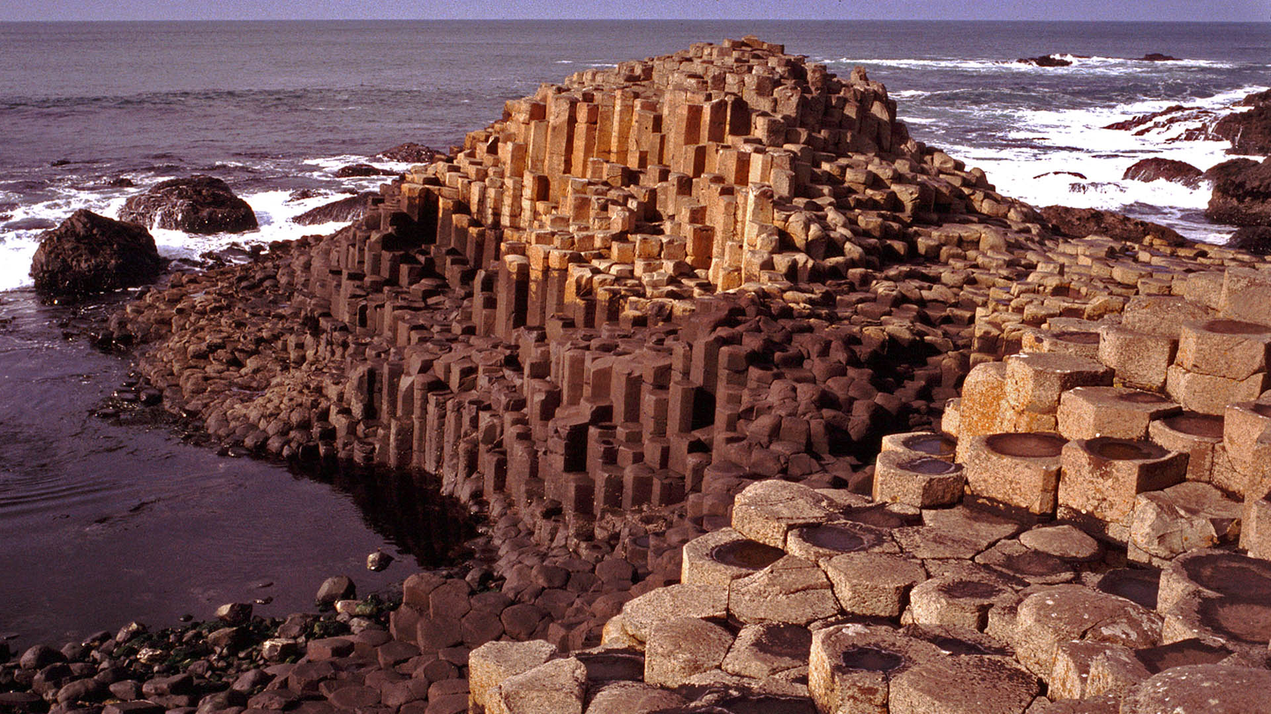](http://www.google.co.uk/url?sa=i&rct=j&q=&esrc=s&frm=1&source=images&cd=&cad=rja&uact=8&ved=0CAcQjRxqFQoTCNz5ud-EjccCFYRZFAodf_gLUA&url=http://makestepsforchanges.blogspot.com/2014/03/giants-causeway-ireland.html&ei=B2-_VZzaJ4SzUf_wr4AF&bvm=bv.99261572,d.cWw&psig=AFQjCNGt6CutcbBoFmxPkpeFx7XvrbjH8g&ust=1438695549532330)

**Giant’s Causeway**

**Natural Landscapes**

[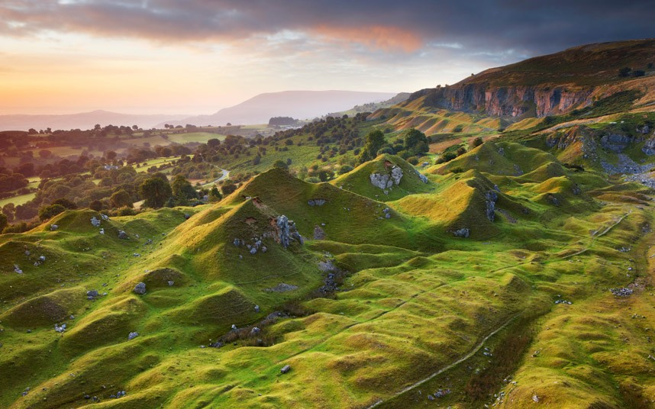](http://www.google.co.uk/url?sa=i&rct=j&q=&esrc=s&frm=1&source=images&cd=&cad=rja&uact=8&ved=0CAcQjRxqFQoTCI7I68eDjccCFQfNFAod4i0JIQ&url=http://www.telegraph.co.uk/news/uknews/defence/10178631/Two-soldiers-die-in-heat-while-training-in-Brecon-Beacons.html&ei=yW2_Vc6_KoeaU-LbpIgC&bvm=bv.99261572,d.cWw&psig=AFQjCNFl-8Iw955D6GMlcDbjdrfO3E1UIQ&ust=1438695236653399)[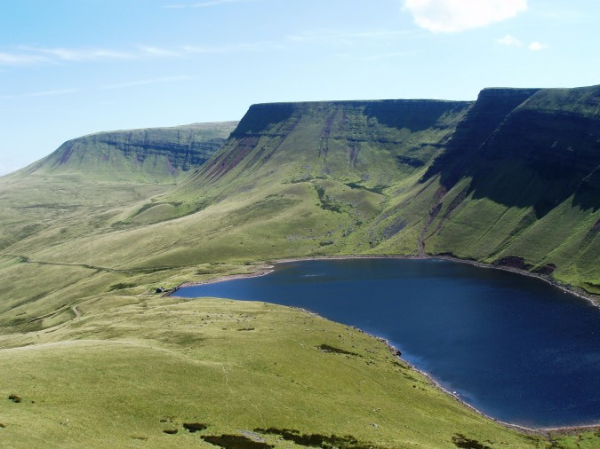](http://www.google.co.uk/url?sa=i&rct=j&q=&esrc=s&frm=1&source=images&cd=&cad=rja&uact=8&ved=0CAcQjRxqFQoTCPCk47GDjccCFQldFAodlZ0Bug&url=http://www.breconbeacons.org/lady-lake-physicians-myddfai&ei=m22_VbDrGYm6UZW7htAL&bvm=bv.99261572,d.cWw&psig=AFQjCNHqyufcQ7ukWbpQ9x-E1hsoq_JmoQ&ust=1438695180063276)

**Brecon Beacons**

**Natural Landscapes**

[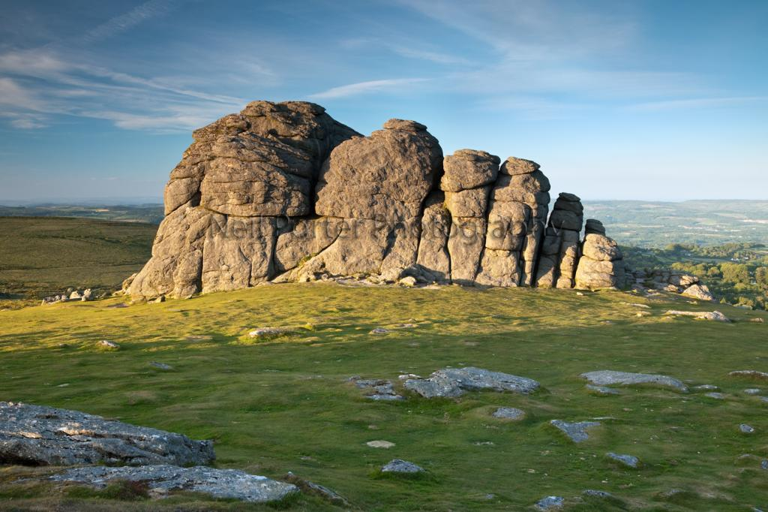](http://www.google.co.uk/url?sa=i&rct=j&q=&esrc=s&frm=1&source=images&cd=&cad=rja&uact=8&ved=0CAcQjRxqFQoTCJemsceFjccCFclZFAodUfEPKg&url=http://www.dphotographer.co.uk/image/260939/haytor&ei=4W-_VdexJcmzUdHiv9AC&bvm=bv.99261572,d.eXY&psig=AFQjCNFBT6gkCTIJCod4Qsc3mIK8ScboSQ&ust=1438695764564455)

[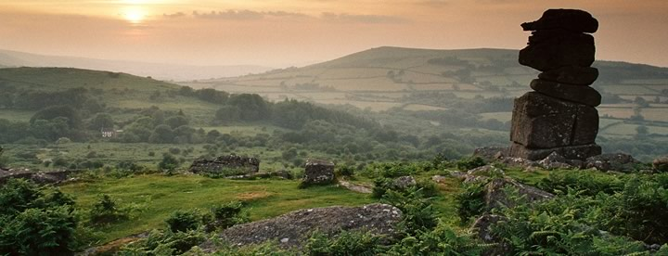](http://www.google.co.uk/url?sa=i&rct=j&q=&esrc=s&frm=1&source=images&cd=&cad=rja&uact=8&ved=0CAcQjRxqFQoTCNGPtdGFjccCFUw6FAodte8Jlw&url=http://www.visitdevon.co.uk/areas-to-visit/dartmoor-national-park-west-devon/&ei=9m-_VdG8J8z0ULXfp7gJ&bvm=bv.99261572,d.eXY&psig=AFQjCNGwy6J1WGFYI6zpwu2YEORkbpYWkA&ust=1438695739063982)

**Dartmoor**

**Natural Landscapes**

[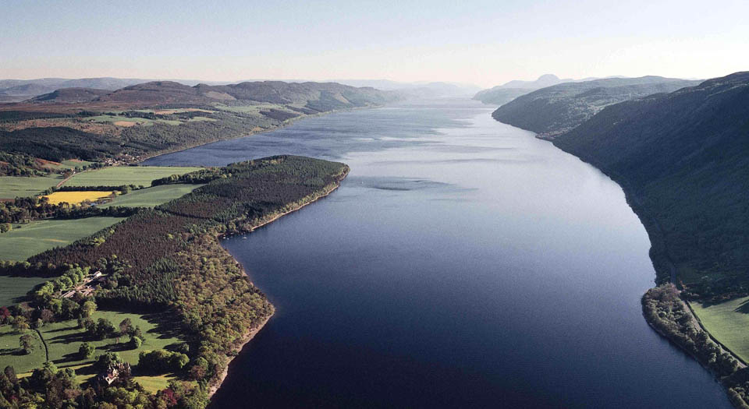](https://www.google.co.uk/url?sa=i&rct=j&q=&esrc=s&frm=1&source=images&cd=&cad=rja&uact=8&ved=0CAcQjRxqFQoTCKr29quEjccCFYXRFAod1SgCfw&url=https://www.aldouriecastle.co.uk/&ei=m26_Veq8JIWjU9XRiPgH&bvm=bv.99261572,d.eXY&psig=AFQjCNF9pXvLq3B7-JCM1bG7enst_QfCTQ&ust=1438695390032262)[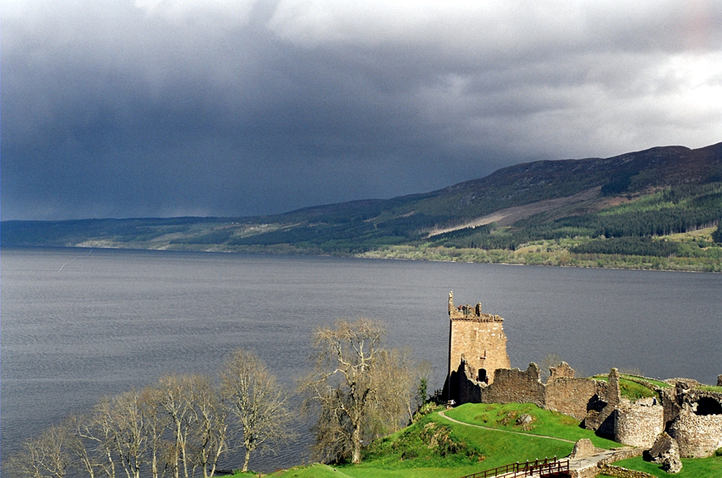](https://www.google.co.uk/url?sa=i&rct=j&q=&esrc=s&frm=1&source=images&cd=&cad=rja&uact=8&ved=0CAcQjRxqFQoTCIq1i5uEjccCFce8FAod4i0IbQ&url=https://en.wikipedia.org/wiki/Loch_Ness&ei=eG6_VYqZEcf5UuLboOgG&bvm=bv.99261572,d.eXY&psig=AFQjCNF9pXvLq3B7-JCM1bG7enst_QfCTQ&ust=1438695390032262)

**Loch Ness**