**Seaside Resorts**

[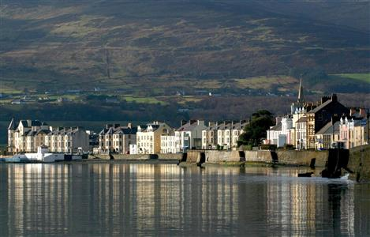](http://www.google.co.uk/url?sa=i&rct=j&q=&esrc=s&frm=1&source=images&cd=&cad=rja&uact=8&ved=0CAcQjRxqFQoTCKTcisqdjccCFQU6FAodnRIBQw&url=http://www.qradionetwork.com/qradio/south-east/south-east-news-sports-features/south-east-news/2-1-million-for-warrenpoint/&ei=EYm_VeSPLIX0UJ2lhJgE&bvm=bv.99261572,d.eXY&psig=AFQjCNGAv76pHI1p9eCwf6njjYaPkwIbeg&ust=1438702147505563)[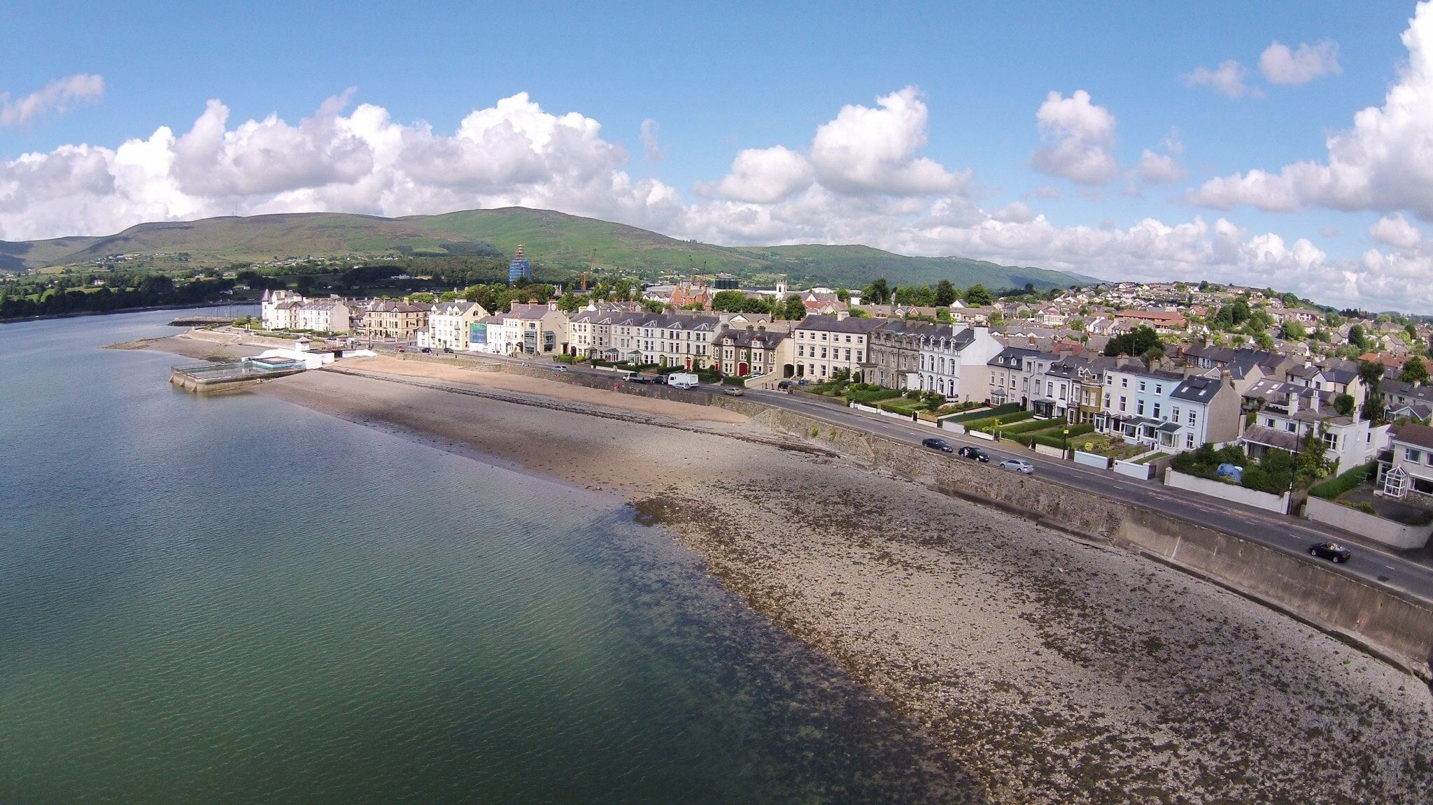](http://www.google.co.uk/url?sa=i&rct=j&q=&esrc=s&frm=1&source=images&cd=&cad=rja&uact=8&ved=0CAcQjRxqFQoTCKvb_7SdjccCFYZtFAodYOcJdw&url=http://www.dronestagr.am/warren-point-beach/&ei=5Yi_VevUHobbUeDOp7gH&bvm=bv.99261572,d.eXY&psig=AFQjCNGRDJt_xClw5QD6w9derPIobuQ8ag&ust=1438702176822584)

**Warrenpoint**

**Seaside Resorts**

[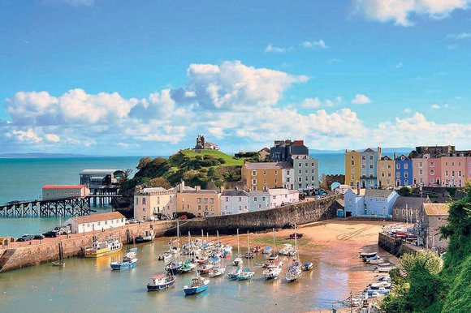](http://www.google.co.uk/url?sa=i&rct=j&q=&esrc=s&frm=1&source=images&cd=&cad=rja&uact=8&ved=0CAcQjRxqFQoTCOXxpKScjccCFclZFAodUfEPKg&url=http://www.thesundaytimes.co.uk/sto/style/homes_and_gardens/Move/article1421993.ece&ei=toe_VeW-AcmzUdHiv9AC&bvm=bv.99261572,d.eXY&psig=AFQjCNHxzGVlYAIT-tw4b5dYa_Qk1EMlhQ&ust=1438701870738999)[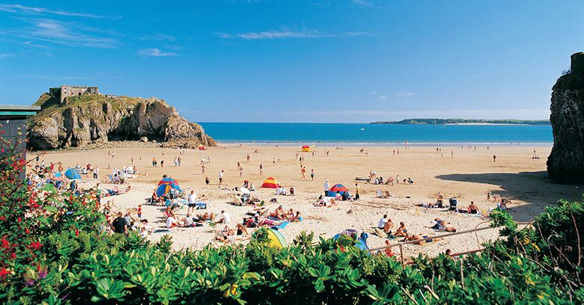](http://www.google.co.uk/url?sa=i&rct=j&q=&esrc=s&frm=1&source=images&cd=&cad=rja&uact=8&ved=0CAcQjRxqFQoTCKiaubecjccCFYm2FAodQogLdQ&url=http://www.tenby-wales.com/&ei=3oe_VaizDIntUsKQrqgH&bvm=bv.99261572,d.eXY&psig=AFQjCNEoAleHbTWxW46CvUqM-E46YDEBlQ&ust=1438701901849599)

**Tenby**

**Tenby**

**Seaside Resorts**

[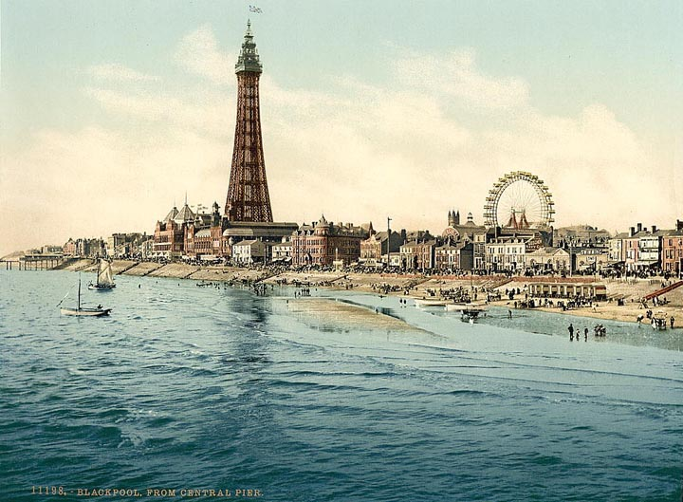](http://www.google.co.uk/url?sa=i&rct=j&q=&esrc=s&frm=1&source=images&cd=&cad=rja&uact=8&ved=0CAcQjRxqFQoTCO2gnPmajccCFcRuFAodHxAGew&url=http://www.victorianweb.org/places/cities/blackpool1.html&ei=T4a_Va29EMTdUZ-gmNgH&bvm=bv.99261572,d.eXY&psig=AFQjCNE4YjroZT0hrz3vNPQ8mVAuKWr6ew&ust=1438701504348129)[](http://www.google.co.uk/url?sa=i&rct=j&q=&esrc=s&frm=1&source=images&cd=&cad=rja&uact=8&ved=0CAcQjRxqFQoTCLfN-dWbjccCFQFxFAod0MIIHA&url=http://www.redspottedhanky.com/trains/trains-to/blackpool/&ei=EYe_VfeALYHiUdCFo-AB&bvm=bv.99261572,d.cWw&psig=AFQjCNG482jgOa9nGisSDtU1ruSA--M0DA&ust=1438701706419347)

**Blackpool**

**Blackpool**

**Seaside Resorts**

[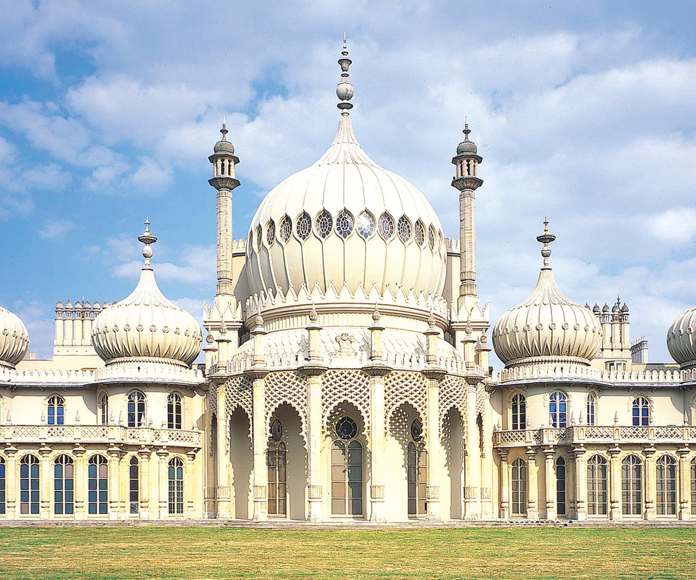](http://www.google.co.uk/url?sa=i&rct=j&q=&esrc=s&frm=1&source=images&cd=&cad=rja&uact=8&ved=0CAcQjRxqFQoTCP2fgICajccCFcFaFAodkoIPkw&url=http://brightonmuseums.org.uk/royalpavilion/&ei=UYW_Vb2zA8G1UZKFvpgJ&bvm=bv.99261572,d.cWw&psig=AFQjCNEPLXWfZQBrrCs_74GRQxKC8ti6hQ&ust=1438701261934119)[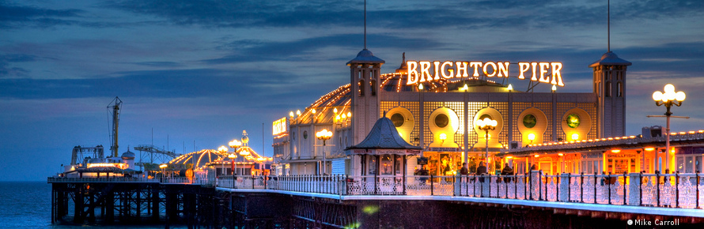](http://www.google.co.uk/url?sa=i&rct=j&q=&esrc=s&frm=1&source=images&cd=&cad=rja&uact=8&ved=0CAcQjRxqFQoTCKCT_ryajccCFQlXFAodWQULQg&url=http://uk.virginmoneygiving.com/ChristianRunsBrighton&ei=0IW_VaDrOYmuUdmKrJAE&bvm=bv.99261572,d.cWw&psig=AFQjCNH3osmYt4JgUnOeM6CT6xdMgsdA0w&ust=1438701242099081)

**Brighton**

**Brighton**

**Brighton**