**Rivers**

[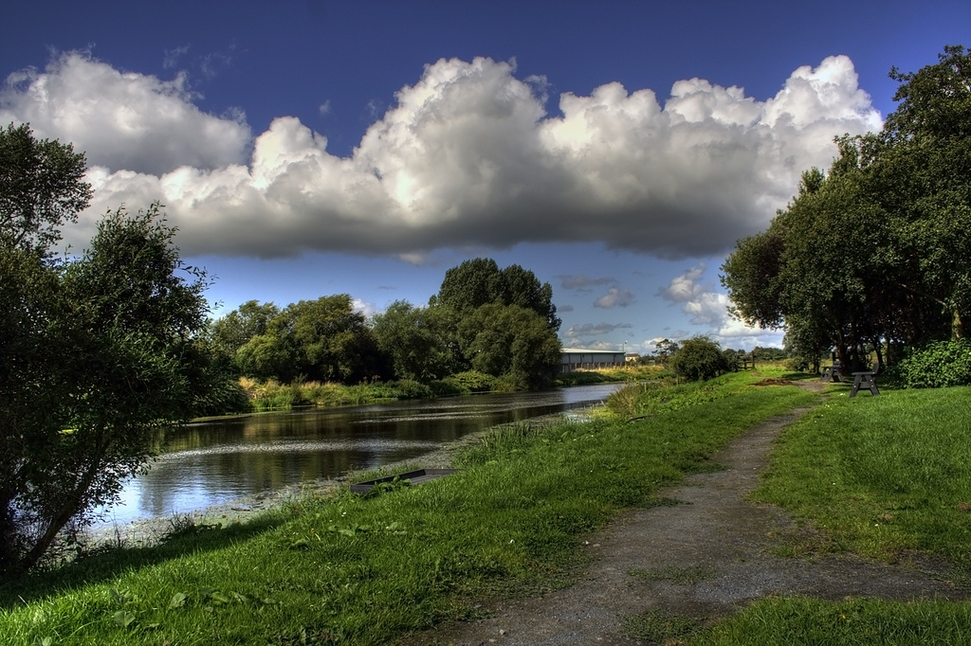](https://www.google.co.uk/url?sa=i&rct=j&q=&esrc=s&frm=1&source=images&cd=&cad=rja&uact=8&ved=0CAcQjRxqFQoTCOPohPaAjccCFYlrFAod4AwPWQ&url=https://www.flickr.com/photos/glenncartmill/3832323284&ei=BWu_VaPSEInXUeCZvMgF&bvm=bv.99261572,d.eXY&psig=AFQjCNFEQBkuqNpmlnIBvowyxP5WWF-jJQ&ust=1438694454344159)

[](https://www.google.co.uk/url?sa=i&rct=j&q=&esrc=s&frm=1&source=images&cd=&cad=rja&uact=8&ved=0CAcQjRxqFQoTCNbGnpaBjccCFcxvFAodY6UIJg&url=https://www.yardgallery.com/the-river-bann-at-coleraine.html&ei=SGu_VdaCMczfUePKorAC&bvm=bv.99261572,d.cWw&psig=AFQjCNGAOI5GBVZrhNjtX2XcxlAZE5k6Hg&ust=1438694579513815)

**Bann**

**Rivers**

[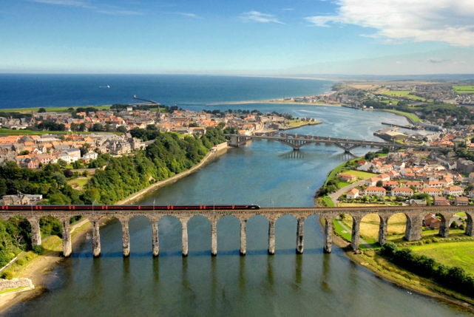](http://www.google.co.uk/url?sa=i&rct=j&q=&esrc=s&frm=1&source=images&cd=&cad=rja&uact=8&ved=0CAcQjRxqFQoTCMa-wc_9jMcCFQU5FAodz8MJgg&url=http://www.ness-st.co.uk/aerial_photographs.html&ei=j2e_VYa7CoXyUM-Hp5AI&bvm=bv.99261572,d.eXY&psig=AFQjCNERccDRh-mCYQg-eT_gxxionndrFA&ust=1438693632328163)[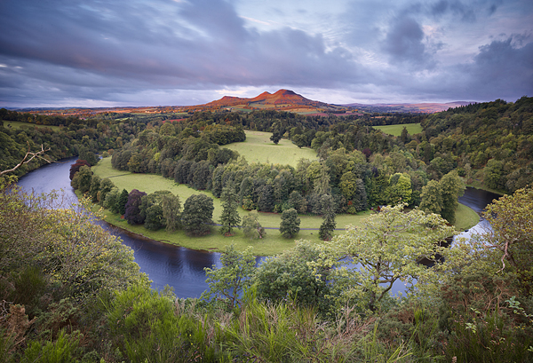](http://www.google.co.uk/url?sa=i&rct=j&q=&esrc=s&frm=1&source=images&cd=&cad=rja&uact=8&ved=0CAcQjRxqFQoTCOvAoPr-jMcCFcFXFAodS04I4w&url=http://blog.2020v.org/2011/11/joecornish/river-tweed/&ei=9Wi_VavyDsGvUcucoZgO&bvm=bv.99261572,d.eXY&psig=AFQjCNGkTK2-2SU0lOjJlZ_nZTIck1w48w&ust=1438693963085764)

**Tweed**

**Tweed**

**Rivers**

[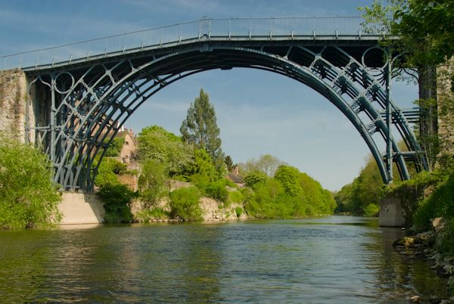](http://www.google.co.uk/url?sa=i&rct=j&q=&esrc=s&frm=1&source=images&cd=&cad=rja&uact=8&ved=0CAcQjRxqFQoTCJyl78b8jMcCFQHVFAodDyIK3Q&url=http://www.britainexpress.com/Where_to_go_in_Britain/Destination_Library/ironbridge.htm&ei=cGa_VZytJYGqU4_EqOgN&bvm=bv.99261572,d.cWw&psig=AFQjCNGc57goUERBZO3Ro59q9vMUuvoqUQ&ust=1438693049705638)[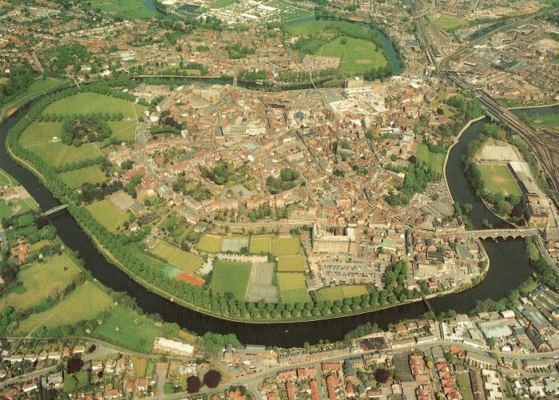](http://www.google.co.uk/url?sa=i&rct=j&q=&esrc=s&frm=1&source=images&cd=&cad=rja&uact=8&ved=0CAcQjRxqFQoTCKi9-e_7jMcCFcpAFAod5LsHkw&url=http://www.starbirthassignment.com/shrewsbury.htm&ei=umW_Vaj4E8qBUeT3npgJ&bvm=bv.99261572,d.cWw&psig=AFQjCNE6UVrGI1cQnFjGnIrGpPbhrcnKQg&ust=1438693080624979)

**Severn**

**Rivers**

[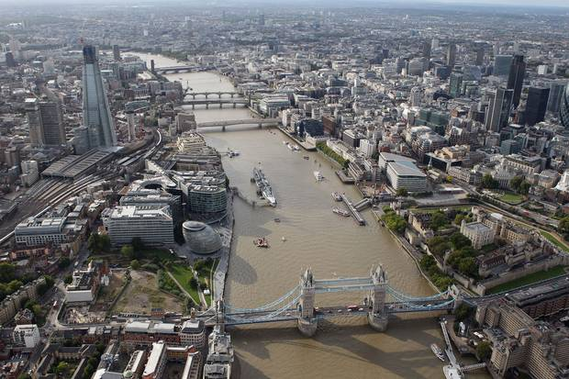](http://www.google.co.uk/url?sa=i&rct=j&q=&esrc=s&frm=1&source=images&cd=&cad=rja&uact=8&ved=0CAcQjRxqFQoTCKSXhPv6jMcCFYftFAod7ccHMg&url=http://www.standard.co.uk/news/crime/mans-body-pulled-from-river-thames-near-rotherhithe-9939610.html&ei=xWS_VeSgCIfbU-2Pn5AD&bvm=bv.99261572,d.eXY&psig=AFQjCNG4uNFKg2vpOtiiZ9pQzrHcOAZqgg&ust=1438692906599322)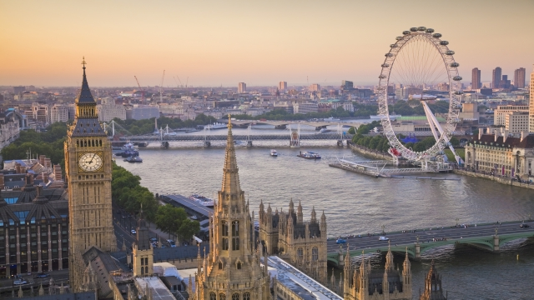

**Thames**