Information Sheet: Somaliland
Where is Somaliland?
Somaliland is located in the east of Africa. It neighbours Ethiopia and Somalia and has a coastline on the Indian Ocean. The capital city is Hargeisa.
How big is Somaliland?
Somaliland covers an area of 137,000 kilometres squared.
How many people live in Somaliland?
Somaliland has a population of 4.5 million people.
What is the religion in Somaliland?
In Somaliland, the main religion is Islam.
What language do the Somalilanders speak?
Somali is the official language. English and Arabic are also spoken by some Somalilanders.
What is the history of Somaliland?
Somaliland used to be part of the British Empire until 1960. In July 1960, Somaliland voluntarily entered into a union with Somalia. In the late 1980s, there was increasing resistance in Somalia towards the Government. In 1991, the President of Somali was overthrown and on 18 May 1991 Somaliland declared independence. However, Somaliland’s independence was not recognised by other countries. It is not a member of the United Nations.
In 2001, 97% of Somaliland’s population voted to support the constitution (a new set of laws) that was adopted in 1997. Somalia regularly holds elections in which its population vote for officials.
What problems has Somaliland faced recently?
Although not recognised as a country, Somaliland has its own government, currency and police force. It is a democracy and holds regular elections. Somaliland and Somalia started talks in 2012 to try and decide what should happen about the future of Somaliland, but these talks collapsed in 2015.
Somaliland argues that is show be recognised as a country as it was an independent country for five days in 1960 before agreeing to join with Somalia.
What do the Somaliland people want?
Somaliland is sometimes called a “country-in-waiting”. It has a population, land and government but other countries do not recognise it as a country. In 2016, over one million Somalilanders signed a petition supporting independence of Somaliland.

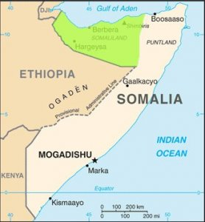
Source: https://unpo.org/members/7916
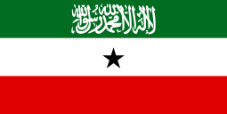
Source: https://unpo.org/members/7916

