[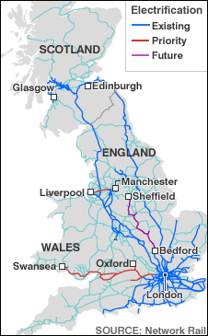](http://www.google.co.uk/url?sa=i&rct=j&q=&esrc=s&frm=1&source=images&cd=&cad=rja&uact=8&ved=0CAcQjRxqFQoTCLDlqMfLlscCFTMW2wod80UCYg&url=http://news.bbc.co.uk/2/hi/uk/8164070.stm&ei=PXHEVfDSJLOs7Abzi4mQBg&bvm=bv.99804247,d.ZGU&psig=AFQjCNF2-83c-nVQ1Mv-mggvwOFK9PZnKw&ust=1439023795877363)[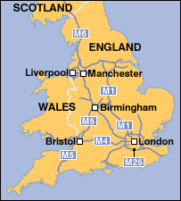](http://www.google.co.uk/url?sa=i&rct=j&q=&esrc=s&frm=1&source=images&cd=&cad=rja&uact=8&ved=0CAcQjRxqFQoTCL-BtpLLlscCFQUG2wod6Z8DGQ&url=http://www.bbc.co.uk/2/hi/uk_news/6691471.stm&ei=znDEVb_iKIWM7Abpv47IAQ&bvm=bv.99804247,d.ZGU&psig=AFQjCNGJYeGaaDGPAK11oFPfxr1n5iMsSw&ust=1439023670983055)[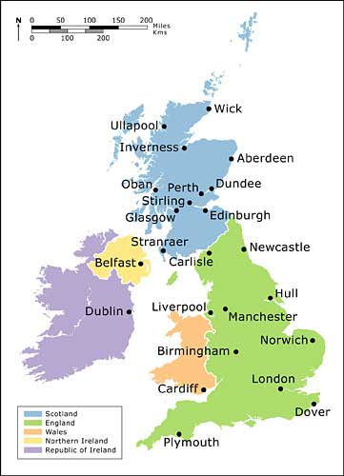](http://www.google.co.uk/url?sa=i&rct=j&q=&esrc=s&frm=1&source=images&cd=&cad=rja&uact=8&ved=0CAcQjRxqFQoTCLyYmtvJlscCFWKh2wodeCwDbw&url=http://www.isizedconsultltd.com.ng/map-and-climate/&ei=Tm_EVby5GuLC7gb42Iz4Bg&bvm=bv.99804247,d.ZGU&psig=AFQjCNF_BcqSutJZKDbnnD0Y-Ey8s4xz4Q&ust=1439023038751936)

**Lesson four: UK Cities and Transport Networks Factsheet**

|  |  |  |
| --- | --- | --- |
| **CITY** | **COUNTRY** | **POP. (Millions)** |
| London | England | 8.25 |
| Birmingham | England | 1.09 |
| Glasgow | Scotland | 0.6 |
| Liverpool | England | 0.55 |
| Bristol | England | 0.53 |
| Sheffield | England | 0.52 |
| Manchester | England | 0.51 |
| Leeds | England | 0.47 |
| Edinburgh | Scotland | 0.46 |
| Leeds | England | 0.44 |
| Cardiff | Wales | 0.35 |
| Belfast | N. Ireland | 0.33 |

UK city growth has resulted from:

* The Industrial Revolution (late 18th C) as people migrated from rural areas to work in factories.
* The growth of the railway network
* Specialisation of industry e.g. Birmingham (Brass)

Since 1950: decentralization of retailing/entertainment owing to increased car ownership and city centre congestion

By the 1930s, there were a million cars on the road in Britain. The development of motor transport changed the way people lived and worked and had an equally big impact upon the railways, signalling the end of their greatest days.

For a video clip on ‘Transport in Britain since 1930’: <http://www.bbc.co.uk/education/clips/z398q6f>