**Lesson four: Tom Finney Roleplay (starter)**

**Sir Tom Finney interview**

Sir Tom Finney will always be remembered as the Preston Plumber. According to the myth, he travelled by bus from his workshop on match days, arriving at the ground not long before kick-off. In truth, although the team coach stopped to pick him up for away games, on home Saturdays he walked from the modest home he shared with his beloved wife Elsie.

He did, though, break into his normal day’s work to catch the bus to and from training. And he does recall that when he started out as an apprentice at Pilkington’s the Plumbers he had to beg time off one Saturday to play in the wartime Cup Final of 1941. To which Mr Pilkington sternly replied: “How long will you be out?”

Sir Tom chuckles at the memory: “He was the only citizen of Preston I’ve ever known who didn’t follow football and the North End.

[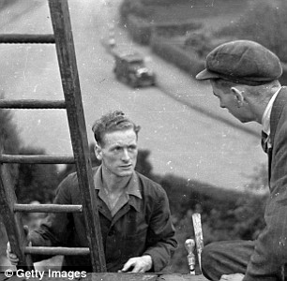](http://www.google.co.uk/url?sa=i&rct=j&q=&esrc=s&frm=1&source=images&cd=&cad=rja&uact=8&ved=0CAcQjRxqFQoTCPPc4a3VmccCFbIH2wodPlEGog&url=http://www.dailymail.co.uk/sport/football/article-2559853/SIR-TOM-FINNEY-INTERVIEW-England-legend-glorious-career-football-21st-century-ultimate-Three-Lions-XI.html&ei=Kw7GVbObI7KP7Aa-opmQCg&psig=AFQjCNEWlJKhAPKaxChty1w3EIDh77bguA&ust=1439129488465809)[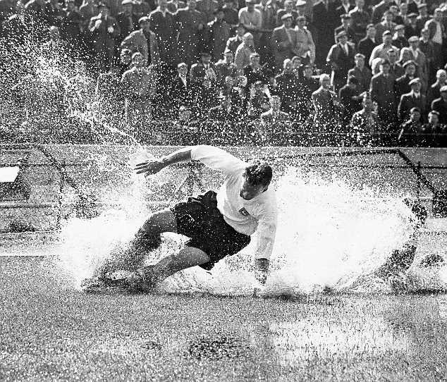](http://www.google.co.uk/url?sa=i&rct=j&q=&esrc=s&frm=1&source=images&cd=&cad=rja&uact=8&ved=0CAcQjRxqFQoTCO7a1-PUmccCFeFm2woduLcJ_g&url=http://www.dailymail.co.uk/sport/football/article-2559875/Farewell-Sir-Tom-Finney-Preston-plumber-England-great.html&ei=kA3GVe7SDeHN7Qa476bwDw&bvm=bv.99804247,d.ZGU&psig=AFQjCNGb0_OE6y_Dof3pNzLK77Ty4EOa9g&ust=1439129339201373)

Not that doing two men’s jobs was a laughing matter at the time. As a player, he earned £12 a week in winter, “dropping to a tenner in summer because we didn’t play football in the summer. Tom Finney stayed at the same football club throughout his career and returned to his job as a plumber when he retired from playing.

*Tom Finney stayed at the same football club throughout his career and returned to his job as a plumber when he retired from playing.*

**ACTIVITY:**

Create a role-play to illustrate Tom Finney’s commitment to Pilkington’s Plumbers and the town of Preston.