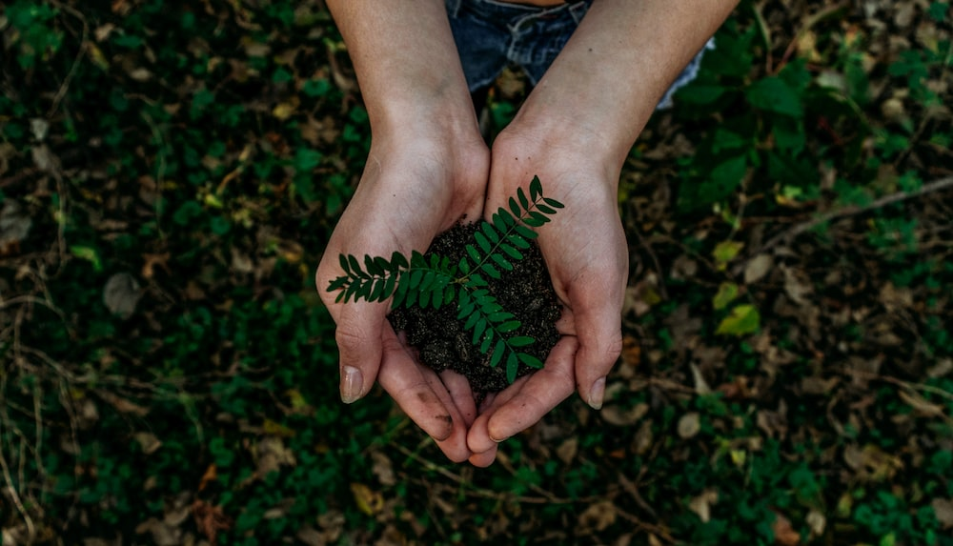

**Key Word/Phrase: Sustainability**

**You cannot use the following!**

* **Farming**
* **Endangered**
* **Preservation**
* **Environment**
* **Future**

Photo Credit: Noah Buscher

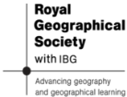

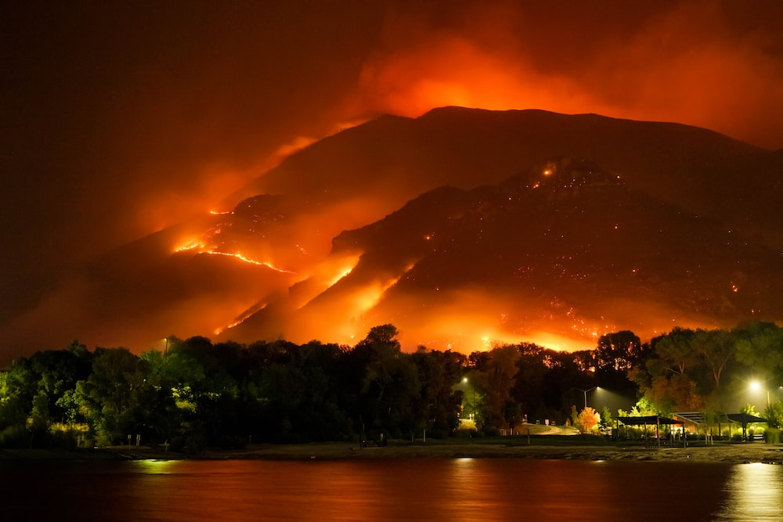

**Key Word/Phrase: Wildfire**

**You cannot use the following!**

* **Flames**
* **Burning**
* **Natural Disaster**
* **Countryside**
* **Australia**

Photo Credit: Mike Newbry



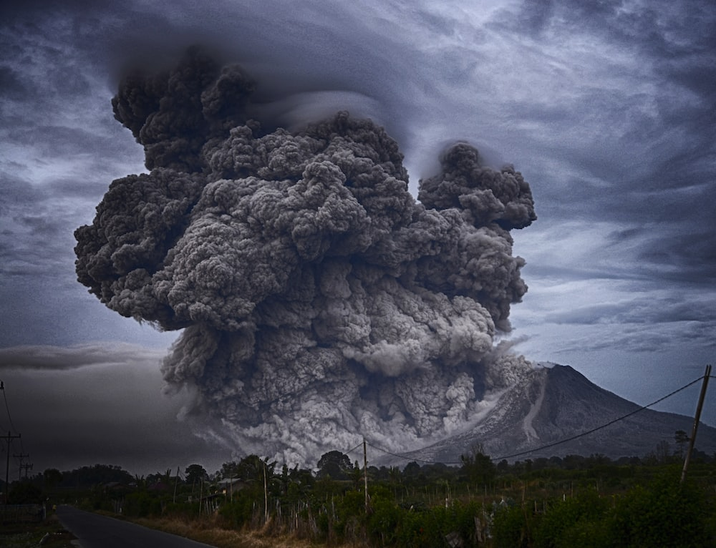

**Key Word/Phrase: Volcanic Eruption**

**You cannot use the following!**

* **Any named examples of volcanic eruptions in the past**
* **Magma**
* **Lava**
* **Explosion**

Photo Credit: Yosh Ginsu

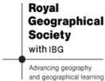

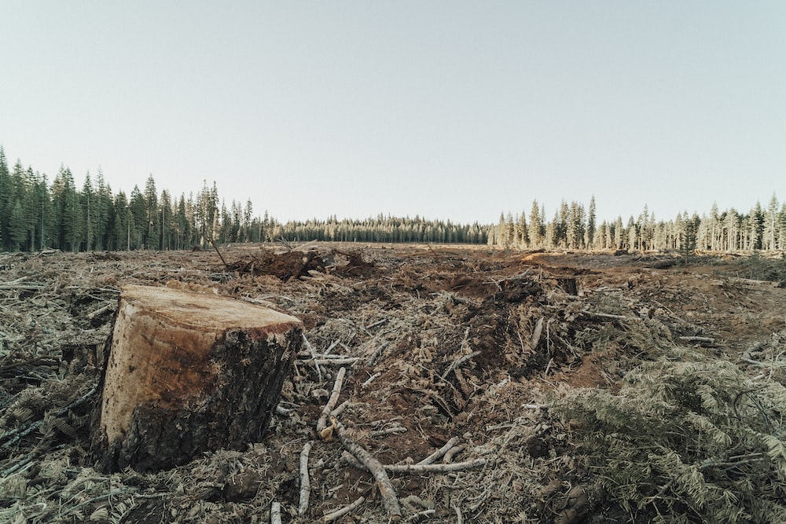

**Key Word/Phrase: Deforestation**

**You cannot use the following!**

* **Rainforests**
* **Trees**
* **Chopping**
* **Amazon**
* **Woodland**

Photo Credit: Roya Ann Miller



**Key Word/Phrase: Geopolitics**

**You cannot use the following!**

* **Government**
* **Foreign Policy**
* **The UN**
* **Armed Forces**
* **Trade**

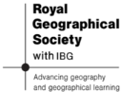

Photo Credit: Marcus Kriseyta

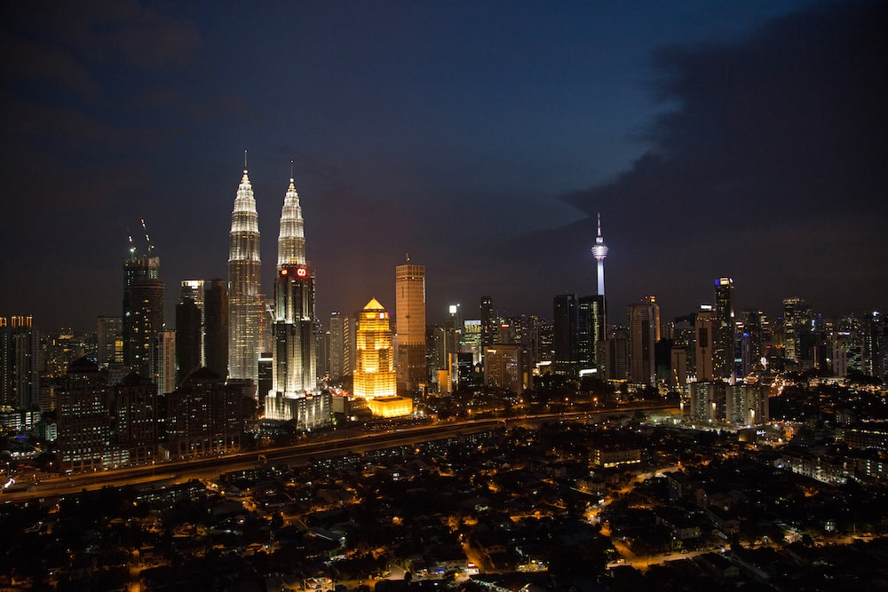

**Key Word/Phrase: Urbanisation**

**You cannot use the following!**

* **Development**
* **Rebranding**
* **Construction**
* **Not a rural space**
* **Greenfield Sites**

Photo Credit: Caitlin Pop



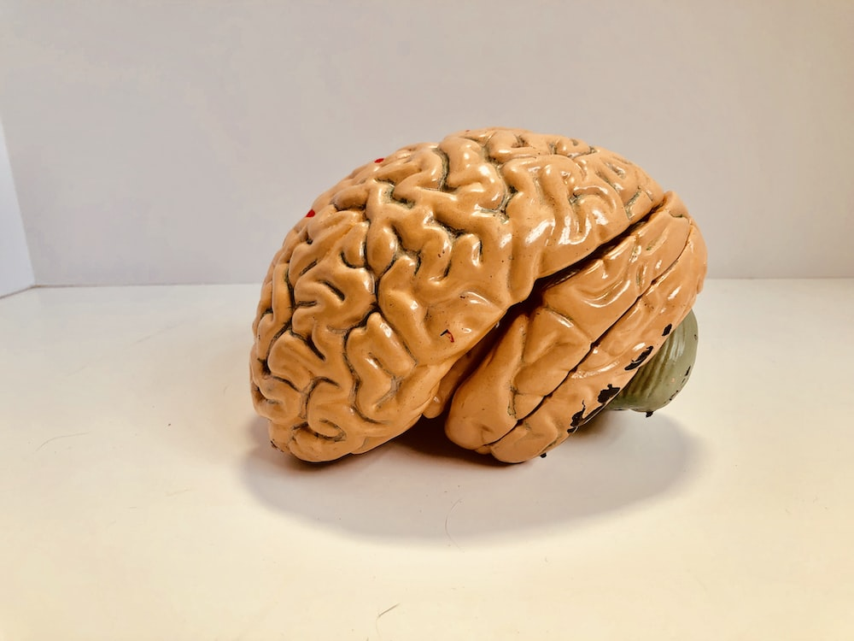

**Key Word/Phrase: Brain Drain**

**You cannot use the following!**

* **Migration**
* **Intelligence**
* **Cities**
* **Countryside**
* **Young People**

Photo Credit: Natasha Connelll



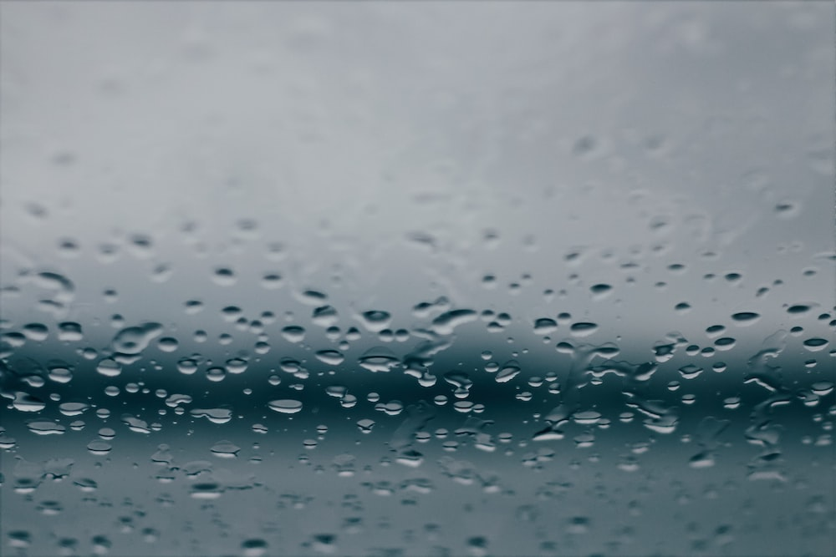

**Key Word/Phrase: Precipitation**

**You cannot use the following!**

* **Rainfall**
* **Snow**
* **Sleet**
* **Falling from clouds in the sky**
* **Part of the Water Cycle**

Photo Credit: Brianna Tucker



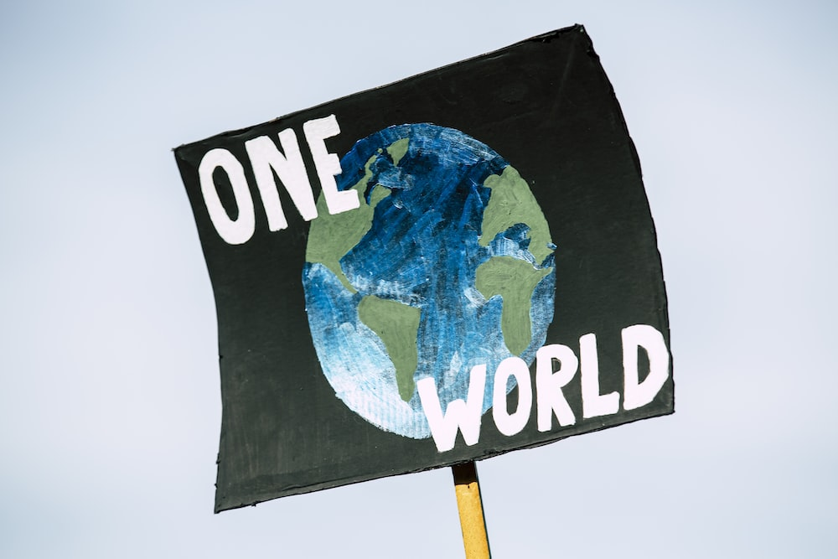

**Key Word/Phrase: Climate Change**

**You cannot use the following!**

* **Global Warming**
* **Extreme Weather**
* **Rising Sea Levels**
* **Melting Ice**
* **Extinction**

Photo Credit: Markus Spiske

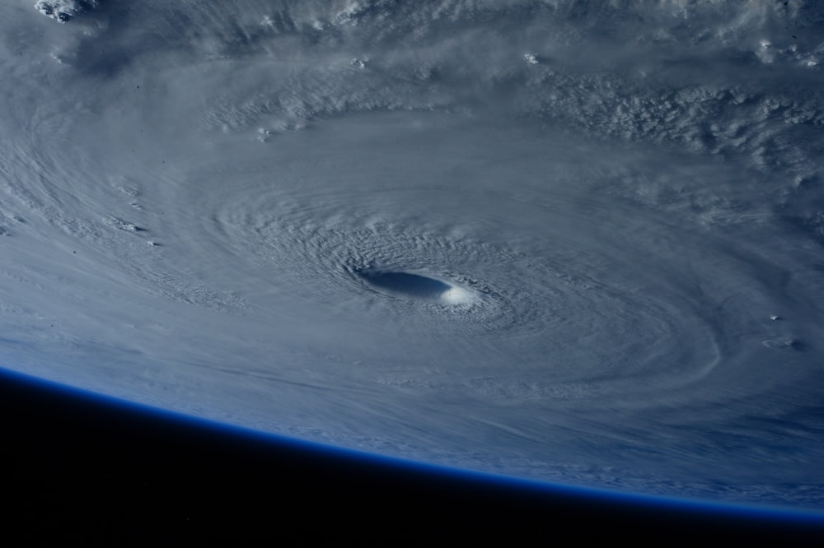

**Key Word/Phrase: Hurricane**

**You cannot use the following!**

**- Typhoon**

**- Eye of the Storm**

**- Any case studies**

**- Storm Surge**

**- Deadly**

Photo Credit: NASA



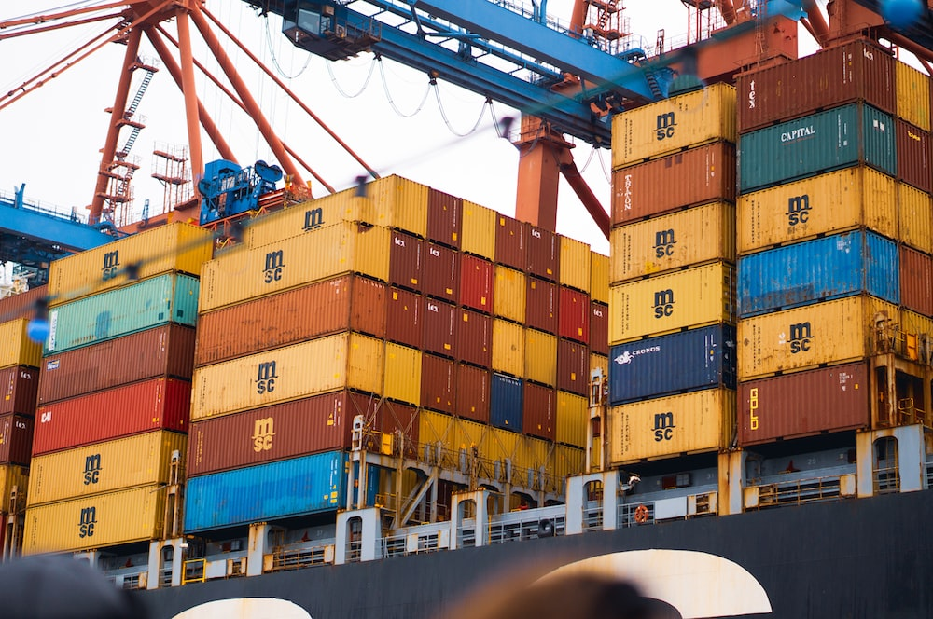

**Key Word/Phrase: Globalisation**

**You cannot use the following!**

* **Trade**
* **Import**
* **Export**
* **Shipping**
* **Connections**

Photo Credit: Eilis Garvey



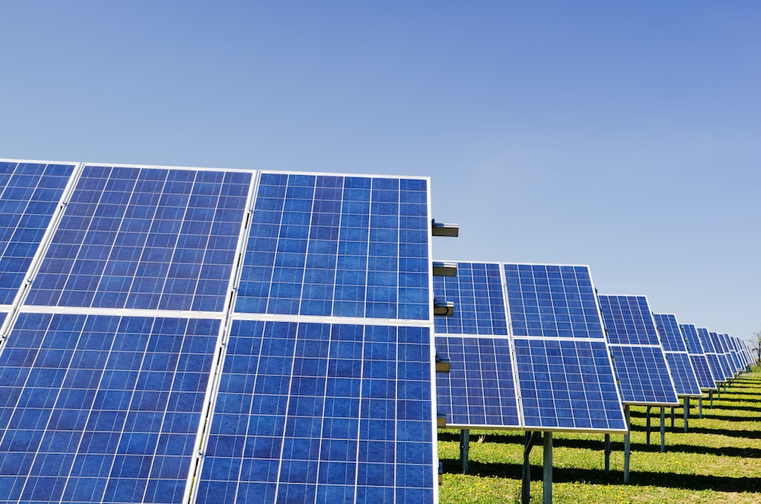

**Key Word/Phrase: Renewable Energy**

**You cannot use the following!**

* **Solar**
* **Wind**
* **Nuclear**
* **Green Energy**
* **Fossil Fuels**

Photo Credit: Zbynek Burival



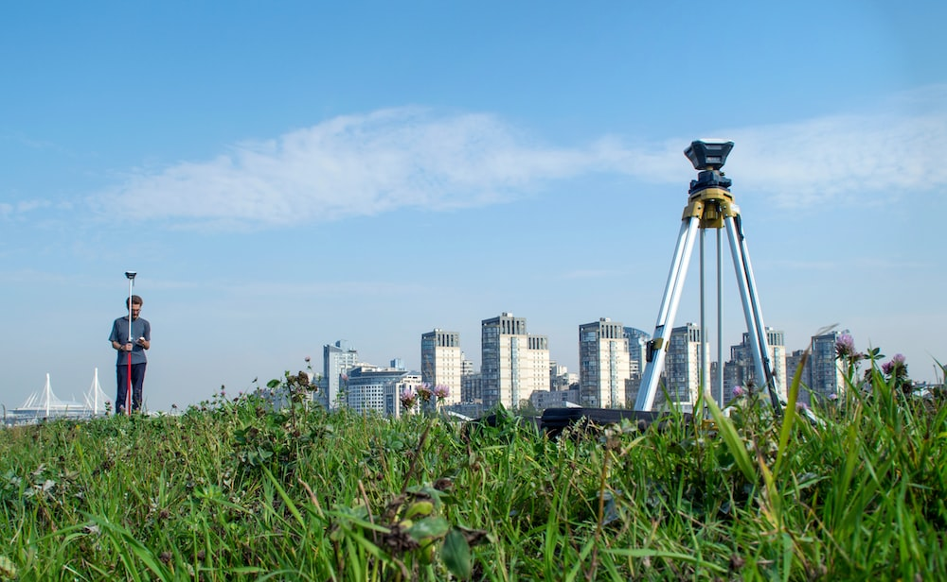

**Key Word/Phrase: Fieldwork**

**You cannot use the following!**

* **Testing**
* **Planning**
* **Research**
* **Hypothesis**
* **Investigation**

Photo Credit: Valerie V



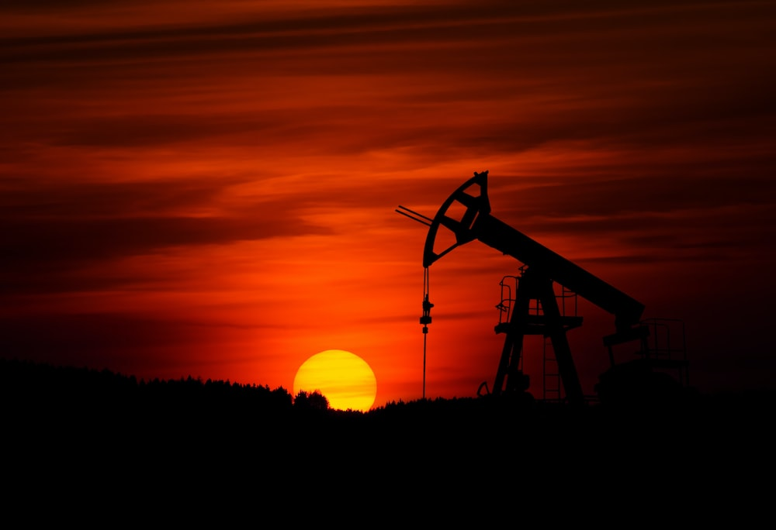

**Key Word/Phrase: Fossil Fuels**

**You cannot use the following!**

* **Mining**
* **Burning**
* **Oil**
* **Coal**
* **Renewable Energy**

Photo Credit: Zbynek Burival



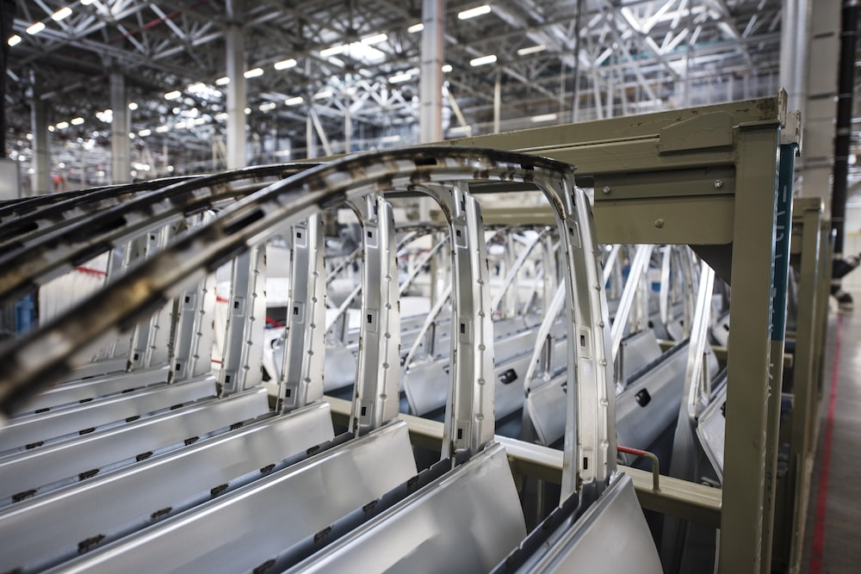

**Key Word/Phrase: Manufacturing**

**You cannot use the following!**

* **Secondary Sector**
* **Creation**
* **Cars**
* **Trade**
* **Workers**

Photo Credit: Carlos Aranda



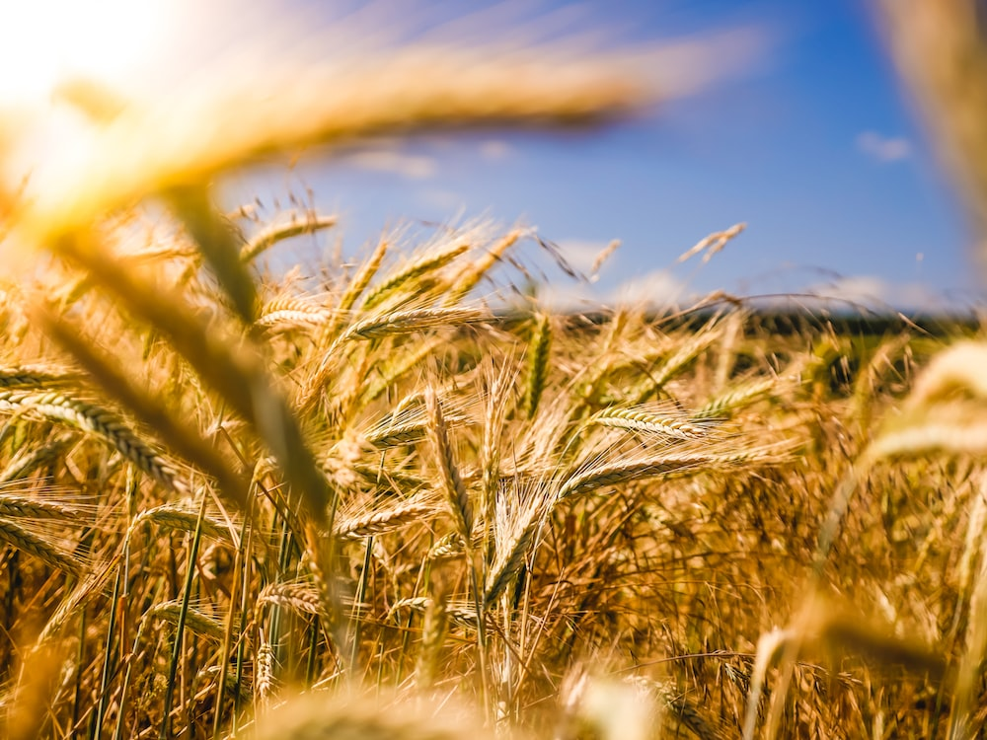

**Key Word/Phrase: Farming**

**You cannot use the following!**

* **Primary Sector**
* **Production**
* **Growth**
* **Food**
* **Crops**

Photo Credit: Raphael Rychetsky





**Key Word/Phrase: Quaternary Sector**

**You cannot use the following!**

* **Consultants**
* **Support**
* **Highest level**
* **Innovation**
* **Entrepreneur**

Photo Credit: KrakenImages





**Key Word/Phrase: Services**

**You cannot use the following!**

* **Tertiary**
* **Services**
* **Retail**
* **Businesses**
* **Goods**

Photo Credit: Patrick Tomasso



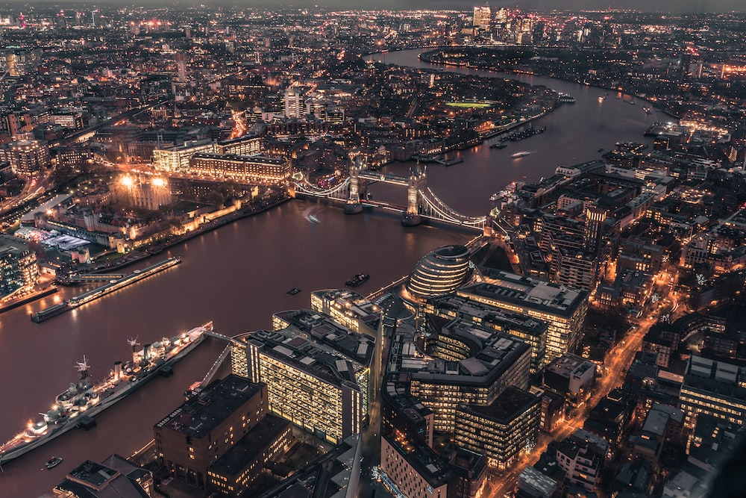

**Key Word/Phrase: World City**

**You cannot use the following!**

* **Opposite to a Mega City**
* **London**
* **Economic Power**
* **Political Influence**
* **Cultural Capital**

Photo Credit: Giammarco Boscaro



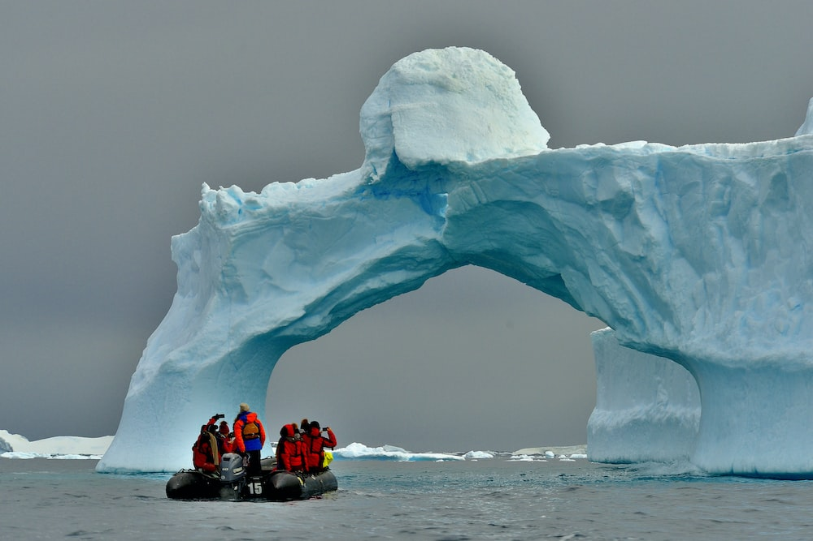

**Key Word/Phrase: Antarctica**

**You cannot use the following!**

* **Cold Environment**
* **South Pole**
* **Penguins**
* **Antarctic Treaty**
* **Weddell Sea**

Photo Credit: Long Ma

