The Fluvial System: Lessons using data skills

Lesson 3: How Stable are Rivers?

Lesson Objectives

- To use Google Earth to generate primary data linked to quantification of river channel stability
- To calculate and analyse the meander geometry of the Green River, USA
- To understand how meander geometry changes through time using the historical imagery tool in Google Earth
- To understand the implications of changing channel stability for the human population who live close to highly unstable rivers

Setting the Scene

Meandering is one of the most common river-channel patterns (Figure 1). Meanders are the result of both erosional and depositional processes where sediment is eroded from the sediment bed or the river banks, transported downstream and deposited on the inside of the meander bend. They are typical of the middle and lower course of a river because vertical erosion, which is common in the upper reaches, is replaced by a sideways form of erosion called lateral erosion. Meandering rivers are highly mobile and channels progressively move by migrating across their floodplains. How quickly or how far the channels move across the floodplain is influenced by variability in environmental conditions. Human-induced environmental changes (e.g. in-channel and landscape modifications by protective measures, agriculture, and urbanisation on or around floodplain landscapes) and climate change alter flow regime, floodplain-erodibility characteristics, and sediment-transport rates, and thus can significantly affect the patterns of channel evolution and floodplain vegetation patterns and processes.

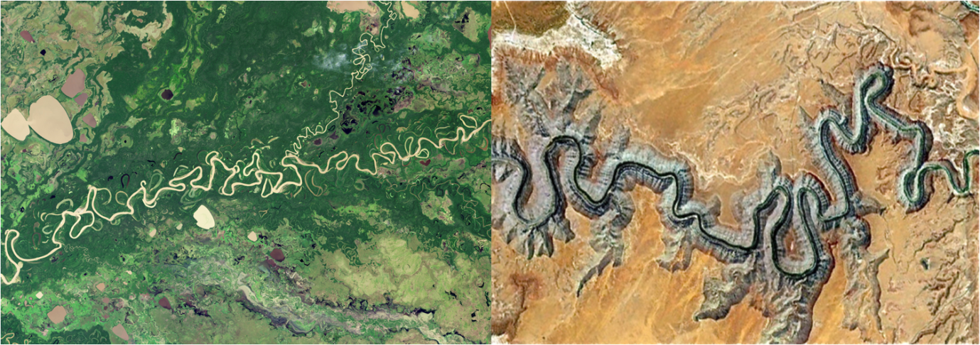
Figure 1: The meandering River Mamore in the Amazon Basin and the San Juan River, USA (Source: NASA- Thematic Mapper (TM) on the Landsat 5 satellite)

The Data

You don’t need to go out into the field to collect primary data! Satellite coverage of the Earth’s surface means we can use tools such as Google Earth to generate our own primary data for places that we can’t visit in the field. This exercise uses the historical imagery button on Google Earth to analyse meander development through time on the Green River, Washington, USA.

1) Historical Changes to the Green River USA

- Open Google Earth from the start menu
- Zoom to Donida Farm Training Centre, Auburn, WA, United States. The Green River is directly to the north.
- Draw a polygon around a section of the river. To do this click Add Polygon from the tabs along the top of the screen. This will allow you to analyse the meander development through time over that area.
- Click on the ‘show historical imagery’ button in Google Earth and scroll through the different images collected over the same area – this will give you an idea of how the river channel has changed and over what time scales

Look at the historical imagery of the Green River and discuss the findings. You might want to think about:

- Are there any obvious changes to the shape, number or morphology of the meanders in the section of the channel you have investigated?
- How quickly are any changes happening? What do you think might be causing these changes? Will these changes have any impact on land users surrounding the river?
- Are there any problems with using the historical imagery tool?

2) Calculating the change in river channels through time

- Starting for the image taken in 1990, trace the outline of the outside of the river channel over the length of your polygon. To do this click Add Path, label it as 1990 and set the measurement tab to miles. It should look something like the image below left.
- Repeat this step for 2002, 2005, 2007, 2011 and 2015 to produce and image that should be similar to below right
Figure 2: River pathways of the Green River for 1990 (left hand image) and 2002, 2005, 2007, 2011 and 2015 (right hand image).

- Are there any obvious changes to the shape, number or morphology of the meanders in the section of the channel you have investigated?
- How could you quantify the changes?

Take it Further

Using the same techniques as above, choose another local river and see if you see the same patterns

- Why might the patterns of change be similar or different?
- Can you see any differences between the land use which surrounds each river? Could you use this to explain any similarities or differences?

3) Analysing Meander Geometry Changes

We describe the appearance of the channel by analysing its planform, what it looks like from above. One way in which meander planform can be analysed quantitatively is by calculating channel sinuosity. We can calculate and compare channel sinuosity to see how it changes over time. Channel sinuosity or how ‘wiggly’ a river looks is calculated as the total channel length divided by the straight line distance.
For each of your time periods calculate:
- Total channel length (when you drew the path of the channel Google Earth automatically calculated this for you – right click on the 1990 data you added on the left hand side menu (under My Places) and click properties).
- Channel sinuosity: calculated as the total channel length divided by the straight line distance. To calculate the straight line distance draw a straight line between the start and end points of your river reach. This number will stay the same for all of your time steps. To calculate the sinuosity, divide the channel length by the straight line distance. A straight channel with no meandering would have a value of 1, so the higher the value the more sinuous the channel.

Look at the data you calculated and discuss the findings. You might want to think about:

- how the channel sinuosity changes through time
- what might cause the channel to change in sinuosity?
- what might be the implications of this change in channel sinuosity?

Plenary

- How useful has the historical imagery been during this practical? Can you think of any advantages and disadvantages of using this rather than carrying out fieldwork?

Figure 3: Headline taken from the Guardian online (November 2017) ‘The shifting river that is making Uganda smaller’.

- Using your data think about the human implications for the changes to the channel planform
  - How can you place this in a global context? You could look at the case of the Ucali river in Uganda where the shifting course of the river is causing significant political and economic tensions
  - Do you think the migration of the Green River is likely to cause such serious implications? Why?

Further Resources
https://www.theguardian.com/environment/2010/dec/07/climate-change-rerouting-semliki-river
http://www.climateactionprogramme.org/news/conflict_between_uganda_and_drc_as_border_shifts
http://www.theeastafrican.co.ke/news/2558-683118-ubpbg0z/index.html

