Bitcoin and El Salvador

What was announced in early June?
On Tuesday 8 June, the Congress of El Salvador approved the proposal by El Salvadoran President Nayib Bukele to formally recognise Bitcoin as legal tender in the Central American country. This was heralded as a remarkable moment — a moment when a decentralised digital currency was first adopted by a nation state.

The president is attempting to change the global financial market and more specifically the flow of capital from foreign El Salvadorean workers into the country as Bitcoin has no single authority and is traded from peer-to-peer, rather than through an intermediary.

At the time of writing Coinbase values 1 Bitcoin at £23,364.56.

President Nayib Bukele
The announcement is groundbreaking as it marks El Salvador as the first country in history to use a digital currency and has propelled President Nayib Bukele to fame. He is in power in opposition to the two traditional political parties in El Salvador. After election in 2019 President Nayib Bukele ordered the occupation of El Salvador’s legislative assembly with troops in 2020, and in May this year removed five judges and the attorney general from the Supreme Court.

Described by Time magazine as ‘iconoclastic’ President Nayib Bukele has used social media to communicate to his base, as exemplified here. On 9 June President Nayib Bukele announced in a post on Twitter that the El Salvadoran Congress had passed #BitcoinLaw.

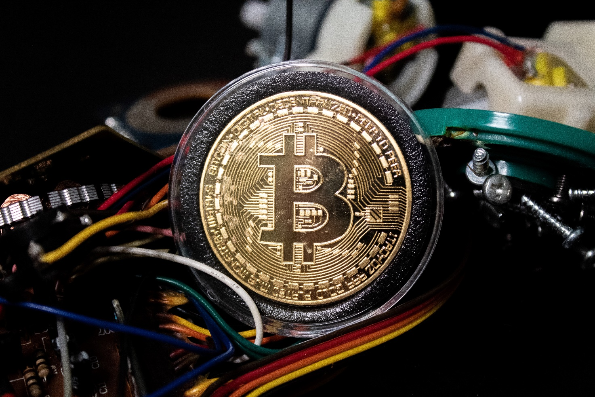
Bitcoin, a cryptocurrency © Brian Wangenheim Unsplash

Bitcoin
Since the Congressional vote on the cryptocurrency a fortnight ago President Nayib Bukele has suggested that the digital currency will help more than a million Salvadorean low-income families with the transfer of money. El Salvador has made history by being the first country to use Bitcoin as legal tender.

There is both excitement (mainly from those who already have Bitcoins) and widespread apprehension about the move away from state-backed currencies. A brief list of the possible positives and negatives of using Bitcoin is outlined below.

Positives
- President Bukele hopes this will help the 70% of El Salvadoreans who ‘are unbanked’, meaning they lack access to a basic bank account

- Bitcoin has no transaction costs (which other competitors have). This is significant as 20% of the GDP of El Salvador comes from international remittances

- The process is simplified, as opposed to Western Union recipients using agent offices (independent businesses that provide money transfer services on behalf of Western Union) for collection

- All that is required is a digital ‘wallet’ on a mobile phone (with internet access)

Negatives
- There is no central bank. Other financial institutions do not have any say in its value

- Currency valuations can skyrocket and plummet due to a number of influencing factors

- The future of the cryptocurrency is uncertain particularly as there are ‘whales’ who have huge amounts of Bitcoin. These individuals are unknown and can cause huge drops in Bitcoin value if they decide to sell

Further reading
- Bitcoin: El Salvador makes cryptocurrency legal tender www.bbc.co.uk/news/world-latin-america-57398274

- Bitcoin: El Salvador’s grand experiment www.theconversation.com/bitcoin-el-salvadors-grand-experiment-162382

- El Salvador’s millennial president is a man with one vision: Power www.latimes.com/world-nation/story/2021-05-16/nayib-bukele-the-most-popular-president-in-the-world-is-a-man-with-one-ideology-power

- Bukele’s Power Grab Is Alarming Everyone but Salvadorans www.worldpoliticsreview.com/articles/29629/as-voters-tire-of-corruption-el-salvador-dictatorship-is-now-an-option

- US expresses concern over El Salvador vote to remove judges US expresses concern over El Salvador vote to remove judges - ABC News

- El Salvador votes to become first country to use Bitcoin as legal tender www.news.sky.com/story/el-salvador-votes-to-become-first-country-to-use-bitcoin-as-legal-tender-12328696

