The Russian Arctic: permafrost Q&A activity sheet 1

Instruction
Using the websites provided (and suggested books) answer the following questions on permafrost. This is a 45-minute research-based activity.

A Level Specification
Edexcel
6.9 Future emissions, atmospheric concentration levels and climate warming are uncertain owing to natural factors (the role of carbon sinks), human factors (economic growth, population, energy sources) and feedback mechanisms (carbon release from peatlands and permafrost, and tipping points, including forest die back and alterations to the thermohaline circulation).

AQA
3.1.1.3. Changes in the carbon cycle over time, to include natural variation (including wildfires, volcanic activity) and human impact (including hydrocarbon fuel extraction and burning, farming practices, deforestation, land use changes).

OCR
2.b. Case study of the Arctic tundra, including: water and carbon cycles specific to Arctic tundra, including the rates of flow and distinct stores.

Eduqas
2.1.10. The implications of feedback within and between the two systems for life on Earth, including Arctic permafrost thawing.

Activity
- NASA Kids. What is permafrost?

- What is permafrost made of?

- Where is frozen ground? Where is it found?

- Climate change and the Russian Arctic. Average global temperatures have warmed by roughly 1°C compared to pre-industrial times but to what extent has climate change been felt equally around the world?

- Satellites pinpoint communities at risk of permafrost thaw. Where is permafrost thawing rapidly?

- How Thawing Permafrost Is Beginning to Transform the Arctic. How much of the world’s permafrost could disappear by 2100?

- Give some examples of the ‘enormous’ consequences of thawing permafrost.

- Permafrost thaw could release bacteria and viruses. Why is thawing permafrost a problem?

- How microbes in permafrost could trigger a massive carbon bomb. How big a store of carbon dioxide is permafrost?

- The fragile future of roads and buildings built on permafrost. What infrastructure is at risk from warming ground and thawing permafrost?

- What fraction of the Arctic’s infrastructure is at risk of permafrost damage in the coming years?

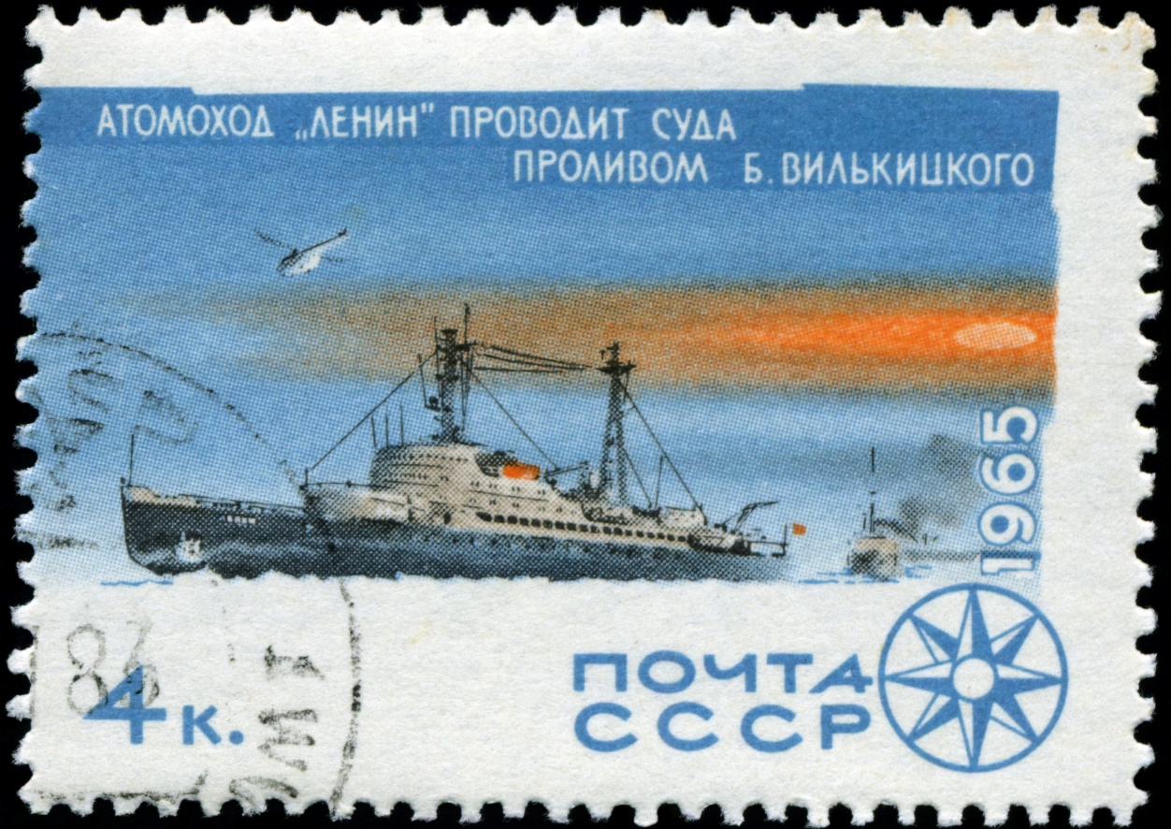
Figure 1 The world’s first nuclear powered ship, clearing sea routes in the Russian Arctic © aarrows

Answers
- Permafrost is ground that remains completely frozen for at least 2 consecutive years. This type of landscape is only found in the polar regions and at high-altitude. Continuous permafrost is an unbroken sheet of frozen material which extends under all surfaces and remains below 0°.

- Permafrost formation begins when water is trapped and frozen in soil, sediment, and rock pores. Above the permafrost lies a layer of soil that does not freeze all year, called the active layer. This layer thaws in the summer and freezes again in the winter. The active layer can range from 10 centimetres to several metres in depth.

- Due to a larger landmass (compared to the southern hemisphere), a large proportion of the world’s permafrost is found in the northern hemisphere. 24% of the land in the northern hemisphere has permafrost underneath it. In the southern hemisphere only the high-altitude Patagonia region of South America and New Zealand's Southern Alps have permafrost. South America also has seasonally frozen ground.

- The poster Climate change and the Russian Arctic section on Permafrost explains ‘Arctic amplification’ as an increase in Arctic temperatures at a rate twice as fast as those experienced in the mid-latitudes. Current estimates go further warning the rate is 2-3 times as fast. The phenomenon causes the active layer of topsoil to deepen, making more organic matter available for biological decomposition.

- The Arctic. Since the 1970s permafrost has warmed dramatically in many areas of the Arctic including Russia, Alaska, Svalbard, and Canada. A human footprint (visible traces of human presence) across the Arctic’s land surface has increased by 15% during the last two decades.

- Some 2.5 million square miles of permafrost, 40 percent of the world’s total, could disappear by the end of the century.

- The release of huge stores of greenhouse gases, including methane, carbon dioxide, and nitrous oxide which were previously locked in the permafrost. Indigenous people will struggle to lead subsistence lifestyles. Ground disintegration will cause slumping, trigger landslides, and accelerate coastal erosion. Stream flow will change, lakes will suddenly drain, and water chemistry will be altered (becoming more acidic). Due to these changes thawing permafrost has the potential to dramatically alter the terrestrial and aquatic food webs of tundra lakes in the Arctic.

- Thawing permafrost has been identified as a major risk because it could release new pathogens. More than 100 diverse microorganisms discovered in Siberia have been found to have antibiotic resistance. Over the last 70 years more than 1,000 settlements have been built on permafrost, significantly increasing the likelihood of transmission to the local Arctic population.

- For most of human history, permafrost has been Earth’s largest terrestrial carbon sink, trapping plant and animal material in its frozen layers for centuries. It currently stores about 1,600 billion tonnes of carbon, more than twice the amount in the atmosphere today. Permafrost is one of the world’s largest carbon sinks. It holds twice as much as currently contained in the atmosphere.

- Buildings, roads, railways, and pipelines constructed in these areas are increasingly at risk of damage.

- A third of the Arctic’s infrastructure is at risk of permafrost damage. The open-access source of the claim Degrading permafrost puts Arctic infrastructure at risk by mid-century also states 45% of the hydrocarbon extraction fields in the Russian Arctic are in regions where thawing permafrost will cause ground instability and severe damage. Across the wider Arctic nearly 4 million people and 70% of current infrastructure in the permafrost domain are in areas with high potential for permafrost thawing.

Thank you to Dr Alexey Kokorin, Head of the Climate and Environment programme at WWF-Russia, for helping with the production of this resource

