The Russian Arctic: ArcGIS permafrost activity sheet 2

A Level Specification
AQA
3.1.4.5 Human impacts on cold environments. Recent and prospective impact of climate change. Management of cold environments at present and in alternative possible futures.

Edexcel
Topic 7: Superpowers. 7.5 Superpowers and emerging nations play a key role in international decision-making concerning people and the physical environment.

OCR
Topic 3.1 – Climate Change. 4.b. The impacts of climate change are global and dynamic. Implications of climate change currently being experienced for people and the environment, such as from changes to ecosystems.

WJEC
4.2: Ecosystems. 4.2.6 The Arctic tundra biome. Impacts of climate change on the Arctic tundra biome.

Where is the Russian Arctic?
The Arctic Circle is a line of latitude 66.5°N of the equator. The Russian Arctic is the largest land mass of all the Arctic countries (there are 8 Arctic countries in total, all are part of an intergovernmental forum called the Arctic Council) stretching along 24,140 kilometres of Arctic Ocean coastline.

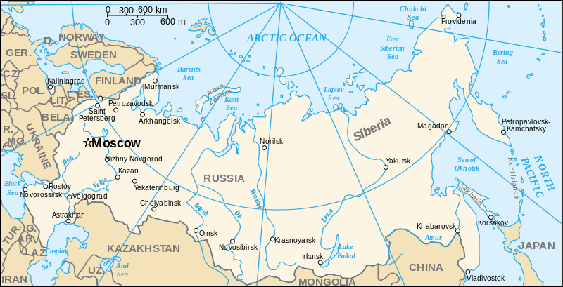
Figure 1 a map of Russia showing the 66°N line of latitude, Norilsk, and the two deep water ports of the Arctic

Infrastructure at risk
The Russian Arctic is rapidly altering due to climate change. As the climate warms, and Arctic permafrost thaws, infrastructure is increasingly at risk of collapse.

Activity
Go to ArcGIS Online and open the RGS-IBG map titled Circumpolar permafrost map for infrastructure risk RCP 4.5 scenario and explore the graphic (screenshot below in Figure 2).

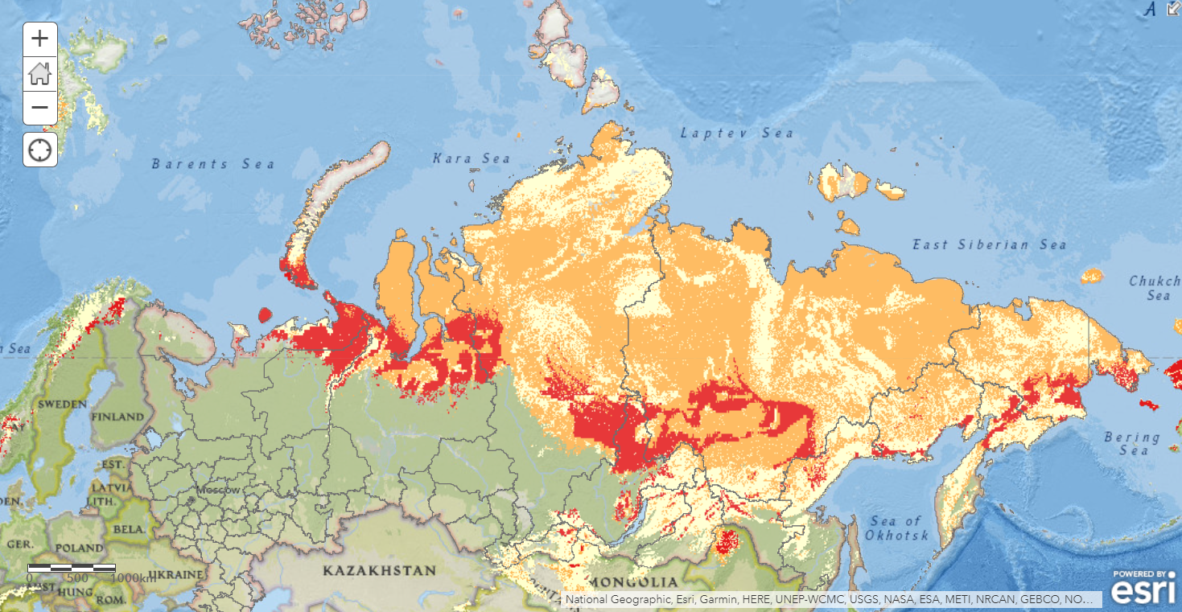
Figure 2 the Circumpolar permafrost map for infrastructure risk RCP 4.5 scenario, for the Russian Federation

This ArcGIS map illustrates infrastructure at risk, on a severity scale of 1 to 3, for the Russian Arctic. The risk zonation index has 3 geohazard indices: 3 = high hazard, 2 = moderate hazard, and 1 = low hazard.

It is open data, extracted from the paper Circumpolar raster grids of permafrost extent and geohazard potential for near-future climate scenarios by Karjalainen et al., 2018, and is based on the RCP scenario 4.5 for 2041-2060 (bear in mind the paper covers the whole circumference of the Arctic).

RCP stands for Representative Concentration Pathways (RCPs). They are a method for capturing those assumptions (on the economic, social, and physical changes to our environment) within a set of scenarios.

There are 4 main scenarios: RCP2.6, RCP4.5, RCP6.0 and RCP8.5.

Each of these projections are tied to a future change in temperature, shown in Table 1.

RCP | Change in temp °C
RCP2.5 | 1.3-2.2
RCP4.5 | 1.6-2.5
RCP6.0 | 1.7-2.6
RCP8.5 | 1.9-3.0
Table 1Carbon Brief mid-term estimates (2041-2060)

The authors of the paper focused on current infrastructure fundamental to the Russian Arctic communities and economic activity, including residential (settlements and buildings), transportation (roads, railways, and airports) and industrial facilities (pipelines and industrial areas).

- Describe the overall pattern of infrastructure risk across the Russian Federation.

- Using the boundary outlines for the Nenets Autonomous Okrug (NAO) and the Yamalo-Nenets Autonomous Okrug (YaNAO) in Appendix A, locate the two districts on the ArcGIS map.

- Zoom into the districts and screenshot that section of the map. Copy this into a PowerPoint slide and overlay the outlines from Appendix A.

- Which Okrug has the most infrastructure at a high level of risk (in red)?

- Using your work from activity sheet 1 locate Norilsk on the Taimyr Peninsula. What level of risk to infrastructure might Norilsk Nickel be vulnerable to in the future?

- Again, use your work from activity sheet 1. Locate the Yamal LNG plant in Sabetta, and the Yamal LNG-2 plant on the Gydan peninsula in the YaNAO. What level of risk to infrastructure might Novatek be vulnerable to in the future?

Further reading
- Pangaea Circumpolar raster grids of permafrost extent and geohazard potential for near-future climate scenarios

- Nature (full article) Degrading permafrost puts Arctic infrastructure at risk by mid-century

- Carbon Brief In-depth Q&A: The IPCC’s sixth assessment report on climate science

- The Arctic Institute Russia, Facts and Figures

- The Economist NATO is facing up to Russia in the Arctic Circle

Appendix A
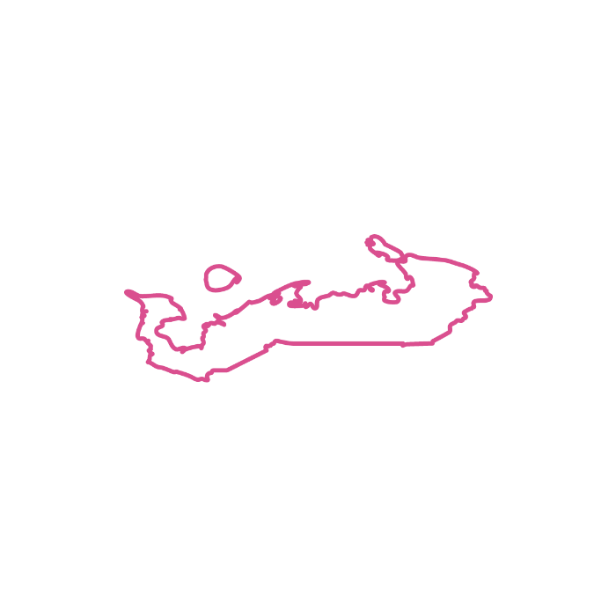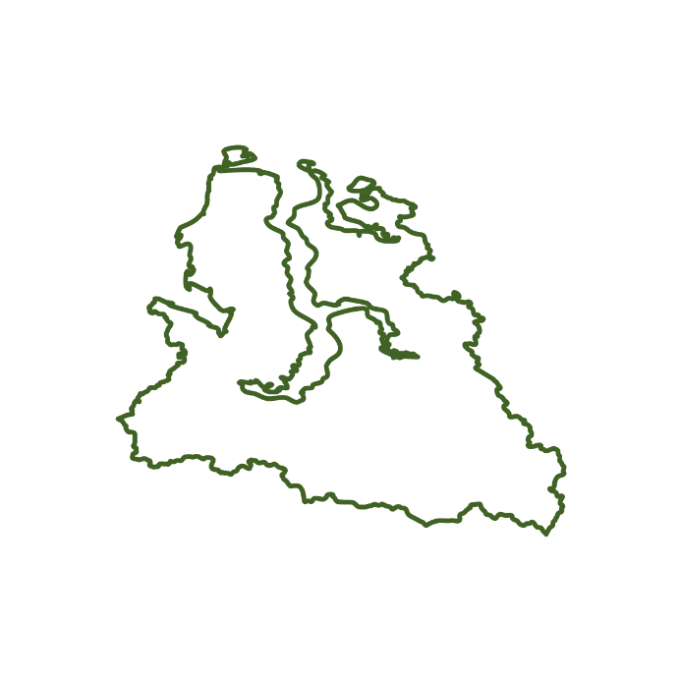
Figure 3 the Nenets Okrug and the Yamalo-Nenets Okrug

Answers
- Much of the Russian Federation above 60°N is at risk of infrastructure damage from thawing permafrost. As expected, infrastructure risk appears greatest across the Arctic tundra (above 66°N within the Arctic Circle). The Nenets and the Yamalo-Nenets Okrugs appear to have a very high level of risk in the northwest of the country, with Salekhard for example being very vulnerable. This high-risk zone then sweeps across the Middle Siberian Plateau with towns like Olёkminsk and Yakutsk being covered along the River Lena. In the Russian Far East another autonomous area, Chukotka, also has areas of high infrastructure vulnerability.

- The NAO is most at risk to infrastructure damage in the mid-term (2041-2060). The coastal region of NAO is considered high risk for infrastructural damage due to thawing permafrost.

- The Norilsk Nickel mine is located in an area which will experience ground deformation from thawing permafrost in the future. There will be a future geohazard to the site. However, it is categorised in the lowest of the 3 geohazard indices for infrastructure risk.

- The Yamal LNG plant at Sabetta is forecast to experience greater infrastructure risk than Norilsk. There will be a moderate geohazard level to the port and nearby LNG facilities from thawing permafrost. This thaw is accelerated in places such as along the Arctic coast as permafrost is eroding into the sea. The same moderate geohazard classification also applies to the site of the LNG-2 plant (across the estuary) on the Gydan peninsula.

Thank you to Dr Alexey Kokorin, Head of the Climate and Environment programme at WWF-Russia, for helping with the production of this resource

