Colombo, Sri Lanka
- Factsheet

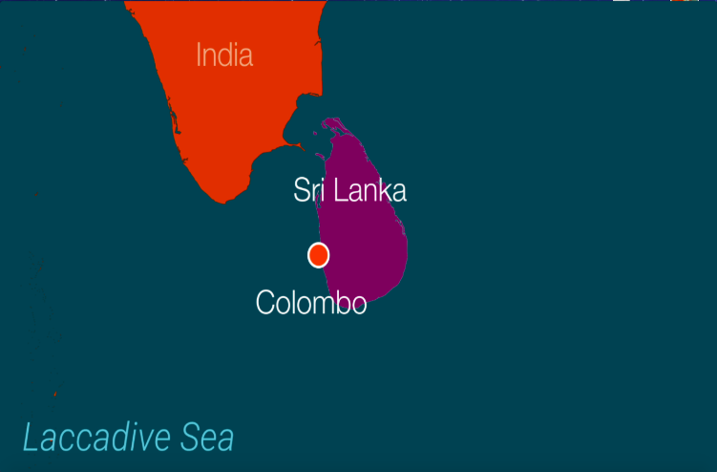
Population
The city’s official population is about 750,000, but the Greater Colombo urban area has a population of more than 2 million. There are three broad ethnic groups: Sinhalese, Tamil and Muslim that work and live in close quarters.

Climate
Colombo has a hot tropical climate with a monsoon season, resulting in annual localised flooding. Average annual temperature is 27⁰C and average annual rainfall is 2348 mm.

Economy
Sri Lanka has a GDP per capita of $12,900. 7.8% of the population work in agriculture; 30.5% in industry and 61.7% in services.

Infrastructure
18.5% of Sri Lankans live in urban areas but this is increasing, with the current annual rate of urbanisation at 0.85%. Due to the history of urban development of Colombo, there is very little spatial difference between the wealthy and the poor. The buildings are a mixture of old colonial buildings, hotels for tourists, and informal settlements. Informal settlements and communities have developed in any space available, often originating in gardens of larger properties.

In the neighbourhoods studied in this research, housing varies from permanent to semi-permanent structures and many families are waiting to be relocated to high-rise buildings as part of a state-led regeneration project.
Politics
Sri Lanka recently came out of a 26-year civil war, exacerbated by religious and ethnic difference.

Why are people moving?
Migrants move from rural or plantation areas to the city often in the hope of seeking better employment opportunities and accessing better infrastructure. Movement has also been driven by environmental change and conflict. Communities often move internally due to forced evictions.

