Everyday Drone Stories
KS3.5 Drone Map

Context
As you saw in Activity 3.3 What are drones? and Activity 3.4 Categories and restrictions, drones are increasingly common in UK skies and are subject to a range of rules and regulations.

This activity encourages you to develop and share your views on drones. To do this, you are going to create a map of a place familiar to you and mark out where you think drones are currently used and could be used in the future, what the drones are used for, and who or what you think this drone use might impact.

There are no right or wrong ways to make or present your map. We are interested in learning about how children and young people view drones.

For this activity you’ll need some paper and drawing materials (pens or pencils).

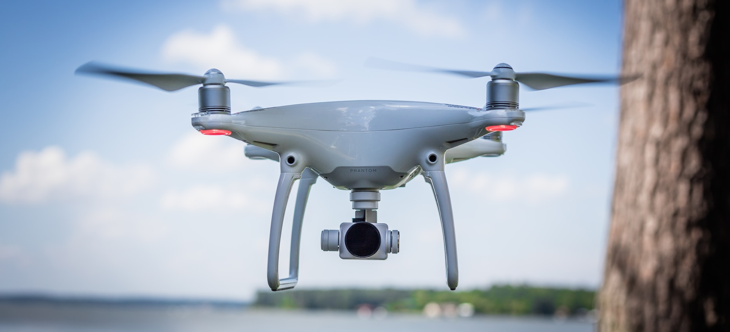
Figure 1 © Vlad Busuioc

Activity: Drone Map. Getting started with your map
- Decide where you’d like your map to cover (this might be your home and garden, route to school, town centre and shops, or a local park – or it can be somewhere completely different!)

Please tell us where you have chosen to focus on for your map:

…………………………………………………………………………………………………………

…………………………………………………………………………………………………………

- Start with a new piece of paper and write your name in small letters on the top of the page.

- Mark some key locations and features on the page. Label the most important places (what are they?) and mark on if they connect together (for example by a path, road, or railway).

You can draw anywhere on the page!

The example below might help you get started, but you are welcome to make your map however you like (there is no right or wrong way, and your map might look really different!).

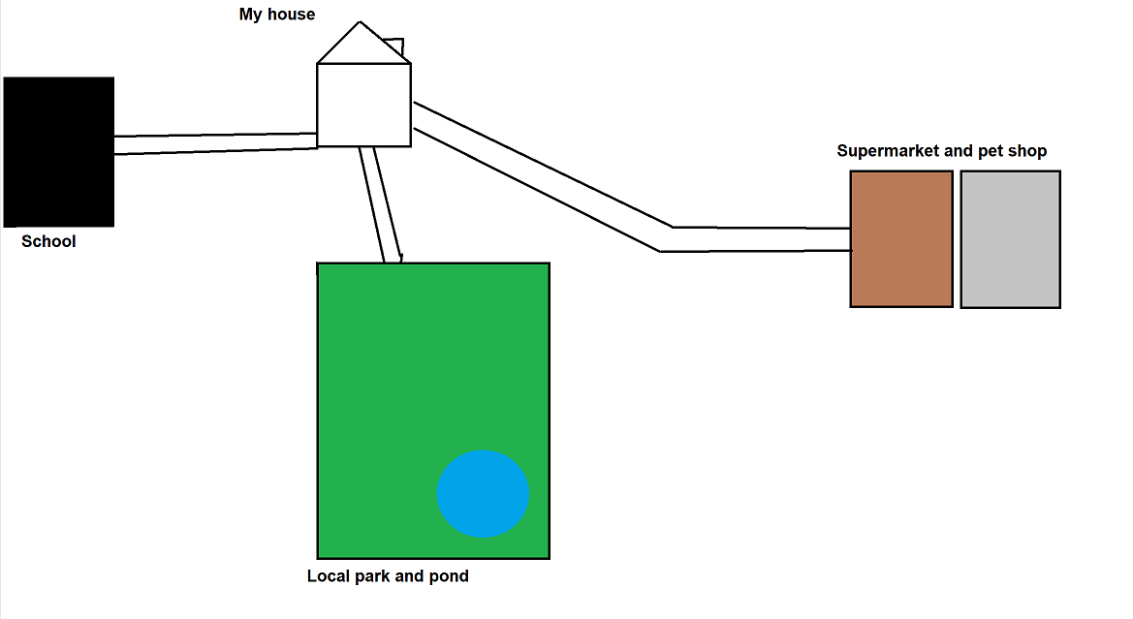
Figure 2 An example drone map

How might drones currently be used in your map’s location?
- Think about how drones, like the one pictured on the page before this, might be used at some of these locations. Could drones be used to take pictures, to monitor or watch over something, to transport something?

Use your imagination – there are no right or wrong answers! Add your ideas about how drones could be used next to each place (you could draw a picture of your idea of drone use, or you could write it down). Tell us what the drone is doing and why.

- It would be great to add in some further information about who might be using these drones, and who might be impacted by these drones? Could drones be used by you, or a local business? Might they excite some people or annoy people or animals with their noise? You can add labels, notes or even emojis to your map!

How might drones be used in the future in your map’s location?
- Lastly, think about how drones might be used in the future – perhaps the technology has changed and can do more things, or you can imagine new or extra applications? There are no right or wrong answers! If you have any ideas about how drones could be used in the future, add these to your map and include a small F (for future) next to them. What might these drones do? Who might be impacted by them?

If you need extra space, you are welcome to use another piece of paper.

If you are happy to share a copy of your map with the researchers, please tell your teacher and they will arrange this. You will be able to keep your original map.

