The Russian Arctic: analysing climate change activity sheet 3

This is a teacher worksheet for A-Level geography that is designed to develop data and GIS skills, and/or complement a wider scheme of work on climate change in the Russian Arctic.

A Level Specification
AQA
3. 1. 4. 5. Human impacts on cold environments, Recent and prospective impact of climate change. Management of cold environments at present and in alternative possible futures.

Edexcel
6. 8 8 There are implications for human wellbeing from the degradation of the water and carbon cycles,

OCR
2. b. It is possible to identify the physical and human factors that affect the water and carbon cycles in an Arctic tundra area.

Eduqas
3. 2. 6 The Arctic tundra biome, Impacts of climate change on the Arctic tundra biome

Context
During their A-level course students should understand the nature and use of different types of geographical information, including qualitative and quantitative data, primary and secondary data, images, factual text and discursive/creative material, digital data, numerical and spatial (GIS) data and other forms of data, including crowd-sourced and 'big data'. Students should collect, analyse, and interpret the information, and demonstrate their ability to understand and apply suitable analytical approaches to the different information types.

Data skills: finding and cleaning secondary data
Time-series climate data for the Russian Arctic are difficult to obtain.

- Why might this be the case?

Using https://climatecharts. net/ (which maps data provided by NOAA) suitable weather stations were located and an Excel workbook created containing historic temperature data (between the years 1989 and 2019) for stations adjacent to the Barents and Kara seas.

Open the Excel file Russian arctic temperature data. xlsx.

- These data were transcribed by hand. Given that a typical error rate for data entry is 1% why might the error rate be higher or lower for a given data series?

- Each location is missing some data (for reasons unknown). Compare the two methods below to determine how many data are likely to be wrong and comment on the results.

Method 1: Six locations with 12x30 data means 2160 data. Calculate 1% of this number.

Method 2: Use the Count function in Excel to improve the accuracy of your estimate – this will provide you with an accurate number of data points. For each location, choose a blank cell, and type =Count(XX:YY) where XX:YY is the range of cells you are counting (click to the top left cell in the data, and drag the mouse to the bottom right cell). Once you’ve done this for each location, add the counts together and calculate 1% of this number.

The original data are provided as a PDF (Russian arctic climate data. pdf). As you can see, the decimal place between numbers is quite hard to read, and the numbers are quite small on the page suggesting that errors are perhaps more likely than would otherwise be the case. (Did you note legibility/eyesight as a potential source of error?)

It would take too long to check each number individually, but it would be good to reduce the number of errors in the data set? if possible — using a method that balances the time this will require with the benefit of better data.

As the data are monthly temperature values, we would expect them to rise and fall with a similar pattern each year, and for this pattern to be a relatively smooth rising and falling curve.

In Excel Sparklines create mini graphs to visualise the patterns of data. They will help draw attention to unusual data points and patterns.

In Excel, click on the Murmansk spreadsheet, and then on cell N2. Click on the Insert menu to open the Insert ribbon, and then online in the Sparklines section.

Click and drag the cursor to select the data for 1989 from January to December, then release the mouse button, and press the OK button. Click on cell N2 again and move the mouse to the bottom-right corner of the cell until the cursor changes to a small black cross, then click and drag down to cell N32. Release the mouse button, and Sparklines will be drawn for all years.

Repeat this process for the other five locations.

Using either a printed copy of the original data or splitting the screen between the PDF and Excel worksheet, look for unusual Sparklines and check the original data. Correct any errors you find.

- How many errors did you find?

- Were the patterns in the data consistent enough for this to be a useful process (i.e., given the time taken, the errors corrected, and the likelihood of errors remaining)? Comment on any issues you have noticed.

Descriptive statistics
To consider the characteristics of the Arctic climate that will provide context for further analysis some basic statistics are useful.

For each of the calculations below, make sure you adjust the displayed number of decimal places using the decrease decimal button on the home ribbon (below).

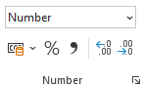

- Using the Murmansk spreadsheet to begin with, write Average/Max./Min./Range as column headings in cells P1-S1.
- To calculate the average temperature for a year, click in cell P1, and type the formula =Average(B2:M2). (You can also click and drag to select the range of cells).
- To determine the maximum average monthly temperature for the year, click on cell Q2, and enter the formula =max(B2:M2).
- To determine the minimum average monthly temperature for the year, click on cell R2, and enter the formula =min(B2:M2).
- To determine the range between minimum and maximum temperatures for the year, click on cell S2, and enter either =Q2-R2, or =Min(B2:M2)-Min(B2:M2).
- Copy the formulae by selecting cells P2:S2 with your mouse, moving the cursor to the bottom-right of cell S2 where it will change to a small black cross, then clicking and dragging down to the bottom row of data.
- Next, type Average temperature in cell A33, then click on cell B33 underneath the column of data for January. Calculate the average January temperature with the formula =Average(B2:B32), then copy this formula across to the December column.
- Type Standard Deviation in cell A34, then click on cell B34 and calculate the standard deviation for the January data with the formula =STDEV. S(B2:B32), then copy this formula across to the December column.

To visualise these data we are going to create three small graphs.

First, select the column of average temperatures (including the title) (Column P). Click on the insert menu, then choose a scatter chart. Click on the key beneath the graph (if displayed) that says average and press the backspace key to delete it, then left click the x-axis, right click, then click Select data. Click the edit button, then the icon to the right of the box labelled Series X values. Choose the years 1989-2019 in Column A, and release the mouse button, then press the OK buttons to return to the spreadsheet.

Repeat this process with the Range column.

For both graphs click the data, right click, and click add trendline.

Next, select the average monthly temperatures and the standard deviations you calculated (cells B33:M34). Click the insert menu, then choose combo chart (see below).

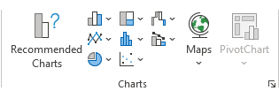

Once the chart has appeared, click on the line graph, then right click, click format data series, and click use secondary axis.

Click on Series 1 underneath the graph, right click to see the context menu, then click Select data. Click average temperature, then the edit button above it, click on cell A33, and press the OK button. Click on Standard deviation, edit, then cell A34, and press OK. Press OK on the Select data dialogue box.

On the ribbon click the Chart Design menu.

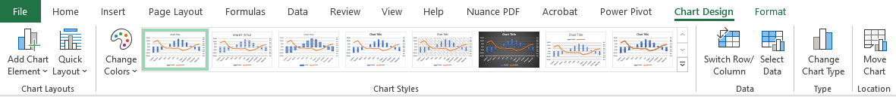

Click add chart element, axis title, then choose primary vertical, and enter Temperature (C) for the axis name. Repeat this to add a secondary vertical title of Standard deviation (C).

Repeat this process to create and format these graphs for each location.

As we are not presenting these graphs, we will not take the time to properly label the other graphs, though the process to do so would be the same.

Looking across all sites:

- Do the missing data affect the validity and/or usefulness of the data set?

- Describe the annual average temperature and temperature range data. Make sure you note and comment on any trends, and any differences between sites (you may want to refer to the Location spreadsheet to comment on the effect of latitude).

- Describe the monthly average temperatures. What do the standard deviations of each month’s temperature data tell us about the effects of climate change?

ArcGIS
Login to ArcGIS and open a new map. Click the Add button, and Search for layers, choosing ArcGIS Online from the dropdown menu above the search box.

Enter the search term climate models 2040 and add the layers for low, moderate, and high emissions published by esri_observations.

Next, enter the search term arctic sea ice extent and add the layer published by Esri.

Click on the Details button, then de-select all layers except Arctic Sea Ice Extent which maps and measures the amount of Arctic Sea ice between 1978 and 2020.

Zoom and move the map to place Norway and Svalbard to the left and top-left of the map window respectively.

Underneath the map window, click on the settings icon (see below)

Click on Show advanced options and enter the following start and end times:

Start time 3/1/1979 12:00PM
End time 4/1/1980 12:00PM

Press OK, and then press the play button to the left of the slider and wait while the images are loaded. The animation will loop but will play more smoothly once the images are cached.

- Describe the change of sea ice extent throughout 1979.

Hover the cursor over the layer name and click on show table. A Data table will appear beneath your map.

- What is the maximum sea ice extent in 1979 (don’t forget units!)

Pause the animation and change the month to March 1980 using the controls to the right of the timeline. Take a screenshot of your map (either use snip & sketch in Windows 10 or press the PrtScn button (normally above or near the backspace key).

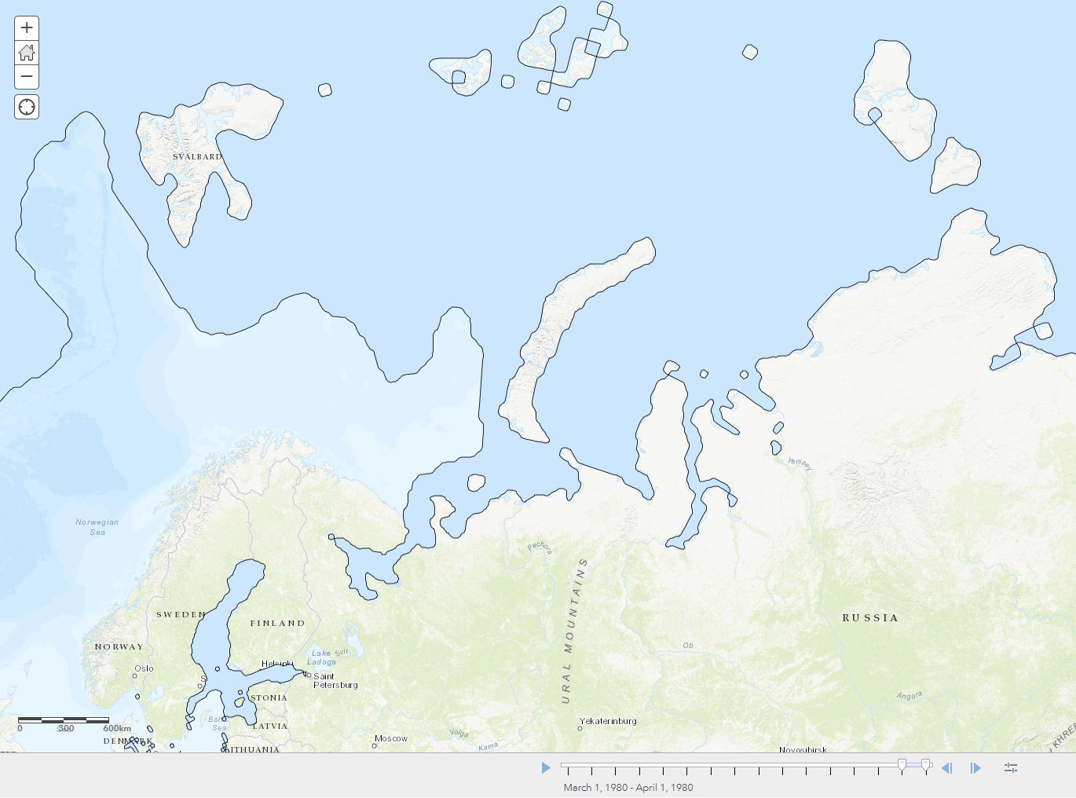

Open a new Word document, give it a title of Changing Arctic sea ice extent, and create a 2 column, 4 row table. (The Arctic ice extent layer takes a long time to load, especially if you haven't selected a small time period and even then, it might take 20 seconds). Paste your screenshot into the upper left cell in the table.

To keep track of which screenshot is which, resize each image when you paste it by clicking on the Picture menu, and resizing the image to 5cm across, then write the month and year underneath the image. In addition, record the sea ice extent from the data table beneath the map.

Repeat this process every 5 years by changing the Start and End date.

e.g. Start 3/1/1984, end 4/1/1985 to screenshot the ice extent in March 1984 — 5 years after the first screenshot.

You should end up with images and ice extent data from 1979, 1984, 1989, 1994, 1999, 2004, 2009, 2014 and 2019.

- Describe the change in sea ice extent between March 1979, and March 2019.

Click on the details tab in ArcGIS and deselect the Arctic Sea ice extent layer.

We are going to consider three different models of potential mid-century climate change that are based on Representative Concentration Pathways (RCPs) that were developed by the Intergovernmental Panel on Climate Change (IPCC) in the early 2000s. These scenarios reflect predictions of change in climate associated with potential future emissions scenarios.
We are interested in future temperatures, so enable the layer for Low Emissions (RCP 2. 6) – Temperature. Hover the cursor over the layer and click on Change style. Choose Temp Maximum in box 1, then click Options for the Counts and Amounts (Colour) layer style that should already be selected. Click on Symbols and change the colour ramp to a warm colour (scroll down to the bottom of the list to see some good options). Change the Transparency to about 60%, press OK, and then Done.

Repeat this process for the Moderate and High emissions scenarios for temperature, enabling and disabling them in turn.

- Considering each scenario in turn, describe the pattern and magnitude of warming (click on the map to find out the range of warming forecast).

Disable all layers again.

Go back to your Excel spreadsheet and click on the Locations sheet. Click File, Save a copy, and save the file as a CSV file (Comma Delimited) (*. csv) file. (Ignore any warning about loss of data or functionality — but make sure you’re saving a copy, or change the file name, otherwise you may overwrite or delete your work!).

Drag this file into ArcGIS and accept the default display options by pressing the Done button.

Re-enable the Arctic sea ice extent layer. Display the sea ice extent for December 2019 by choosing a start date of 12/1/2019, and an end date of 1/1/2020.

- Considering your answers to questions 7, 8, 11 and 12, describe and explain the extent to which climate change has already affected each location, and how it might do so by 2060.

Review the following information provided by WWF on Arctic climate change, indigenous populations, and human-animal conflicts in the Russian Arctic.

Further reading
- WWF Arctic Climate

- WWF The Arctic Circle magazine No. 2 2020 (pages 12-15)

- PBSG Summary of polar bear population status 2013

- Polar bears international When Will Polar Bear Populations Likely Start Collapsing?

- WWF Keeping people and polar bears safe

- WWF On the edge of the world: An Arctic village on the frontline of climate change

- WWF Living with polar bears

- WWF 61 polar bears gathered near a village in Chukotka, Russia

- WWF The work of polar bear patrols

- The Carbon Brief How will your local area warm in the future?

- The Guardian The Arctic is in a death spiral. How much longer will it exist?

Thank you to Dr Caroline Coch, Polar specialist at WWF-UK, for helping with the production of this resource

SPaG tip. The word data is plural. Consequently, when referring to more than one data, you should write ‘tehse data’, and not ‘the data’.

