The Russian Arctic: analysing climate change activity sheet 4

This is a teacher KS3 geography worksheet that is designed to develop data and GIS skills, and/or complement a wider scheme of work on climate change in the Russian Arctic.

Curriculum relevance
In GCSE geography students are expected:

- To obtain, illustrate, communicate, interpret, analyse, and evaluate geographical information
- To use an example data type, such as geo-spatial data presented in a geographical information system (GIS) framework

Context
The effects of climate change are increasingly being witnessed around the world. For example, in 2020, extreme heat and wildfires have been recorded across significant parts of northern Siberia.

This resource will encourage students to process data, use ArcGIS and appreciate the changes in sea ice extent.

Data skills: finding and cleaning secondary data
Time-series climate data for the Russian Arctic are difficult to obtain.

- Why might this be the case?

Using https://climatecharts.net/ (which maps data provided by NOAA) suitable weather stations were located and an Excel workbook created containing historic temperature data (between the years 1989 and 2019) for stations adjacent to the Barents and Kara seas.

Open the Excel file Russian arctic temperature data (KS3).xlsx.

- These data were transcribed by hand. A typical error rate for data entry is 1%. Compare the two methods below to determine how many data are likely to be wrong.

Method 1: Six locations with 12x30 data cells? equals 2160 data in total. Calculate 1% of this number.

Method 2: Use the Count function in Excel to improve the accuracy of your estimate by giving you an accurate number of data. For each location (there are 6 tabs), choose a blank cell, and type =Count(XX:YY) where XX:YY is the range of cells you are counting (click to the top left cell in the data, and drag the mouse to the bottom right cell). Once you’ve done this for each location, add the counts together and calculate 1% of this number.

The actual number of errors is three.

- Why might the error rate be so low? (Hint — think about what might affect how well a person could enter data without making mistakes?)

Descriptive statistics
To consider the characteristics of the Arctic climate some basic statistics are useful. These will help us identify patterns in the data. Excel will do all of the hard work!

For each of the calculations below, make sure you adjust the displayed number of decimal places using the decrease decimal button on the home ribbon (below).

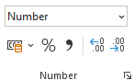

- Using the Murmansk spreadsheet to begin with, write Average/Max./Min./Range as column headings in cells P1-S1.
- To calculate the average temperature for a year click in cell P1, and type the formula =Average(B2:M2). (You can also click and drag to select the range of cells).
- To determine the maximum average monthly temperature for the year, click on cell Q2, and enter the formula =max(B2:M2).
- To determine the minimum average monthly temperature for the year, click on cell R2, and enter the formula =min(B2:M2).
- To determine the range between minimum and maximum temperatures for the year, click on cell S2, and enter either =Q2-R2.
- Copy the formulae by selecting cells P2:S2 with your mouse, moving the cursor to the bottom-right of cell S2 where it will change to a small black cross, then clicking and dragging down to the bottom row of data.

(This is a really useful thing Excel can do that will save you lots of time).

These data will be easier to understand if we visualise them. To do that we are going to create three small graphs.

To create the first two graphs select the column of average temperatures (including the title) (Column P). Click on the insert menu, then choose a scatter chart. Click on the key beneath the graph (if displayed) that says average and press the backspace key to delete it, then left click the x-axis, right click, then click Select data. Click the edit button, then the icon to the right of the box labelled Series X values. Choose the years 1989-2019 in Column A, and release the mouse button, then press the OK buttons to return to the spreadsheet.

Repeat this process with the Range column.

For both graphs click the data, right click, and click add trendline.

On the ribbon click the Chart Design menu

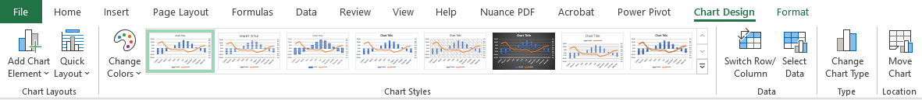

Click add chart element, axis title, then choose primary vertical, and enter Temperature (C) for the axis name.

Repeat this process to create and format these graphs for each location.

Congratulations — you have now done over 6000 calculations and plotted nearly 130 data on 12 graphs!

Looking across all 6 sites:

- Do you think the months that are missing data matter? (There are over 2000 data in total)

- What is happening to average temperature (Hint — look at the trend line). Is the same thing happening at each location?

- Looking at the Range graphs — is the climate becoming more variable (i.e. is the range increasing)? Is the same thing happening at each location?

ArcGIS
Login to ArcGIS and open a new map. Click the Add button, and Search for layers, choosing ArcGIS Online from the dropdown menu above the search box.

Enter the search term climate models 2040 and add the layers for moderate emissions published by esri_observations.

Next, enter the search term arctic sea ice extent and add the layer published by Esri.

Click on the Details button, then de-select all layers except Arctic Sea Ice Extent which maps and measures the amount of Arctic Sea ice between 1978 and 2020.

Zoom and move the map to place Norway and Svalbard to the left and top-left of the map window respectively.

Underneath the map window, click on the settings icon (see below)

Click on Show advanced options and enter the following start and end times:

Start time 3/1/1979 12:00PM
End time 4/1/1980 12:00PM

Press OK, and then press the play button to the left of the slider and wait while the images are loaded. The animation will loop but will play more smoothly once the images are cached.

- Describe the change of sea ice extent throughout 1979. When is it greatest, when is it lowest? Does it change consistently or faster/slower at certain times of the year?

Pause the animation and change the month to March 1980 using the controls to the right of the timeline. Take a screenshot of your map (either use snip & sketch in Windows 10 or press the PrtScn button (normally above or near the backspace key).

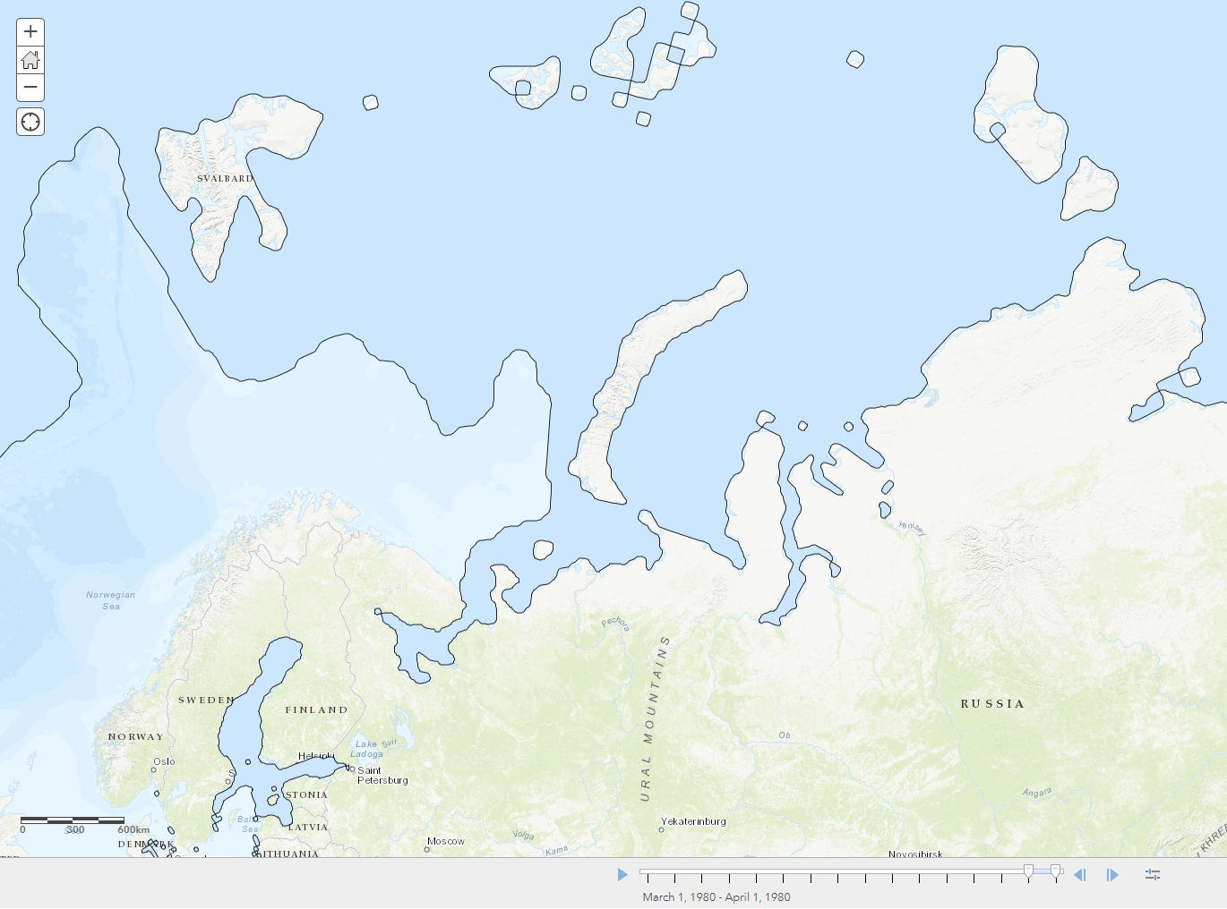

Open a new Word document, give it a title of Changing Arctic sea ice extent, and create a 2 column, 3 row table. (The Arctic ice extent layer takes a long time to load, especially if you haven't selected a small time period and even then, it might take 20 seconds). Paste your screenshot into the upper left cell in the table.

To keep track of which screenshot is which, resize each image when you paste it by clicking on the Picture menu, and resizing the image to 5cm across, then write the month and year underneath the image.

Repeat this process every 10 years by changing the Start and End date.

e.g. Start 3/1/1989, end 4/1/1990 to screenshot the ice extent in March 1990 – 10 years after the first screenshot.

You should end up with images from 1979, 1989, 1999, 2009, and 2019.

- Describe the change in sea ice extent between March 1979, and March 2019.

Click on the details tab in ArcGIS and deselect the Arctic Sea ice extent layer.

We are going to look at a map of potential climate change by 2060 if we reduce our emissions of key greenhouse gases (like carbon dioxide and methane) to levels significantly lower than they are at present.

We are interested in future temperatures, so enable the layer for Low Emissions (RCP 2.6) — Temperature, which is a climate projection. Hover the cursor over the layer and click on Change style. Choose Temp Maximum in box 1, then click Options for the Counts and Amounts (Colour) layer style that should already be selected. Click on Symbols and change the colour ramp to a warm colour (scroll down to the bottom of the list to see some good options). Change the Transparency to about 60%, press OK, and then Done.

- Describe the pattern and magnitude of warming (click on the map to find out the range of warming forecast). For example, where might it warm the most and the least, and by how much?

Find the file called Russian arctic temperature data — site locations for ArcGIS.csv and drag it onto your map.

Accept the default display options by pressing the Done button.

- Looking at the projected warming around the locations we’ve been studying, do you think the patterns/trends you described for questions 5 and 6 will continue? Why?

Further reading
- Human polar bear conflict https://arcticwwf.org/newsroom/news/61-polar-bears-gathered-near-a-village-in-chukotka-russia/

- The work of polar bear patrols https://arcticwwf.org/newsroom/stories/tatyana-minenko-the-polar-bear-patrol-chief/

- Sea ice retreat is also linked to more walrus hauling out on the land instead of sea ice (which attracts bears as well) https://arcticwwf.org/species/walrus/

Thanks to Dr Caroline Coch (WWF-UK) for helping with the content of the materials

SPaG tip. The word data is plural. Consequently, when referring to more than one data, you should write ‘these data’, and not ‘the data’.

