The Russian Arctic: sink or source activity sheet 2

The aim of this teacher worksheet is to develop understanding about the importance of permafrost and the difference between landscapes that absorb or release carbon.

A Level Specification
Edexcel
6.9 Future emissions, atmospheric concentration levels and climate warming are uncertain owing to natural factors (the role of carbon sinks), human factors (economic growth, population, energy sources) and feedback mechanisms (carbon release from peatlands and permafrost, and tipping points, including forest die back and alterations to the thermohaline circulation).

AQA
3.1.1.3. Changes in the carbon cycle over time, to include natural variation (including wildfires, volcanic activity) and human impact (including hydrocarbon fuel extraction and burning, farming practices, deforestation, land use changes).

OCR
2.b. Case study of the Arctic tundra, including: water and carbon cycles specific to Arctic tundra, including the rates of flow and distinct stores.

Eduqas
2.1.10. The implications of feedback within and between the two systems for life on Earth, including Arctic permafrost thawing.

Biomes
There are 9 global biomes. In this activity only two — tundra and taiga will be analysed. A summary biome map of Russia is in Appendix A. This is available for download on our website and has been sent to all secondary schools in England.

Permafrost
Permafrost formation begins when the temperature of the ground goes below 0°C. Often, water is trapped and frozen in soil, sediment, and rock pores. After at least two consecutive years, if the earth is still frozen, it is called permafrost. Whilst permafrost only holds 0.022% of the Earth’s water it covers a substantial 24% of the land in the northern hemisphere. It can even be found in alpine high mountain environments. Crucially, as frozen ground it slows down the process of plant decomposition and therefore ‘locks in’ organic carbon, which can be released as greenhouse gases such as carbon dioxide and methane during a thawing period via the action of microbes.

Permafrost is found in two biomes in Russia: the Taiga and the Arctic tundra. Go to Appendix B to see Figures 2 and 3 of these locations, not a speck of ice or snow is visible in either of these previously snow-covered landscapes. As a result of rising temperatures, methane and carbon dioxide are entering the Earth’s atmosphere, contributing further to climate change.

The Earth’s CO₂ levels are at an all-time high. The last time atmospheric CO₂ concentration was over 400ppm was during the Pliocene, some 3 million years ago. This means that the Earth has warmed significantly in recent decades, The Arctic is warming twice as fast as the rest of the planet due to the consequences of a positive feedback loop — where the effects of an action (the increase in carbon dioxide) are amplified by subsequent secondary effects. For example, further carbon dioxide is released as thawing intensifies and microbes digest organic material in ‘the active layer’ of the soil — emitting additional carbon dioxide and methane in the process, and accelerating the warming even further. As a result of the warming trend, permafrost temperatures have been rising globally for half a century. This is a huge concern for scientists because globally, permafrost holds up to 1,600 gigatons of organic carbon which is nearly twice the amount [of carbon] currently circulating in the Earth’s atmosphere.

Permafrost is abundant in the Arctic tundra and is particularly extensive in Siberia, Russia. However, this area saw dramatic fluctuations in climatic conditions in 2020 with a heatwave moving across the region from January to June. Temperatures reached a record-breaking 38°C in Verkhoyansk which is above the Arctic Circle. Wildfires ensued, releasing even more greenhouse gases. The Carbon Brief reported that this heatwave was made ‘600 times more likely’ by climate change in an article in July. The original study is from World Weather Attribution.

What is a carbon source and a carbon sink?
A natural landscape can either be classified as a carbon source or a carbon sink. This essentially means that it can either release carbon or absorb and store it. Carbon sources can be natural, such as volcanic eruptions, or they can be artificial due to the burning of fossil fuels or deforestation activities. Conversely, natural carbon sinks can include forests like the Amazon rainforest, oceans such as the Southern Ocean, or a cryospheric landscape such as permafrost. Carbon sinks are largely natural, but scientists have developed artificial forms of carbon removal termed CCS or Carbon Capture Storage.

It was widely reported that the Siberian Arctic wildfires in 2020 were especially bad as they released carbon due to combustion, which caused additional thawing of permafrost and simultaneously consumed large areas of peatland which are carbon-rich soils resulting from the decay of waterlogged plants. In this Nature article The Arctic is burning like never before — and that’s bad news for climate change Alexandra Witze reported that a colossal 244 megatons of carbon dioxide were emitted when the wildfire season came to close in August, 35% more than the same time period last year. Importantly, peatlands store ancient carbon. Almost half the world’s peatlands are located from 60° to 70° latitude, running along the Arctic Circle and they are vulnerable to switching from being a carbon sink to a carbon source as in the example above.

Even more worrisome is the recent occurrence of peatland ‘zombie fires’ which scientists think have smouldered beneath the Arctic permafrost for months, or even years, before emerging, zombie-like, in the spring thaw.

This year saw a record high of Arctic CO₂ emissions.

Activity
This activity is based on the data from the Open Access Nature research journal and the paper Permafrost is warming at a global scale.

It can be completed with the extra stimulus of the RGS-IBG Climate Change and the Russian Arctic poster mentioned earlier. On the poster you will notice two red dots locating two borehole sites in Russia — your task is to use the ..CSV file 2 Permafrost borehole data 1113 and 1710 to create a suitable chart to represent these data.

- Import the .CSV file into Excel. What type of data are they? Use the flow diagram in Appendix C to help you answer this question. And the following websites to read up on data classification: definitions https://www.statsandr.com/blog/variable-types-and-examples/ and types of data BBC Bitesize https://www.bbc.co.uk/bitesize/guides/zwcw6yc/revision/1

- Now you have identified your data type and have chosen your graph, attempt to extrapolate the data from 2016 through to 2026.

- What predictions can you make about these two borehole locations?

Impact
There are also human-related impacts from thawing permafrost and burning Arctic peatlands.

- Study the Figures 4 and 5 in Appendix D closely. How have these human structures been affected by climate change in the Russian Arctic? Print them off and annotate your answer around the photographs.

Extension task
- Read this National Geographic article on how permafrost thawing is reshaping the landscape. Why is it concerning that ‘geologically speaking, it is thawing almost overnight?’

- Look at the previous Figures again, what do you think has happened to these buildings?

Further reading
- Norden Atlas of population, society, and economy in the Arctic

- The Circle Magazine A New Deal for the Arctic

- GRID-Arendal’s graphics (you can filter for Arctic, Arctic tundra or polar)

- Try the WWF Newsroom

- WWF Arctic General information about reindeer threats

- Arctic vegetation map data of the high Arctic

- Biogeosciences Carbon stored in permafrost

- Polarpedia Arctic permafrost

- Bloomberg Why Vladimir Putin Suddenly Believes in Global Warming

- Geography Directions (the Society’s blog linked to scholarly journals) Permafrost, carbon and thermokarsts: the Arctic importance

Appendix A
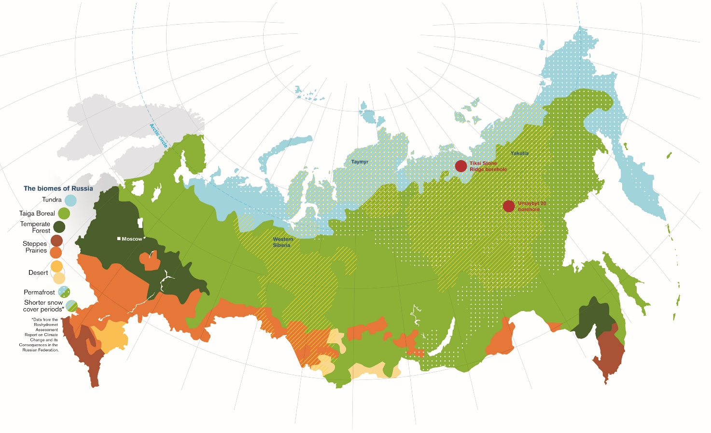
Figure 1 © the Royal Geographical Society (with IBG)
Appendix B
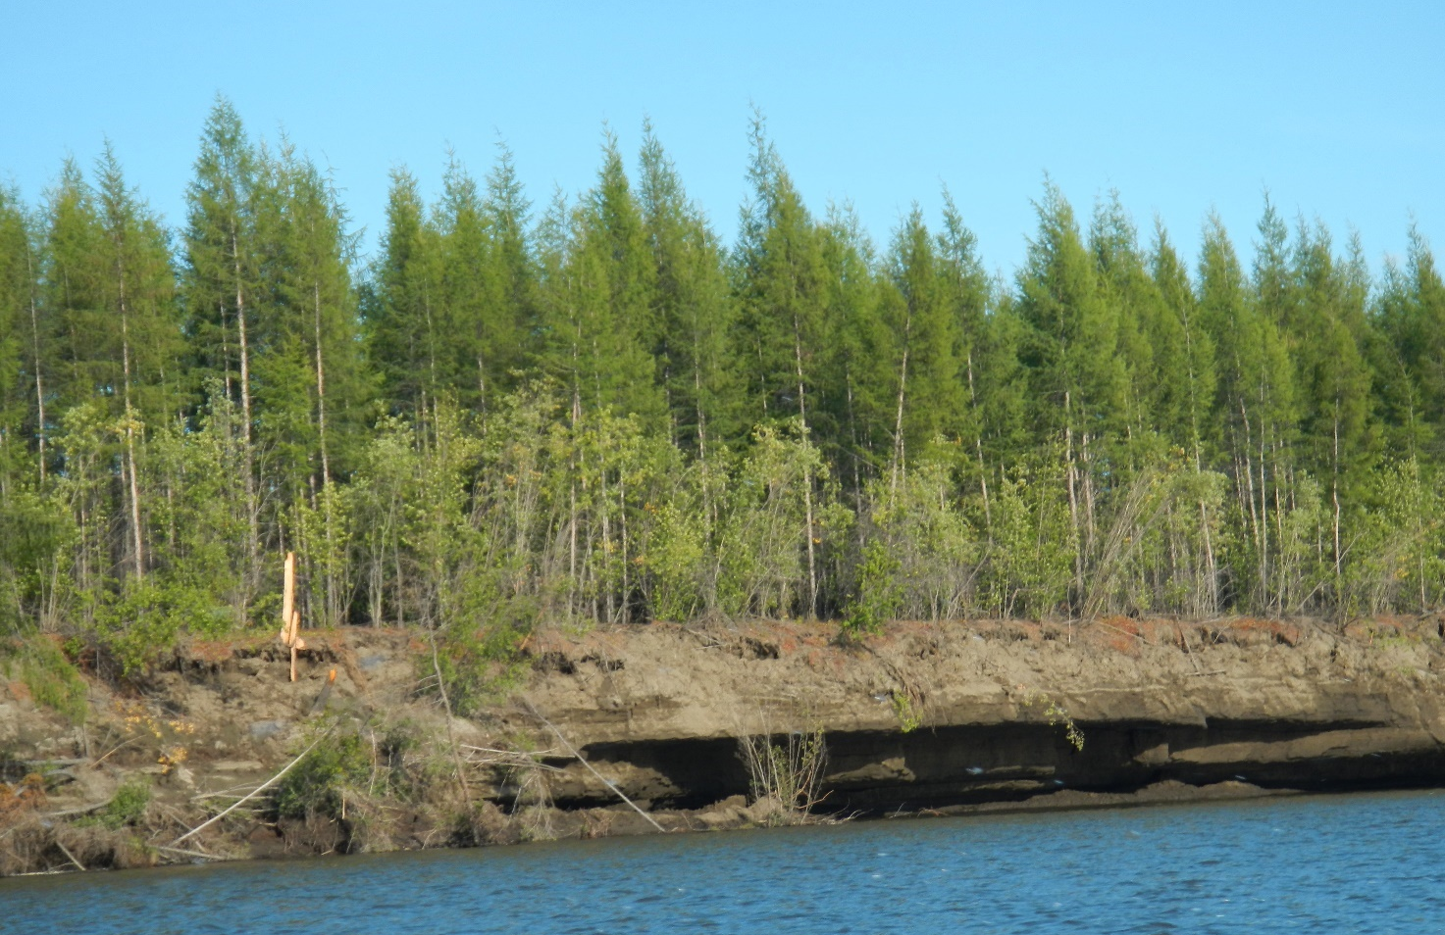
Figure 2 Russian Taiga © Thomas Opel
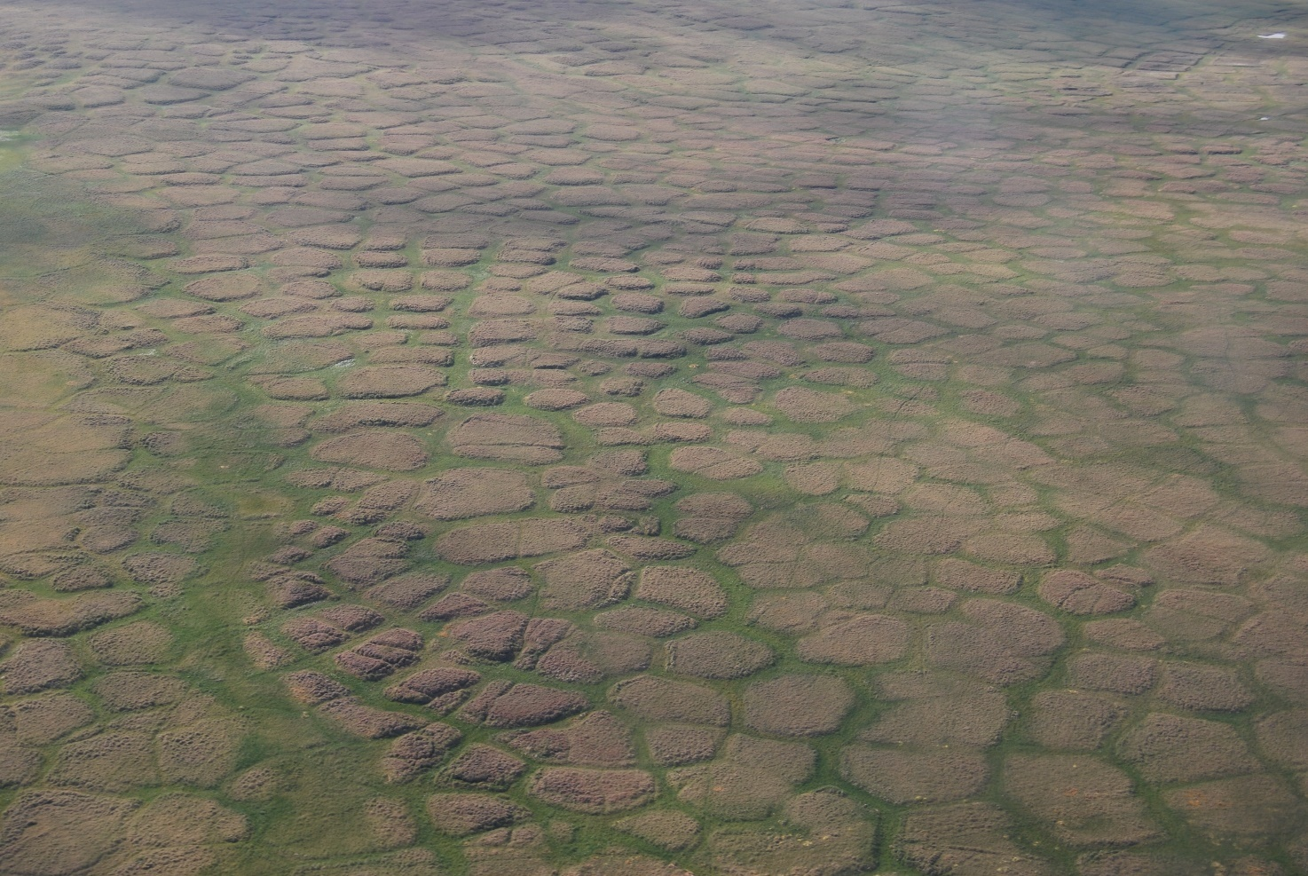
Figure 3 Russian tundra © Thomas Opel
Appendix C

Data

Quantitative
Qualitative

Categories Numerical

Ordinal
Discrete
Continuous
Nominal

Names — no order Order implied per level Finite possibilities Infinite possibilities

Which graph should I choose?
Nominal | Ordinal | Discrete | Continuous
Bar graph | Bar graph | Bar graph | Histogram
Column chart | Pictogram |  | Scatterplot
Pictogram |  |  | Boxplot
Pie chart |  |  | Line graph
 |  |  | Area chart
Table 1

Appendix D
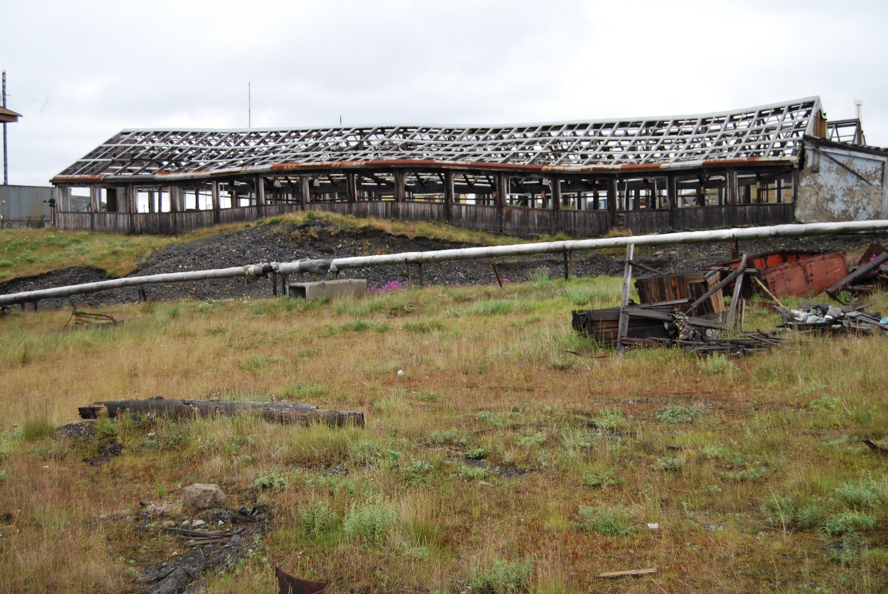
Figure 4 © Thomas Opel

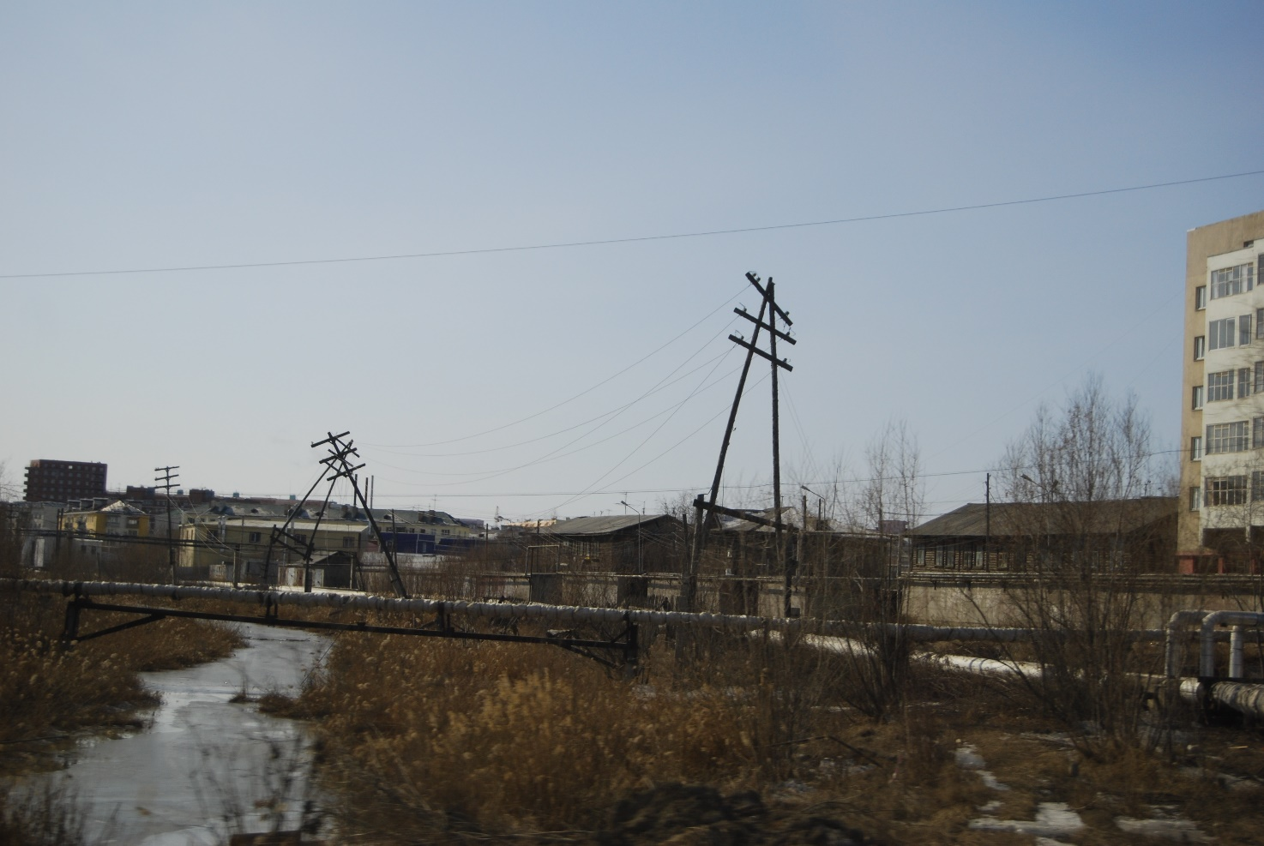
Figure 5 © Thomas Opel

Thank you to Dr Caroline Coch, Polar specialist at WWF-UK, for helping with the production of this resource

