Amazon deforestation and its impact on weather: students

The purpose
The purpose of this resource is to encourage the uptake and practice of data skills in geography. The task is also aimed at highlighting the importance of meteorology understanding in physical geography

Specification links
AQA A level 3.1.6.3 Biomes. The concept of the biome. The global distribution of major terrestrial biomes. The nature of two contrasting biomes: tropical rainforest and savanna grassland.

3.4.2.4 Statistical skills. Inferential and relational statistical techniques to include Spearman’s rank correlation and Chi-square test and the application of significance tests.
Edexcel A level 5.3 The hydrological cycle influences water budgets and river systems at a local scale. Water budgets which show the annual balance between inputs (precipitation) and outputs (evapotranspiration) and their impact on soil, water availability and are influenced by climate type (tropical, temperate, or polar examples).

This specification requires students to: collect, analyse, and interpret such information, and demonstrate the ability to understand and apply suitable analytical approaches for the different information types including, qualitative approaches such as coding and sampling and quantitative approaches such as measures of dispersion, measures of correlation and association from the
following statistical tests: t-tests, Spearman’s rank, Chi-squared, Gini Co-efficient, Lorenz curve.

OCR A level 2.a. It is possible to identify the physical and human factors that affect the water and carbon cycles in a tropical rainforest.

4.4 Quantitative skills: b) tests of association and significance tests, such as Chi-squared, Spearman’s rank, Mann-Whitney U test and T-test.

Eduqas A level 2.1.7 Carbon stores in different biomes. Size of carbon stores in the tropical rainforest and temperate grassland and factors influencing the size of these stores including temperature, precipitation, and light.

Number and statistical calculations: measures of correlation, including a scatter plot, lines of best fit and Spearman Rank. Learners may also use other relevant techniques and statistical techniques. These techniques could include Mann Whitney U Test, Pearson’s Product Moment, and Simpson’s diversity correlation.

Introduction
You may like to revise statistical techniques before attempting this exercise using this FSC statistical methods teaching resource this guide on the Mann Whitney U Test, both are useful references.

Watch the RMetS animation on climate change water cycles and read this NASA article on the Amazon rainforest.

- Write a short paragraph summarising how deforestation can impact rainfall in the Amazon and elsewhere.
The figure below shows the Amazon rainforest (A) and a subset region within it (B). The area was studied over the period 2002- 2012 to see how the vegetation and water cycle parameters changed. At the end of the observation period, the squares were described as either ‘intact’ (no deforestation had taken place) or deforested (non-intact, moderate, or severe deforestation). The deforested areas were compared against nearby ‘intact’ areas to determine the impact the deforestation had on the climate.

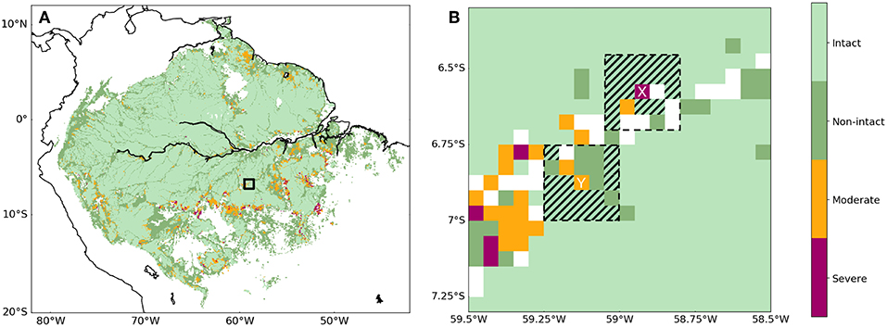
© Jessica Baker and Dominick Spracklen www.frontiersin.org/articles/10.3389/ffgc.2019.00047/full

- In the Google Earth app, search ‘Amazon Rainforest’. Zoom to find the location of the dataset, using the latitude and longitude coordinates of the figure above (you can change the latitude and longitude formatting to decimal in Google Earth).

- Click View Historical Imagery or, above the 3D viewer, click Time.

- Select 2002, copy the image, and do the same for 2012.

- Describe any differences between the images.

Open deforestation data activity_final.xlsx to view the datasets.

- In Excel, go to the first tab labelled ‘deforestation data’ and calculate the average change in leaf area index between 2002 and 2012 for the intact (Column F) and deforested (Column I) area.
Is it best to use mean, mode or median? Why?
[Hint: In Excel to calculate a mean, use =AVERAGE(A1:A30) where A1 is the top cell you want to include in the calculation, and A30 is the bottom. To calculate a mode, use =MODE(A1:A30) and to calculate a median use =MEDIAN(A1:A30)]

- Describe what happened to the leaf area in the intact and deforested areas between 2002 and 2012.

- Why is the Mann Whitney U test appropriate for comparing the change in leaf area index between intact and deforested areas?
In the ‘temperature’ tab of the Excel spreadsheet, the Land surface temperature data from both the intact and deforested regions have been combined and converted from Kelvin into °C.

- Create a scatterplot of temperature in 2012 against temperature in 2002. [Hint, select all the data you want to include and then go to the Insert menu and select ‘Insert Scatter (X, Y) or Bubble Chart’].

What can you say has happened to the land surface temperature over the 10 years?

- All other things being equal, what would you expect to happen to the rate of evapotranspiration with this change in temperature?
- Now, going back to the ‘deforestation data’ tab of the spreadsheet, use columns V and W to create a scatterplot showing the change in temperature in deforested areas against the change in temperature in intact areas.

- Have temperatures changed the same amount in both types of area?
With this data set, we have to be careful because the data are in fact paired – there is some data for both an intact and a deforested site at each set of coordinates. This allows soil, microclimate, species composition etc to be comparable. The figure below shows the difference between the change in evapotranspiration rate as the y axis (column R in the spreadsheet). A positive value indicates that, between 2002 and 2012 there was a greater increase in evapotranspiration rates in the intact forest than in the deforested. This might be the case if temperatures were increasing, promoting more evapotranspiration, in both areas, but the amount of vegetation has decreased in the deforested region. The x axis shows the difference in change in Leaf area index (column J in the spreadsheet). A positive value implies more leaf area has been lost in the deforested area than in the intact area.

- What can you suggest might be the case from this plot?

- What statistical technique would be appropriate to investigate the strength of this relationship?

- Using the data in columns R and J in the spreadsheet, use this technique to test the relationship. [Hint: not all statistical techniques are built into Excel but there is advice available online about how to calculate them – you will probably want to use the RANK.AVG and CORREL functions].

- What can you conclude?

Further reading
- For help with the Mann Whitney U Test and Spearman’s Rank Correlation Coefficient go to our student guide for the NEA https://www.rgs.org/schools/teaching-resources/a-student-guide-to-the-a-level-independent-investi/

- International pressure can save the Amazon from Bolsonaro. FT opinion piece https://www.ft.com/content/0f97c674-b7aa-4ec4-8fa1-88b810bc3dc7

- Deforestation and forest degradation https://www.worldwildlife.org/threats/deforestation-and-forest-degradation

- Fires in Brazil’s Amazon rainforest jump in October, Al Jazeera reports https://www.aljazeera.com/news/2020/11/2/fires-in-brazils-amazon-rainforest-jump-in-october

Geography Directions
- Biodiversity: where the world is making progress — and where it is not. Geography Directions https://blog.geographydirections.com/2020/10/01/biodiversity-where-the-world-is-making-progress-and-where-its-not/

- Five countries hold 70% of the world’s remaining wilderness but do they agree? — Brazil Geography Directions https://blog.geographydirections.com/2019/03/05/five-countries-hold-70-of-worlds-remaining-wilderness-but-does-anyone-there-agree/

