Migrants on the Margins
- Defining internal migration – resource linked to the video

Introduction:
Before watching the video write down a definition of internal migration.
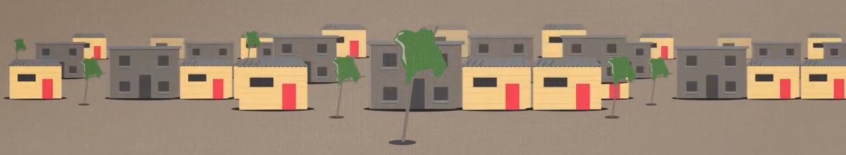

Questions to answer during the video
- What percentage of the world’s population currently lives in a city? ______________

- What percentage is expected to live in an urban area by 2050? _________________

- Name a type of internal migration __________________________________________

- Give 4 reasons why people migrate ________________________________________

- If you have no choice in your decision to move, it is known as forced migration. Why does this occur? ______________________________________________________________

- How many internal migrants are there worldwide? _______________________________

Activity to follow the video
Categorise the following into positives and negatives using two colours of your choice.

Extension: Categories them into social, economic and environmental impacts.

Job opportunities | Diverse societies | Access to healthcare
Energy stress | Inequality | Deprivation
Informal employment | Access to education | Unequal access to healthcare
Unequal access to education | Unreliable water supply | Exclusion

Discussion opportunities
Why might some migrants feel trapped?

What does Sustainable Development Goal 11 aim to achieve and how might this help cities?

