Harare, Zimbabwe
- Factsheet

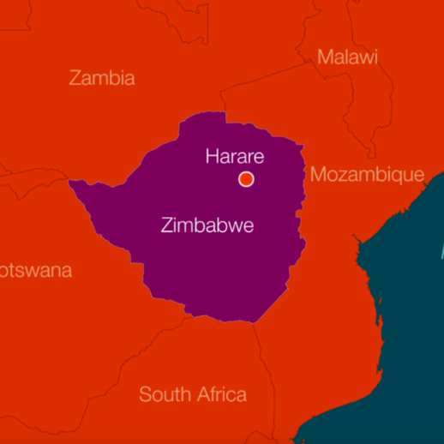
Population
Harare is the capital of Zimbabwe. This country was previously known as Rhodesia and between 1965 and 1980 there was armed conflict between the white minority government and black nationalist forces. The armed conflict came to an end in 1980 through a peace agreement which established universal enfranchisement for all of Zimbabwe’s people. It has a population of around 1.5 million.

Climate
Zimbabwe has a tropical climate with a rainy season between November and March. However, because Harare is situated on a plateau, the high altitude and cooler south-easterly airflow results in a cooler and drier climate. This means droughts are common.

Economy
Zimbabwe has been experiencing a financial crisis, including hyper-inflation and in 2019 it introduced a new currency, the Zimbabwean Dollar. Harare is Zimbabwe's leading financial, commercial, and communications centre, as well as a trade centre for tobacco, maize, cotton, and citrus fruits. Manufacturing, including textiles, steel, and chemicals, are also economically significant, as is local gold mining.

Infrastructure
The southern part of the city is high density and includes the former African townships, as well as some new middle-class developments. Informal settlements have expanded dramatically since 2000.
Politics
Emmerson Mnangagwa became president in November 2017, following Robert Mugabe who resigned after 37 years in office. In 2005, the capital city of Harare under Mugabe’s rule, began ‘Operation Restore Order’, an urban rationalisation program, which resulted in the destruction of 700,000 homes and businesses, mostly in poverty-stricken opposition settlements. These forced evictions have caused these internally displaced people to set up in informal settlements on the edge of Harare, such as Hopley, Hatcliffe Extension and Epworth Ward 7, which Migrants on the margins has been researching.

