Amazon deforestation and its impact on weather: teachers

The purpose
The purpose of this resource is to encourage the uptake and practice of data skills in geography. The task is also aimed at highlighting the importance of meteorology understanding in physical geography

Specification links
AQA A level 3.1.6.3 Biomes. The concept of the biome. The global distribution of major terrestrial biomes. The nature of two contrasting biomes: tropical rainforest and savanna grassland.

Edexcel A level 5.3 The hydrological cycle influences water budgets and river systems at a local scale. Water budgets which show the annual balance between inputs (precipitation) and outputs (evapotranspiration) and their impact on soil, water availability and are influenced by climate type (tropical, temperate, or polar examples).

OCR A level 2.a. It is possible to identify the physical and human factors that affect the water and carbon cycles in a tropical rainforest.

Eduqas A level 2.1.7 Carbon stores in different biomes. Size of carbon stores in the tropical rainforest and temperate grassland and factors influencing the size of these stores including temperature, precipitation, and light.

Introduction
You may like to revise statistical techniques before attempting this exercise using this FSC statistical methods teaching resource this guide on the Mann Whitney U Test, both are useful references.

Watch the RMetS animation on climate change water cycles and read this NASA article on the Amazon rainforest.

- Write a short paragraph summarising how deforestation can impact rainfall in the Amazon and elsewhere.
The figure below shows the Amazon rainforest (A) and a subset region within it (B). The area was studied over the period 2002- 2012 to see how the vegetation and water cycle parameters changed. At the end of the observation period, the squares were described as either ‘intact’ (no deforestation had taken place) or deforested (non-intact, moderate, or severe deforestation). The deforested areas were compared against nearby ‘intact’ areas to determine the impact the deforestation had on the climate.

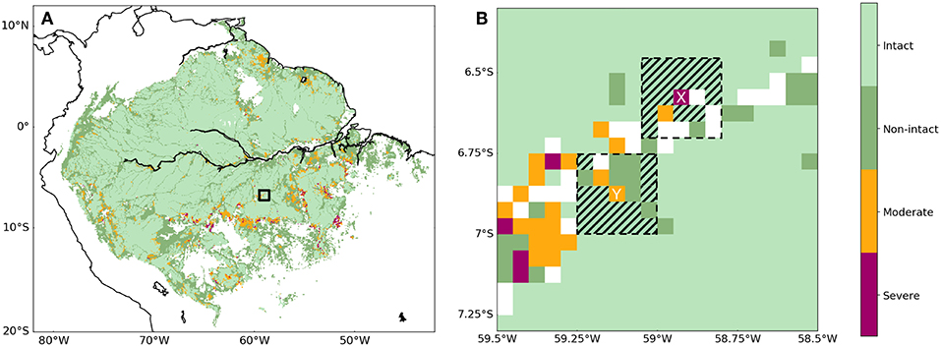
© Jessica Baker and Dominick Spracklen www.frontiersin.org/articles/10.3389/ffgc.2019.00047/full

- In the Google Earth app, search ‘Amazon Rainforest’. Zoom to find the location of the dataset, using the latitude and longitude coordinates of the figure above (you can change the latitude and longitude formatting to decimal in Google Earth).

- Click View Historical Imagery or, above the 3D viewer, click Time.

- Select 2002, copy the image, and do the same for 2012.

2012
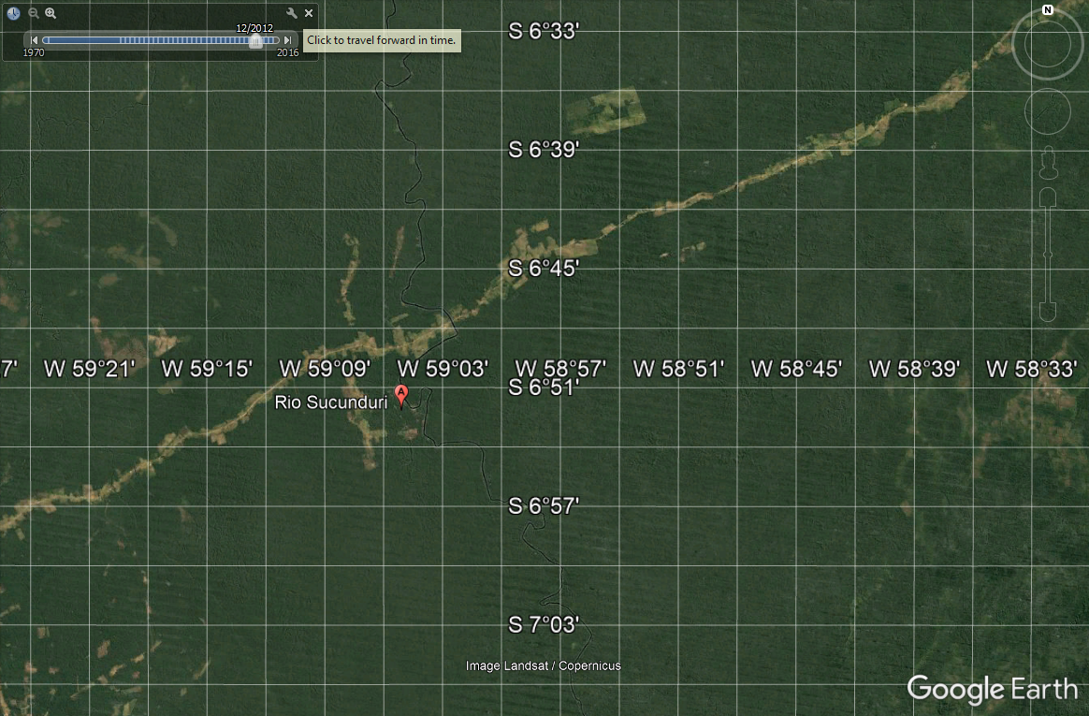

2002
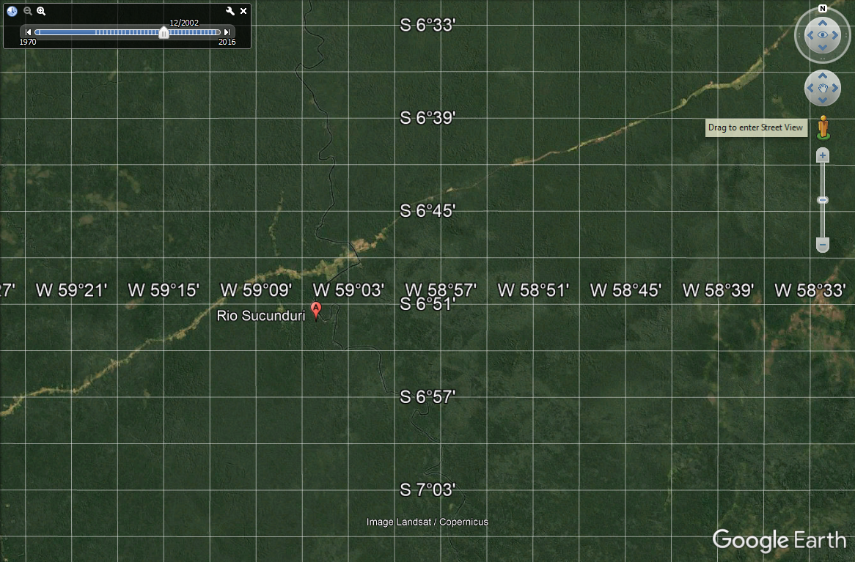

- Describe any differences between the images.
Open deforestation data activity_final.xlsx to view the datasets.
- In Excel, go to the first tab labelled ‘deforestation data’ and calculate the average change in leaf area index between 2002 and 2012 for the intact (Column F) and deforested (Column I) area.

Is it best to use mean, mode or median? Why?

[Hint: In Excel to calculate a mean, use =AVERAGE(A1:A30) where A1 is the top cell you want to include in the calculation, and A30 is the bottom. To calculate a mode, use =MODE(A1:A30) and to calculate a median use =MEDIAN(A1:A30)]
Mode is clearly wrong, the other two are arguable. The best answer might be ‘median because it’s more robust to differently distributed data and outliers’
Mean change: intact, -0.12, deforested -0.44
Median change: intact = -0.10, deforested = -0.29

- Describe what happened to the leaf area in the intact and deforested areas between 2002 and 2012.
On average, the leaf area index decreased in both intact and deforested plots, however it typically decreased more in the deforested plots than the intact ones

Mann Whitney U Test
- Why is the Mann Whitney U test appropriate for comparing the change in leaf area index between intact and deforested areas?
Because it can compare two groups of measurements and test if they are significantly different. This test is good because it is robust to differences in the way the data is distributed, including outlying data points.

In the ‘temperature’ tab of the Excel spreadsheet, the Land surface temperature data from both the intact and deforested regions have been combined and converted from Kelvin into °C.

- Create a scatterplot of temperature in 2012 against temperature in 2002. [Hint, select all the data you want to include and then go to the Insert menu and select ‘Insert Scatter (X, Y) or Bubble Chart’].

What can you say has happened to the land surface temperature over the 10 years?

The red line shows where all the points would be if the temperature had stayed the same. In most places, the temperature has increased.

- All other things being equal, what would you expect to happen to the rate of evapotranspiration with this change in temperature?
In warmer temperatures, without any changes to vegetation and with no lack of water availability, you would expect the rate of evapotranspiration to increase as the temperature increases.

- Now, going back to the ‘deforestation data’ tab of the spreadsheet, use columns V and W to create a scatterplot showing the change in temperature in deforested areas against the change in temperature in intact areas.

- Have temperatures changed the same amount in both types of area?
If temperatures had changed the same amount in both types of area, then all the points would be on the red line. In fact, deforested areas have mostly warmed more.

With this data set, we have to be careful because the data are in fact paired – there is some data for both an intact and a deforested site at each set of coordinates. This allows soil, microclimate, species composition etc to be comparable. The figure below shows the difference between the change in evapotranspiration rate as the y axis (column R in the spreadsheet). A positive value indicates that, between 2002 and 2012 there was a greater increase in evapotranspiration rates in the intact forest than in the deforested. This might be the case if temperatures were increasing, promoting more evapotranspiration, in both areas, but the amount of vegetation has decreased in the deforested region. The x axis shows the difference in change in Leaf area index (column J in the spreadsheet). A positive value implies more leaf area has been lost in the deforested area than in the intact area.

- What can you suggest might be the case from this plot?
The figure does seem to show a trend, suggesting that the greater the amount of vegetation has decreased in the deforested region, the less evapotranspiration is occurring in the deforested region, despite the increase in temperatures.

- What statistical technique would be appropriate to investigate the strength of this relationship?
Spearman’s Rank Correlation.

Spearman’s Correlation Coefficient
- Using the data in columns R and J in the spreadsheet, use this technique to test the relationship. [Hint: not all statistical techniques are built into Excel but there is advice available online about how to calculate them – you will probably want to use the RANK.AVG and CORREL functions].
The Spearman’s Rank Correlation coefficient between the data in columns R and J in the spreadsheet is equal to 0.558. Using a Spearman’s Rank significance table or graph e.g., https://geographyfieldwork.com/SpearmansRankSignificance.htm, with n=467, this suggests a significant correlation.

- What can you conclude?
The greater the amount of vegetation has decreased in the deforested region; the less evapotranspiration is occurring in the deforested region.

An extra for teachers: More able students will notice that the temperatures increased more in deforested areas. You might therefore expect there to be more evapotranspiration in deforested areas, but in fact there is less. Evapotranspiration cools land surface temperatures – so less evapotranspiration (because of deforestation) leads to higher temperatures, rather than higher temperatures leading to more evapotranspiration.

Further reading
- For help with the Mann Whitney U Test and Spearman’s Rank Correlation Coefficient go to our student guide for the NEA https://www.rgs.org/schools/teaching-resources/a-student-guide-to-the-a-level-independent-investi/

- International pressure can save the Amazon from Bolsonaro. FT opinion piece https://www.ft.com/content/0f97c674-b7aa-4ec4-8fa1-88b810bc3dc7

- Deforestation and forest degradation https://www.worldwildlife.org/threats/deforestation-and-forest-degradation

- Fires in Brazil’s Amazon rainforest jump in October, Al Jazeera reports https://www.aljazeera.com/news/2020/11/2/fires-in-brazils-amazon-rainforest-jump-in-october

Geography Directions
- Biodiversity: where the world is making progress — and where it is not. Geography Directions https://blog.geographydirections.com/2020/10/01/biodiversity-where-the-world-is-making-progress-and-where-its-not/

- Five countries hold 70% of the world’s remaining wilderness but do they agree? — Brazil Geography Directions https://blog.geographydirections.com/2019/03/05/five-countries-hold-70-of-worlds-remaining-wilderness-but-does-anyone-there-agree/

