US President Joe Biden and the Paris Climate

Who is President Joe Biden?
In 1972, Joe Biden became the fifth youngest senator in US history and on 20 January 2021 he became the 46th US President of the United States of America. At 78-years-old he is the oldest man to take the presidential oath. In his first day in office, during his first hours as Commander-in-chief, President Biden signed an executive order for the US to re-join the Paris climate agreement. This move reverses the decision by former US President Donald Trump to leave the Paris climate accords (which at the time made the US the only country to have pulled out of the historic multilateral agreement).

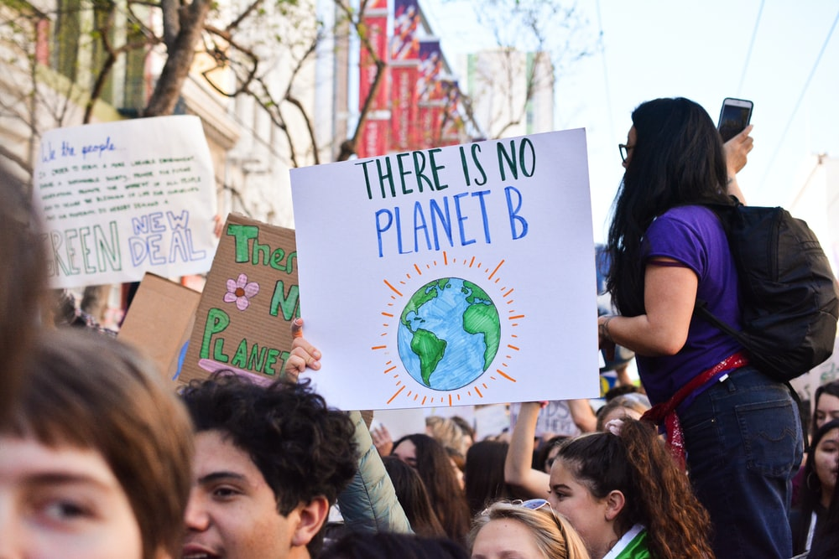
A climate protest in the US © Li-An Lim

The Paris agreement
The Paris climate accords were drafted in Paris, France, in 2015. The agreement is a legally binding international treaty on climate change and was adopted by a staggering 196 countries. The aim of the accords is to keep global warming ‘well below’ 2°C and preferably down to 1.5°C of pre-industrial levels. It works on a 5-year cycle of increasingly ambitious climate action. Watch this video What is the Paris Agreement to learn more.

Why is American participation so important?
The US is renowned for being a top global polluter of greenhouse gases and has a very high level of plastic waste. Levels of waste in the US have tripled since 1960 with around 55% currently buried in landfill and 12% being incinerated. Incineration further releases carbon dioxide (CO₂), carbon monoxide (CO) and harmful dioxins into the atmosphere, creating air pollution.

The US is the second biggest emitter of CO₂ and is the number one emitter in historical carbon. Although CO₂ makes up less than 1% of our atmosphere it is nevertheless very important. CO₂ is one of the key greenhouse gases responsible for trapping heat which has led to the melting of ice caps, global warming, unpredictable weather, and severe flooding linked to rising sea levels.

Surprisingly, the US has been lauded recently for its efforts in lowering carbon dioxide emissions which continued even during the last presidency. This achievement is largely due to the impact of national lockdowns from COVID-19, which produced a fall in vehicle traffic and air travel. US political momentum really began in 2009 when former US President Barack Obama targeted a 17% drop in CO₂ by 2020. This year CNN reported on 12 January 2021 that:

Under the 2009 Copenhagen Accord, the US pledged that by 2020, it will have cut its emissions by 17% from 2005 levels. Because of the pandemic, emissions were 21.5% lower in 2020, compared to 2005.

However, it is important to stress that the Paris climate accords aim to keep global warming down to 1.5°C of pre-industrial levels (not 2005).

The future
Many environmentalists are hopeful that in 2021 there will be greater strides towards being carbon neutral by 2050, if not earlier.

In 2020 China announced it would ‘aim’ for carbon neutrality by 2060 which has received widespread praise. Some critiques argue these deadlines could easily be brought forward however either way this surprise statement of intent by China injected some much-needed momentum into global climate politics of 2020 (as COP26 was delayed to November 2021).

If the world is to keep global warming down to a 1.5°C rise in temperature it is essential that the top two polluters, namely China and the US, are determined to achieve net zero. The US should not only engage with the climate accords but must also lead the world to a low-carbon future.

The scale of both their contributions to global pollution is clear in Table 1 below, showing the top 10 emitters of carbon dioxide in 2018.

Country | 2018 CO₂ Emissions in billion metric tons | Global share | Change Since Kyoto Protocol
China | 9.43 | 27.8% | 54.6%
US | 5.15 | 15.2% | -12.1%
India | 2.48 | 7.3% | 105.8%
Russia | 1.55 | 4.6% | 5.7%
Japan | 1.15 | 3.4% | -10.1%
Germany | 0.73 | 2.1% | -11.7%
South Korea | 0.70 | 2.1% | 34.1%
Iran | 0.66 | 1.9% | 57.7%
Saudi Arabia | 0.57 | 1.7% | 59.9%
Canada | 0.55 | 1.6% | 1.6%
Table 1 © Forbes The World’s Top 10 Carbon Dioxide Emitters (forbes.com)

On 20 January 2021, the American Association of Geographers wrote an open letter to US President Joe Biden which, among other priorities, keenly emphasised ‘the worsening threats of climate change’. You can read the letter on the AAG website which also stressed the importance of geospatial data and the role geography plays in promoting diversity, equality and inclusion.

On 27 January 2021, US President Joe Biden addressed the world saying the US had ‘already waited too long to deal with this climate crisis — and we can’t wait any longer’. He went on to add that the planet faced an ‘existential threat’ and in a promising sign of global leadership announced that the US would host world leaders in a climate summit on Earth Day on 22 April 2021.

Further reading
Biden to return US to Paris climate accord Biden returns US to Paris climate accord hours after becoming president | Climate change | The Guardian

US is back in the Paris Accords as Biden signs wave of climate executive orders https://www.independent.co.uk/environment/climate-change/biden-paris-agreement-rejoin-executive-order-b1789555.html

US carbon fell by 10% in 2020 US carbon emissions fell 10% in 2020 (msn.com)

China Climate change: China aims for 'carbon neutrality by 2060' - BBC News

Should we burn or bury? Should we burn or bury waste plastic? - BBC News

Countries not in the Paris climate accords Countries That Are Not Part Of the Paris Climate Agreement - WorldAtlas

The world’s top 10 carbon dioxide emitters The World’s Top 10 Carbon Dioxide Emitters (forbes.com)

An op-ed letter by the AAG to US President Joe Biden Statement on January 6-Final (aag.org)

Biden takes action to address climate crisis https://www.aljazeera.com/news/2021/1/27/new-biden-climate-orders-to-target-drilling-and-fossil-fuel

Biden signs ‘existential’ executive orders on climate change and the environment https://www.bbc.co.uk/news/world-us-canada-55829189

Biden to convene world leaders to talk climate on Earth Day https://www.bloomberg.com/news/articles/2021-01-22/biden-to-convene-world-leaders-to-talk-climate-on-earth-day

