Weddell Sea Ice Shelves

Latitude | Longitude | Ice Shelf Feature
68 degrees South | 63 degrees West
78 degrees South | 55 degrees West
78 degrees South | 40 degrees West
73 degrees South | 16 degrees West

Complete the table with the matching ice -shelf using the latitude and longitude information.

The ice shelves are named here:
Ronne Ice Shelf
Filchner Ice Shelf
Riiser-Larsen Ice Shelf
Larsen C Ice Shelf

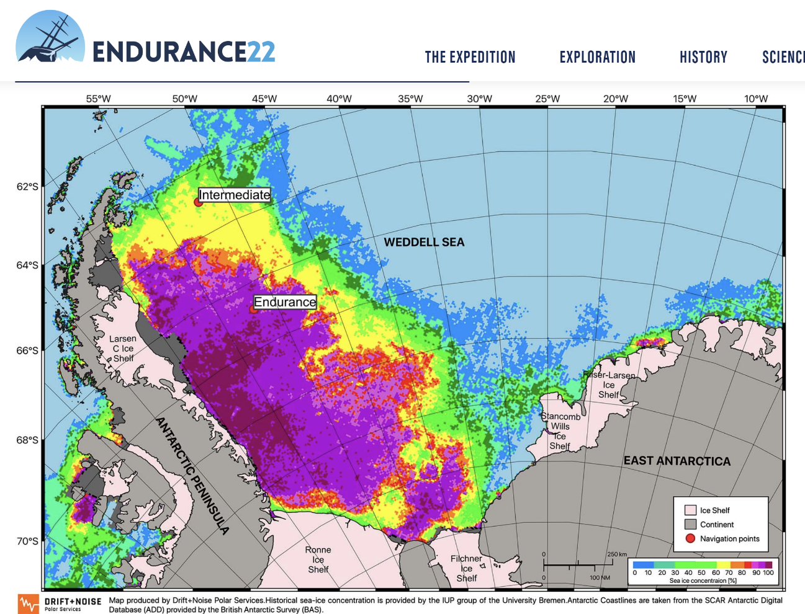
Sea Ice Research - Endurance22

